- 练习1：重要参数及文本和按钮
  - 请用GUI制作一个游戏开始界面，上面有开始游戏，退出游戏，设置等等按钮选项，点击开始游戏可以切换到游戏场景
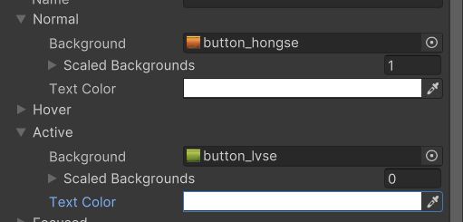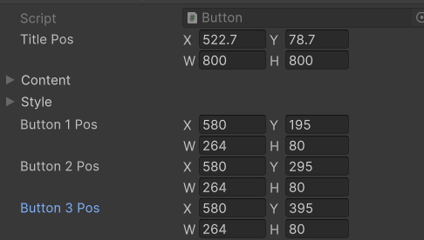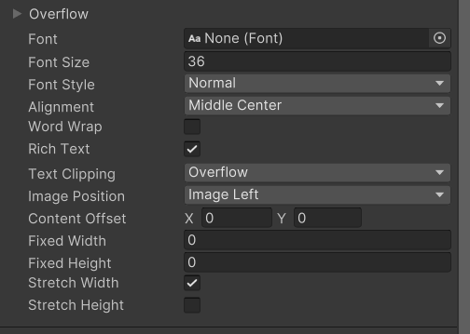
public class Button : MonoBehaviour
{
//标题变量
public Rect titlePos;
public GUIContent content;
public GUIStyle style;
//按钮变量
public Rect button1Pos;
public Rect button2Pos;
public Rect button3Pos;
//共同的变量 共用就行
public GUIStyle buttonStyle;
private void OnGUI()
{
GUI.Label(titlePos, content, style);
//按下处理逻辑
if (GUI.Button(button1Pos, "开始游戏", buttonStyle))
//切换场景
SceneManager.LoadScene("Game");
if (GUI.Button(button2Pos, "设置", buttonStyle))
{

}
if (GUI.Button(button3Pos, "结束游戏", buttonStyle))
{

}
}
}
- 练习2：多选框和单选框
  - 在上一知识点练习题基础上制作一个游戏设置面板
上面有背景音乐的开关和音效的开关
并且点击开始界面的设置面板可以打开设置面板
public class Button : MonoBehaviour
{
//类似单例模式的静态变量
private static Button instance;
//隐藏窗口
public static void ShowMe()
{
//保护 防止报错
if (instance != null)
{
instance.gameObject.SetActive(true);
}
}
//显示窗口
public static void HidMe()
{
if (instance != null)
instance.gameObject.SetActive(false);
}
public Rect titlePos;
public GUIContent content;
public GUIStyle style;

public Rect button1Pos;
public Rect button2Pos;
public Rect button3Pos;
public GUIStyle buttonStyle;
//启动之际就让静态变量等于自己
private void Awake()
{
instance = this;
//显示窗口的同时隐藏设置窗口
//因为暂时还没办法设置窗口优先级 只能这样处理
Setting.HidMe();
}
private void OnGUI()
{
GUI.Label(titlePos, content, style);
if (GUI.Button(button1Pos, "开始游戏", buttonStyle))
SceneManager.LoadScene("Game");
if (GUI.Button(button2Pos, "设置", buttonStyle))
{
//调用设置窗口的显示 再关闭自己
Setting.ShowMe();
HidMe();
}
if (GUI.Button(button3Pos, "结束游戏", buttonStyle))
{

}
}
}
public class Setting : MonoBehaviour
{
private static Setting instance;
public static void ShowMe()
{
if (instance != null)
instance.gameObject.SetActive(true);
}
public static void HidMe()
{
if (instance != null)
instance.gameObject.SetActive(false);
}
public Rect pos1;
public Rect pos2;
public Rect pos3;

bool a;
bool b;

public GUIStyle style;
public GUIStyle style1;

private void Awake()
{
instance = this;
}
private void OnGUI()
{
if (GUI.Button(pos3, " ", style1))
{
HidMe();
Button.ShowMe();
}
a = GUI.Toggle(pos1, a, "背景音乐", style);
b = GUI.Toggle(pos2, b, "背景音乐", style);

}
}
- 练习3：输入框和拖动条
  - 请在上一知识点的练习题基础上
在置面板中加入拖动条控制条控制音乐大小请在之前的基础上
public class Setting : MonoBehaviour
{
public Rect VocalPos1;
public Rect VocalPos2;
public float nowVocal1;
public float nowVocal2;
private void OnGUI()
{
nowVocal1 = GUI.HorizontalSlider(VocalPos1, nowVocal1, 0, 100);
nowVocal2 = GUI.HorizontalSlider(VocalPos2, nowVocal2, 0, 100);
}
}
  - 制作一个登陆面板
有用户名输入和密码输入有进入游戏和返回上一级按钮
点击开始界面中的开始游戏后 进入登陆面板
输入的用户名为admin密码为8888才能切换场景
public class Login : MonoBehaviour
{
private static Login instance;
public static void ShowMe()
{
if (instance != null)
{
instance.gameObject.SetActive(true);
}
}
public static void HidMe()
{
if (instance != null)
instance.gameObject.SetActive(false);
}
public Rect titlePos;
public GUIContent content;
public GUIStyle style;

public Rect pos1;
public Rect pos2;
public GUIStyle loginStyle;

public string userID = "请输入账号";
public string password = "请输入密码";
public Rect pos3;
public Rect pos4;

public Rect pos5;
public Rect pos6;
public GUIStyle style2;

private void Awake()
{
instance = this;
Setting.HidMe();
}
private void OnGUI()
{
GUI.Label(titlePos, content, style);
GUI.Label(pos1, "账号", loginStyle);
GUI.Label(pos2, "密码", loginStyle);
userID = GUI.TextField(pos3, userID);
password = GUI.PasswordField(pos4, password, '*');
if (GUI.Button(pos5, "返回", style2))
{
Button.ShowMe();
HidMe();
}
if (GUI.Button(pos6, "进入游戏", style2))
{
if (userID == "admin" && password == "8888")
{
SceneManager.LoadScene("Game");
}
else
{
Debug.Log("用户名或密码输入错误");
}
}
}
}

- 练习4：图片绘制和框
  - 为之前的各个面板加上背景图片
public class Login : MonoBehaviour
{
public Rect groundPos;
public Texture tex;
private void OnGUI()
{
GUI.DrawTexture(groundPos, tex);
}
}
}
- 练习5：工具栏和选择网格
  - 制作三个页签，选择不同的页签将在下方显示不同的信息
public class Toolbar : MonoBehaviour
{
public int toolbarIndex = 0;
public Rect pos;
public Rect pos2;
public string[] str = { "强化","进阶","幻化" };

public Rect textPos;
private void OnGUI()
{
toolbarIndex = GUI.Toolbar(pos, toolbarIndex, str);
toolbarIndex = GUI.SelectionGrid(pos2, toolbarIndex, str, 1);
switch (toolbarIndex)
{
case 0:
GUI.Label(textPos, str[0]);
break;
case 1:
GUI.Label(textPos, str[1]);
break;
case 2:
GUI.Label(textPos, str[2]);
break;
}
}
}
- 练习6：滚动列表和分组
  - 制作一个滚动视图，外部有一个字符串数组，通过在Inspector修改这个字符串数组数量，会在滚动视图内部动态的创建label依次显示内容
public class BeginScrollView : MonoBehaviour
{
public Rect svPos;
public Rect showPos;
public Vector2 nowPos;
public string[] strs;
private void OnGUI()
{
//动态变化内容的高度
showPos.height = strs.Length * 30;
nowPos = GUI.BeginScrollView(svPos, nowPos, showPos);
for (int i = 0; i < strs.Length; i++)
{
//动态变化字符串的y轴位置
GUI.Label(new Rect(100, i * 30, 100, 30), strs[i]);
}
GUI.EndScrollView();
}
}
- 练习7:窗口
  - 在之前制作的开始界面中，点击退出游戏按钮，弹出一个模态窗口，让玩家确定是否退出（退出，取消），点击取消后关闭窗口，点击退出后退出游戏
public class Exit : MonoBehaviour
{
public Rect pos;
public Rect pos2;
public Rect pos3;
public Rect pos4;

private static Exit instance;
public static void ShowMe()
{
if (instance != null)
{
instance.gameObject.SetActive(true);
}
}
public static void HidMe()
{
if (instance != null)
instance.gameObject.SetActive(false);
}
private void Awake()
{
instance = this;
}
private void OnGUI()
{
GUI.ModalWindow(1, pos, DrawWindow,"提示");
}
public void DrawWindow(int id)
{
GUI.Label(pos4,"是否退出");
if (GUI.Button(pos2, "退出"))
Application.Quit();
if (GUI.Button(pos3, "取消"))
{
HidMe();
Button.ShowMe();
}
}
}

