核心阶段——练习
2026年3月16日
3:43

练习1：类和对象
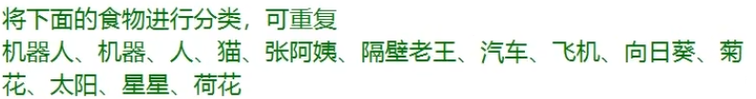
生物
人、猫、张阿姨、隔壁老王、向日葵、菊花、荷花
非生物
机器人、机器、汽车、 飞机、太阳、星星
工业制品
机器人、机器、汽车、飞机
人
人、张阿姨、隔壁老王
植物
向日葵、菊花、荷花
动物
猫
天体
太阳、星星
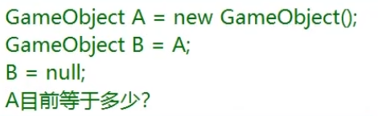
new Game Obieject()
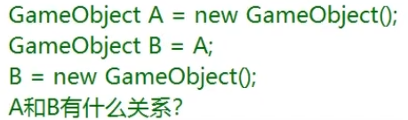
没有任何关系

练习2：成员对象和访问修饰符
访问修饰符
Public 公开的
Private 私有的
Protected 保护的
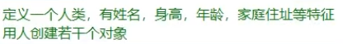
class Person
{
public string name;
public float height;
public int age;
public string address;
}

Person p = new Person();
p.age = 10;
p.name = "牛子";
p.address = "地球";
p.height = 150.1f;
Person p2 = new Person();
p2.age = 12;
p2.name = "子牛";
p2.address = "火星";
p2.height = 170.1f;

class Student
{
public string name;
public int ID;
public int age;
public Person deskMate;
}

Student s = new Student();
s.name = "牛";
s.ID = 1;
s.age = 20;
s.deskMate = p;
Student s2 = new Student();
s.name = "子";
s.ID = 2;
s.age = 21;
s.deskMate = p2;

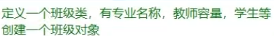
class Class
{
public string zhuanYeName;
public int teacherNum;
public Student[] student;
}

Class c = new Class();
c.teacherNum = 999;
c.zhuanYeName = "unity";
c.student = new Student[] { s, s2 };

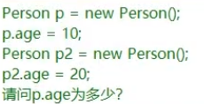
10
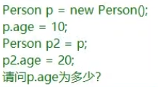
20
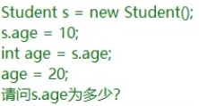
10
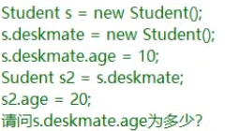
20

练习3：成员方法
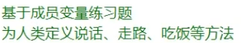
public void Speak(string str)
{
Console.WriteLine("{0}说了{1}", name, str);
}
public void Walk()
{
Console.WriteLine("{0}开始走路了", name);
}
public void eat(Food f)
{
Console.WriteLine("{0}开始吃{1}了", name, f.name);
}
}

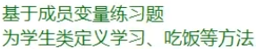
public void study()
{
Console.WriteLine("{0}开始学习了", name);
}
public void eat(Food f)
{
Console.WriteLine("{0}开始吃{1}了", name, f.name);
}

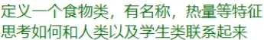
class Food
{
public string name;
public int kcal;

public void BeiEat(Student s)
{
Console.WriteLine("{0}被{1}喝了", name, s.name);
}
public void BeiEat(Person p)
{
Console.WriteLine("{0}被{1}喝了", name, p.name);
}
}
f.BeiEat(p);
f.BeiEat(s);
s.eat(f);
p.eat(f);

练习4：构造函数和析构函数
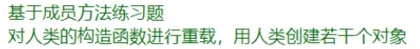
class Person
{
public string name;
public float height;
public int age;
public string address;
public Person[] friend;

public Person(string name, float height, int age, string address)
{
this.name = name;
this.height = height;
this.age = age;
this.address = address;
}

public Person(string name, float height)
{
this.name = name;
this.height = height;
}

Person p3 = new Person("真剑", 186f);
Person p4 = new Person("龙", 186f, 20, "日本");

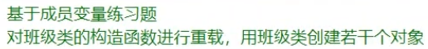
class Class
{
public string zhuanYeName;
public int teacherNum;
public Student[] student;

public Class(string str, int i, Student[] s)
{
this.student = s;
this.zhuanYeName = str;
this.teacherNum = i;
}
public Class(string zhuanYeName, int teacherNum)
{
this.zhuanYeName = zhuanYeName;
this.teacherNum = teacherNum;
}
}

Class c = new Class("unity",999, new Student[] { s, s2 });
Class c1 = new Class("Math",999);

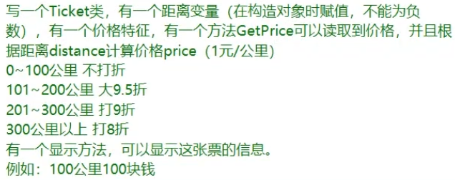
class Ticket
{
public uint distance;
public float price;

public Ticket(uint distance)
{
this.distance = distance;
price = GetPrice();
}

private float GetPrice()
{
if (distance <= 100)
{
return distance;
}
else if (distance <= 200 && distance > 100)
{
return distance * 0.95f;
}
else if (distance <= 300 && distance > 200)
{
return distance * 0.9f;
}
else
{
return distance * 0.8f;
}
}
public void Write()
{
Console.WriteLine("{0}公里{1}块钱", distance, price);
}
}

Ticket t = new Ticket(400);
t.Write();

练习5：成员属性
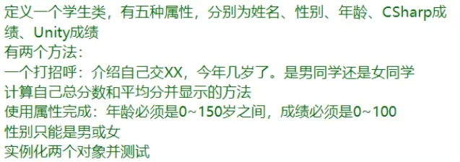
class Student
{
public int age;
public int cSharp;
public int unity;
public string sex;
public string Name
{
get;
set;
}
public string Sex
{
get
{
return sex;
}
set
{
if (value != "男" && value != "女")
{
sex = "扶他";
}
else
{
sex = value;
}
}
}
public int Age
{
get
{
return age;
}
set
{
if (value < 0)
{
age = 0;
}
else if (value > 150)
{
age = 150;
}
else
{
age = value;
}
}
}
public int CShare
{
get
{
return cSharp;
}
set
{
if (value < 0)
{
cSharp = 0;
}
else if (value > 100)
{
cSharp = 100;
}
else
{
cSharp = value;
}
}
}
public int Unity
{
get
{
return unity;
}
set
{
if (value < 0)
{
unity = 0;
}
else if (value > 100)
{
unity = 100;
}
else
{
unity = value;
}
}

}

public void SayHello()
{
Console.WriteLine("我叫{0}，今年{1}岁了，是{2}同学", Name, Age, Sex);
}
public void JiSuan()
{
int sum = CShare + Unity;
float avg = sum / 2f;
Console.WriteLine("总分是{0}，平均分是{1}", sum, avg);
}
}

Student s = new Student();
s.Name = "张";
s.Sex = "女";
s.Age = 180;
s.CShare = 101;
s.Unity = 99;
s.SayHello();
s.JiSuan();

练习6：索引器
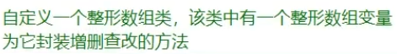
class Arr
{
private int[] arr;
private int length;
private int capacity;

public Arr()
{
length = 0;
capacity = 5;
arr = new int[capacity];

}
public void Add(int value)
{
if (length < capacity)
{
arr[length] = value;
++length;
}
else
{
capacity *= 2;
int[] tempArr = new int[capacity];
for (int i = 0; i < length; i++)
{
tempArr[i] = arr[i];
}
arr = tempArr;
tempArr[length] = value;
++length;
}
}
//删
public void Remove(int value)
{
for (int i = 0; i < length; i++)
{
if (arr[i] == value)
{
RemoveAt(i);
return;
}
}
Console.WriteLine("没有找到");
}
public void RemoveAt(int index)
{
if (index > length - 1)
{
Console.WriteLine("越界！");
return;
}
else if ( index == length - 1 )
{
arr[index] = 0;
--length;
}
else
{
for (int i = index; i < length - 1; i++)
{
arr[i] = arr[i + 1];

}
--length;
}
}

//查改
public int this[int index]
{
get
{
return arr[index];
}
set
{
arr[index] = value;
}
}
}

Arr arr = new Arr();
arr.Add(1000);
arr.Add(2000);
arr.Add(3000);
arr.Add(4000);
arr.Add(5000);
arr.RemoveAt(4);
Console.WriteLine(arr[4]);

练习7：静态成员
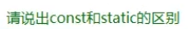
同
都可以通过类名点出来
异
Const 不能写在 访问修饰符前面
const必须初始化 不能修改
Const 只能修饰变量
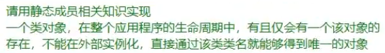
class Test
{
private static Test t = new Test();
public int testInt = 999;
public static Test T
{
get
{
return t;
}
}
private Test()
{

}
}

Console.WriteLine(Test.T.testInt);

练习8：静态类和静态构造函数
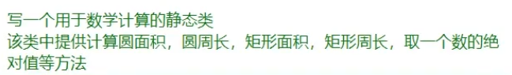
static class JiSuan
{
public static float pi = 3.14159f;

public static float YuanMianJi(int r)
{
return r * pi * pi;
}
public static float YuanZhouChang(int r)
{
return 2 * pi * r;
}
public static int JvXingMianJi(int w, int h)
{
return w * h;
}
public static int JvXingZhouChang(int w, int h)
{
return (w + h) * 2;
}
public static int JueDuiZhi(int i)
{
if (i >= 0)
{
return i;
}
else
{
return -i;
}
}
}

Console.WriteLine(JiSuan.YuanMianJi(2));
Console.WriteLine(JiSuan.YuanZhouChang(2));
Console.WriteLine(JiSuan.JvXingMianJi(4, 5));
Console.WriteLine(JiSuan.JvXingZhouChang(4, 5));
Console.WriteLine(JiSuan.JueDuiZhi(-8));
Console.WriteLine(JiSuan.JueDuiZhi(6));

练习9：拓展方法
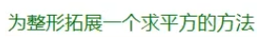
static class Tool
{
public static int PingFang(this int i)
{
return i * i;
}

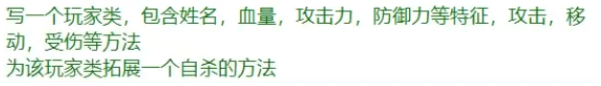
static class Tool
{
public static void KillSelf(this Player p)
{
Console.WriteLine("玩家" + p.name + "自杀了");
}
}
class Player
{
public string name;
public int hp;
public int atk;
public int def;
public Player(string name, int hp, int atk, int def)
{
this.name = name;
this.hp = hp;
this.atk = atk;
this.def = def;
}

public void GongJi(Player otherPlayer)
{
Console.WriteLine("{0}发起了攻击", name);
}
public void Move()
{

}
public void ShouShang(Player otherPlayer)
{

}
}

练习10：运算符重载
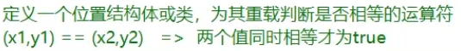
class Test
{
public int x;
public int y;

public static bool operator ==(Test t, Test t1)
{
if (t.x == t1.x && t.y == t1.y)
{
return true;
}
return false;
}
public static bool operator !=(Test t, Test t1)
{
if (t.x == t1.x && t.y == t1.y)
{
return false;
}
return true;
}
}

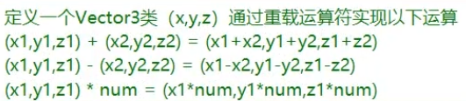
class Vector3
{
public int x, y ,z;
public Vector3(int x, int y, int z)
{
this.x = x;
this.y = y;
this.z = z;
}

public static Vector3 operator +(Vector3 v, Vector3 v1)
{
return new Vector3(v.x += v1.x, v.y += v1.y, v.z += v1.z);
}
public static Vector3 operator -(Vector3 v, Vector3 v1)
{
return new Vector3(v.x -= v1.x, v.y -= v1.y, v.z -= v1.z);
}
public static Vector3 operator *(Vector3 v, int num)
{
return new Vector3(v.x *= num, v.y *= num, v.z *= num);
}
}

练习11：继承的基本概念
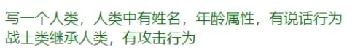
class Person
{
public string Name
{
get;
set;
}
public int Age
{
get;
set;
}

public void Speak()
{
Console.WriteLine("我叫{0},我今年{1}岁了",Name , Age);
}
}
class Warrior : Person
{
public void GongJi(Warrior otherWarrior)
{

}
}

练习12：里氏继承原则
Is 判断一个对象是否是指定类 返回一个bool值
As 将一个对象改成指定类 返回指定类或者null
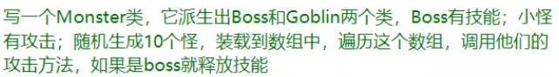
class Monster
{
public string name;
}
class Boss : Monster
{
public void Skill()
{
Console.WriteLine("boss释放了技能");
}
}
class Goblin : Monster
{
public void Atk()
{
Console.WriteLine("怪物发动了攻击");
}
}

Random r = new Random();
Monster[] monsters = new Monster[10];
for (int i = 0; i < 10; i++)
{
int random = r.Next(0,2);
if (random == 0)
{
monsters[i] = new Boss();
}
else
{
monsters[i] = new Goblin();
}
}

for (int i = 0;i < monsters.Length ;i++)
{
if (monsters[i] is Boss )
{
(monsters[i] as Boss).Skill();
}
else
{
(monsters[i] as Goblin).Atk();
}
}

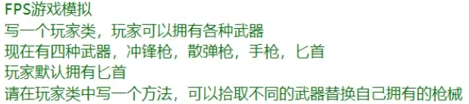
class Weapon
{

}
class BiShou : Weapon
{

}
class ChongFengQiang : Weapon
{

}
class XianDanQiang : Weapon
{

}
class ShouQiang : Weapon
{

}

Player p = new Player();
Weapon w = new XianDanQiang();
p.PickUp(w);

练习13：继承中的构造函数
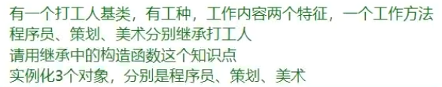
class WorkMan
{
public string type;
public string workNeiRong;
public WorkMan(string type,string workNeiRong)
{
this.type = type;
this.workNeiRong = workNeiRong;
}
public void WorkFangfa()
{
Console.WriteLine(type + workNeiRong);
}
}
class ChengXuYuan : WorkMan
{
public ChengXuYuan() :base("程序员", "写代码")
{

}
}
class CeHua : WorkMan
{
public CeHua() : base("策划", "写案子")
{

}
}
class Artist : WorkMan
{
public Artist() : base("美术", "画画")
{

}
}

ChengXuYuan c = new ChengXuYuan();
c.WorkFangfa();
CeHua ch = new CeHua();
ch.WorkFangfa();
Artist a = new Artist();
a.WorkFangfa();

练习14：万物之父和装箱拆箱
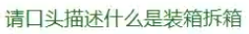
把值类型用引用类型存储
把引用类型存储的值类型取出来

object obj = 1;
int i = (int)obj;
object obj2 = "1234";
string str = obj2 as string;

练习15：密封类
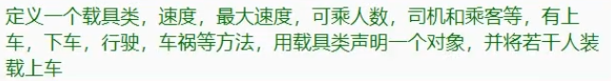
class Parson
{

}
class Driver : Parson
{

}
class ChengKe : Parson
{

}
class Car
{
public int speed;
public int maxSpeed;
public int num;
public Parson[] chengKe;
public Car(int speed, int maxSpeed, int num)
{
this.speed = speed;
this.maxSpeed = maxSpeed;
this.num = 0;
chengKe = new Parson[num];
}
public void ShangChe(Parson p)
{
if ( num >= chengKe.Length )
{
Console.WriteLine("满载");
}
chengKe[num] = p;
num++;
}
public void XiaChe(Parson p)
{
for (int i = 0; i < chengKe.Length; i++)
{
if (chengKe[i] == null)
{
break;
}
if (chengKe[i] == p)
{
for (int j = i; j < num - 1; j++)
{
chengKe[j] = chengKe[j - 1];
}
chengKe[num - 1] = null;
num--;
break;
}
}

}
public void XingShe()
{

}
public void CheHuo()
{

}
}

Car car = new Car(10, 20, 20);
Driver d = new Driver();
car.ShangChe(d);
ChengKe ck = new ChengKe();
car.ShangChe(ck);
ChengKe ck2 = new ChengKe();
car.ShangChe(ck2);
ChengKe ck3 = new ChengKe();
car.ShangChe(ck3);
car.XiaChe(ck2);

练习16：多态VOB
class Duck
{
public virtual void Jiao()
{
Console.WriteLine("嘎嘎");
}
}
class MTDuck : Duck
{
public override void Jiao()
{
Console.WriteLine("吱吱");
}
}
class XJDuck : Duck
{
public override void Jiao()
{
Console.WriteLine("唧唧");
}
}

Duck d = new Duck();
d.Jiao();
Duck d2 = new MTDuck();
d2.Jiao();
Duck d3 = new XJDuck();
d3.Jiao();

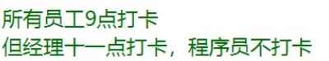
class Worker
{
public virtual void DaKa()
{
Console.WriteLine("9点打卡");
}
}
class JingLi : Worker
{
public override void DaKa()
{
Console.WriteLine("11点打卡");
}
}
class Programer : Worker
{
public override void DaKa()
{
Console.WriteLine("不打卡");
}
}

Worker w = new Worker();
w.DaKa();
Worker w2 = new JingLi();
w2.DaKa();
Worker w3 = new Programer();
w3.DaKa();

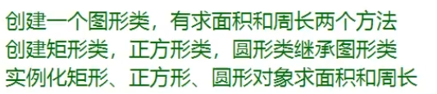
class Worker
{
public virtual void DaKa()
{
Console.WriteLine("9点打卡");
}
}
class JingLi : Worker
{
public override void DaKa()
{
Console.WriteLine("11点打卡");
}
}
class Programer : Worker
{
public override void DaKa()
{
Console.WriteLine("不打卡");
}
}

TuXing t = new JvXing(3,4);
Console.WriteLine(t.MianJi() + " " + t.ZhouChang());
TuXing t2 = new ZhengFangXing(3);
Console.WriteLine(t2.MianJi() + " " + t2.ZhouChang());
TuXing t3 = new YuanXing(2);
Console.WriteLine(t3.MianJi() + " " + t3.ZhouChang());

练习17：抽象类和抽象函数
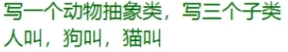
abstract class Animal
{
public abstract void Speak();
}
class Person : Animal
{
public override void Speak()
{

}
}
class Dog : Animal
{
public override void Speak()
{

}
}
class Cat : Animal
{
public override void Speak()
{

}
}

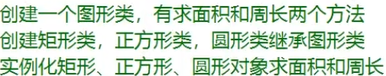
abstract class TuXing
{
public abstract float MianJi();
public abstract float ZhouChang();
}
class JvXing : TuXing
{
private float w;
private float h;
public JvXing(int w, int h)
{
this.w = w;
this.h = h;
}
public override float MianJi()
{
return w * h;
}
public override float ZhouChang()
{
return (w + h) * 2;
}
}
class ZhengFangXing : TuXing
{
private float w;
public ZhengFangXing(int w)
{
this.w = w;
}
public override float MianJi()
{
return w * w;
}
public override float ZhouChang()
{
return w * 4;
}
}
class YuanXing : TuXing
{
private float r;
public YuanXing(int r)
{
this.r = r;
}
public override float MianJi()
{
return 3.14f * r * r;
}
public override float ZhouChang()
{
return 2 * 3.14f * r;
}
}

JvXing j = new JvXing(3, 4);
Console.WriteLine(j.MianJi() + " " + j.ZhouChang());
ZhengFangXing z = new ZhengFangXing(3);
Console.WriteLine(z.MianJi() + " " + z.ZhouChang());
YuanXing y = new YuanXing(2);
Console.WriteLine(y.MianJi() + " " + y.ZhouChang());

练习18：接口
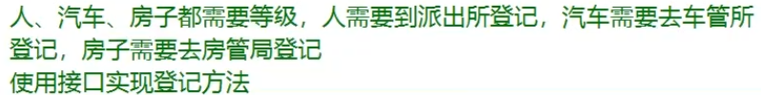
interface IDengJi
{
void DengJi();
}
class Person : IDengJi
{
public void DengJi()
{
Console.WriteLine("派出所登记成功");
}

}
class House : IDengJi
{
public void DengJi()
{
Console.WriteLine("房管局登记成功");
}
}
class Car : IDengJi
{
public void DengJi()
{
Console.WriteLine("车管所登记成功");
}
}

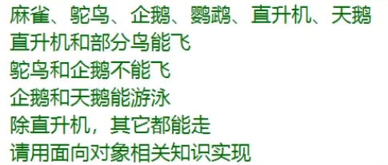
abstract class Bird
{
public abstract void Walk();
}
interface IFly
{
void Fly();
}

interface ISwim
{
void Swim();
}
class MaQue : Bird, IFly
{
public override void Walk()
{

}
public void Fly()
{

}
}
class TuoNiao : Bird
{
public override void Walk()
{

}
}
class QiE : Bird, ISwim
{
public override void Walk()
{

}
public void Swim()
{

}
}
class YingWu : Bird, IFly
{
public override void Walk()
{

}
public void Fly()
{

}
}
class ZhiShengJi : IFly
{
public void Fly()
{

}
}
class TianE : Bird, IFly, ISwim
{
public override void Walk()
{

}
public void Fly()
{

}
public void Swim()
{

}
}

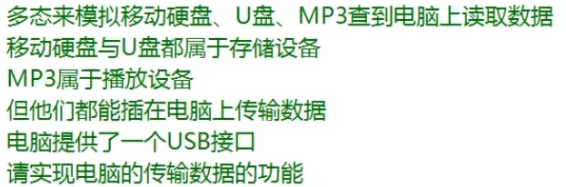
class CunChuSheBei : IUSB
{
public string name;
public CunChuSheBei(string name)
{
this.name = name;
}
public void ChuanShuShuJv()
{
Console.WriteLine(name + "传输数据");
}
}
class MP3 : IUSB
{
public void ChuanShuShuJv()
{
Console.WriteLine("MP3传输数据");
}
}
interface IUSB
{
void ChuanShuShuJv();
}

class Computer
{
public IUSB usb;
}

CunChuSheBei yp = new CunChuSheBei("移动硬盘");
CunChuSheBei up = new CunChuSheBei("U盘");
MP3 mp = new MP3();
Computer c = new Computer();
c.usb = yp;
c.usb.ChuanShuShuJv();
c.usb = up;
c.usb.ChuanShuShuJv();
c.usb = mp;
c.usb.ChuanShuShuJv();

练习19：命名空间
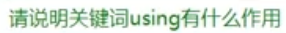
用于引用命名空间的 引用命名空间才能使用其中的内容
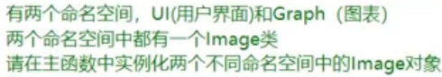
namespace UI
{
class Image
{

}
}
namespace Graph
{
class Image
{

}
}

UI.Image i = new UI.Image();
Graph.Image i2 = new Graph.Image();

练习20：万物之父中的方法
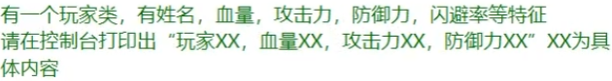
class Player
{
private string name;
private int hp;
private int atk;
private int def;
private int miss;
public Player(string name, int hp, int atk, int def, int miss)
{
this.name = name;
this.hp = hp;
this.atk = atk;
this.def = def;
this.miss = miss;
}
public override string ToString()
{
return string.Format("玩家{0}，血量{1}，攻击力{2}，防御力{3}，闪避率{4}", name, hp, atk, def, miss);
}
}

Player p = new Player("Hentai", 999, 999, 999, 100);
Console.WriteLine(p);

class Monster
{
public int Atk
{
get;
set;
}
public int Def
{
get;
set;
}
public int Hp
{
get;
set;
}
public int SkillId
{
get;
set;
}
public Monster()
{
Atk = 1;
Def = 1;
Hp = 1;
SkillId = 1;
}
public Monster Clone()
{
return MemberwiseClone() as Monster;
}
}

Monster A = new Monster();
Monster B = A.Clone();

练习21：string
Substring
Replace
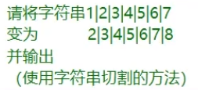
string str = "1|2|3|4|5|6|7";
string[] strs = str.Split('|');
str = "";
for (int i = 0; i < strs.Length; i++)
{
str += int.Parse(strs[i]) + 1;
if (i != strs.Length - 1)
{
str += "|";
}
}
Console.WriteLine(str);
后者是前者的别名，是一个关键字
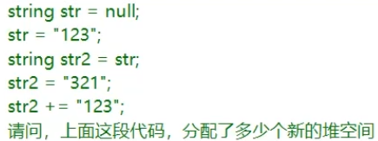
3
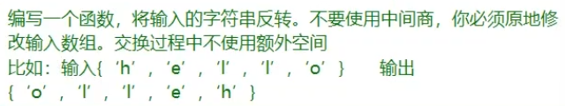

Console.WriteLine("请输入字符串");
string str = Console.ReadLine();
char[] chars = str.ToCharArray();
for (int i = 0; i < chars.Length / 2; i++)
{
chars[i] = (char)(chars[i] + chars[chars.Length - i - 1]);
chars[chars.Length - i - 1] = (char)(chars[i] - chars[chars.Length - i - 1]);
chars[i] = (char)(chars[i] - chars[chars.Length - i - 1]);
}
Console.WriteLine(chars);

练习22：StringBuilder
string 相对更容易产生垃圾 每次修改拼接都会产生垃圾
string 更加灵活 因为他提供了更多方法供使用
需要使用string独特的一些方法处理的特殊逻辑可以用string
需要频繁修改拼接的字符串可以用StringBuilder

节约内存 少new 新对象 少产生垃圾
尽力减少GC 合理使用static、string、StringBuilder

