进阶阶段——练习
2026年3月23日
17:27

练习1：ArrayList
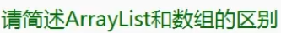
ArrayList本质上就是一个object数组的封装
ArrayList可以不用一开始就定长 单独使用数组默认是定长的
ArrayList默认为object类型 数组可以存储指定类型
ArrayList 封装了方便的API供我们增删查改 而数组需要自己去实现
ArrayList使用时可能存在装箱拆箱 数组只要不是object数组就不存在这个问题
ArrayList的长度为Count 数组的长度为Length

class Backpack
{
private ArrayList items;
private int money;

public Backpack()
{
items = new ArrayList();
money = 9999;
}

public void BuyItem(Item item)
{
int sumMoney = item.num * item.money;
if (item.num <= 0 || item.money < 0)
{
Console.WriteLine("不好意思，请传入正确的物品信息");
return;
}
//判断钱够不够
if (money < sumMoney)
{
Console.WriteLine("不好意思，您的余额不足");
return;
}
money -= sumMoney;
Console.WriteLine("你购买了{0}个{1}，一共花费{2}元，剩余{3}元", item.num, item.name, sumMoney, money);
//判断背包内是否有这个物品
for (int i = 0; i < items.Count; i++)
{
if ((items[i] as Item).id == item.id)
{
//叠加数量
(items[i] as Item).num += item.num;
return;
}
}
items.Add(item);

}

public void SellItem(Item item)
{
int sum;
int num = 0;
string name;
int money;
for (int i = 0; i < items.Count; i++)
{
if ((items[i] as Item).id == item.id)
{
name = (items[i] as Item).name;
money = (items[i] as Item).money;
if ((items[i] as Item).num > item.num)
{
num = item.num;
(items[i] as Item).num -= num;
}
else
{
num = (items[i] as Item).num;
items.RemoveAt(i);
}
sum = (int)((money * num) * 0.8f);
this.money += sum;
Console.WriteLine("你卖出了{0}个{1}，一共卖出{2}元，剩余{3}元", num, name, sum, this.money);
return;
}
}

}
public void SellItem(int id, int num = 1)
{
Item item = new Item();
item.id = id;
item.num = num;
SellItem(item);
}

public void ShowItem(Item item)
{
for (int i = 0; i < items.Count; i++)
{
if ((items[i] as Item).id == item.id)
{
Console.WriteLine("你拥有{0}{1}个", (items[i] as Item).name, (items[i] as Item).num);
return;
}
else
{
Console.WriteLine("你没有该物品");
return;
}
}
}
}
class Item
{
public string name;
public int id;
public int money;
public int num;

public Item()
{

}
public Item(string name, int id, int money, int num)
{
this.name = name;
this.id = id;
this.money = money;
this.num = num;
}
}

Backpack bag = new Backpack();
Item i1 = new Item("R键", 0, 99999, 1);
Item i2 = new Item("圣心", 1, 99, 10);
Item i3 = new Item("果汁", 2, 9, 100);
bag.BuyItem(i1);
bag.BuyItem(i2);
bag.BuyItem(i3);
bag.SellItem(2, 1);
bag.SellItem(2, 1);
bag.SellItem(2, 1);
bag.SellItem(2, 1);
bag.SellItem(2, 50);
bag.SellItem(2, 50);
bag.SellItem(2, 50);
bag.SellItem(2, 50);
bag.ShowItem(i3);

练习2：Stack
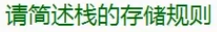
可以存任何对象
先进后出
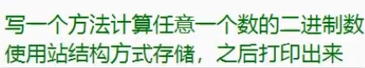
public static void Tool(int i)
{
Console.Write("{0}的二进制是：", i);
Stack stack = new Stack();
while (true)
{
stack.Push(i % 2);
i /= 2;
if (i == 1)
{
stack.Push(i);
break;
}
}
while (stack.Count > 0)
{
Console.Write(stack.Pop());
}
Console.WriteLine();
}
Tool(10);
Tool(2);
Tool(3);
Tool(8);
Tool(16);
Tool(9999);

练习3：Queue
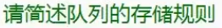
先进后出
Queue queue = new Queue();
string str = "你收到了一条新消息";
int index = 0;
for (int i = 0; i < 9; i++)
{
queue.Enqueue(str);
}
while (true)
{
if (index % 700000000 == 0)
{
if (queue.Count > 0)
{
Console.WriteLine(queue.Dequeue());
}
index = 0;
}
++index;
}

练习4：Hashtable
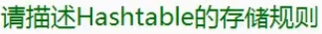
一个键值对形式存储的容器
一个键 对应 一个值
类型是object
class MonsterMgr
{
private static MonsterMgr instance = new MonsterMgr();
Hashtable monster = new Hashtable();
public static MonsterMgr Instance
{
get
{
return instance;
}
}
private MonsterMgr()
{

}
private int monsterID = 0;
public void Add()
{
Monster m = new Monster(monsterID);
Console.WriteLine("添加了ID为{0}的怪物", monsterID);
monster.Add(monsterID, m);
++monsterID;
}

public void Remove(int id)
{
if (monster.ContainsKey(id))
{
Console.WriteLine("移除了ID为{0}的怪物", id);
monster.Remove(id);
}
else
{
Console.WriteLine("找不到ID为{0}的怪物", id);
}
}

}
class Monster
{
public int id;
public Monster(int id)
{
this.id = id;
}
}
MonsterMgr.Instance.Add();
MonsterMgr.Instance.Add();
MonsterMgr.Instance.Add();
MonsterMgr.Instance.Add();
MonsterMgr.Instance.Add();
MonsterMgr.Instance.Add();
MonsterMgr.Instance.Add();
MonsterMgr.Instance.Add();
MonsterMgr.Instance.Add();
MonsterMgr.Instance.Add();

MonsterMgr.Instance.Remove(999);
MonsterMgr.Instance.Remove(0);
MonsterMgr.Instance.Remove(1);
MonsterMgr.Instance.Remove(2);
MonsterMgr.Instance.Remove(6);
MonsterMgr.Instance.Remove(5);
MonsterMgr.Instance.Remove(1);

练习5：泛型
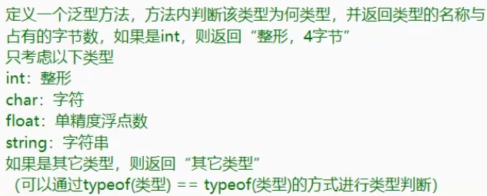
public static string Tool<T>()
{
string str;
int i;
if (typeof(T) != typeof(string))
{
i = Marshal.SizeOf(typeof(T));
}
else
{
return "字符串，?字节";
}

if (typeof(T) == typeof(int))
{
str = "整形";
}
else if (typeof(T) == typeof(char))
{
str = "字符";
}
else if (typeof(T) == typeof(float))
{
str = "单精度浮点数";
}
else if (typeof(T) == typeof(string))
{
str = "字符串";
}
else
{
return "其他类型";
}
return string.Format("{0}，{1}字节", str, i);
}
Console.WriteLine(Tool<int>());
Console.WriteLine(Tool<string>());
Console.WriteLine(Tool<float>());
Console.WriteLine(Tool<double>());
Console.WriteLine(Tool<char>());
Console.WriteLine(Tool<bool>());

练习6：泛型约束
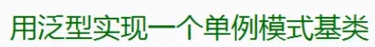
class InstanceBase<T> where T : new()
{
private static T instance = new T();
public static T Instance
{
get
{
return instance;
}
}

}
class Test : InstanceBase<Test>
{
//小缺点 必须保留无参构造函数
//但是在开发中 程序员有约定俗成的规矩 单例模式不会new新对象
public int a = 10;
}

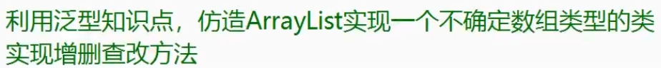
class ArrayList<K>
{
public K[] array;
private int count;
public ArrayList()
{
count = 0;
array = new K[5];
}

public void Add(K value)
{
if (Capacity <= count)
{
K[] temp = new K[Capacity * 2];
for (int i = 0; i < count; i++)
{
temp[i] = array[i];
}
array = temp;
}
array[count] = value;
++count;
}
public void RemoveAt(int index)
{
if (index > count - 1 || index < 0)
{
Console.WriteLine("请输入合法的值");
return;
}
for (int j = index; j < count - 1; j++)
{
array[j] = array[j + 1];
}
array[count - 1] = default(K);
--count;
}
public void Remove(K value)
{
for (int i = 0; i < count - 1; i++)
{
if (array[i].Equals(value))
{
RemoveAt(i);
return;
}
}
}

public K this[int index]
{
get
{
if (index > count - 1 || index < 0)
{
Console.WriteLine("请输入合法的值");
return default(K);
}
return array[index];
}
set
{
if (index > count - 1 || index < 0)
{
Console.WriteLine("请输入合法的值");
return;
}
array[index] = value;
}
}
public void BL()
{
for (int i = 0; i < count; i++)
{
Console.WriteLine(array[i]);
}
}
public int Count
{
get
{
return count;
}
}
public int Capacity
{
get
{
return array.Length;
}
}
}

ArrayList<int> list = new ArrayList<int>();
list.Add(0);
list.Add(1);
list.Add(2);
list.Add(3);
list.Add(4);
list.Add(5);
list.Add(6);

list.RemoveAt(0);
list.RemoveAt(2);
list.RemoveAt(4);
list.RemoveAt(5);

list.Remove(1);

Console.WriteLine(list[-1]);

list.BL();
Console.WriteLine("*****************************");
list[0] = 999;
list.BL();

ArrayList<string> list2 = new ArrayList<string>();
list2.Add("啊是阿萨的");
list2.Add("阿斯顿");
list2.Add("啊是阿斯顿萨的");
list2.Add("啊是1阿萨的");
list2.Add("啊是阿134萨的");
list2.Add("啊是阿萨345的");
list2.Add("啊是53阿萨的");

list2.RemoveAt(0);
list2.RemoveAt(2);
list2.RemoveAt(4);
list2.RemoveAt(5);

list2.Remove("啊是阿134萨的");

Console.WriteLine(list2[-1]);

list2.BL();
Console.WriteLine("*****************************");
list2[0] = "Hentai";
list2.BL();

练习8：List
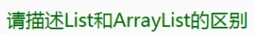
List是一个可变类型的泛型数组
ArrayList是一个object数组
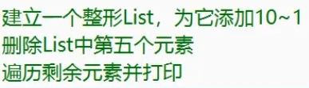
List<int> array = new List<int>();
for (int i = 10; i > 0; i--)
{
array.Add(i);
}
array.RemoveAt(4);
for (int i = 0; i < array.Count; i++)
{
Console.WriteLine(array[i]);
}

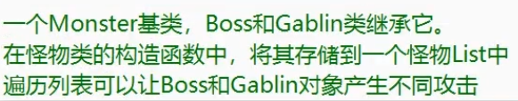
abstract class Monster
{
public static List<Monster> monster = new List<Monster>();
public Monster()
{
monster.Add(this);
}
public abstract void Atk();
}
class Boss : Monster
{
public override void Atk()
{
Console.WriteLine("Boss攻击");
}
}
class Gablin : Monster
{
public override void Atk()
{
Console.WriteLine("哥布林攻击");
}
}
Boss b = new Boss();
Gablin g = new Gablin();
Boss b1 = new Boss();
Gablin g1 = new Gablin();
for (int i = 0; i < Monster.monster.Count; i++)
{
Monster.monster[i].Atk();
}
Boss b = new Boss();
Gablin g = new Gablin();
Boss b1 = new Boss();
Gablin g1 = new Gablin();
for (int i = 0; i < Monster.monster.Count; i++)
{
Monster.monster[i].Atk();
}

练习9：Dictionary
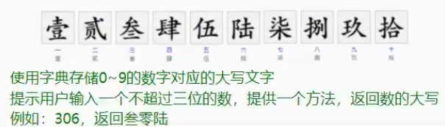
public static string GetInfo(int input)
{
string str = "";
Dictionary<int, string> dic = new Dictionary<int, string>();
dic.Add(0, "零");
dic.Add(1, "壹");
dic.Add(2, "贰");
dic.Add(3, "叁");
dic.Add(4, "肆");
dic.Add(5, "伍");
dic.Add(6, "陆");
dic.Add(7, "柒");
dic.Add(8, "捌");
dic.Add(9, "玖");

int b = input / 100;
if (b != 0)
{
str += dic[b];
}
int s = input % 100 / 10;
if (s != 0 || str != "")
{
str += dic[s];
}
int g = input % 10;
str += dic[g];
return str;
}
try
{
Console.WriteLine("请输入一个不超过3位的数");
Console.WriteLine(GetInfo(int.Parse(Console.ReadLine())));
}
catch
{
Console.WriteLine("请输入合法的数");
}

Dictionary<char, int> dic1 = new Dictionary<char, int>();
string str = "welcome to unity world";
str = str.ToLower();
for (int i = 0; i < str.Length; i++)
{
if (str[i] == ' ')
{
continue;
}
if (dic1.ContainsKey(str[i]))
{
dic1[str[i]] += 1;
}
else
{
dic1.Add(str[i], 1);
}
}

foreach (char item in dic1.Keys)
{
Console.WriteLine("字母{0}出现{1}次", item, dic1[item]);
}

练习10：顺序存储和链式存储
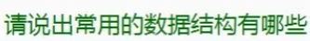
数组、栈、队列、链表、树、图、堆、散列表

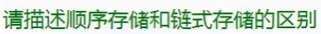
顺序存储是 用一组地址连续的存储单元 依次存储线性表的 各个数据元素
链式存储是 用一组任意的存储单元 存储线性表中的各个数据元素

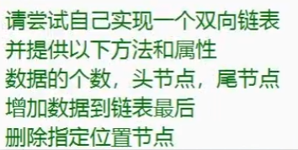
class LinkedNode<T>
{
public T value;
public LinkedNode<T> nextNode;
public LinkedNode<T> previous;
public LinkedNode(T value)
{
this.value = value;
}
}

class LinkedList<T>
{
public int count = 0;
public LinkedNode<T> head;
public LinkedNode<T> last;

public LinkedNode<T> Head
{
get
{
return head;
}
}
public LinkedNode<T> Last
{
get
{
return last;
}
}
public int Count
{
get
{
return count;
}
}
public void Add(T value)
{
LinkedNode<T> node = new LinkedNode<T>(value);
if (head == null)
{
head = node;
last = node;
}
else
{
node.previous = last;
last.nextNode = node;
last = node;
}
++count;
}
public void RemoveAt(int index)
{
if (index < 0 || index > count - 1)
{
Console.WriteLine("只有{0}个节点，请输入合法的数字", count);
return;
}
int tempCount = 0;
LinkedNode<T> tempLinkedNode = head;
while (true)
{
//找移除第几个元素
if (tempCount == index)
{
if (tempLinkedNode.previous != null)
{
tempLinkedNode.previous.nextNode = tempLinkedNode.nextNode;
}
if (tempLinkedNode.nextNode != null)
{
tempLinkedNode.nextNode.previous = tempLinkedNode.previous;
}
if (index == 0)
{
head = head.nextNode;
}
else if (index == count - 1)
{
last = last.previous;
}
break;
}
tempLinkedNode = tempLinkedNode.nextNode;
++tempCount;
}
--count;
}
}

LinkedList<int> list = new LinkedList<int>();
list.Add(0);
list.Add(1);
list.Add(2);
list.Add(3);
list.Add(4);
list.Add(5);
list.Add(6);
list.Add(7);

LinkedNode<int> head = list.head;
while (head != null)
{
Console.WriteLine(head.value);
head = head.nextNode;
}

LinkedNode<int> last = list.last;
while (last != null)
{
Console.WriteLine(last.value);
last = last.previous;
}

Console.WriteLine("***********************");

Console.WriteLine("***********************");

list.RemoveAt(0);
list.RemoveAt(0);
list.RemoveAt(0);
list.RemoveAt(0);

head = list.head;
while (head != null)
{
Console.WriteLine(head.value);
head = head.nextNode;
}

last = list.last;
while (last != null)
{
Console.WriteLine(last.value);
last = last.previous;
}

Console.WriteLine("***********************");

list.RemoveAt(0);
list.RemoveAt(0);
list.RemoveAt(0);
list.RemoveAt(0);
list.RemoveAt(0);
list.Add(0);
list.Add(0);
list.RemoveAt(11);

head = list.head;
while (head != null)
{
Console.WriteLine(head.value);
head = head.nextNode;
}

last = list.last;
while (last != null)
{
Console.WriteLine(last.value);
last = last.previous;
}

练习11：LinkedList
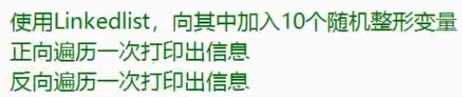
LinkedList<int> list = new LinkedList<int>();
Random r = new Random();
int randomNum;
for (int i = 0; i < 10; i++)
{
list.AddLast(r.Next(1, 100));
}

LinkedListNode<int> nowNode = list.First;
while (nowNode != null)
{
Console.WriteLine(nowNode.Value);
nowNode = nowNode.Next;
}
Console.WriteLine("****************************");

nowNode = list.Last;
while (nowNode != null)
{
Console.WriteLine(nowNode.Value);
nowNode = nowNode.Previous;
}

练习12：泛型栈和队列
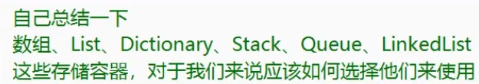
普通线性表
数组、List、LinkedList
- 数组：固定的不变的一组数据
- List：经常改变 经常通过下标查找
- LinkedList：不确定长度的 经常临时插入改变 查找不多
先进后出
栈
- 对于一些可以利用先进后出存储特点的逻辑
比如：ui面板显隐规则
先进先出
队列
- 对于一些可以利用先进先出存储特点的逻辑
比如：消息队列 有了就往里放 然后慢慢依次处理
键值对
dictionary
- 需要频繁查找的 有对应关系的数据
比如一些数据存储 ID对应内容
道具ID → 道具信息
怪物ID → 怪物对象
等等

练习13：委托
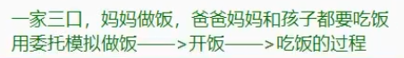
abstract class Person
{
public abstract void Eat();
}
class Mother : Person
{
public Action beginEat;
public override void Eat()
{
Console.WriteLine("妈妈吃饭");
}
public void Cook()
{
Console.WriteLine("妈妈做饭");

Console.WriteLine("开饭啦！");
if (beginEat != null)
{
beginEat();
}
}
}
class Father : Person
{
public override void Eat()
{
Console.WriteLine("爸爸吃饭");
}
}
class Son : Person
{
public override void Eat()
{
Console.WriteLine("儿子吃饭");
}
}
Mother m = new Mother();
Father f = new Father();
Son s = new Son();
m.beginEat += f.Eat;
m.beginEat += s.Eat;
m.beginEat += m.Eat;
m.Cook();

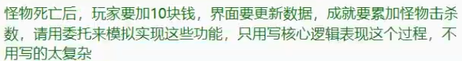
class Monster
{
public Action<Monster> monsterDie;
public int money = 10;
public void Die()
{
Console.WriteLine("怪物死亡");
if (monsterDie != null)
{
monsterDie(this);
}
monsterDie = null;
}
}
class Player
{
private int money = 0;
public void Money(Monster m)
{
money += m.money;
Console.WriteLine("玩家获得{0}块钱", money);
}
}
class UI
{
private int money = 0;
public void Ui(Monster m)
{
money += m.money;
Console.WriteLine("当前持有{0}块钱", money);
}
}
class ChengJiu
{
private int nowKillMonster = 0;
public void CJ(Monster m)
{
++nowKillMonster;
Console.WriteLine("当前击杀{0}只怪物", nowKillMonster);
}
}
Monster monster = new Monster();
Player player = new Player();
UI ui = new UI();
ChengJiu chengJiu = new ChengJiu();
monster.monsterDie += player.Money;
monster.monsterDie += ui.Ui;
monster.monsterDie += chengJiu.CJ;

monster.Die();
练习14：事件
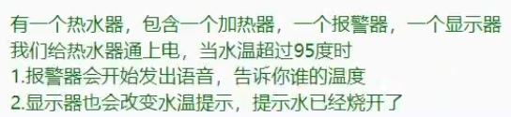
class JiaReQi
{
public int value = 0;
public event Action<int> hot;
public void AddHot()
{
int index = 0;
while (true)
{

if (value == 100)
{
break;
}
if (index % 9999999 == 0)
{
++value;
if (value >= 95)
{
if (hot != null)
{
hot(value);
}
hot = null;
}
Console.WriteLine("加热到{0}°", value);
index = 0;
}
++index;
}
}
}
class XianShiQi
{
public void ShowInfo(int i)
{
Console.WriteLine("语音提示：当前水温{0}°", i);
}
}
class BaoJingQi
{
public void ShowInfo(int i)
{
Console.WriteLine("当前水温{0}°,水烧开了！", i);
}
}
BaoJingQi b = new BaoJingQi();
XianShiQi x = new XianShiQi();
JiaReQi j = new JiaReQi();
j.hot += b.ShowInfo;
j.hot += x.ShowInfo;
j.AddHot();

练习15：匿名函数
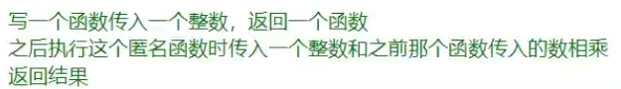
public static Func<int, int> Test(int i)
{
return delegate (int v)
{
return v * i;
};
}
Func<int, int> funk = Test(2);
Console.WriteLine(funk(3));

Console.WriteLine(Test(2)(3));

练习16：lambda表达式
public static Action Test()
{
Action action = null;
for (int i = 1; i <= 10; i++)
{
int index = i;
action += () =>
{
Console.WriteLine(index);
};
}
return action;
}
Test()();

练习17：List排序
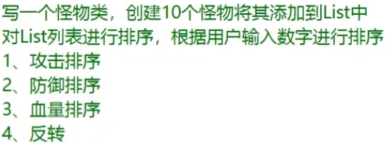
class Monster
{
//生成一个全局静态函数 用来记录排序方法
public static int sortType = 1;
public int atk;
public int def;
public int hp;
private Random r = new Random();
public Monster()
{
atk = r.Next(1, 101);
def = r.Next(1, 101);
hp = r.Next(1, 101);
}

//重载 ToString
public override string ToString()
{
return string.Format("攻击力{0}防御力{1}血量{2}", atk, def, hp);
}
}

public static int SortFun(Monster m1, Monster m2)
{
switch (Monster.sortType)
{
case 1:
return m1.atk > m2.atk ? 1 : -1;
case 2:
return m1.def > m2.def ? 1 : -1;
case 3:
return m1.hp > m2.hp ? 1 : -1;
}
return 0;
}

Console.WriteLine("请输入数字进行排序\n1攻击排序\n2防御排序\n3血量排序\n4反转");

List<Monster> m = new List<Monster>();
for (int i = 0; i < 10; i++)
{
m.Add(new Monster());
Console.WriteLine(m[i]);
}

switch (Console.ReadLine())
{
case "1":
m.Sort((Monster a, Monster b) => { return a.atk > b.atk ? 1 : -1; });
break;
case "2":
m.Sort((Monster a, Monster b) => { return a.def > b.def ? 1 : -1; });
break;
case "3":
m.Sort((Monster a, Monster b) => { return a.hp > b.hp ? 1 : -1; });
break;
case "4":
m.Reverse();
break;
}

for (int i = 0; i < m.Count; i++)
{
Console.WriteLine(m[i]);
}

Console.WriteLine("请输入数字进行排序\n1攻击排序\n2防御排序\n3血量排序\n4反转");

//排序方法 等于 用户输入值
Monster.sortType = int.Parse(Console.ReadLine());

if (Monster.sortType == 4)
{
m.Reverse();
}
else
{
m.Sort(SortFun);
}

for (int i = 0; i < 10; i++)
{
Console.WriteLine(m[i]);
}


List<Item> item = new List<Item>();

for (int i = 0; i < 10; i++)
{
item.Add(new Item());
Console.WriteLine(item[i]);
}

item.Sort((Item a, Item b) =>
{
//类型不同 按类型比
if (a.type != b.type)
{
return a.type > b.type ? -1 : 1;
}
//类型相同 按品质比
else if (a.pingZhi != b.pingZhi)
{
return a.pingZhi > b.pingZhi ? -1 : 1;
}
//类型 品质相同 按长度比
else
{
return a.name.Length > b.name.Length ? -1 : 1;
}
});

Console.WriteLine("******************************");

for (int i = 0; i < 10; i++)
{
Console.WriteLine(item[i]);
}


Dictionary<int, string> dic = new Dictionary<int, string>();
dic.Add(7, "1234312");
dic.Add(3, "1234312");
dic.Add(4, "1234312");
dic.Add(1, "1234312");
dic.Add(5, "1234312");
dic.Add(2, "1234312");
dic.Add(6, "1234312");

List<KeyValuePair<int, string>> d = new List<KeyValuePair<int, string>>();

foreach (KeyValuePair<int,string> di in dic)
{
d.Add(di);
Console.WriteLine(di.Key + "_" + di.Value);
}

Console.WriteLine("******************************");

d.Sort((a, b) =>
{
return a.Key > b.Key ? 1 : -1;
});

for (int i = 0; i < d.Count; i++)
{
Console.WriteLine(d[i].Key + "_" + d[i].Value);
}

练习18：协变逆变
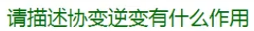
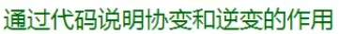
用来修饰泛型替代符的 只能用在泛型委托和泛型接口中
用out修饰的泛型 只能作为返回值
用in修饰的泛型 只能作为参数
用来遵循里氏替换原则
用 out 和 in 修饰的泛型委托 可以互相装载（有父子关系的泛型）
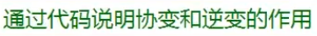
delegate T TestOut<out T>();
delegate void TestIn<in T>(T t);

class Father
{

}
class Son : Father
{

}

TestOut<Son> s = () =>
{
return new Son();
};

TestOut<Father> f = s;

Father fa = f();

TestIn<Father> f1 = (a) =>
{

};

TestIn<Son> s1 = f1;

s1(new Son());

练习19：多线程
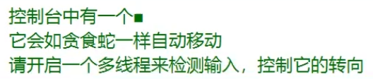
enum E_MoveDir
{
up,
down,
left,
right,
}

class Icon
{
public E_MoveDir dir;
public int x;
public int y;

public Icon(int x, int y, E_MoveDir dir)
{
this.x = x;
this.y = y;
this.dir = dir;
}

public void Move()
{
switch (dir)
{
case E_MoveDir.up:
--y;
break;
case E_MoveDir.down:
++y;
break;
case E_MoveDir.left:
x -= 2;
break;
case E_MoveDir.right:
x += 2;
break;
}
}
public void Draw()
{
Console.SetCursorPosition(x, y);
Console.Write("■");
}
public void Cleal()
{
Console.SetCursorPosition(x, y);
Console.Write(" ");
}
public void ChangeDir(E_MoveDir dir)
{
this.dir = dir;
}
}

static Icon icon;
public static void DIR()
{
while (true)
{
switch (Console.ReadKey(true).Key)
{
case ConsoleKey.W:
icon.ChangeDir(E_MoveDir.up);
break;
case ConsoleKey.S:
icon.ChangeDir(E_MoveDir.down);
break;
case ConsoleKey.A:
icon.ChangeDir(E_MoveDir.left);
break;
case ConsoleKey.D:
icon.ChangeDir(E_MoveDir.right);
break;
}
}
}

icon = new Icon(10, 5, E_MoveDir.right);
Thread t = new Thread(DIR);
t.Start();
t.IsBackground = true;
while (true)
{
Thread.Sleep(500);
icon.Cleal();
icon.Move();
icon.Draw();
}

练习20：预处理器指令
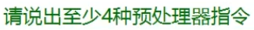
define undef
if elif else endif
warning error

public int Add(int a, int b)
{
#if Unity5
return a + b;
#elif Unity2017
return a * b;
#elif Unity2020
return a - b;
#else
return 0;
#endif
}

练习21：反射
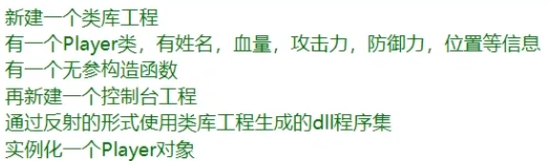
//加载程序集信息
Assembly asembly = Assembly.LoadFrom(@"D:\Program\Microsoft Visual Studio\2022\Community\repos\学习\类库测试\bin\Debug\类库测试");
Type[] type = asembly.GetTypes();
for (int i = 0; i < type.Length; i++)
{
Console.WriteLine(type[i]);
}

Console.WriteLine("*********************");

//加载程序集中的类信息
Type PlayerType = asembly.GetType("类库测试.Player");
//得到成员信息
MemberInfo[] members = PlayerType.GetMembers();
for (int i = 0; i < members.Length; i++)
{
Console.WriteLine(members[i]);
}

Console.WriteLine("*********************");

object playerObj = Activator.CreateInstance(PlayerType);
Console.WriteLine(playerObj);

练习22：特性
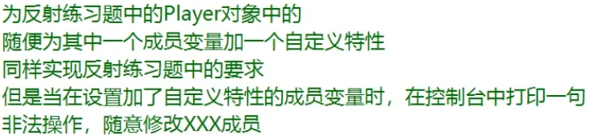
namespace 类库测试
{
//创建自定义特性
class MyCustomAttribute : Attribute
{

}

public struct Position
{
public int x;
public int y;

public Position(int x, int y)
{
this.x = x;
this.y = y;
}
}
public class Player
{
//加了一个自定义特性
[MyCustom]
public string name;
public int hp;
public int atk;
public int def;
public Position pos;
public Player()
{

}
}
}

//加载程序集信息
Assembly asembly = Assembly.LoadFrom(@"D:\Program\Microsoft Visual Studio\2022\Community\repos\学习\类库测试\bin\Debug\类库测试");
Type[] type = asembly.GetTypes();
for (int i = 0; i < type.Length; i++)
{
Console.WriteLine(type[i]);
}

Console.WriteLine("*********************");
//获取类信息
Type PlayerType = asembly.GetType("类库测试.Player");
//实例化对象
object playerObj = Activator.CreateInstance(PlayerType);
Console.WriteLine(playerObj);
//得到所有成员变量
FieldInfo[] fields = PlayerType.GetFields();

for (int i = 0; fields.Length > i; i++)
{
Console.WriteLine(fields[i]);
}

Console.WriteLine("*********************");

//得到自定义特性的Type
Type attribute = asembly.GetType("类库测试.MyCustomAttribute");

//得到成员变量
FieldInfo fieldStr = PlayerType.GetField("name");

//判断有没有特性
if (fieldStr.GetCustomAttribute(attribute) != null)
{
Console.WriteLine("非法操作，随意修改name成员");
}
else
{
//修改成员变量值
fieldStr.SetValue(playerObj, "Test_改变值");
}

练习23：迭代器

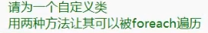
class Test : IEnumerable, IEnumerator
{
private int[] array;
private int position = -1;
public Test()
{
array = new int[] { 1, 2, 3, 4, 5, 6, 7, 8, 9 };
}
public object Current
{
get
{
return array[position];
}
}

public IEnumerator GetEnumerator()
{
Reset();
return this;
}

public bool MoveNext()
{
++position;
return position < array.Length;
}

public void Reset()
{
position = -1;
}
}

class Test2 : IEnumerable
{
private int[] array;
public Test2()
{
array = new int[] { 1, 2, 3, 4, 5, 6, 7, 8, 9 };
}

public IEnumerator GetEnumerator()
{
for (int i = 0; i < array.Length; ++i)
{
yield return array[i];
}
}
}

Test test = new Test();
foreach (int item in test)
{
Console.WriteLine(item);
}
Console.WriteLine("************************");
foreach (int item in test)
{
Console.WriteLine(item);
}
Console.WriteLine("************************");

Test2 test2 = new Test2();
foreach (int item in test2)
{
Console.WriteLine(item);
}
Console.WriteLine("************************");
foreach (int item in test2)
{
Console.WriteLine(item);
}

