## UML Diagrams

### UML Use Case Diagram

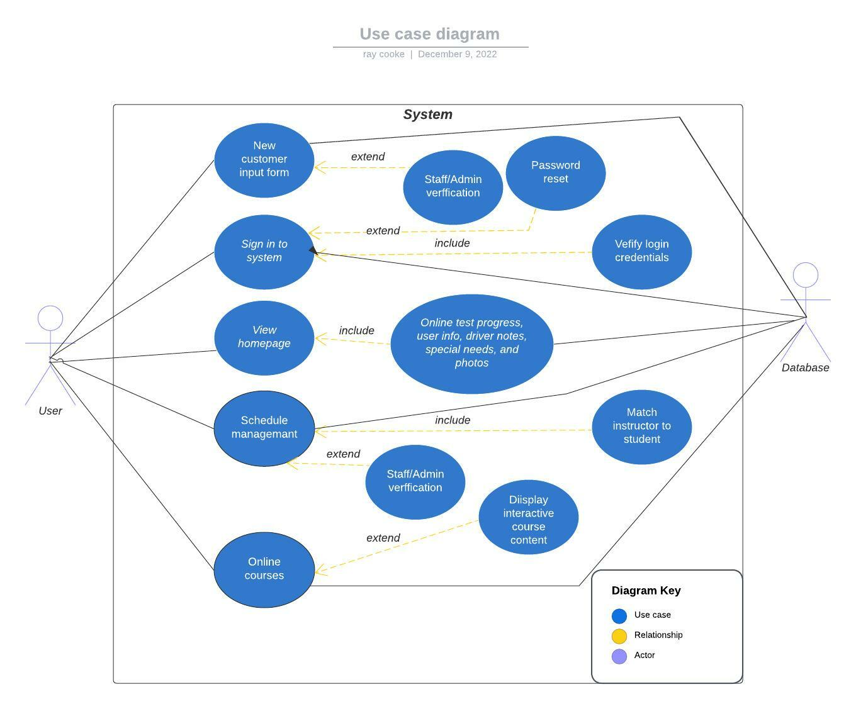

### UML Activity Diagrams

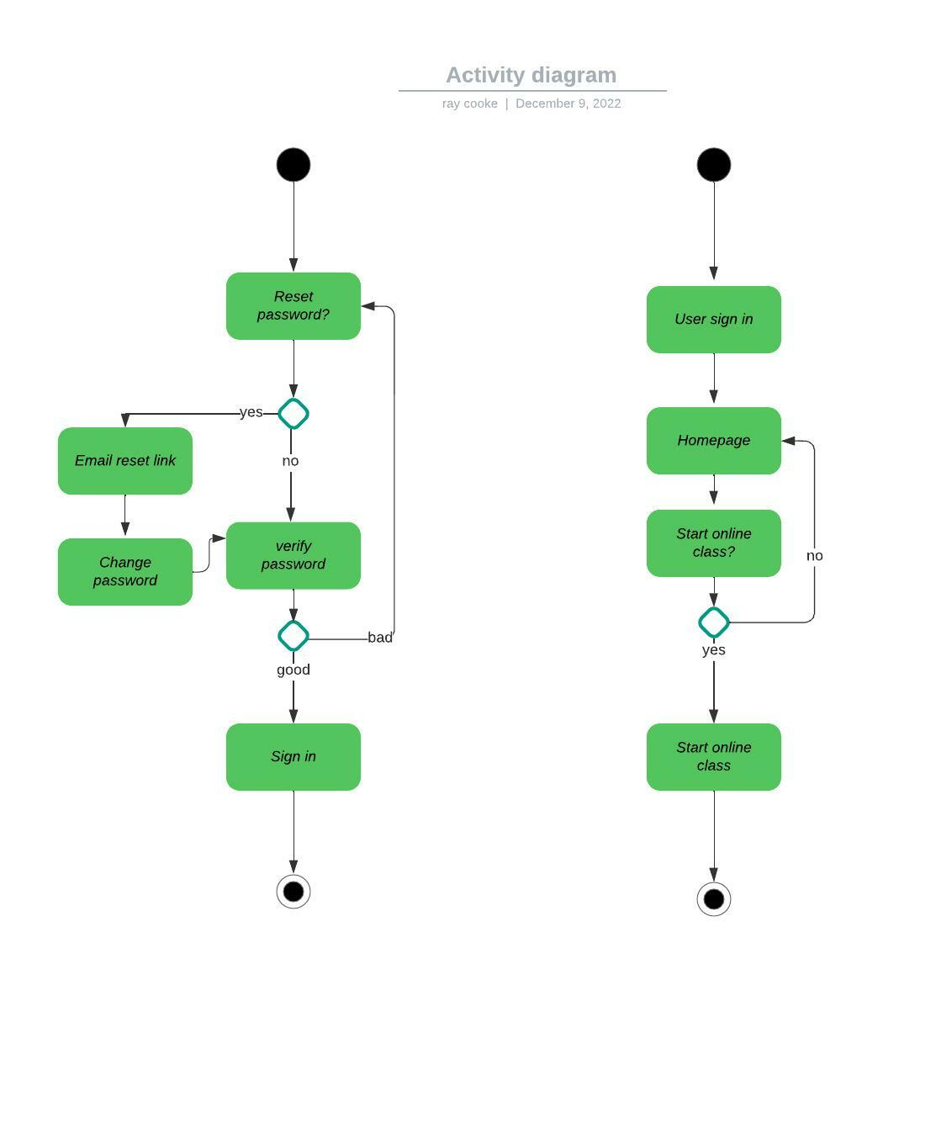

### UML Sequence Diagram

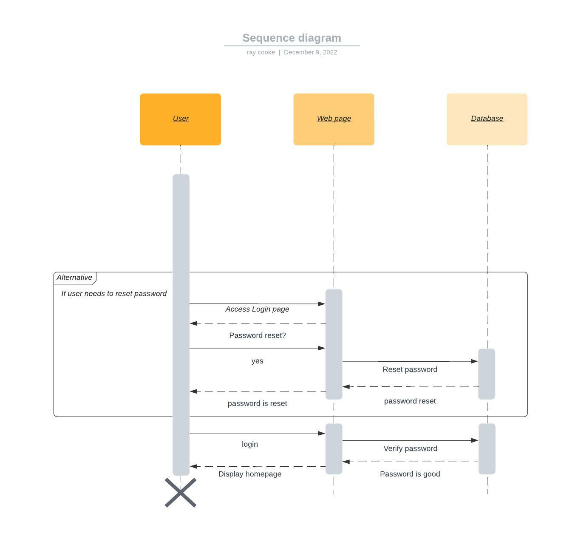

### UML Class Diagram

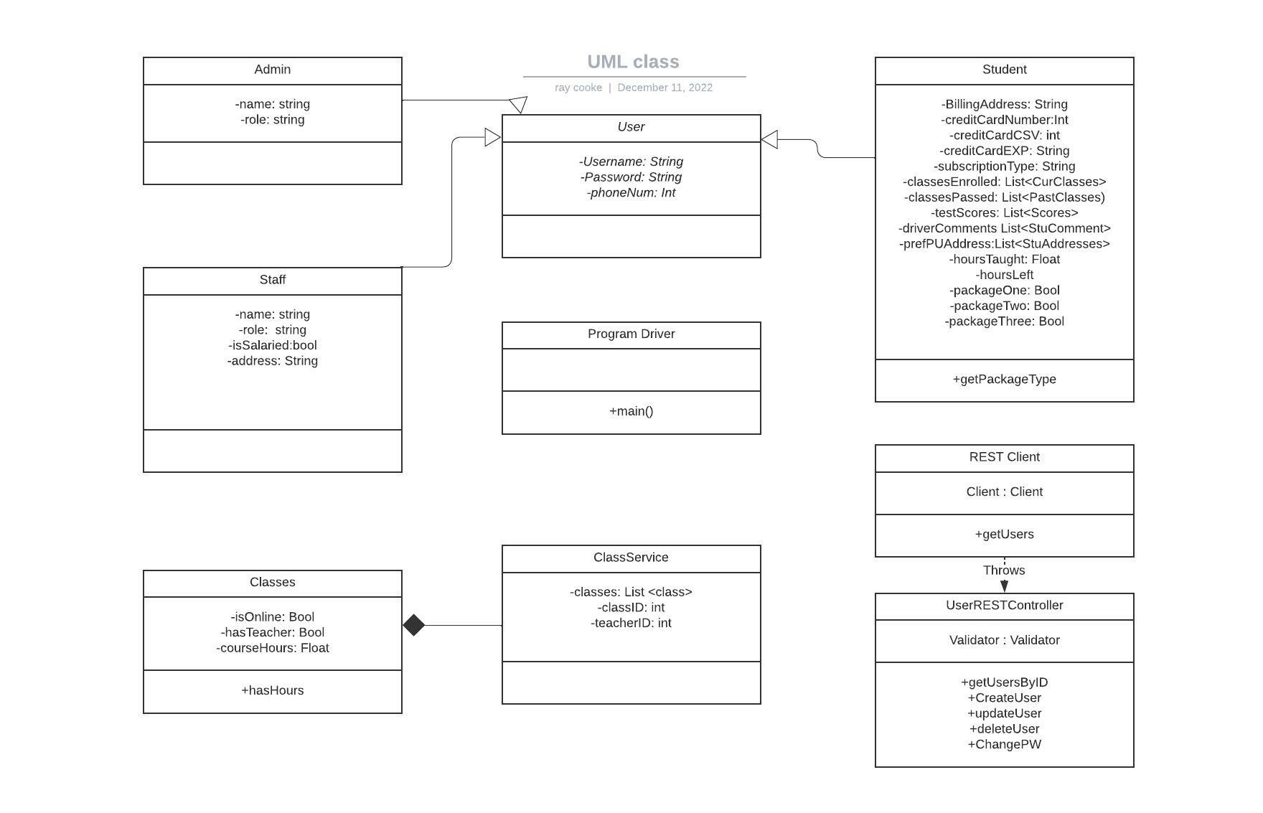

## Technical Requirements

The server side of this system will be written in Java and USE a RESTful API with DropWizard. The client side will be developed with HTML, CSS, and JavaScript. This system and its data will be hosted in the cloud. Eclipse and VS code will be used to develop this system. Subscription packages can be added or modified in the “Student” class where there’s a variable to track a student’s remaining balance of hours. Database hosting method will depend on which cloud provider DriverPass selects to host the system. This should allow for easy file handling and data import/export.