# CS 340 Project Two

## About the Project/Project Title

This project uses Python to interact with a cloud-based database that uses MongoDB. The Restful API that was used provides a user interface that enables a user to modify search parameters through a dashboard.

## Motivation

The motivation behind this project was to provide an extremely user-friendly way to view and manipulate the information in the provided CSV file.

## Getting Started

To get started with this program, a Linux terminal configured with MongoDB will be required. For these purposes, most programs are pre-configured through the SNHU learning environment. Jupyter Notebook will be required for the Python scripts.

## Installation

This program was designed to run within the provided environment which is Linux based and pre-configured MongoDB setup. To achieve similar results, a system that is configured in a similar manner will be required. The first step will be to import the CSV file.

Next, we must establish security by setting up user privileges.

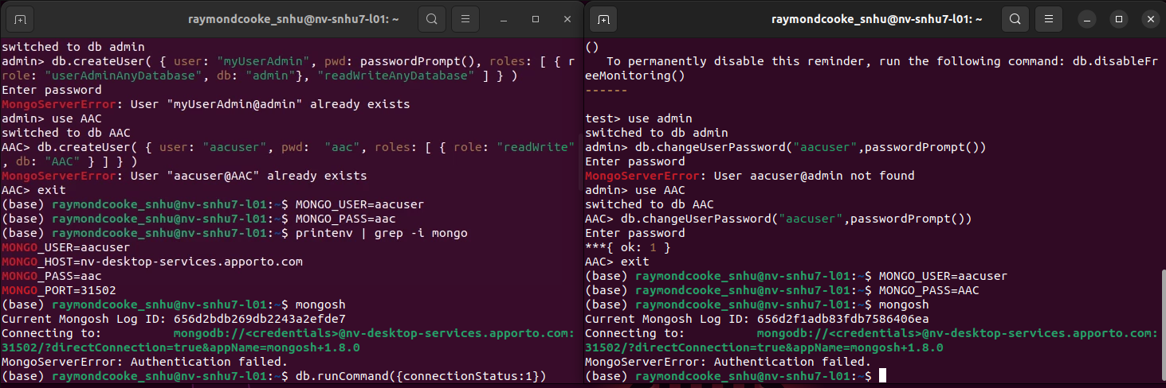

Using Jupyter Notebook, upload the file named “animal_shelter.py” containing the source code for the *AnimalShelter* class that enables CRUD operations.

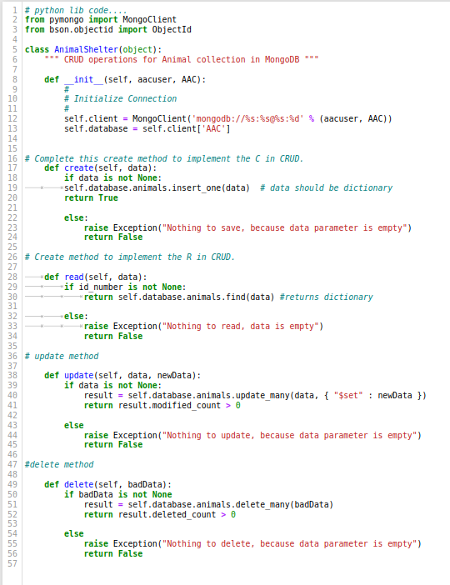

Then load the “ProjectTwoDashboard.ipynb” into Jupyter Notebook. This file should be executable within Jupyter Notebook.

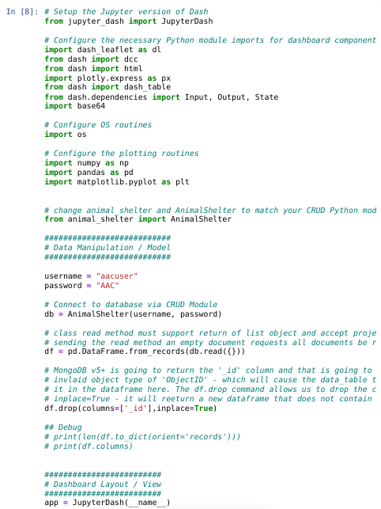

The program does not reach desired functionality.

MongoDB and Python were used for this project because they interface nicely to provide a user-friendly Restful API. While previous explorations with Java and Spring boot seem to be quite simpler to implement, this combination of client and server-side technologies provide a great way to quickly provide the end user with a dashboard that fits their needs for administering their databases.

The Dash framework provides software developers a standardized way to display information pertaining to the systems that they’re building. These dashboards are commonplace in networking applications and are seen as the industry standard for administrating them.

Interfacing with the Linux environment was very challenging throughout this course. I was never quite able to get it set up correctly. This will be a learning opportunity to develop my skills in unfamiliar areas.