ESSSS Centralized Document Management System with QR Code Technology

A Capstone Project Proposal Presented to

The Faculty of the Information Technology Department Bulacan State University-Hagonoy Campus

In Partial Fulfillment

of the Requirements of the Degree Bachelor of Science in Information Technology

By: BALATAYO, Leila Anne

FELIPE, Reo Roi LOPEZ, Aleck Joseph

MIRANDA, Francine Louisse VERANO, John Sandrex

May 2025

## Chapter 1 Introduction

This chapter introduces the project context, purpose and description, objectives of the study, and scope and limitations of the study.

## Project Context

Traditional record-keeping methods that rely on the vertical file system developed by Edwin Grenville Seibels continue to be used by certain companies, with records being organized in stacked cabinets. This system of document storage, which was created in 1898, mostly relies on manual procedures and physical space. According to Wpengine (2024), 80% of the information in most businesses is still in paper form. Since original paper records are frequently needed to satisfy legal or regulatory requirements and maintain operational integrity, many businesses and organizations are unable to fully digitize or abandon papers records.

To address the limitations of traditional record-keeping and leverage the capabilities of Quick Response (QR) code technology, a comprehensive solution that integrates digital and physical document management will be developed. Piloton et al. (2023), in their study Development of Records Tracking Management System with QR Code, demonstrated the effectiveness of such an approach. Their system successfully tracks documents, verifies user authenticity, retrieves files, and maintains a detailed audit trail—functions that align with both organizational goals and user needs. By incorporating modern identification technologies, the system ensures secure and efficient monitoring and retrieval of records, while also complying with legal and regulatory requirements. Each document is assigned a unique QR code that links it to a centralized database, allowing real-time updates to storage locations and instant access to metadata.

Building on these technological innovations, the significance of implementing such an integrated system is further underscored by research. Ismael and Okumus (2017) shows the implementation of a document management offers benefits on institutions by reducing expenses, automating operations, improving document security, and avoiding errors. It is crucial that these organizations establish a document management system that can integrate digital operation with the preservation of physical documents. This will enhance document accessibility, prevent the risks of data loss and non-compliance, improve company operations, and ensure the continuity of the organization and legal accountability.

Modern technologies like QR codes offer a more efficient way to access and organize documents. Libraries, retail, healthcare, and logistics are a few of the businesses that utilize QR code technology to enable rapid and effective data access. These codes are simple to read with cellphones or specialized scanners and can hold a variety of data, including text, video, and URLs (Sethy & Dadhich, 2023). Dynamic content updates are now supported by advanced QR codes, enabling businesses to change connected data without creating new codes. To stop fraud and illegal access, security elements including encryption and authentication procedures have also been included. Furthermore, tracking features are being added to QR codes more frequently to track user interactions and data analytics.

Along with this, many industries have shown how QR code technology can simplify operating and paperwork procedures. For instance, the study by Uzun and Bilgin (2016) on the evaluation and implementation of a QR Code Identity Tag system for healthcare highlights its effectiveness. Their research emphasizes that integrating QR codes on patient wristbands enables healthcare providers to easily access medical records, thereby reducing paperwork and ensuring accurate data retrieval. Moreover, Ahn et. al., (2018) highlighted that Quick Response (QR) code implementation in construction management significantly reduced unnecessary procedures in material handling and improved data accuracy. By bridging the gap between digital tracking systems and physical records, QR codes improve information accessibility, increasing efficiency and decreasing operational delays, according to the study. This idea can be used in document management, where QR codes are a crucial tool for safe authentication, speedy retrieval, and better record-keeping procedures.

Given these advancements, the need for modernization becomes more evident for organizations with years of traditional practices and regulatory compliance, such as ES Santos Surveying Services (ESSSS). For two decades, the company has established itself as a reputable land surveying company by providing accurate surveying services. It is also visible that the company is dedicated to regulatory compliance and accuracy in its preservation of an extensive archive of physical documents, which includes legal contracts, survey maps and other legal documents.

However, the current document management system at ES Santos Surveying Services (ESSSS) poses significant challenges. As stated by Wpengine (2024), organizations relying on manual, paper-based systems face a 21.3% productivity loss and 7.5% of all paper documents are reported lost. These figures directly mirror the inefficiencies experienced by ESSSS, as the company encounters a two-day delay in responding to document requests, which hinders the rapid execution of operations and the formulation of decisions.

Furthermore, there have been substantial security vulnerabilities identified, which threaten legal documents and sensitive survey data and increase the risk of document loss. A fishbone diagram analysis of ES Santos Surveying Services (ESSSS) document management process identified extended retrieval times and inadequate security measures as critical weaknesses. These discoveries underscore the pressing necessity for ES Santos Surveying Services (ESSSS) to implement a contemporary, centralized document management system that capitalizes on QR code technology. This will reduce operational complexity, improve document accessibility, and strengthen overall security and compliance.

The researchers conducted an evaluation comparing three candidate solutions. Each of the candidates was analyzed based on how well it aligned with the operational requirements, technical expertise, financial resources, and implementation timeline of the company. The evaluation considers how effectively each option addresses issues such as slow document retrieval, disorganized storage, and insufficient security measures. Based on the assessment, the most feasible candidate solution for the company was identified for its efficiency, affordability, and ease of deployment. While some of the choices presented advanced features, they also come with complications concerning cost or the timeline for implementation. The selected solution was chosen for how well it aligned with the current needs and limitations of the company while having the flexibility for future improvement.

In response to these challenges, the researchers will propose the development of a Centralized Document Management System with QR Code Technology. This system will integrate both physical and digital document tracking, ensuring that every record is uniquely identifiable and easily retrievable. The QR code system will facilitate instant access to document metadata and storage locations, providing an efficient workflow for employees while maintaining security. This innovative approach will modernize the company document management practices to improve digital document management while retaining physical documents.

## Purpose and Description

The ESSSS Centralized Document Management System with QR Code Technology for ES Santos Surveying Services is a web-based application that keeps track of both digital and physical records by storing, retrieving, and tracking documents efficiently. This makes sure that documents are properly organized and increases system security. The office department and the chief operating officer of the company are authorized to access the system, but they have different access rights to ensure the integrity of the data.

The system will focus on its primary functions, wherein the users will manage both physical and digital documents effectively and efficiently. The system allows users to upload files on the system and store physical documents in the storage cabinet within the control of the system. This eliminates the time consumed on searching and location survey documents. Along with this, it includes QR code technology to make document retrieval faster. Each physical document will have a QR code to keep everything organized and easy to access.

Physical documents must be kept accessible and well-organized to preserve efficiency and organization in the storage cabinets. A systematic approach of document management lowers the possibility of misplacement by ensuring that documents are kept in the right places. This speeds up and simplifies retrieval, particularly when working with a lot of records.

Additionally, the system also makes sure that only authorized individuals may access documents, which helps to safeguard sensitive data. It records every activity by monitoring who views or retrieves files. This ensures that papers stay safe while still being accessible to those who require them, preserving accountability and preventing unwanted access.

The ESSSS Centralized Document Management System with QR Code Technology offers several benefits. It increases efficiency by automating document tracking and retrieval, reducing the time spent locating records. QR code technology enhances accuracy by minimizing human error in document handling. Security is improved through role-based access controls and authentication, protecting sensitive information. Real-time document tracking ensures users have up-to-date information about physical and digital records. Automated logging audit and compliance requirements by maintaining a detailed record of document interactions.

The ESSSS Centralized Document Management System will benefit key personnel including the Chief Operating Officer, Secretary, Researcher, Compliance Officer, and CAD Operator by improving the efficiency of document handling and processing. It reduces manual effort, enhances accuracy, and accelerates document retrieval, leading to increased productivity. Furthermore, clients will benefit from faster service delivery and greater satisfaction as a result of streamlined operations.

The beneficiaries of the developed system state as follows:

**Chief Operating Officer.** The document files of the company will be easier to track through notification, audit trail, and monitor document status. The operation of the company will monitor better through these features that ensure efficient, real-time, and secure monitoring.

**Secretary.** The system will enable the Secretary to quickly locate files relevant to administrative tasks while restricting access to unauthorized content through role-based access control.

**Researcher/Compliance Officer.** The system will enable the Researcher/Compliance Officer to quickly locate approved survey plans, approved transmittal forms, approved field notes, property transfer documents, and approved survey authorities, ensuring efficient access to validated and compliant information.

**CAD Operator.** The system will enable the CAD Operator to easily find technical descriptions, lot data, reference plans, and lot titles, streamlining the design and drafting process

**Clients.** The system will improve the company response to client requests, enhancing client satisfaction through efficient document tracking and secure access.

**Future Researchers.** This system will benefit future researchers by demonstrating the efficiency and effectiveness of a Centralized Document Management System with QR Code Technology in a company setting. It can serve as a foundation and reference for the development of the project.

The ESSSS Centralized Document Management System with QR Code Technology will be developed to resolve the inefficiencies and security vulnerabilities of the current manual, paper-based document system at ES Santos Surveying Services (ESSSS). The existing lack of standardized procedures will continue to cause delayed document retrieval, increased human error, and elevated data security risks if left unaddressed. These issues are particularly critical in a regulated sector like land surveying, where timely access to accurate documentation will remain essential.

The proposed system will modernize document handling by integrating QR code technology within a centralized digital framework, allowing for faster retrieval, precise tracking, and improved access control. Once implemented, it will reduce document retrieval time from two days to just three minutes—significantly enhancing workflow efficiency, minimizing project delays, and improving client service.

Since ESSSS will still be required by law to maintain certain records—such as survey reports and legal agreements—in physical form, the solution will support a hybrid document management model. QR codes will provide the bridge between physical and digital formats, thereby making both forms of documents organized, searchable, and safely stored. Additionally, this method will improve compliance with the Data Privacy Act since sensitive information will be accessed only by authorized individuals using embedded security mechanisms.

This necessity for modernization is underscored by the persistent problems, including the delay in obtaining Certified True Copies (CTCs) from the Land Registration Authority (LRA), which now hinder project workflows and risk financial setbacks. Through the adoption of the proposed system, ESSSS will prevent further inefficiencies and provide continuity of operations, client satisfaction, and regulatory compliance.

The system will also align with broader industry trends in digital transformation. Similar implementations, such as those described by Rodriguez III et al. (2024), have already been proven to reduce administrative workloads and document retrieval times. For ESSSS, the project will not only improve internal operations but also serve as a forward-looking model for other organizations facing comparable document management challenges.

With its ability to address immediate operational inefficiencies while supporting long-term digital transformation, the ESSSS Centralized Document Management System with QR Code Technology will be a pivotal step toward modernizing the workflow of the company. By enhancing data security, improving document accessibility, and ensuring regulatory compliance, the system will not only meet current demands but also equip ES Santos Surveying Services (ESSSS) to thrive in a future where efficient, hybrid document management is essential to organizational success.

## General Objective

The study aims to develop a Centralized Document Management System with QR Technology.

## Specific Objectives

Specifically, the study aims to:

1. Integrate the following main functions:
   1. Digital Document Information Management
      1. Process Digital Document Information
      2. Process Digital Document Storage Information
      3. Generate Digital Document Storage Location
   2. Physical Digital Information Management
      1. Generate Physical Document QR Code
      2. Process Physical Document Information
   3. Physical Storage Information Management
      1. Generate Physical Document Storage Location
      2. Process Physical Document Storage Information
   4. User Information Management
      1. Process User Information
      2. Process User Authentication
      3. Generate Audit Trail

## Scope and Delimitation

The proposed ESSSS Centralized Document Management System with QR Code Technology will be designed to manage and secure both digital and physical documents within ES Santos Surveying Services (ESSSS). It will enhance document organization, security, and traceability by integrating QR codes for tracking and implementing access controls. The proposed system will operate internally, utilizing network connectivity for accessing digital documents.

The company Chief Operating Officer (COO) and office department personnel, including the secretary, CAD operator, and researcher, will use the proposed system to manage survey-related documents efficiently. The COO will serve as the system administrator, while office personnel will have role-based access to the system. This setup will benefit both ESSSS employees and clients by providing a streamlined, secure, and efficient document management solution.

Operations and efficiency will improve significantly with the introduction of the proposed system, addressing challenges in document retrieval speed and storage organization. The proposed system will streamline processes and enhance productivity, leading to increased profitability. The development of the ESSSS Centralized Document Management System with QR Code Technology will occur between the second semester of academic year 2023–2024 and the first semester of 2025–2026, ensuring an organized, secure, and efficient document management process.

The proposed system will feature centralized digital document management, enabling the office department to upload documents or images such as lot titles, survey plans, tax declarations, lot data, technical descriptions, research approvals, transmittals, field notes, contracts and agreements, cadastral maps, survey authorities, boundary point records, and CAD files. Users will also be able to update document information, delete files, and add new documents. It will also automatically sort and categorize documents, facilitating easy organization. Each digital document will be linked to its physical counterpart via a unique QR code.

In addition, the proposed system will provide physical document management, allowing the office department to update document information, locate, and track the status of physical documents. The system will generate unique QR codes for each physical document, which will be printed on labels and attached to document folders. This will ensure the physical documents are stored in their designated filing cabinets according to category. The office department will scan the QR codes to view essential document details, such as file number, lot number, location, type of survey, date, and status.

The office department will have access to the proposed system, enabling them to upload, retrieve, view, search, delete, and update documents according to their assigned permissions. Their access will be tailored to their specific roles to ensure data security and prevent unauthorized modifications. The Chief Operating Officer will have full control over the proposed system and will be able to monitor user activities through notifications and audit trails.

## Limitation

The proposed system cannot completely eliminate all risks, even with enhanced security measures. There are still possibilities of human error, system vulnerabilities, and unforeseen external threats that may affect the security and integrity of documents. While the proposed system aims to improve security, it cannot guarantee absolute protection against all hazards.

Instant document access and delivery are not possible with the proposed system. Document processing still requires following security protocols and, in some cases, manual retrieval of physical files from storage. These steps are necessary to maintain security and proper documentation, but they can introduce unavoidable delays.

The proposed system depends on the familiarity of the user with digital documentation and QR code technology. Staff who are not accustomed to these technologies may experience difficulties during the transition. Training is required to ensure proper use, and there may be a temporary increase in workload as current records are encoded and both digital and physical documents are managed.

During implementation, the proposed system requires users to scan QR codes for file retrieval and searching. This process is new for some staff and may initially affect the speed of document handling.

The proposed system does not include full automation of all processes. Some manual steps remain, such as encoding existing records and retrieving certain documents, which may affect overall efficiency.

## Chapter 2

**Review of Related Literature and Studies**

This chapter tackles the studies, systems, and other reliable publications that will further explain the importance of the research and support the feasibility of the proposed project. It establishes a strong basis for the system practicality, relevance, and potential for successful deployment. This section acknowledges the works published researchers, developers, and institutions

# TECHNICAL BACKGROUND

## Document Management System

A Document Management System is a digital solution that is used to capture, store, manage, and track digital documents and images of physical documents. It gives businesses the ability to organize, access, and secure documents in a centralized location, ensuring compliance with the data management laws and allowing for limited access (Hyland. n.d.). To maintain the past activities and integrity of documents, DMS usually includes capabilities like version control, metadata tagging, and audit trails (AIIM, n.d.). DMS solutions reduce the need for physical storage while facilitating effective document retrieval, sharing, and collaboration. They also provide complex search features that let users find papers fast by using tags and keywords.

## Quick Response (QR) Technology

A Quick Response (QR) code is a two-dimensional barcode that can easily be read by QR code scanners, smartphones, or tablets to retrieve saved data. It is in the form of a small, square grid of pixels that can hold a total of 7,089 numeric characters or 4,269 alphanumeric data (Dhiway Networks Private Limited, 2021). The design of QR codes allows for higher data storage and faster readability, making them an excellent tool for a range of applications, such as marketing, inventory management, and secure information retrieval. They have grown in popularity in both commercial and technological contexts due to their capacity to encode URLs, contact details, and even payment information (Hayes, 2025).

## Role-based Access Control System

Role-Based Access Control is a security approach used to manage resource access by users of an organization based on their roles. It assigns permissions to roles and not users individually, thus it is efficient and scalable. As stated by Digital Guardian, RBAC supports reduction of risk due to unauthorized access since the users are provided with only required permissions to conduct their job roles (Digital Guardian, 2018). Users are allocated particular roles depending on their duties, and every role comes with pre-defined permissions that allow access to different systems or information. This model gives organizations more control over data security, minimizes the complexity of managing users, and promotes compliance with regulatory requirements. As explained by Auth0, RBAC

eases the task of implementing access control policies through the grouping of permissions into roles, thus enabling easy updates in user privileges without having to edit individual user access (Auth0, n.d.). Centralized access control and fewer access points improve overall security and simplify administration.

## Network Technology (LAN)

A Local Area Network (LAN) is IEEE 802 network that uses devices such as computers, laptops, and mobiles that are connected in small ranges from 100m to 10km (Agarwal, 2020). The devices are connected via a common communication line or wireless connection to a server. Moreover, LAN comprises cables, access points, switches, routers, and other components that enable devices to connect to internal servers, web servers, and other LANs via wide area networks. It is used to exchange data between small and large information, which is used in educational institutions as well as business. Additionally, it helps improve resource sharing, such as printers and storage devices, and support collaborative work environments by enabling fast and reliable communication among connected devices.

## Centralized Storage

Centralized storage is the primary source for storing, managing, and retrieving data across different business units, teams, workspaces for different purposes. By consolidates organizational data into a single, unified repository, it simplifies data access since everything is located in one place. This maintains data consistency, reduce the risk of duplication and errors, ensures proper data management using appropriate storage and keeps information updated. Moreover, a well-organized centralized storage enables fast and efficient retrieval of information, supporting quick decision-making and smoother daily operations. It is also essential for businesses, which is most popular and successful method to keep the data safe and reliable (Courtaway,2024).

## Audit Trail Technology

According to Vicente, V. (2024), an Audit Trail is a detailed and chronological record that captures date and time-stamped transactions, project details, financial data, sources of funds, and trade information. Any types of work activity or process can be documented in an audit trail to trace and track many types of transactions, sequence of events or actions, and viewing audit log in as close to real time that are part of day-to-day operations which are monitored by organization. Audit Trails is used to determine the validity of accounting records to secure the data, ensure the transparency and accountability, and to enhance the efficiency in the operational processes. Furthermore, in the daily operations of a company, it allows the identification of unauthorized activities, and discrepancies to maintain the data integrity and make the processes effective.

## Indexing Technology

Indexing Technology plays a vital role in how information is organized, retrieved, and presented across various types of platforms particularly in search engines, and database management systems (Next Business Media, 2024). Indexing is a systematic process of organizing data, classifying information, and grouping the values in order to facilitate efficient retrieval of data. It is also a process of compiling an index of documents or web pages based on specific keyword or content type including text, images, and metadata to easily locate and quickly return relevant results.

Traditional businesses use indexing technologies to analyze the information of a huge volume of data in retrieval. Furthermore, indexing technologies are scalable, high-performance indexing, ensures the organizing of information efficiently, rapid retrieval, enhancing user experience, and improving online visibility.

# RELATED LITERATURES

## Foreign Literature

Knowmax (2025) highlights the importance of automation in Document Management Systems (DMS). It is stated effective DMS should also support automated processes, this reduces manual labor required for document processing and ensures a more error-free workflow. The article suggests that integrating automation into DMS will enhance its productivity by accelerating processes. This concept aligns with the goal of the proposed system to automate certain aspects of document management, such as tracking the status of physical documents and streamlining access permissions for digital files.

Additionally, the article stated that by integrating features such as document indexing and automatic categorization. By using metadata (e.g., document type, date, author) to classify documents, the system will allow users to locate the files seamlessly. By applying these principles to the proposed system, it will help achieve the objective of reducing retrieval time from 2 days to just 3 minutes.

Building on the fundamental of a DMS to organize, secure, and automate document workflows, digital DMS takes this one step further by utilizing advanced technologies to manage electronic records more efficiently and securely. According to Consentia LLC (2023), DMS offers several benefits such as easy document retrieval, enhanced collaboration, data protection and automation The study highlights that DMS allows businesses to store and access documents quickly and securely, reducing the time spent searching for paper-based records. Furthermore, DMS can automate routine tasks, which minimizes human error and accelerates document processing times. These features are useful for businesses that deal with legal documents, where confidentiality and availability are critical. By

implementing these features into the proposed system that combines both physical and digital document management, retrieval time can be drastically reduced, aligning with the objective of decreasing retrieval time from two days to three minutes.

While digital document management system improves electronic document management, processing and consolidating physical documents remains a critical aspect of organizational functions, particularly in legal and confidential document- reliant businesses. Laatre (2023) further asserts that good physical document management is not just ensuring proper storage and arrangement but also the conducting of regular audits and having clear access protocols to ensure the integrity and confidentiality of the records. Laatre points out that businesses should maintain a controlled facility like locked filing cabinets, to ensure against unauthorized access or damage. Furthermore, effective document tracking is required for proper retrieval of documents, particularly in the handling of legal documents, as delays or mishandling can cause extreme legal and operational risks. These practices are particularly relevant to the proposed system, which seeks to integrate physical documents with digital records in a streamlined, secure manner, reducing the time spent searching for physical documents and enhancing retrieval accuracy.

Given the critical role of DMS in the storage and handling of sensitive data, it requires attention to their security. Sargiotis (2024) emphasizes that the safeguarding of sensitive information is a critical responsibility in digital systems, and especially for organizations responsible for the management of confidential

and legal documents. The chapter explains the importance of the application of strong encryption, access controls, and audit trails in DMS to reduce the threats of unauthorized access and data loss. For companies that deal with legal documents, tampering, loss, or unauthorized disclosure has the potential to bring critical legal and reputational consequences. The authors propose a multi-layered approach to security that incorporates technical controls with administrative procedures to maintain the integrity and confidentiality of data. This is in line with the goal of the proposed system, which is to ensure the safe, timely, and traceable retrieval of both physical and digital legal documents, leading to trust and compliance in document handling practices.

To further support these security features, the incorporation of QR code technology into document management systems adds an extra layer of governance and traceability, with instant, secure, and verifiable access to physical and digital records. Canteli (2024) describes how OpenKM, a document management system, uses QR codes as digital seals that hold key metadata like the document version and status. With a mobile scanning application, users can simply check whether the document in their possession is the most up-to-date version, thereby reducing the risk of errors associated with old files. Moreover, customized QR codes accelerate document identification and retrieval processes, even when viewed through a smartphone camera, and can monitor document usage, including who viewed the document and when. This functionality directly supports the core objective of our proposed system, which is to reduce document retrieval time from two days to just three minutes. By integrating similar QR code

capabilities, our system can ensure real-time verification, enhance document security, and provide comprehensive audit trails for both physical and digital records, especially crucial in legal and regulated business environments.

## Local Literature

According to RJ Gumban, the concept of Document Management Systems (DMS) involves managing the life cycle of an entire document right from its creation to its disposal. It incorporates important aspects of automating tasks such as storing and retrieving information, boosting productivity and security. Gumban highlights that DMS should provide efficient workflows, ensure compliance, and protect sensitive information. These principles align with the goal of the proposed system to automate document management and reduce retrieval times, ensuring both security and efficiency for legal and business operations.

Furthermore, alongside optimizing document workflows, it is essential to prioritize the security of documents within the DMS. In ensuring effective document security, access control plays a crucial role in DMS. According to Richartz (2024), access control features in a DMS allow administrators to assign various levels of access to users, preventing unauthorized individuals from accessing or modifying documents. By adopting similar access control features, the proposed system can ensure that only authorized personnel access and interact with sensitive records, thus ensuring compliance and security in document management procedures.

In addition to these security measures, consistent folder structures and naming conventions are fundamental in enhancing document retrieval efficiency. By organizing files systematically and following a standardized naming protocol, the retrieval process becomes faster and more precise. This practice will support the goal of the proposed system to reduce document retrieval time from two days to three minutes, ensuring that users can quickly locate and access the necessary records (Archive One, 2024).

# RELATED SYSTEMS

## Local System:

**Continuous Trial Monitoring System (CTMS)**

To assist the Philippine judiciary in enhancing its case management and curbing court delays, The Asia Foundation in collaboration with the Supreme Court of the Philippines created the Continuous Trial Monitoring System (CTMS) in 2023, the system was launched as part of the nation initiative towards digitalizing court services and enhancing criminal case proceedings efficiency. The CTMS is a centralized computer-based monitoring system that records comprehensive case details like case types, case history, and demographic information of the accused. In this way, the system facilitates real-time monitoring of court procedures, making it possible for administrators to detect delays, evaluate bottlenecks, and facilitate quicker case resolutions. Though the CTMS is court-specific and not integrated with QR technology or wide-ranging document handling capabilities, the

centralized and real-time tracking system is consistent with the goals of our suggested Centralized Document Management System with QR Technology.

## Ricoh

The Document Management by Ricoh is a smart solution designed to provides businesses an effective document-related processes. It helps the traditional paper- based workflows by making them into efficient digital process. This also help to easily organize, manage, retrieve documents, and supports environmental sustainability. With features, the system simplifies data retrieval, and quickly access documents and information from a centralized, digital location, and reduce the time spent in searching through physical files. Furthermore, the system enhances employee management such as approval and tracking of documents, making more efficient and maintaining smooth processes in business operations.

## E-Dawa

To address the problems of processing paper-based documents and enhance efficiency, the Ilocos Sur Polytechnic State College (ISPSC) developed and utilized a web-based Document Management System (DMS) at its Tagudin Campus in 2025. It was intended to facilitate the capturing, storage, organization, retrieval, and management of files and documents in a single digital environment. The DMS was introduced in response to the growing volume of paper documents, limited storage space, inability to retrieve particular data, and rising operating costs associated with conventional document management practices. As ISPSC

becomes a university with more campuses and increased enrolments and manpower, it has been decided to automate the process of documents through DMS for the entire organization.

## Document Tracking System (DTS)

University of the Philippines (UP) Document Tracking System (DTS) is created by the UP Information Technology Development Center (ITDC) and deployed on January 1, 2022. The DTS intends to track the paper trail of documents between UP offices, showing originating and receiving offices, staff involved, and time lapse between units. It is equipped with attachments of documents, revisions, updates, and comments, which maximize document management effectiveness. The advantages of the system are enhanced tracking and transparency of document movement and minimized follow-up communications. The DTS focus on centralized tracking and real-time monitoring also aligns with our proposed Centralized Document Management System with QR Technology, emphasizing the advantages of optimized document processes. UP ITDC states that the DTS has drastically enhanced document tracking effectiveness in the university.

## Document Management System by VastResult

Document Management System (DMS) by VastResult is an integrated solution that helps organizations easily manage both physical and digital documents. The system offers core features like document indexing, file input, and

sophisticated searching, which enable rapid and effortless retrieval of documents. It also includes document processing for the conversion of handwritten or typed information into electronic data, and workflow automation that sends documents through the right channels in an organization. The system also prioritizes document security through encryption and access control to safeguard sensitive data. Although it does not as yet incorporate QR code technology, its concern with centralized document management, secure processing, and streamlined workflow is very pertinent to our Centralized Document Management System with QR Technology proposal.

According to VastResult Inc. (n.d.), their DMS focuses on the necessity of effective handling and security of documents in modern organizations, which is coinciding with our aim of having a more secure, traceable, and effective document management system with QR codes for increased verification.

## Foreign System:

**Qandle**

A Qandle is a software application which launched on April 2, 2025, it is a versatile HR and productivity suite designed to improve HR processes and enhance efficiency. It combines fundamental HR capabilities like employee management, payroll, and performance tracking, as well as reliable document management. The significant features concerning the centralized document management system are safe storage of documents, simple collaboration, version management, and easy integration with HR processes. Key features enable

organizations to securely store, organize, and retrieve employee documents and HR records in a single location. By using this centralized approach, businesses can reduce workloads, keep records in order, increase productivity, and employee engagement.

**Ruddersoft: File Management System**

Ruddersoft Solutions Private Limited introduced their File Management System: Tracking File-Document With RFID & QR Code on July 4, 2024. The system integrates Radio Frequency Identification (RFID) and Quick Response (QR) codes to enhance document tracking and management to become smoother and more efficient. With features such as real-time tracking, improved visibility of file locations, and extra security measures to protect sensitive data. It also facilitates easy sharing and retrieval of documents, which ensures organizational workflow runs smoothly. Its application to our intended Centralized Document Management System with QR Technology is that it illustrates how the use of QR codes can enhance traceability and security of documents substantially, which aligns with our objective of creating a system for efficient and secure document handling.

According to Ravi Pal (2024), the File Management System substantially boosts organizational control over document security and accessibility by incorporating technologies such as RFID and QR codes, transforming conventional file handling into a strategic business process.

**Timly**

The QR Code Inventory Management System, created by Timly Software AG (2024), provides a cloud-based solution that is intended to simplify asset tracking and management across different sectors. The system works using QR code labels so that employees can enroll and track items with rapid scans, thus improving real-time data accuracy and operational effectiveness. Key functionalities are centralized tracking of assets, real-time asset status monitoring, and instant integration with handheld devices to provide access to information irrespective of asset location. Although dealing mainly with inventory and asset tracking, The methodology of used by Timly in applying QR codes for streamlined tracking and retrieval of information backs up the aims of our proposed system, Centralized Document Management System with QR Technology, but points to the possible advantages of incorporating QR codes to improve document traceability and access.

According to Jennifer Ritz (2024) states, QR codes make inventory management processes simpler and faster, allowing employees to easily register items with a quick scan, thereby greatly simplifying their workload and making inventory tracking virtually effortless.

**Folderit**

Folderit is a white-label Document Management System designed by Folderit Ltd. that was implemented in October 2016 and aims to meet the needs of organizations that require a secure, customizable, and cloud-based system.

Folderit offers central document storage with version control, tagging of metadata, workflow automation, and granular access permissions. Folderit runs on Amazon Web Services (AWS) to maintain data security, reliability, and ISO 27001 standards compliance. White-labeling provides the companies with an opportunity to relabel the system using their logo, color profile, and domain name, while Folderit manages backend processes and support. Although it does not exploit QR technology, its focus on safe document access, automation, and centralized data management shares similarities with the objectives of our Centralized Document Management System with QR Technology.

Folderit system is intended to provide complete user control with a secure, highly available setup, which is a pointer to the significance of centralized document systems in improving business efficiency.

**Simpel: QR Docs**

QR Docs, created by Project Simpel (2024), is a document management system that aims to enhance the availability of project documents on-site. The system employs QR codes enabling workers to instantly access the latest plans and documents using smartphones or tablets without the need to log into a system. This integration means workers always gain access to real-time information and that the probability of errors based on outdated documents is minimized. Its ease of use and that one can pull out documents with just an instant mirror the ambitions of our subject Centralized Document Management System with QR Technology in that QR technology could greatly enhance the accessibility as well as correctness

of documents. The application of QR codes in document management enhances on-site efficiency by reducing delays and avoiding information errors (Project Simpel, 2024).

# RELATED STUDIES

## Development of Records Tracking Management System with QR Code

The study by Jennica G. Amodia et al. (2023), "Development of Records Tracking Management System with QR Code", examines the application of QR code technology to enhance document tracking and retrieval in the organizational environment. The researchers created a system in which users scan QR codes affixed to physical documents to immediately display their present status and location within the file system. By using Agile methodology, the team was able to keep improving system throughout development, using real feedback from users The findings showed significant improvements in both efficiency and accuracy, with much less time spent searching for files and minimizing lost or misplaced records.

The advantages of incorporating QR technology into existing procedures, particularly for organizations handling massive amounts of documents like schools, government departments, or medical centers. This research shows that simple yet innovative technologies such as QR codes can significantly improve

information systems by filling the void between manual operations and computer ease—a concept that specifically favors the objective of our proposed system.

## Online QR Code Digital Contact and Quarantine Tracing Using Independent Software Vendor Oracle – Cloud Computing

The study conducted by Jerry I. Teleron et al. (2022), entitled "Online QR Code Digital Contact and Quarantine Tracing Using Independent Software Vendor Oracle – Cloud Computing," deals with the inefficiency of manual contact tracing practices during the COVID-19 pandemic. The researchers came up with a digital system using QR codes and Oracle Cloud Computing to automate the process of tracking the movement of people in public places. By scanning an individual QR code using a smartphone, the system rapidly fetches personal data and exposure history, greatly minimizing time and physical contact associated with conventional logbook procedures. The research identifies the efficiency of the system to improve accuracy in contact tracing and advises using it nationwide as an effective means of managing and alleviating risk in virus spread. The Online QR Code Digital Contact and Quarantine Tracing demonstrates how flexible QR technology can be. not only for health but for any system that needs rapid, precise, and secure tracking. Its success in the management of sensitive, bulk data underlines the potential of QR-based solutions for document management systems, where real- time access and accountability are no less critical.

## Enhancing Chemical Inventory Management in Laboratory through a Mobile- Based QR Code Tag

One such study entitled "Enhancing Chemical Inventory Management in Laboratory through a Mobile-Based QR Code Tag" by Shukran, M. A. M. et al. (2017) investigated the use of a mobile-based inventory management system using QR code tagging to enhance the tracking and managing of laboratory chemicals. The researchers used the development research approach to develop and create a mobile app with the ability to scan QR codes assigned to chemical containers. This enabled real-time access to important information like chemical quantity, expiration dates, and hazard classifications.

The findings indicated that the system had a significant decrease in manual recording errors and increased the efficiency of laboratory inventory audits. The study concluded that combining QR codes with a centralized mobile system improves data accuracy and encourages a safer laboratory environment. The authors suggested that the implementation of such digital inventory systems be extended to other high-risk environments that necessitate rigorous tracking and handling procedures. This reinforces the applicability of using QR code-enabled systems in centralized data management, for example, in document archiving and monitoring purposes.

## Web-Based Document Tracking System Using Barcode Technology with SMS Notification

Another relevant study is entitled "Web-Based Document Tracking System Using Barcode Technology with SMS Notification" by Rellon, S. J. et al. (2020) The purpose of this study was to design a system in which users can trace the location and status of documents through barcode technology and SMS notification. The system was designed to enhance document management by enabling real-time tracking, person-to-person identification, and simple location tracking though barcode scanning. The development approach used the Agile System Development Life Cycle Model, which is focuses on continuous improvement with regular feedback from the users. Throughout development, they worked on creating barcodes for identifying documents, creation of an upload page to track documents, and adding SMS notifications to keep both the sender and recipient updated on the status of their documents. It was suggested in the study that there should be further testing with a larger sample of documents to ascertain the reliability and performance of the system under different real-life situations. It also emphasized the need for ongoing testing to ascertain the effectiveness of the system prior to complete implementation.

## Computer Laboratory Network Centralization Files Management System

Another study is "Computer Laboratory Network Centralization Files Management System" by Alex L. Ledonio, published in March 2021. The research aimed at creating a system that could automatically back up files in the laboratory on a scheduled basis, sort them out in an organized manner, and act as a central repository where it can be easily retrieved. This research confirms the notion that

centralizing digital assets leads to improved management and less risk of data loss. This study emphasizes the efficiency of centralized document systems in enhancing file access, organization, and security. It demonstrates that these systems are necessary for the handling of massive amounts of documents in organized settings. A notion in direct alignment with our suggested centralized Document Management System.

## Role of Document Management System for Business Processes Optimization

A study titled "Role of Document Management System for Business Processes Optimization" by I.V. Orlov (2024) discusses the way Document Management Systems (DMS) can optimize business processes. The research applied a qualitative research approach to evaluate the role of DMS on business activities, considering their integration with Enterprise Resource Planning (ERP) systems. The findings presented that DMS highly automated document handling, facilitated collaboration, and enhanced business process automation. The research revealed that companies employing DMS had lower operational costs, enhanced security, and streamlined workflows.

The research advised organizations to adopt DMS to enable effective document management across their lifecycle, from creation to dissemination. It also proposed the integration of DMS with other business systems to enhance processes further and enhance organizational structure and decision-making.

## A Blockchain-Based Audit Trail Mechanism: Design and Implementation

Regueiro, C. et al. (2021) discusses the audit trail mechanisms to improve data security and integrity. The research followed a design and implementation approach to develop a prototype that provides tamper-proof, traceable, and user- friendly audit logs. The research suggests the implementation of audit trail systems to enhance the reliability and transparency of monitoring processes across different organizational systems. This applies to the proposed system because including audit trail increases the traceability and integrity of document tracking so that safe and transparent tracing of crime-related documents is made within the system of the police station.

## Design and Implementation of Storage System Based on Big Data

One research paper titled "Design and Implementation of Storage System Based on Big Data" by Biao Wan (2018) identifies challenges of holding big datasets in the age of big data. The study compares trending cloud storage and cloud computing products, analyzing their models and structures to meet changing data storage demands. The results emphasize the need for sophisticated storage technologies to effectively handle the increasing amount and variety of data. The research suggests implementing cloud-based storage systems to improve data processing capacity and facilitate strategic decision-making in businesses.

Integrating cloud-based storage technologies, as proposed in the study of Wan, It would greatly increase the capacity of the proposed system for effective handling of large amounts of data. Implementing cloud storage would offer expandable and

stable data management, consistent with the goals of the system to facilitate document tracking and enhance data access.

# SYNTHESIS

This chapter reviewed several technologies, systems, and studies that directly support and influence the development of our proposed Document Management System with QR Code Technology. The literature, systems, and studies examined serve as both reference and justification for the design, functionality, and objectives of our system. The integration of different types of technologies and concepts such as QR code technology, role-based access control (RBAC), audit trail mechanisms, indexing, network (LAN) connectivity, and centralized storage systems emphasizes necessity of building a modern, hybrid DMS that addresses the limitations of traditional document handling.

The technical background highlights how a DMS organizes documents not only digitizes but also ensures compliance, traceability, and ease of access through features like version control, metadata tagging, and centralized repositories. Adding QR code technology makes document access faster, more secure, and easily verifiable, which is especially useful for tracking physical documents that remain essential in legal and regulated industries. Likewise, using RBAC strengthens security by controlling access based on user roles, helping prevent unauthorized entry. With LAN connectivity and centralized storage, teams can quickly collaborate and access files, while audit trails and indexing systems make it easier to track data and retrieve information efficiently.

Both foreign and local literature reinforce the significance of these technical elements. International studies emphasize the importance of automation, metadata indexing, and security protocols in boosting DMS efficiency and reducing human error. Local literature supports these insights by stressing the role of automated workflows, access control, and structured naming conventions in ensuring fast and secure document handling. The objective of the proposed system is to reduce document retrieval time from two days to just three minutes is repeatedly supported through findings that show the value of integrating automation, QR code scanning, and structured indexing into DMS platforms.

Security and compliance also emerge as recurring themes. Literature from both foreign and local sources agrees on the necessity of implementing layered security approaches, combining both technical solutions and administrative strategies. These measures are especially critical for industries handling sensitive and legal documents, where data breaches or delays can result in severe consequences.

Several local systems reflect the functional objectives of the proposed Centralized Document Management System with QR Technology, particularly in the areas of document management, QR code integration, and tracking or audit trail functionalities.

Archive One and OpenKM are both robust Document Management

Systems (DMS) that support secure digital s torage and access of documents.

What makes these two systems particularly relevant is their integration of QR code

technology for document verification and version control. Archive One uses QR

stamps to authenticate documents and prevent fraud by ensuring consistency

between printed and digital versions. OpenKM, on the other hand, emphasizes

version tracking using QR codes, allowing users to instantly verify the timeliness

and accuracy of documents—an essential feature in environments that handle

sensitive or time-critical data.

Complementing these systems is the University of the Philippines Document Tracking System (UP DTS), which designed to track documents in real time. It comes with helpful features such as document attachments, revision logs, and records of staff involvement. Although UP DTS does not use QR codes, its emphasis on centralized tracking, transparency, and maintaining clear audit trails aligns well with the goal of proposed system ensuring the documents is accountable and traceable.

Meanwhile, the DMS by VastResult contributes to this collective functionality with its centralized handling of physical and digital documents, workflow automation, and data security features like encryption and access control. While it currently lacks QR capabilities, its focus on efficient document retrieval, structured workflows, and secure processing resonates with the core functions of the proposed system.

Lastly, the Continuous Trial Monitoring System (CTMS), developed in 2023 to assist the Philippine judiciary, brings in the strength of real-time case tracking and centralized data recording, including case history and demographic details. Although CTMS is case-specific and does not handle general documents or QR technology, its centralized, transparent, and time-sensitive structure aligns

conceptually with the aim of the proposed system of improving efficiency and accountability.

Several studies focus on the effectiveness of QR technology in improving tracking and access. For example, Amodia et al. (2023) developed a QR-based records tracking system that greatly enhanced retrieval efficiency and minimized lost documents. Similarly, Shukran et al. (2017) applied QR codes in laboratory inventory systems to reduce manual errors and improve tracking accuracy— highlighting how QR implementation can enhance data precision across different sectors. Adding to this, Teleron et al. (2022) showcased how QR codes paired with cloud computing enabled fast, secure, and contactless tracing during the pandemic, proving the scalability and adaptability of such technologies in high-risk scenarios.

Expanding on document and communication efficiency, Rellon et al. (2020) developed a barcode-based system integrated with SMS notifications, allowing for real-time document tracking and updates. Though it used barcodes, the underlying concept of coded identification and instant status updates parallels the intended use of QR in the proposed system.

On the side of centralized storage and file management, both Ledonio (2021) and Orlov (2024) emphasized the role of digital centralization in increasing operational efficiency and reducing risks of data loss. Ledonio developed a system that centralized laboratory files through scheduled backups, while Orlov highlighted how integrating DMS with enterprise systems could optimize workflows and reduce operational costs through automation and streamlined document lifecycles.

When it comes to security and traceability, Regueiro et al. (2021) introduced a blockchain-based audit trail system that ensures transparent logging which is relevant to the tracking and accountability goals of the proposed system. This level of secure monitoring supports high-integrity environments like government offices or law enforcement agencies.

Wan (2018) addressed the growing need for cloud-based, scalable storage solutions in managing massive datasets. His findings highlight the importance of cloud integration in ensuring system flexibility, efficiency, and readiness for future data expansion—an essential feature of the proposed centralized document system.

# CHAPTER 3

**DESIGN AND METHODOLOGY**

This chapter provides an explanation of the overall design and methodological framework used in the development of the system. It covers the process of requirements analysis and documentation, the creation of system design through diagrams, the structured approach to development and testing, and the implementation plan that will guide the deployment of the system into its intended operational environment.

# RESEARCH METHODOLOGY

In this study, the researchers will adopt a hybrid methodology that combines Rapid Application Development (RAD) and Agile methodologies, specifically utilizing the Scrum framework during the development phase. This hybrid methodology aims to balance speed, flexibility, and user involvement.

## Figure 9

*Agile Methodology*

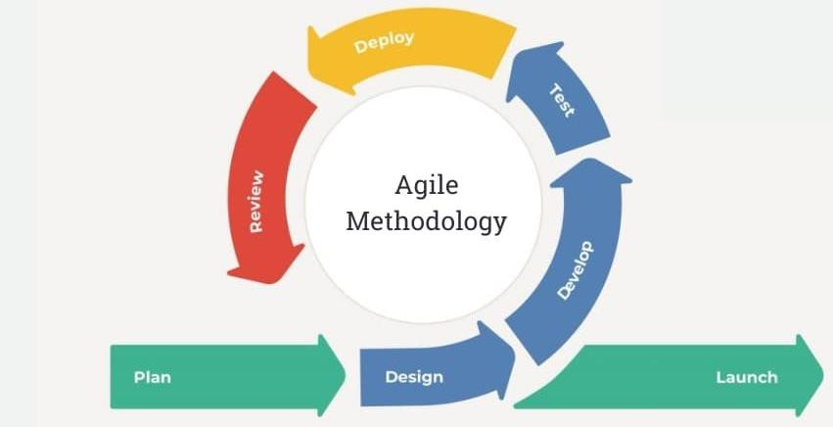

The Figure 9 illustrate the Agile methodology, specifically the scrum framework, which allows continuous testing, frequent feedback, and iterative sprints to create a workflow that is both flexible and organized. This method will be utilized in the construction phase of software development since this approach guarantee the delivery of high-quality, functioning components more quickly, continuous testing, frequent feedback, and incremental upgrades are given top priority. By promoting consistent stakeholder involvement throughout the development process, rapid adaptation to changing needs, and frequent communication among team members, this methodology—in particular, the Scrum framework—reduces overhead. Scrum, as a key Agile practice, organizes workflows into defined roles, time-boxed events, and clear deliverables, fostering both team efficiency and client satisfaction. As noted by Alsaedi (2020), Agile was introduced as a lightweight, dynamic solution to address the rigidity of earlier methodologies. Its adaptability and iterative nature make it ideal for projects that demand ongoing improvement and client collaboration (InterQuality, n.d.).

## Figure 10

*Rapid Application Development Methodology*

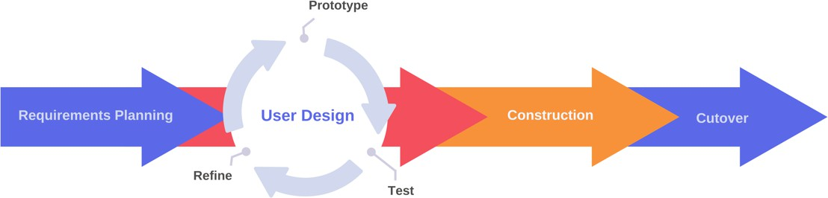

The Figure 10 shows the Rapid Application Development (RAD) which empathizes quick prototyping, active stakeholder involvement, and iterative development. It is highly beneficial for the development of ESSSS Centralized Document Management System with QR Code Technology. By using RAD, we will be able to rapidly build and test the prototypes of core features based on feedback from the user. This method ensures that the system aligned with actual user requirements, reducing rework, and improving overall satisfaction. As RAD encourages minimal planning and rapid iterations, it allows our developers to be more responsive to changes, which is essential for a system that integrates both physical and digital document management processes (Marc, 2023).

# REQUIREMENTS ANALYSIS

The researchers conducted requirement analysis to identify and understand the needs of the user and determine the system specifications necessary for the development process. This involved gathering detailed information directly from the client, allowing researchers to assess the specific types of data and functionalities required in the system. Additionally, the software and hardware components are evaluated to ensure that all technical requirements will be met effectively. The researchers also analyzed the types of information needed in the system to complete the requirements and to outline the centralized document management, retrieval, storage, and organization of documents. The requirements ensure that the system will be built to support efficient data management and enhance operational efficiency.

# REQUIREMENTS DOCUMENTATION

Requirement documentation is essential for ensuring the quality and functionality of the ESSSS Centralized Document Management System with QR Code Technology, it ensures if the system works properly and meets the quality standard through the two types of requirements which is functional and non- functional. Functional requirements describe the specific features, capabilities, and behaviors of the system which ensure the user needs and organization achieve its goals, while non-functional requirements specify how the system should perform. The following section presents the specific functional and non-functional requirements necessary for the development of the system.

# FUNCTIONAL REQUIREMENTS

## Input

* The system should capture project document information upon entry.
* The system should capture search parameters to retrieve specific project or document data.
* The system should record employee login credentials and login activities.
* The system should record all employee interactions with documents to maintain a detailed audit trail.

## Output

* The system should generate automated QR code labels for each document.
* The system should display the complete project or document information based on the search query of the user.
* The system should generate and provide audit trail reports accessible to the admin.
* The system should organize and display storage location information for each document.

## Process

* The system must provide a document release and return monitoring feature to track the movement of physical documents from storage.
* The system should authenticate employee credentials during the login process.
* The system should implement role-based access control, allowing employees to access only documents permitted by their assigned roles.
* The system should facilitate document retrieval through a search mechanism that allows users to locate specific project documents efficiently.
* The system must log and process all activities related to document handling for audit trail purposes.
* The system must synchronize digital and physical copies of documents, ensuring that both versions share the same QR code and are accessible through search.
* The system should enable cloud-based digital document access for users based on their permissions.
* The system must centralize the management, tracking, and access of both physical and digital project documents in a unified platform.

## Stored Data

* Project documents must be stored with integrated QR code labels that encapsulate essential document data.
* Project documents should be stored and organized according to their corresponding lot location.
* All document-related actions must be tracked and stored in chronological order by date and time.
* Documents should be securely stored with enforced access control measures based on user roles and permissions.

## Non-Functional Requirements PERFORMANCE

**Throughput**

* The user must be able to retrieve a specific physical project document within 3 minutes.
* The user must be able to instantly retrieve a specific digital project document upon search.
* The system must generate and display the QR code label of a newly stored document within 1 minute after saving.
* The system must update the audit trail record immediately after any document retrieval, return, or modification action is performed.

## Response Time

* The system must immediately send a notification to the user account associated with the document when another user requests access to it.
* The system must instantly reflect the availability status of a document during search operations, showing if it is currently checked out or held by another user.

# INFORMATION

## Input

* The system must capture and securely handle document data during file retrieval
* The system must capture employee login credentials securely during file retrieval processes.
* The system must capture searched keywords and searched QR code during document retrieval
* The system must record timestamped entries each time a document is accessed, retrieved, updated, or restored.

## Output

* The system must generate an audit trail report whenever requested by the admin
* The system must automate file QR code labeling during document upload operations.
* The system must display complete project or document information after a successful search.
* The system must immediately update all linked records whenever changes are made to project documents.
* The system must display only the document name and file number when scanned by other device.

## Stored Data

* The system must securely store all document access records with chronological sorting.
* The system must encrypt stored employee credentials and sensitive document information.
* The system must ensure that physical document metadata is synchronized with digital document metadata.

# ECONOMY

* The system must eliminate material costs related to reproducing lost or misplaced documents.
* The system should achieve an estimated savings of at least ₱3,000 annually by minimizing document loss incidents.
* The system must be fully developed, tested, and deployed within 1 year and 5 months.

# CONTROL

* The system must include the login authentication before allowing any document access.
* The system must apply role-based access control, ensuring users can only access documents appropriate to their roles.
* The system must protect sensitive document data without requiring additional special handling.
* The system must record any unauthorized access attempts and notify administrators.
* The system must encrypt QR code data such that only the document name and file number are visible when scanned by other device.

# EFFICIENCY

* The system must avoid redundant storage of documents across multiple computers and physical envelopes.
* The system must optimize document retrieval processes to minimize unnecessary searches and reduce storage duplication.
* The system must efficiently log the document status using the QR code scanning feature.
* The system must allow efficient document search using the QR code, ensuring quick access to project data by scanning the QR code.

# SERVICE

* The system must support different types of users, including Researchers, CAD Operators, and Secretaries, with the Chief Operating Officer (COO) acting as the admin.
* The system must distinguish administrative and authorized user user roles clearly.
* The system must provide efficient and consistent user interface which easy for all users to navigate.
* The system must include a comprehensive user manual and administrator guide for troubleshooting and operations.

# SYSTEM DESIGN

## User Story

The user story diagram defines the specific tasks and goals of every category of user in the Document Management System. It provides an insight into what the users must achieve and directs the development team towards creating features that aid them in achieving that.

## Figure 11

*User Login Feature*

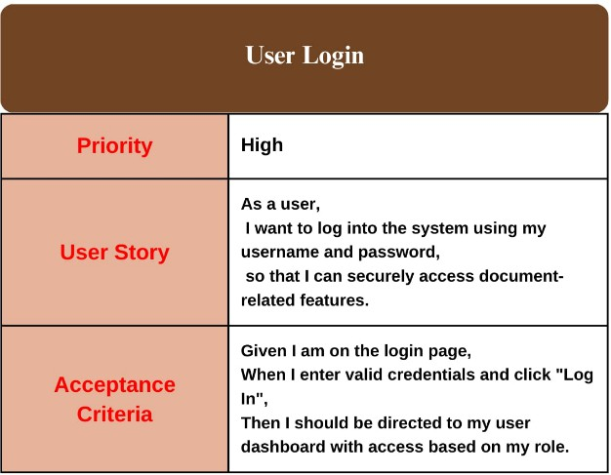

This table outlines the user story for the login feature of the system. It highlights the high-priority need for users to securely access their dashboards

using valid credentials, ensuring role-based access control to document-related functions.

## Figure 12

*User Logout Feature*

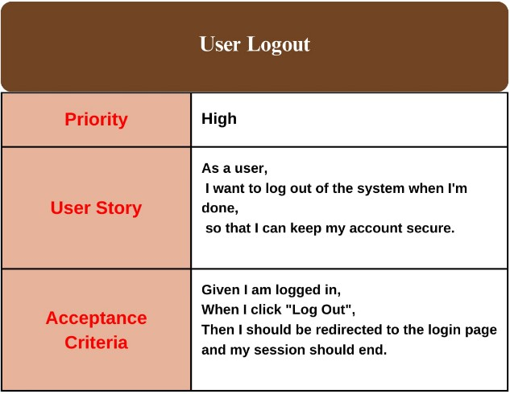

This table shows the user story for logging out of the system. It explains that users should be able to log out safely and be taken back to the login page when they are done.

## Figure 13

*Store Document Feature*

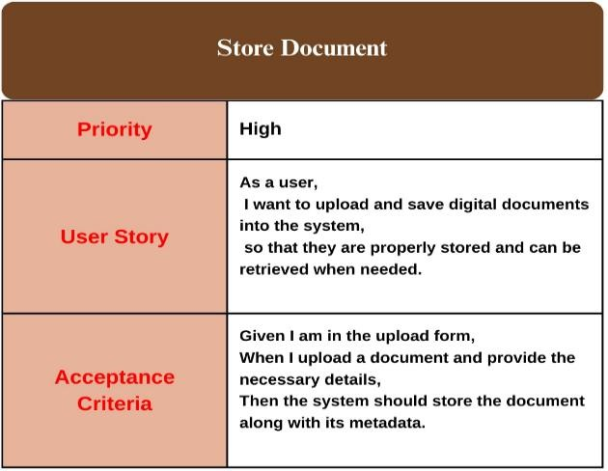

This table explains the user story for storing documents in the system. It shows that users should be able to upload files with details so they can be saved and retrieve when needed.

## Figure 14

*Retrieve Document Feature*

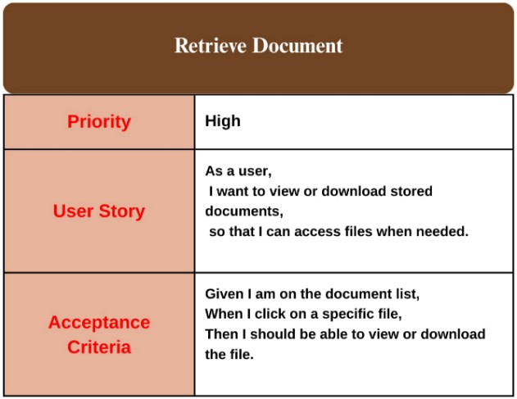

This table describes how users can retrieve saved documents. It allows them to view or download files by clicking on them from the list.

## Figure 15

*Search Document Using QR code Feature*

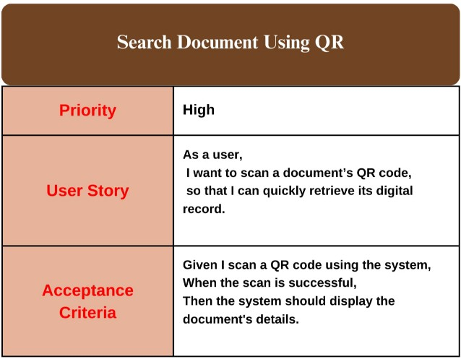

This table describes the user story for searching a document using a QR code. It allows users to quickly find a document by scanning its QR code, which shows the details of the file.

## Figure 16

*Manage Document Feature*

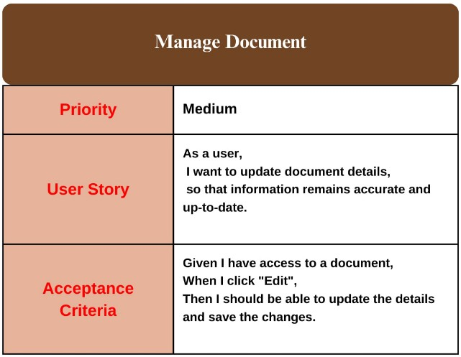

This table describes the user story for managing document details. It allows users to update document information to ensure it remains accurate and up to date.

## Figure 17

*Track Document Activity Feature*

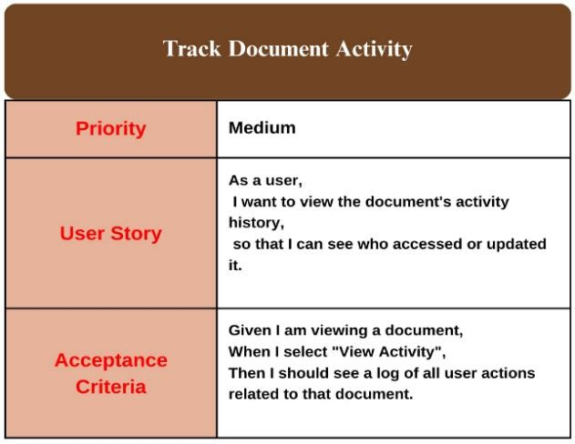

This table describes the user story for tracking document activity. It allows users to view a log of all actions taken on a document, including who accessed or updated it.

## Figure 18

*Search Using Document Metadata Feature*

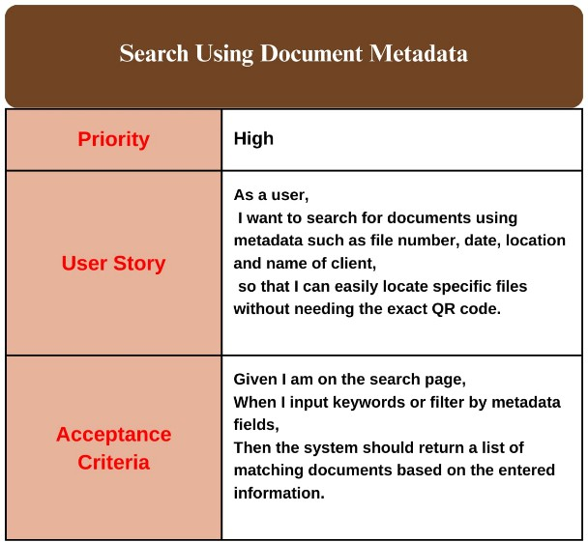

This table describes the user story for searching documents using metadata. It allows users to find specific files by entering details like file number, date, location, or client name without needing the exact QR code.

## Figure 19

*Generate QR Code Feature*

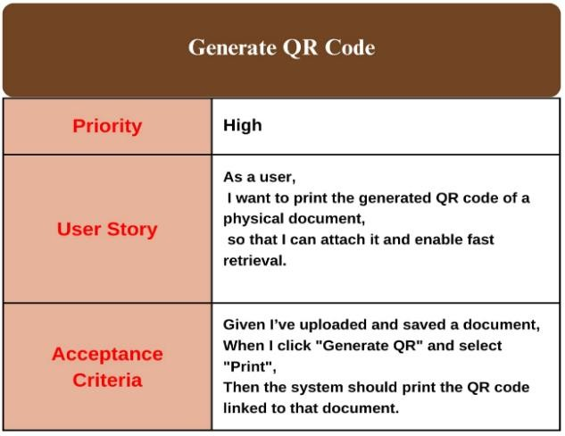

This table describes the user story for generating and printing a QR code for a document. It allows users to generate a QR code for a saved document and print it for easy attachment and quick retrieval.

## Figure 20

*Admin Logout Feature*

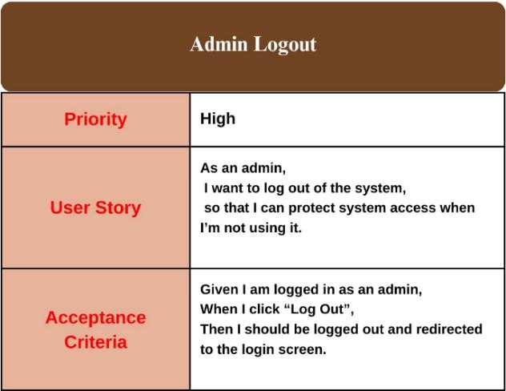

This table describes the user story for admin logout. It allows the admin to securely exit the system and return to the login screen to protect system access.

## Figure 21

*Admin Login Feature*

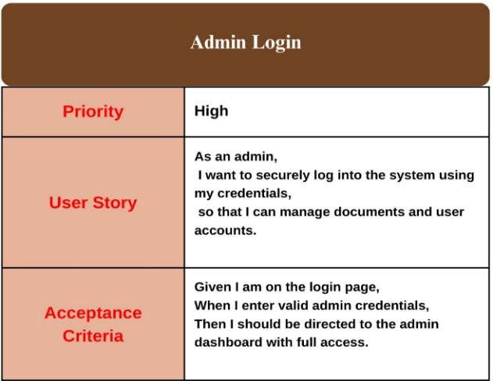

This table describes the user story for admin login. It allows the admin to securely access the system using credentials and manage documents and user accounts.

## Figure 22

*Manage Document Feature*

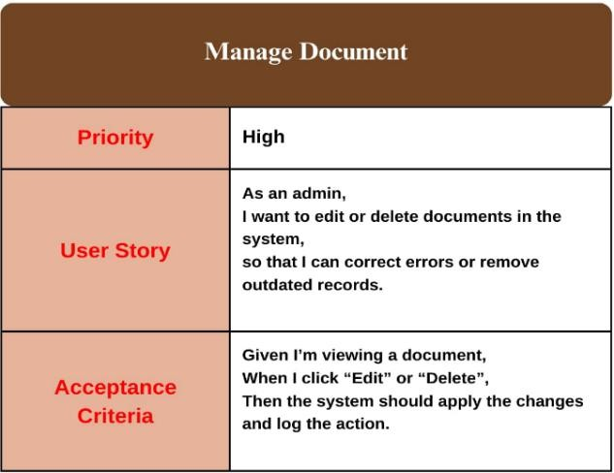

This table describes the user story for managing documents as an admin. It allows the admin to edit or delete documents to maintain accurate and up-to- date records.

## Figure 23

*Search Document Using QR Code Feature*

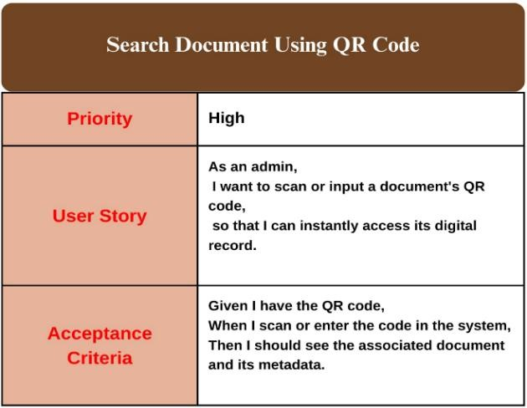

This table describes the user story for searching a document using a QR code. It allows the admin to quickly access the digital record of the document by scanning or entering its QR code.

## Figure 24

*Store Documents includes QR Generation Feature*

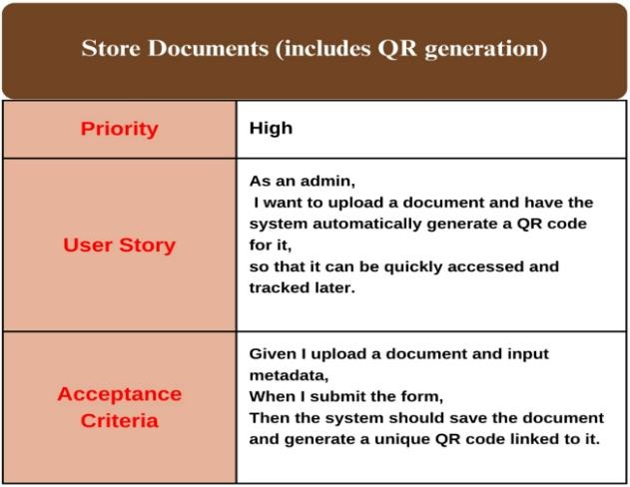

This table describes the user story for storing documents with automatic QR code generation. It allows the admin to upload a document, save its metadata, and generate a QR code for easy access and tracking.

## Figure 25

*Retrieve Document Feature*

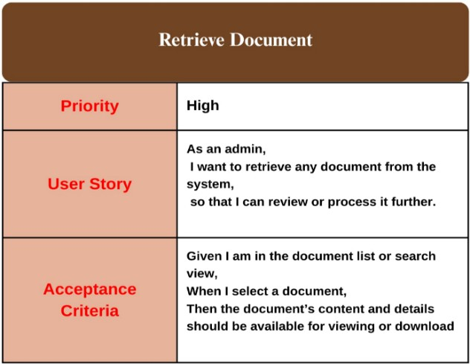

This table describes the user story for retrieving documents from the system. It allows the admin to view or download any stored document for review or further processing.

## Figure 26

*Track Document Activity Feature*

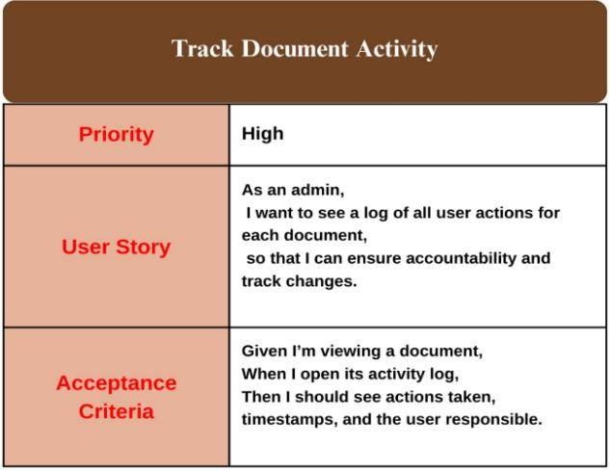

This table describes the user story for tracking document activity as an admin. It allows the admin to view a log of actions, including who made changes and when, to ensure accountability.

## Figure 27

*Manage User Accounts Feature*

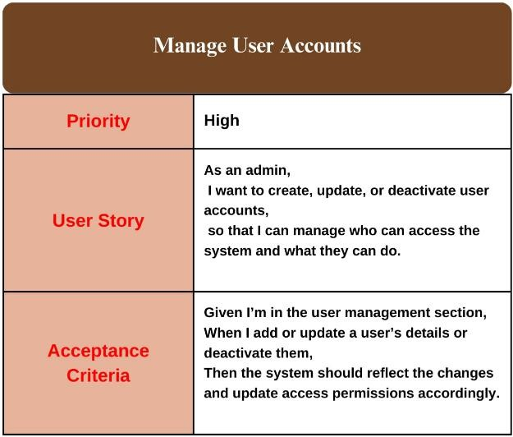

This table describes the user story for managing user accounts. It allows the admin to create, update, or deactivate accounts to control system access and permissions.

## Figure 28

*Receive Document Activity Notification Feature*

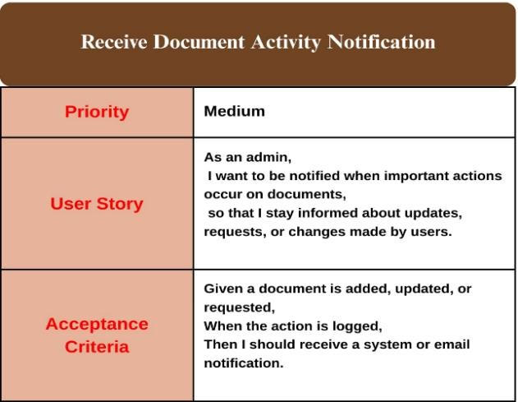

This table describes the user story for receiving document activity notifications. It allows the admin to stay informed through alerts when users add, update, or request documents.

## Figure 29

*Search Using Document Metadata Feature*

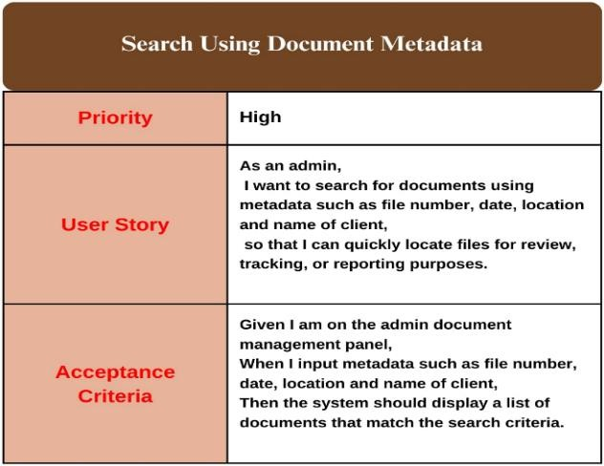

This table describes the user story for searching documents using metadata. It allows the admin to quickly locate specific files by filtering them based on metadata like file number, date, location, and client name for review, tracking, or reporting.

## Figure 30

*User Story* — *Generate Audit Trail Report Feature*

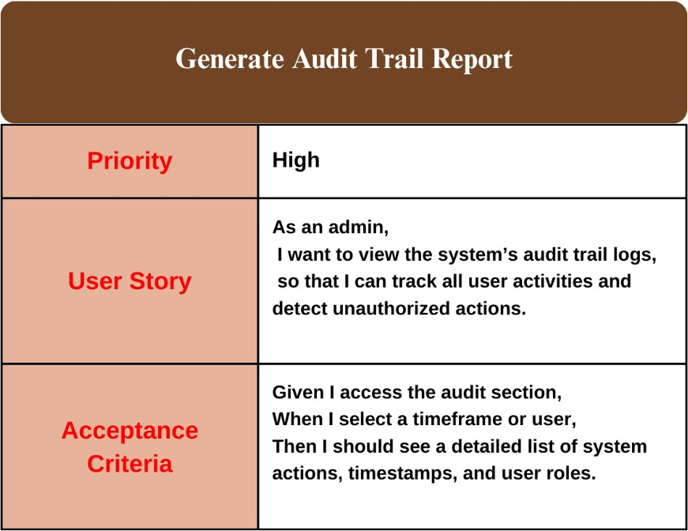

This table describes the user story for accessing the audit trail. It allows the admin to track user activities by viewing detailed logs, including timestamps and user roles, to detect unauthorized actions.

## Figure 31

*Use Case Diagram*

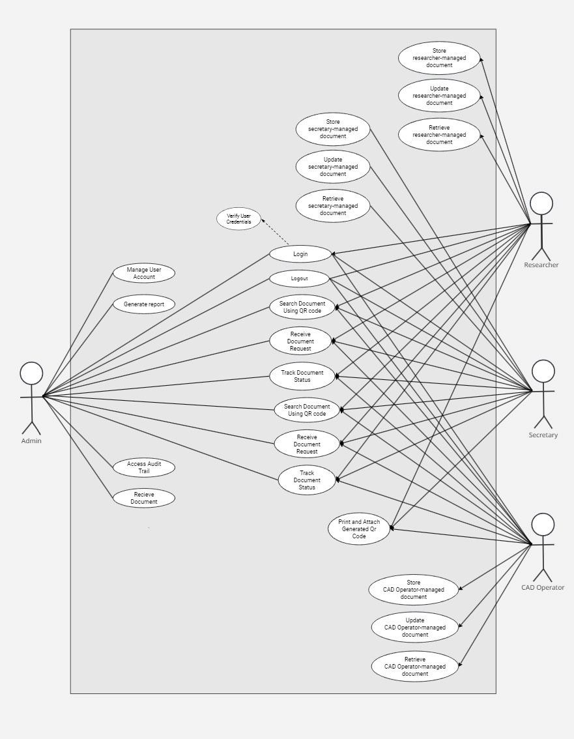

The Figure 31 illustrate the use case diagram which shows the core functional interactions within the ESSSS Centralized Document Management System with QR Code Technology. It outlines the roles of the Chief Operating Officer (COO) as the system administrator, and the Secretary, CAD Operator, and Researcher as system users. Each user accesses role-specific functions for storing, updating, and retrieving documents, while also sharing common tasks

such as logging in, searching documents via QR code, tracking document status, and handling requests. The diagram emphasizes role-based access and collaborative document handling, ensuring a secure and efficient system workflow. **Figure 32**

*Hierarchical Diagram*

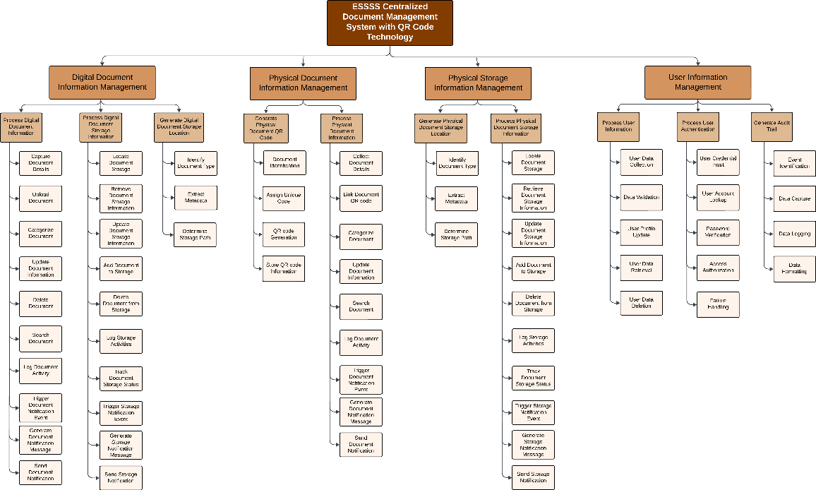

The Figure 32 illustrate the hierarchical diagram which shows the major functional components of the ESSSS Centralized Document Management System with QR Code Technology. It is divided into four main modules: Digital Document Information Management, Physical Document Information Management, Physical Storage Information Management, and User Information Management. Each module is broken down into specific processes to handle document capturing,

categorization, storage, user authentication, and audit trail generation, ensuring a streamlined and organized system workflow.

## Figure 33

*Context Data Flow Diagram*

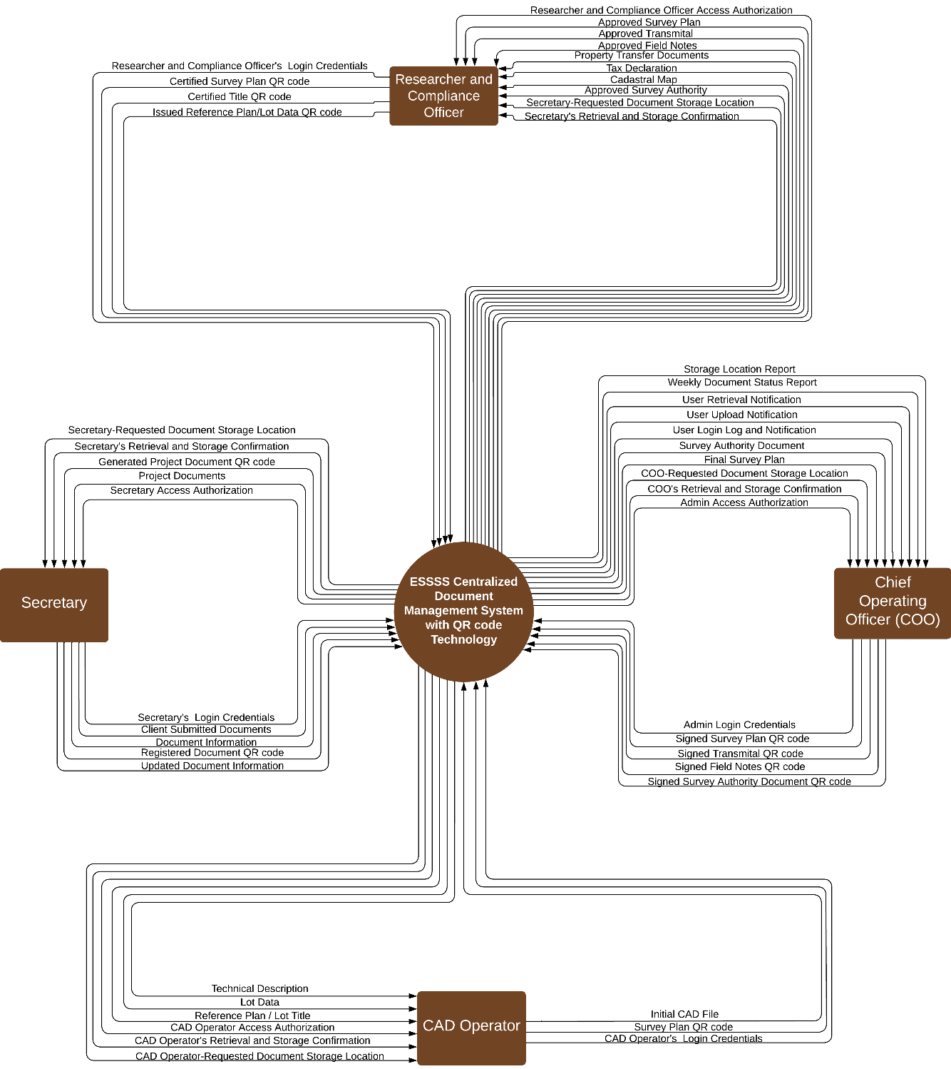

The Figure 33 shows the context data flow diagram which presents an overview of how information moves within the ESSSS Centralized Document Management System with QR Code Technology. It shows the interaction between

external entities such as the Research and Compliance Officer, Secretary, Chief Operating Officer (COO), and CAD Operator with the centralized system. The diagram outlines the processes of document handling, user authentication, and information retrieval, highlighting the inputs, outputs, and storage activities that ensure efficient document and user data management.

## Figure 34

*Event Diagram*

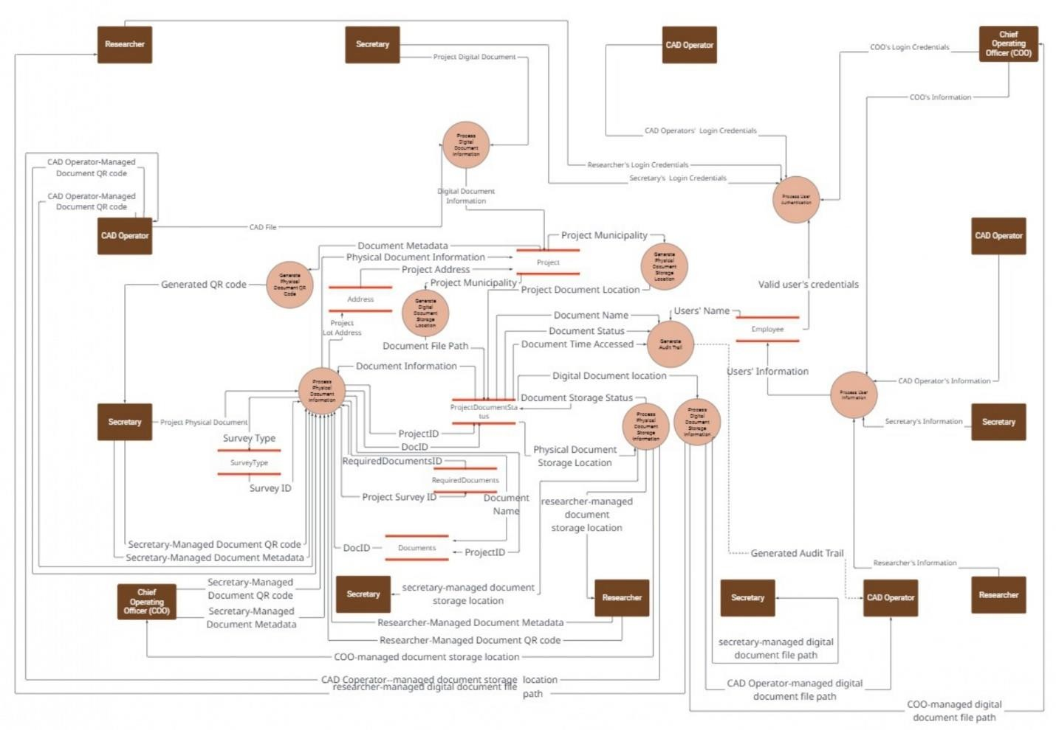

The Figure 34 illustrates the flow of document-related events within the ESSSS Centralized Document Management System with QR Code Technology. It highlights how various roles—such as the Secretary, CAD Operator, Researcher, and Chief Operating Officer—interact with system processes. Each event is

triggered by a user activity or system function, ensuring accurate tracking of document metadata, file paths, access logs, and storage statuses. Central to the diagram are the data stores, represented by parallel lines, which include repositories for project document information, physical and digital document storage locations, document metadata, user information, and audit trails. The diagram ensures traceability and security by integrating audit trail generation for every access and update made to both digital and physical documents.

## Graphical User Interface Figure 35

*Admin Dashboard*

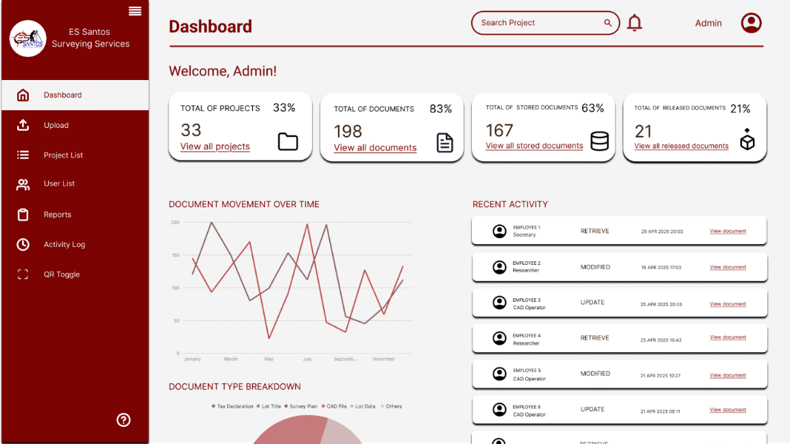

The Figure 35 Admin Dashboard illustrate the key features of ESSSS Centralized Document Management System with QR Code Technology. It will serve as the central interface for administrators,

organized into key functional areas such as document upload, project list, user list, reports, activity log, and QR scan. Administrators will be able to access each section, enabling them to efficiently track user actions and monitor document modifications, ensuring effective system oversight and management.

## Figure 36

*User Dashboard*

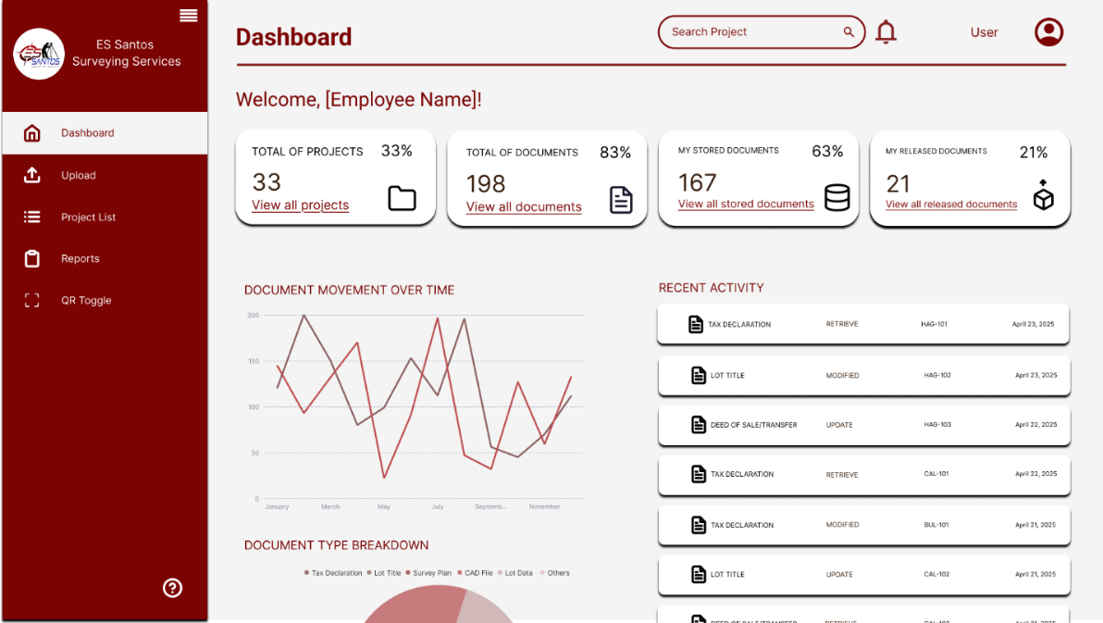

The Figure 36 User Dashboard illustrate the key features of ESSSS Centralized Document Management System with QR Code Technology. It will outline the roles of the Secretary, CAD Operator, and Researcher as system users. Each user will have access to and navigate specific functions such as uploading documents, updating projects, generating reports, and scanning QR codes. The Dashboard Overview will display a summary of document progress and recent activity, allowing users to track their latest

document-related actions—ensuring easy monitoring, faster retrieval, and efficient storage of documents.

## Figure 37

*Upload Page*

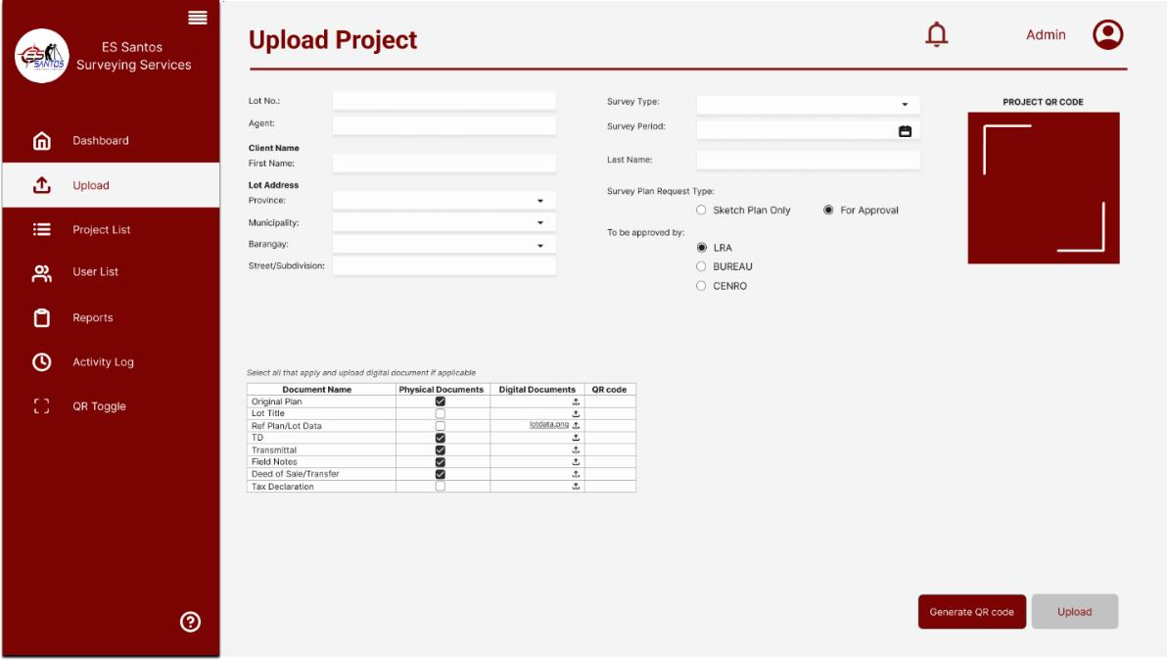

The Figure 37 Upload Page illustrate a key feature of ESSSS Centralized Document Management System with QR Code Technology. It will outline the process for both users and administrators to upload projects into the system, helping to track, monitor, and view documents. Users and administrators will be required to fill out a form with necessary document details such as Lot Number, Survey Type, Survey Period, Agent, Client Name, Lot Address, and Survey Plan Request Type, along with selecting the digital file to upload if available. Additionally, the system will generate a unique QR code for each project, as well as for each document within the

project, enabling quick retrieval and identification of files once the Project QR Code is scanner.

## Figure 38

*Project List*

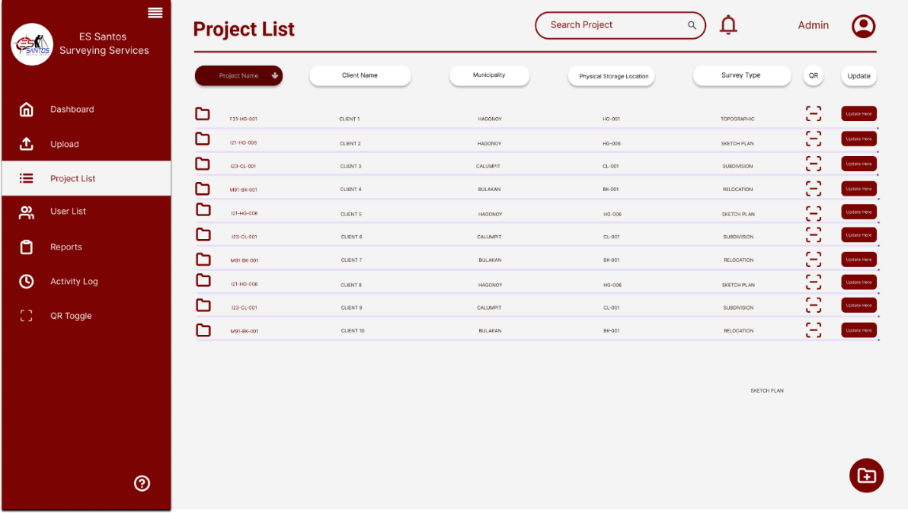

The Figure 38 Project List interface, illustrate a key feature of ESSSS Centralized Document Management System with QR Code Technology. It will serve as a central hub for both administrators and users to navigate through documents stored in the system. Users and administrators will be able to view, track, and manage project-related files from this interface. Additionally, they will have the ability to update existing projects if any documents or information needs to be modified, ensuring seamless document management and project oversight.

## Figure 39

*QR Search*

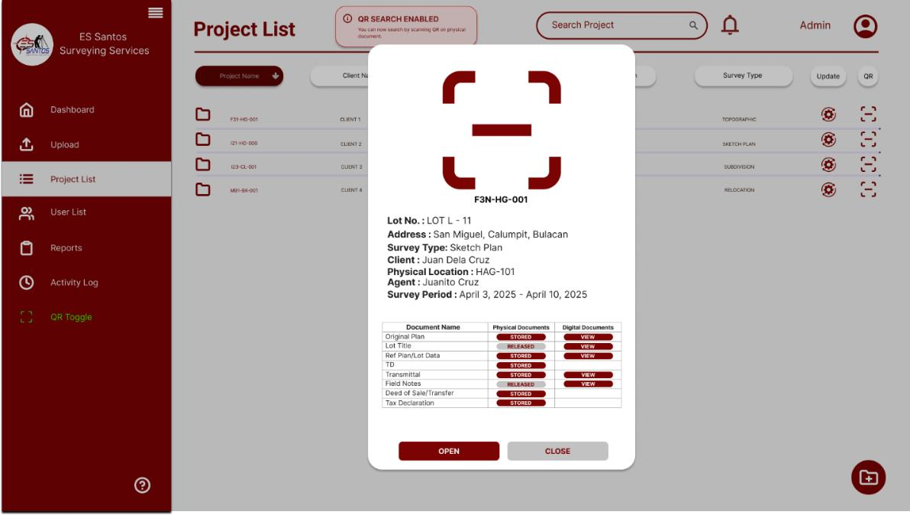

The Figure 39 QR Code Access interface illustrate one of the key features of ESSSS Centralized Document Management System with QR Code Technology. It will display project-related information when a project is accessed via QR code, allowing both users and administrators to view and, if necessary, make modifications. An alert will appear at the top of the screen to indicate that QR code search is currently enabled. Additionally, the QR toggle in the sidebar will turn green when this feature is active, ensuring quick access and streamlined navigation.

## Figure 40

*Entity Relationship Diagram*

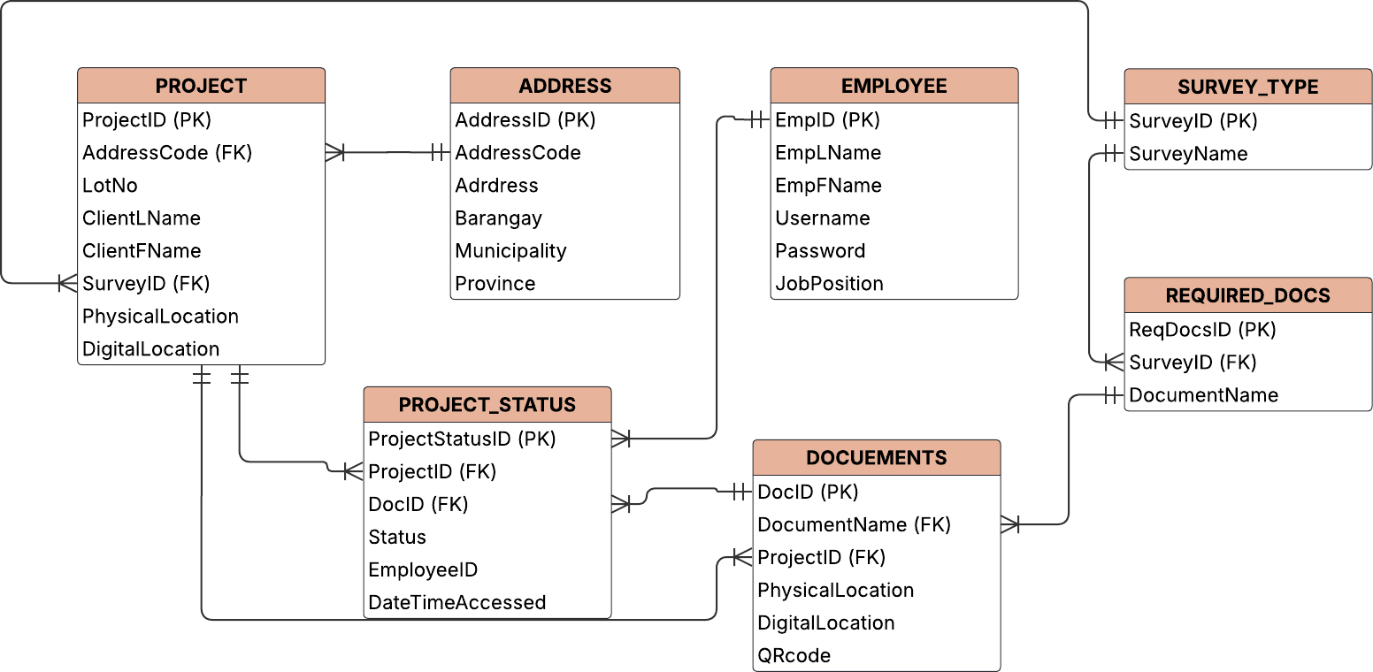

The Figure 40 entity-relationship diagram (ERD) illustrates the structure of the database for the ESSSS Centralized Document Management System with QR Code Technology. It highlights the key entities: Project, Address, Employee, Survey Type, Required Documents, Project Status, and Documents, along with their attributes and relationships. The diagram shows how projects are linked to addresses and survey types, how documents are associated with projects and employees, and how required documents depend on specific survey types. This structure ensures efficient organization, tracking, and management of document and project data.

# DEVELOPMENT AND TESTING

## Development Phase

The ESSSS Centralized Document Management System with QR Code Technology will also be developed as a web-based application to improve accessibility and flexibility. The web version will allow the company to access, manage, and scan documents through browsers installed on laptops and desktop computers. The development will utilize HTML, CSS, and JavaScript for the front end, while PHP will serve as the server-side scripting language. MySQL database will be use as the storage for document metadata. The technologies were selected for the company wide adoption, compatibility, and ease of deployment. HTML, CSS, and JavaScript provide responsive and dynamic user interfaces, while PHP ensures smooth server-side processing. MySQL offers a robust and scalable solution for data management. The QR code libraries chosen allow easy integration of real-time scanning features within the browser, without needing additional software.

Each device using the system should have at least an Intel Core i3 (10th Gen or newer) or AMD Ryzen 3 processor, 4GB RAM, and a 128GB SSD. It also needs a modern browser (e.g., Chrome or Firefox) and a stable internet connection are required. Office desktops and laptops will use QR code scanners, while laptops can use their built-in webcams for QR code scanning directly through the web application.

## System Testing

The proposed system ensure the quality and reliability through conducting system testing following the Software Testing Life Cycle (STLC). This a step-by-step process that defines a series of phases in testing activities, including requirement analysis, test planning, test case development, environment setup, test execution, and test closure. Following the STLC helps ensure that testing is systematic, repeatable, and transparent testing process. It allows the team to identify defects early, improves system stability, and ensures the system meets both business requirements and user expectations. The team will perform the following:

**User Acceptance Testing**. Once basic functions worked, user acceptance testing was conducted with some end-users, specifically administrative personnel who would have daily use of the system. By having direct access to the system, the researchers could receive feedback regarding whether the system would meet the expectations and requirements of the user.

**Unit Testing**. Having validated the overall behavior, unit testing was done for individual modules. Every component of the system, such as the QR code generator, file uploader, login authenticator, and document search function—was tested independently to ensure it worked properly on its own. This enabled the researchers to catch and correct minute mistakes at the module level prior to integrating them into a complete system.

**Integration Testing**. After each unit had been tested, integration testing was done to analyze how these modules worked together when connected. This involved testing if uploading a document automatically initiated the generation of a QR code, if the QR code correctly referenced the document in the search system, and if user role constraints were being observed across modules.

**Regression Testing**. While introducing fixes and feature improvements, regression testing was continuously done to ensure that existing functionality was not affected. This process was very important to keep the system stable, particularly when changes were made to enhance performance or add new features. It ensured that earlier development continued to work fine even though there were modifications in the system.

**Black Box Testing**. It was also used by the researchers to mimic the user experience without considering internal code. By assuming the system as a closed box, the testers interacted with the interface to ensure inputs like file uploads and search queries produced expected and correct outputs. This helped in ensuring that the system reacted properly to various user actions.

**White Box Testing**. Lastly, white box testing was conducted to analyze the inner logic and framework of the code. Developers reviewed logic flows, condition management, and loop constructs to ensure that the processing mechanisms of the system were efficient, precise, and secure.

This phase made sure that, aside from the interface, the system functioned properly from the inside out.

# IMPLEMENTATION PLAN

The deployment of the ESSSS Centralized Document Management System with QR Code Technology will be carried out in a carefully structured and phased approach to ensure seamless integration while minimizing disruptions to daily operations. A detailed schedule has been devised to guarantee that each step is executed without affecting the workflow of the company

The pre-implementation phase will span the first week, during which the necessary hardware and software will be acquired and configured. This includes the installation of software and libraries, which are integral to the operation of the system. Existing documents will also be transitioned during this stage, where a sample set is initially tested for compatibility with the new system. To reduce any disruptions, system downtime will be planned at off-peak hours to enable the IT team to perform initial configurations without disrupting business processes. Also, during this time, the system will be installed on a dedicated computer, and user accounts and access levels will be established based on the organizational chart of the company. Particular care will be taken to set up strong security measures to safeguard sensitive information. To further reduce disruption, the system will be rolled out in phases, beginning with departments that have less direct effect on core operations. This makes it possible to closely observe the

transition to the new system and make any slight changes before the entire system is up and running.

Once the system is deployed, training will begin. This will be an intensive week of intense training for all users, which will be conducted through workshops and detailed manuals. The training will be conducted outside regular working hours so that employees can attend without interfering with their usual duties. Aside from educating the end users, the IT support staff will also have the skills required to offer continuous technical support to enable smooth system functionality. The management team will similarly undergo training in how to manage system processes and troubleshoot frequent problems.

Following the pre-implementation and training, the implementation process will be initiated. In the implementation phase, the functionality of the system will be adhered to rigidly so that everything goes as intended. A technical support group will be in place to deal with any technical issues or faults in a timely manner. To facilitate continuous improvement and flexibility, a feedback mechanism will be in place where employees can express their experience of the system. Such permit necessitated fine-tuning and tweaks to be accomplished, further refining the user experience without disrupting business continuity.

By closely planning the implementation process, we will strive to provide the ESSSS Centralized Document Management System with QR Code Technology a seamless transition into operational usage, causing no more than necessary disruption to the business and creating maximum end-user adoption. Not only will

the system improve document management, it will also secure and make it more accessible, adding to the future success and efficiency of the company.

# REFERENCE

Mejidana, M. K. L. &. M. (2023, April 11). SDLC Methodology 101: A Beginner’s Guide to Rapid Application Development (RAD). *Medium*. [https://medium.com/@myelmarc/sdlc-methodology-101-a-beginners-](https://medium.com/%40myelmarc/sdlc-methodology-101-a-beginners-guide-to-rapid-application-development-rad-492ab88de7ef)

[guide-to-rapid-application-development-rad-492ab88de7ef](https://medium.com/%40myelmarc/sdlc-methodology-101-a-beginners-guide-to-rapid-application-development-rad-492ab88de7ef)

InterQuality. (n.d.). *Agile Methodology*. Retrieved from [https://interqualitybg.com/en/resources/scrum-and-agile-resources/agile-](https://interqualitybg.com/en/resources/scrum-and-agile-resources/agile-methodology)

[methodology](https://interqualitybg.com/en/resources/scrum-and-agile-resources/agile-methodology)

# REFERENCE:

Agarwal, T. (2020, February 5). Network Technology: different types, Advantages and disadvantages. ElProCus - Electronic Projects for Engineering Students. https://[www.elprocus.com/what-is-a-network-technology-types-](http://www.elprocus.com/what-is-a-network-technology-types-) advantages-disadvantages/

Aiim. (n.d.). What is Document Management (DMS)? [https://www.aiim.org/what-](https://www.aiim.org/what-is-document-imaging) [is-document-imaging](https://www.aiim.org/what-is-document-imaging)

Archive One (2024). Managing Documents for Businesses: Document Management System Best Practices. Archive One. https://archive- one.net/blogs/document-management-best-practices

By need DMS. (n.d.). Ricoh. https:/[/www.ricoh.com.ph/campaigns/by-need-dms](http://www.ricoh.com.ph/campaigns/by-need-dms) Camteli, A. (2024). Document Management and Version Control with QR Codes |

OpenKM. OpenKM. https:/[/www.openkm.com/blog/document-](http://www.openkm.com/blog/document-) management-and-version-control-with-qr-codes.html

Consentia LLC. (2023, January 24). Boost efficiency and security with digital document management. Consentia. https://consentia.com/how-digital- document-management-can-help-improve-efficiency-and-security/

Courtaway, K. (2024, November 22). Centralized Data Storage System: How Your Business Can Benefit? *DataProfit*. https://www.data- profit.com/blog/centralized-data-storage-system-how-your-business-can- benefit

Dhiway Networks Private Limited. (2021, December 1). A definitive guide to QR code. Dhiway. https://dhiway.com/a-definitive-guide-to-qr-code/

Glöckner S. (2022). Archiving | Definition, facts, and challenges. Portal Systems. https:/[/www.portalsystems.de/en/wiki/archiving/](http://www.portalsystems.de/en/wiki/archiving/)

Gumban, RJ. (2023). The Complete Guide to Document Life Cycle*.* UNAWA. https://unawa.asia/blog/document-management-10/complete-guide- document-life-cycle-9

Harry, & Harry. (2025). Best practices for managing, archiving, and storing documents. Restore Information Management. https:/[/www.restore.co.uk/informationmanagement/resource-](http://www.restore.co.uk/informationmanagement/resource-) hub/insights/news/document-management-archiving-and-storage-best- practices/

Hayes, A. (2025, March 5). Quick Response (QR) code: definition and how QR codes work. Investopedia. https:/[/www.investopedia.com/terms/q/quick-](http://www.investopedia.com/terms/q/quick-) response-qr-code.asp

Hyland. (n.d.). What is Document Management <https://www.hyland.com/en/resources/terminology/document-management>

Ilocos Sur Polytechnic State College. (n.d.). DAWA | ILOCOS sur Polytechnic State College. https://ispsc.edu.ph/research/e-dawa/

Knowmax. (2025, January 28). Document Management System: definition, tools, and features. [https://knowmax.ai/document-management-syste](https://knowmax.ai/document-management-system)

Laatre, M. (2024). Best Document Management Practices 2024. Folderit.

https:/[/www.folderit.com/blog/best-document-management-practices-](http://www.folderit.com/blog/best-document-management-practices-) 2024/

Mahraz, M.-I. et al. (2019)*.* A Systematic literature review of Digital Transformation*.* https://ieomsociety.org/toronto2019/papers/236.pdf

MESHDS (2024). The Impact of Document Archiving on Data Security: A Comprehensive Analysis. [https://blog.mesltd.ca/the-impact-of-document-](https://blog.mesltd.ca/the-impact-of-document-archiving-on-data-security-a-comprehensive-analysis) [archiving-on-data-security-a-comprehensive-analysis](https://blog.mesltd.ca/the-impact-of-document-archiving-on-data-security-a-comprehensive-analysis)

Richartz, T. (2024). Access control in document management systems (DMS). Assai Software. [https://assai-software.com/access-control-in-document-](https://assai-software.com/access-control-in-document-management-systems-dms/) [management-systems-dms/](https://assai-software.com/access-control-in-document-management-systems-dms/)

Sargiotis D. (2024). Data security and privacy: Protecting sensitive information. In Data governance (pp. 217–245). Springer. [https://doi.org/10.1007/978-3-](https://doi.org/10.1007/978-3-031-67268-2_6) [031-67268-2_6](https://doi.org/10.1007/978-3-031-67268-2_6)

Vicente, V. (2024). What is an audit trail? Everything you need to know.

AuditBoard. https://[www.auditboard.com/blog/what-is-an-audit-trail/](http://www.auditboard.com/blog/what-is-an-audit-trail/)

User. (2024, December 16). Indexing Technology: Understanding its impact. Next Business Media. https://nextbusinessmedia.com/indexing-technology-its- impact/

Archive One Document Management System | Imaging Services Philippines. (n.d.). <https://archive-one.net/blogs/document-validation-using-qrcodes>

OpenKM. (2024). Document Management and Version Control with QR Codes | OpenKM. OpenKM. [https://www.openkm.com/blog/document](https://www.openkm.com/blog/document-management-and-version-control-with-qr-codes.html) [management-and-version-control-with-qr-codes.html](https://www.openkm.com/blog/document-management-and-version-control-with-qr-codes.html)

QandleBlog. (2024). 10 Top Document Management System Software. The Qandle Blog. [https://www.qandle.com/blog/10-top-document-](https://www.qandle.com/blog/10-top-document-management-system-software/) [management-system-software/](https://www.qandle.com/blog/10-top-document-management-system-software/)

The Asia Foundation. (2020). Philippine courts go paperless. The Asia Foundation. <https://asiafoundation.org/philippine-courts-go-paperless/>

The UP Document Tracking System (DTS) | University of the Philippines Information Technology Development Center. (2022.). <https://itdc.up.edu.ph/news/the-up-document-tracking-system-dts>

Document Management System -. (2022). [https://vastresult.com/document-](https://vastresult.com/document-management-system/) [management-system/](https://vastresult.com/document-management-system/)

File Management System. (2024.). [https://www.ruddersoft.com/blog/1042-file-](https://www.ruddersoft.com/blog/1042-file-management-system-tracking-file-document-with-rfid-qr-code) [management-system-tracking-file-document-with-rfid-qr-code](https://www.ruddersoft.com/blog/1042-file-management-system-tracking-file-document-with-rfid-qr-code)

Ritz, J. (2024, December 17). QR code Inventory Management: Simplify and streamline your asset tracking. Timly Software. [https://timly.com/en/qr-](https://timly.com/en/qr-code-inventory-management/?fbclid=IwZXh0bgNhZW0CMTAAAR7xMLIClKSclcjEUE0S-fv8hUxOKa0t06hpsED2qn6vXV5_su0lL0G4NkVEyw_aem_Oi-dloftGMf6mcOHt4Mxdw) [code-inventory-](https://timly.com/en/qr-code-inventory-management/?fbclid=IwZXh0bgNhZW0CMTAAAR7xMLIClKSclcjEUE0S-fv8hUxOKa0t06hpsED2qn6vXV5_su0lL0G4NkVEyw_aem_Oi-dloftGMf6mcOHt4Mxdw) [management/?fbclid=IwZXh0bgNhZW0CMTAAAR7xMLIClKSclcjEUE0S-](https://timly.com/en/qr-code-inventory-management/?fbclid=IwZXh0bgNhZW0CMTAAAR7xMLIClKSclcjEUE0S-fv8hUxOKa0t06hpsED2qn6vXV5_su0lL0G4NkVEyw_aem_Oi-dloftGMf6mcOHt4Mxdw) [fv8hUxOKa0t06hpsED2qn6vXV5_su0lL0G4NkVEyw_aem_Oi-](https://timly.com/en/qr-code-inventory-management/?fbclid=IwZXh0bgNhZW0CMTAAAR7xMLIClKSclcjEUE0S-fv8hUxOKa0t06hpsED2qn6vXV5_su0lL0G4NkVEyw_aem_Oi-dloftGMf6mcOHt4Mxdw) [dloftGMf6mcOHt4Mxdw](https://timly.com/en/qr-code-inventory-management/?fbclid=IwZXh0bgNhZW0CMTAAAR7xMLIClKSclcjEUE0S-fv8hUxOKa0t06hpsED2qn6vXV5_su0lL0G4NkVEyw_aem_Oi-dloftGMf6mcOHt4Mxdw)

Folderit Ltd. (2023, November 12). White-label Single-Tenant Document Management System Software - Document Management System Folderit. Document Management System Folderit. [https://www.folderit.com/white-](https://www.folderit.com/white-label-document-management-system-software/?gad_source=1&gclid=CjwKCAjwktO_BhBrEiwAV70jXhHtnQLkODiCpkgQlBrBckFT2jS-2oZV9_NxR8HXxbD8vJmpoVYYnBoC9dUQAvD_BwE) [label-document-management-system-](https://www.folderit.com/white-label-document-management-system-software/?gad_source=1&gclid=CjwKCAjwktO_BhBrEiwAV70jXhHtnQLkODiCpkgQlBrBckFT2jS-2oZV9_NxR8HXxbD8vJmpoVYYnBoC9dUQAvD_BwE) [software/?gad_source=1&gclid=CjwKCAjwktO_BhBrEiwAV70jXhHtnQLkO](https://www.folderit.com/white-label-document-management-system-software/?gad_source=1&gclid=CjwKCAjwktO_BhBrEiwAV70jXhHtnQLkODiCpkgQlBrBckFT2jS-2oZV9_NxR8HXxbD8vJmpoVYYnBoC9dUQAvD_BwE)

[DiCpkgQlBrBckFT2jS-](https://www.folderit.com/white-label-document-management-system-software/?gad_source=1&gclid=CjwKCAjwktO_BhBrEiwAV70jXhHtnQLkODiCpkgQlBrBckFT2jS-2oZV9_NxR8HXxbD8vJmpoVYYnBoC9dUQAvD_BwE) [2oZV9_NxR8HXxbD8vJmpoVYYnBoC9dUQAvD_BwE](https://www.folderit.com/white-label-document-management-system-software/?gad_source=1&gclid=CjwKCAjwktO_BhBrEiwAV70jXhHtnQLkODiCpkgQlBrBckFT2jS-2oZV9_NxR8HXxbD8vJmpoVYYnBoC9dUQAvD_BwE)

SIMPEL. (2025, January 22). QR Docs | SIMPEL Construction Management Software. Project Simpel. <https://www.projectsimpel.com/qr-docs/>

# REFERENCE:

Ahn, J., Jung, Y., Smith, S., & Varzavand, S. (2018b). QR-Code implementation to reduce unnecessary procedures in material handling. *Construction Research Congress 2022*, 642–650. https://doi.org/10.1061/9780784481264.063

Ismael, A., & Okumus, I. (2017). Design and implementation of an electronic document management system. *Mehmet Akif Ersoy Üniversitesi Uygulamalı Bilimler Dergisi*, *1*(1), 9–17. https://doi.org/10.31200/makuubd.321093

Piloton, A. J. L., Cerna, M. a. D., Reyna, R. A., & Gamboa, G. Z., Jr. (2023). Development of Records Tracking Management System with QR Code. International Journal for Multidisciplinary Research, 5(4). https://doi.org/10.36948/ijfmr.2023.v05i04.5508

Prasetyo, Y. T., Castillo, A. M., Salonga, L. J., Sia, J. A., & Seneta, J. A. (2021). (“Cruise traveling behavior post-COVID-19: An integrated model of health

...”) Determination of factors influencing young adults' intention to have

COVID-19 vaccine in the Philippines: An integration of Health Belief Model and the Theory of Planned Behavior. Philippine Journal of Science, Engineering, and Technology, 1(1), 57.

https://doi.org/10.63179/pjset.v1i1.57

Sethy, S., & Dadhich, M. (2023). Adoption of QR code technology for easy access to library and management information services: A Comprehensive analysis. EBSCOhost.

https://openurl.ebsco.com/EPDB%3Agcd%3A4%3A26136564/detailv2?sid

=ebsco%3Aplink%3Ascholar&id=ebsco%3Agcd%3A175554928&crl=c&lin k_origin=scholar.google.com

Uzun, V., & Bilgin, S. (2016). Evaluation and implementation of QR Code Identity Tag system for Healthcare in Turkey. SpringerPlus, 5(1). https://doi.org/10.1186/s40064-016-3020-9

Wpengine, & Wpengine. (2024, September 3). 3 Important document management Statistics you should know - Record storage systems. *Record Storage Systems - Document & Data Management*. https://recordstorage.com/blog/3-document-management-statistics-for- your-organization/