**The project consists of three Python files**,

1. QuandlUtils.py: It contains a wrapper class and a helper class for the Quandl API.
2. FutureCaseStudy.py: It contains a class that performs all required tasks, such as pulling future data from Quandl, computing analytics and creating charts.
3. main.py: It is a test driver that calls the class methods in FutureCaseStudy.py.

Please make sure all three files are in the same folder

**Usage**:

There are three command line arguments,

1. –k: The Quandl API key
2. –s: The start date of the query
3. –d: The end date of the query

To run this script without specifying any dates, use the following syntax,

main.py -k YOURAPIKEYHERE

To run the script with dates, use the following syntax,

main.py -k YOURAPIKEYHERE –s 2001-01-01

or

main.py -k YOURAPIKEYHERE –s 2001-01-01 –d 2015-11-10

**Inputs**:

Soybean future contract Quandl code: CHRIS/CME_S1

Soybean Oil Futures Quandl code: CHRIS/CME_BO1

Soybeans CTR Quandl code: CFTC/S_F_ALL

Soybeans oil CTR Quandl code: CFTC/BO_F_ALL

**Results**:

I ran the script without specifying any dates. The following are the charts from the projects,

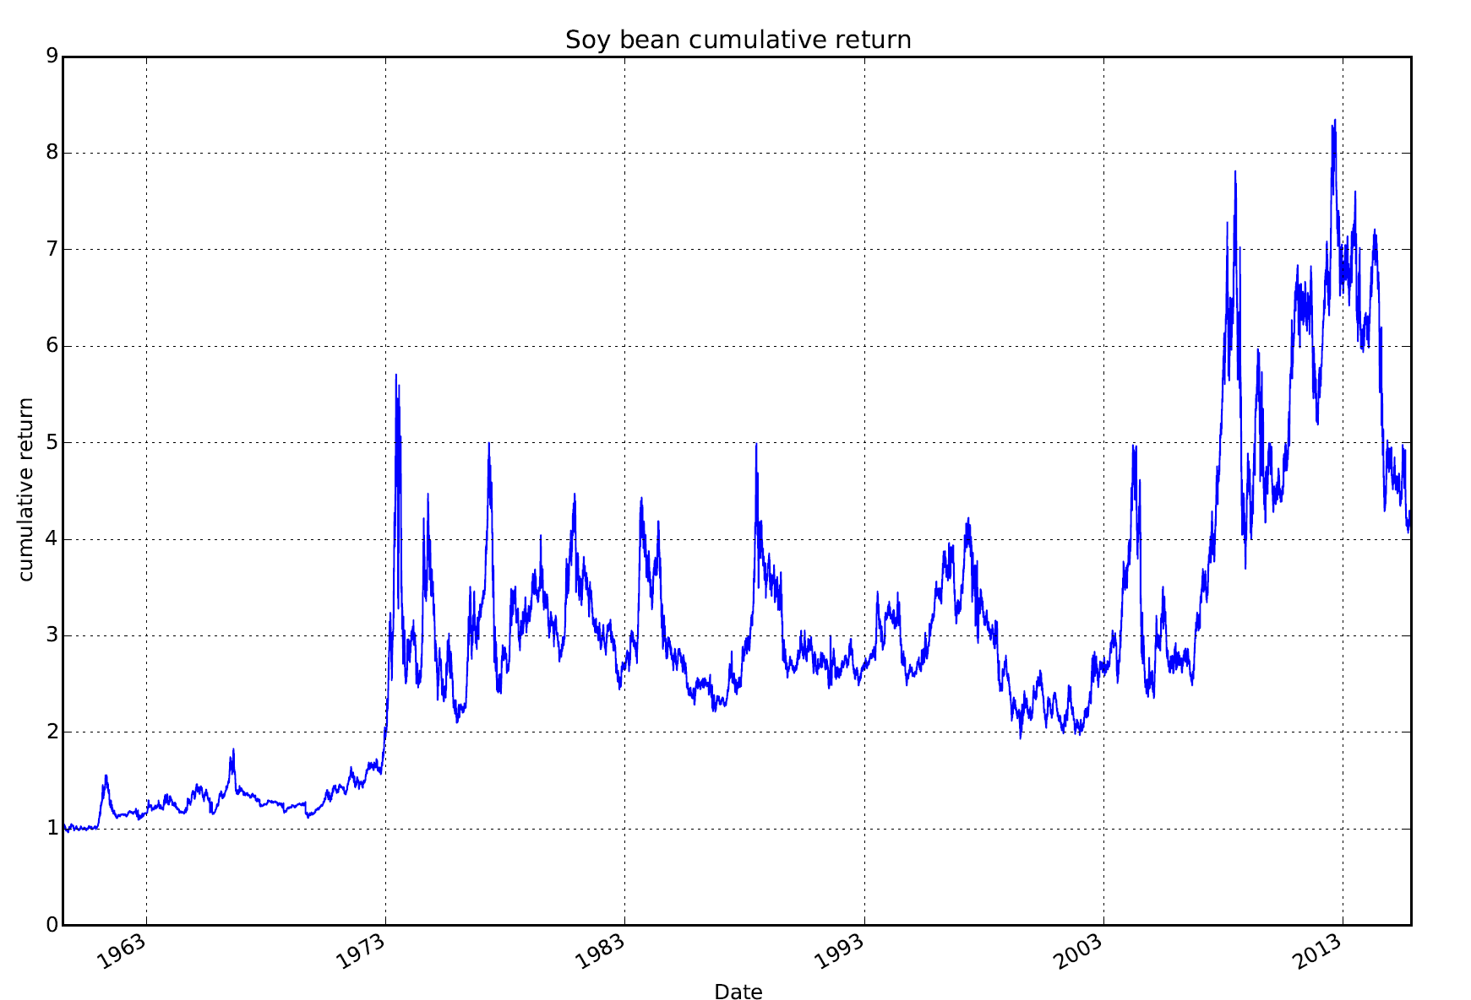

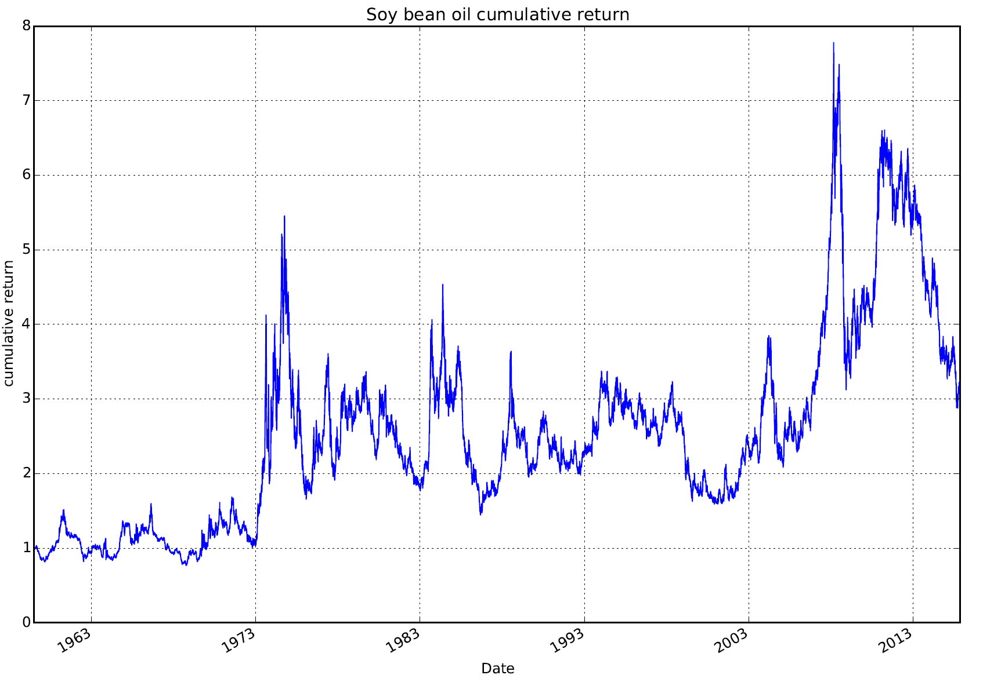

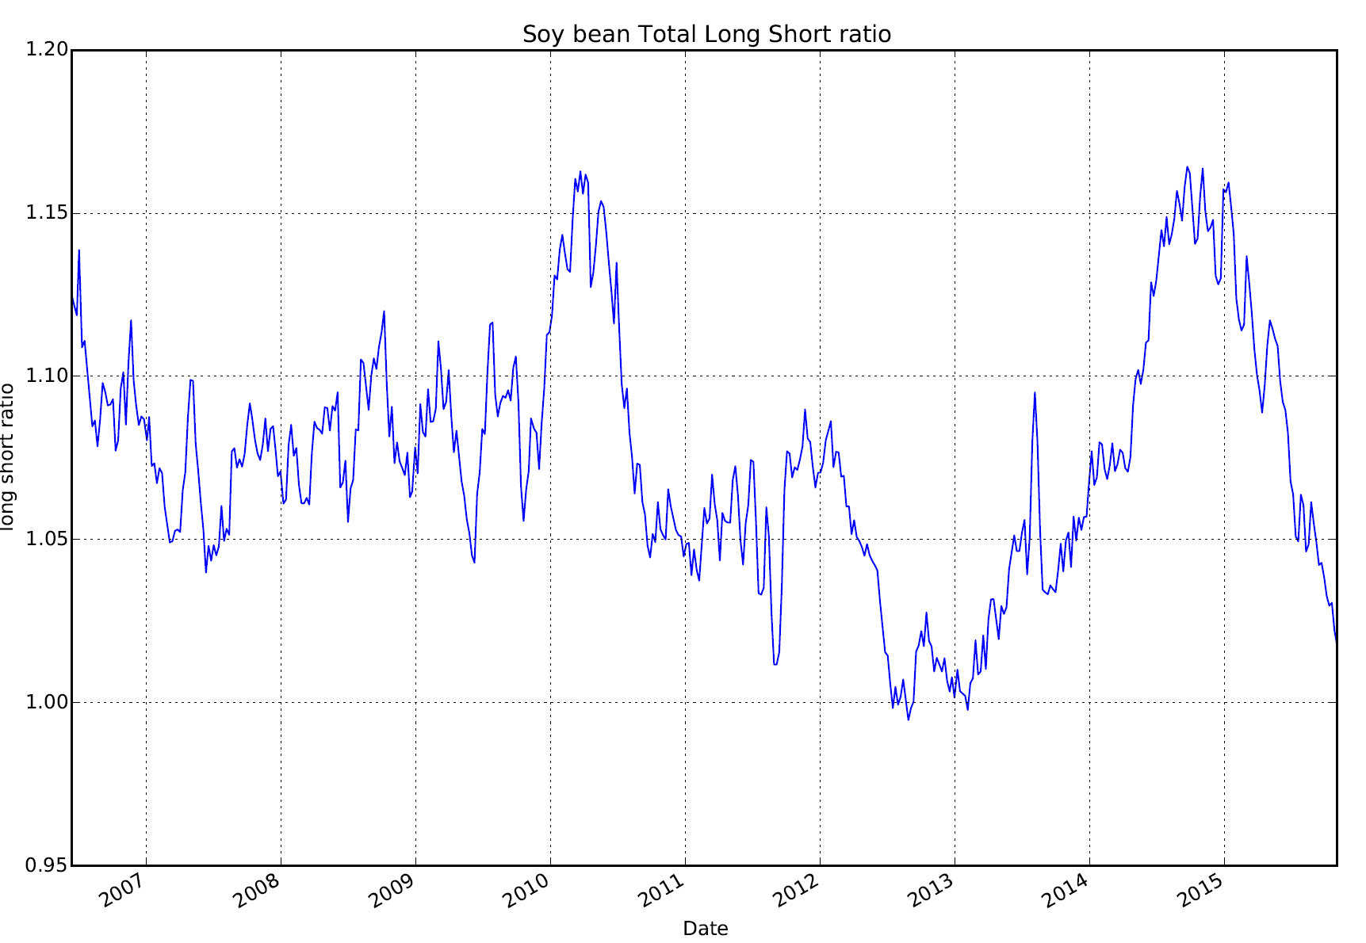 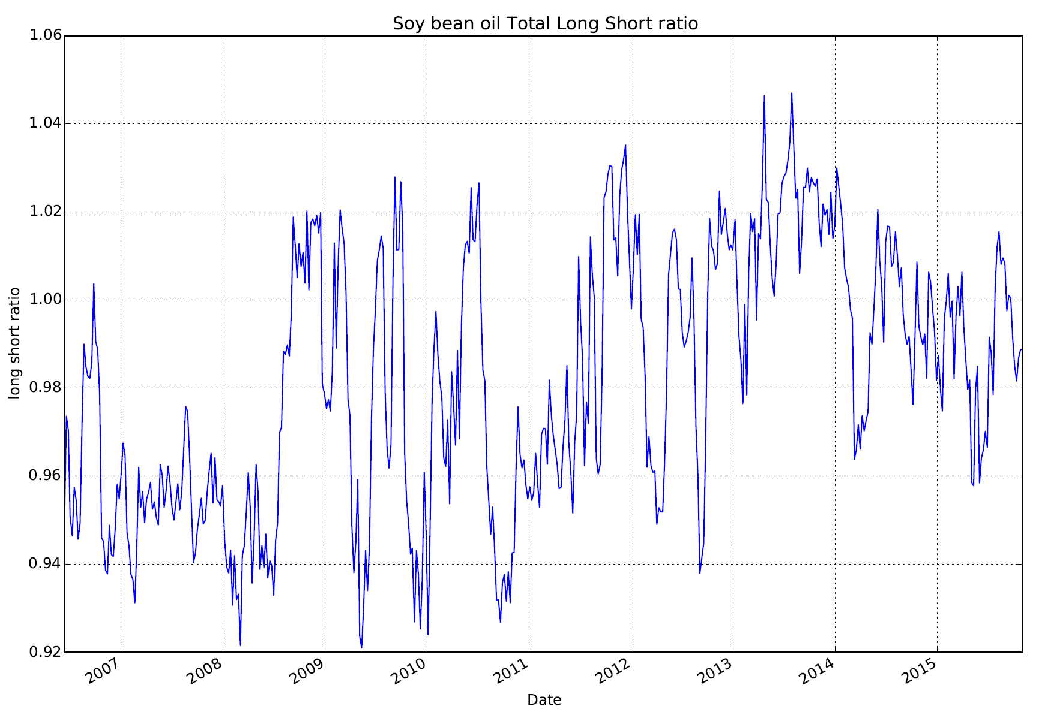

The correlation for daily returns between soybean and soybean oil is **0.628586**.