**My Translate**

I have create 2 version of my app

1. CLI – Version (using google api; accurate)
2. React Native (using libretranslate api; sometimes it’s not very accurate)

Because limitation from package node-google-translate-skidz, in react native I using another api to translate.

**How to use**

1. CLI – Version (Any language to English)

* Download zip and extract
* Change directory to “My Translate”
* Install node and npm
* Open console and type npm install to install all packages
* Change directory to “My-Translate/cli-version”
* In console, type node translate.js
* Enter words want to translate (Ex: Baik, selamat pagi, selamat datang)
* And result is (Baik = Good, selamat pagi = good morning, selamat datang = welcome)

Source language = Any language (in example I using Indonesia)

Target language = English

1. React Native (Any language to English)

* After using CLI-Version, Change directory to “My Translate”
* Install expo with npm
* Open console and type npm run start
* Download Expo Go in smartphone app store (see official doc expo how to use it)
* In app you can type like this

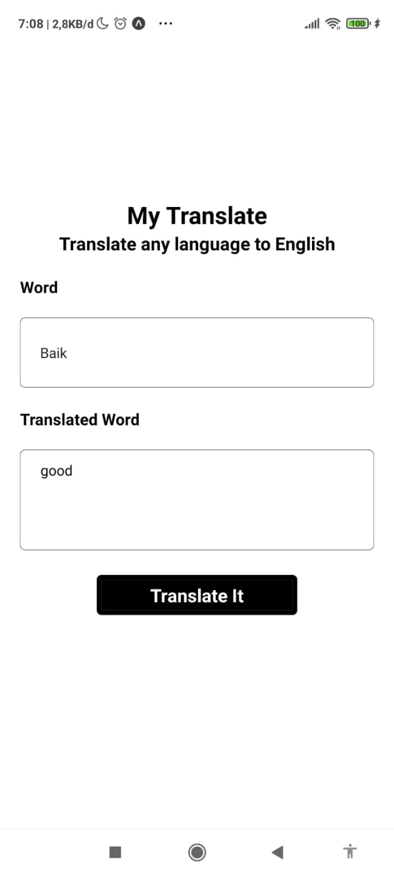

Baik (Indonesia) to good (English)

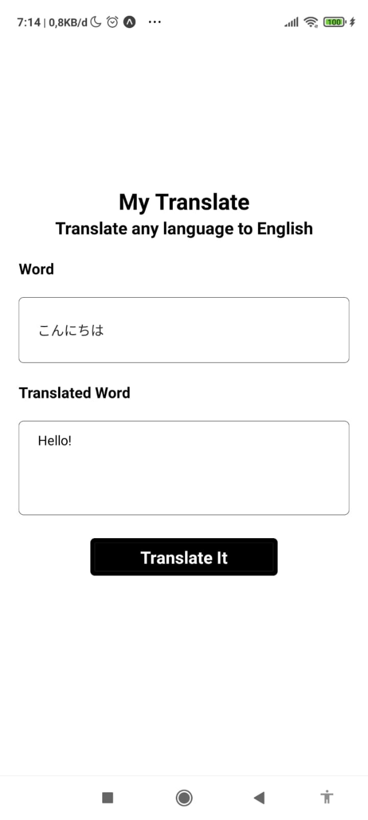

こんにちは (Japan) to Hello! (English)

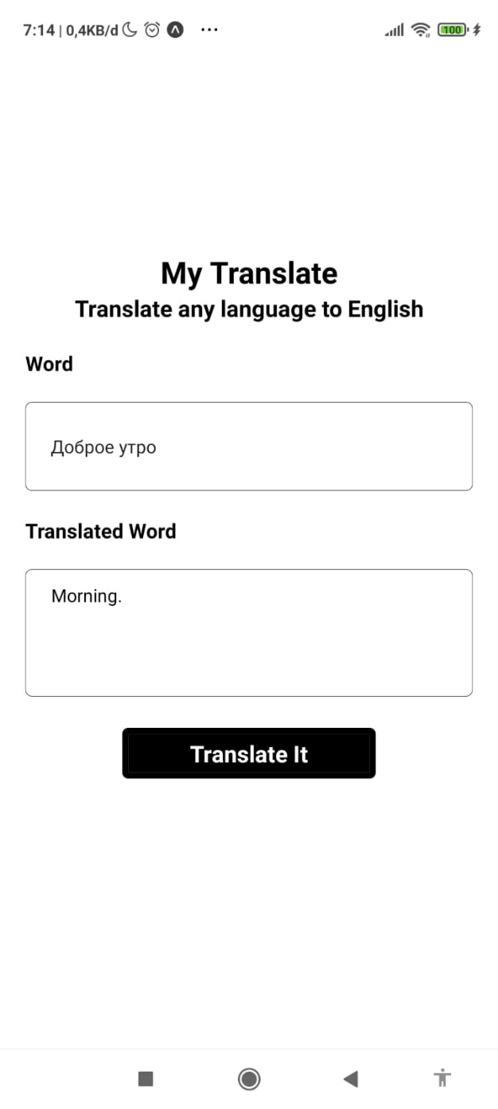

Доброе утро (Russian) to Morning (English)

Source language = Any language (in example I using Indonesia, Japan, Russian)

Target language = English