OOP

TASK

1. You should create a function constructor ‘Student’ which you can call with two arguments name and email.

Name, email and homeworkResults fields should be hidden from user.

Instance of Student should provide the following methods to get or change it’s state:

getName(): returns student’s name.

getEmail(): returns student’s email.

addHomeworkResult(topic, success): you can call this method with 2 arguments: topic(string) and success(boolean). This method should add new element to student’s homeworkResults property.

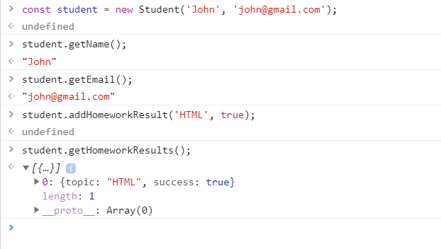

2. You should create a function constructor ‘FrontendLab’ which you can call with two arguments students and failedLimit.

Instance of FrontendLab should have 2 property fields: failedHomeworksLimit and studentsList. This fields should be hidden from user.

Instance of Student should provide the following methods to get or change it’s state.

printStudentsList(): this method logs to console list of students with their homeworks results.

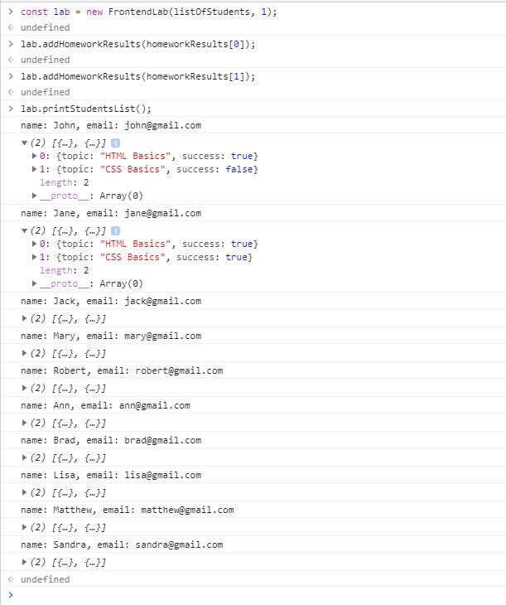

addHomeworkResults(homeworkResults): this method can be called with argument homeworkResult, object with 2 fields: topic(string) and results(array of objects with 2 fields: email(string) and success(boolean)). This method should update all student objects in FrontendLab studentsList.

printStudentsEligibleForTest(): this method should log to console list of students who didn’t fail more homework, than allowed failedLimit.

