Inheritance

TASK
- Create your own assign method which mimics Object.assign.
- Create Vehicle, Car, Motorcycle

Classes accept the following properties during creation;
Vehicle: color, engine,
Car: model, color, engine;
Motorcycle: model, color, engine
All classes by default have maxSpeed property. For Vehicle maxSpped = 70,
Car: maxSpeed = 80, Motorcycle: maxSpeed = 90;

NOTE: If you need other properties you can add them

All classes have the following methods:
- upgradeEngine(newEngine, maxSpeed) – sets new engine and update maxSpeed; NOTE: You can upgrade engine only if car is stopped;
- getInfo() – returns information about class { engine, color, maxSpeed, model }.
- drive() - The vehicle starts to drive and every 2 seconds speed increase at 20.
If speed is greater than maxSpeed the warning message should be shown
'speed is too high, SLOW DOWN!'. But vehicle continues to drive;
When Motorcycle class starts to drive the message ‘Let’s drive’ is shown.
Also for class Motorcycle if difference between current speed and maxSpeed is greater than or equal to 30 the message ‘Engine overheating’ is shown and Motorcycle begin braking.

NOTE: if car already drive you can't call this method again.
- stop() - The vehicle decrease it's speed every 1,5 second at 20.
When vehicle is stopped, the following messages should be shown:
  - For Vehicle class - “ Vehicle is stopped. Maximum speed during the drive was *** ”;
  - For Car class – “Car ** is stopped. Maximum speed during the drive *** ”;
  - For Motorcycle – “Motorcycle ** is stopped. Good drive”;

** - model of the vehicle;
*** - max speed from moment the vehicle begin drive until stopped;

NOTE: if vehicle begin braking you can't do it again, the message ‘Already slows down’ should be shown, but you can continues to drive;

The Car class has changeColor(newColor) method – sets the new color for the Car.
NOTE: you can’t choose the color in which the car is already painted

NOTE: If you need other methods you can add them

RESTRICTIONS
- Do not use ES6 classes
- Do not use any external libraries

CODE
TASK 1
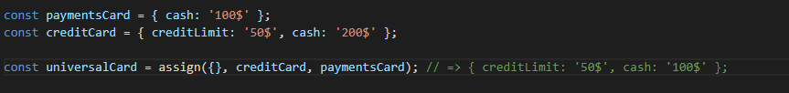

TASK 2
