AJAX
TASK
Using AJAX, you need to implement simple application to manage users.
- As a user I want to see a form with ‘name’, ‘username’ inputs and ‘Add New User’ button. When button is clicked – app sends request to server and tries to create a new user with proper values of inputs as well. While request is processed button should be disabled. In case of success response update user list.

- After page loading I want to see a list of existing users under this form. While request for getting users is in process there must be some notification or loader (‘Loading….’ will be enough) to inform about execution process.

- Each list element must be represented as: ‘UserId’ field, ‘name’ and ‘username’ inputs, ‘Update’ and ‘Delete’ buttons.
During update/delete requests proper button should be disabled (you can block all UI or just current user element, but it is not necessary). After getting response update user list and enable buttons.
Server part has been implemented already and provides such API's:
- GET /users – returns list of users
Request Options: no
Response:
Code: 200 / Body: JSON – list of users
- POST /users – creates new user
Request Options:
{
name: ‘string’,
username: ‘string’
}
Parameter content type: application/json
Response:
Code: 201 / Body: empty
- PUT /users/:userId – updates existing user
Request Options: Body:
{
name: ‘string’,
username: ‘string’
}
Parameter content type: application/json
Response:
Code: 204 / Body: empty
- DELETE /users/:userId – deletes user
Request Options: no
Header: ‘Authorization’ : ‘admin’
Response:
Code: 204 / Body: empty
IMPORTANT! Before you begin working:
- install Node.js (https://nodejs.org/ )
- go to server folder
- open terminal(or cmd)
- run npm install command
- run npm run server to launch server
(there should be message: Server is listening on port: 3000)
- to stop running server press Ctrl+C
Note: after restarting server all data will be reverted to its initial state

EXAMPLE
TIP: Don’t spend your time on styling, just create simple but efficient app.
It might look like this: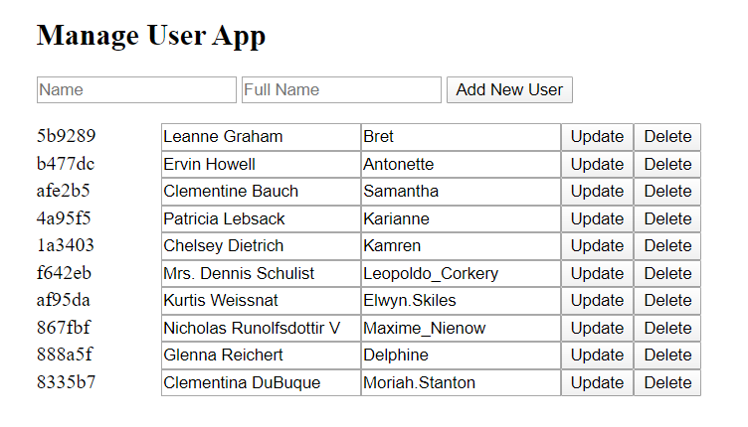
RESTRICTIONS
- Do not use fetch for this homework.

