Responsive

TASK
In this homework, you should create a web page and provide styles for specific screen resolutions as shown in the pictures (pixel perfect is not required):
- examples/desktop.png - shows how the page should look like on the large screen
- examples/tablet.png - shows how the page should look like on the tablet
- examples/mobile.png - shows how the page should look like on the phone screen
Colors already declared in the FL13_HW5/homework/css/styles.css file.

Requirements:
- The @media query breakpoints that are used in the example (desktop first):
  - max-width: 1400px (for the desktop)
  - max-width: 768px (for the tablet)
  - max-width: 480px (for the phone screen)

- The even elements should have description on the left and preview image on the right
- The odd elements should have description on the right and preview image on the left (reverse)
Please note! This logic should not be ‘hardcoded’ in HTML or CSS. Please use appropriate pseudo-class to place elements.
So in a case we need to add a new post, then the last added item should be shown reversed regarding the previous one.
Also pay attention to post dates.

Figure 1:
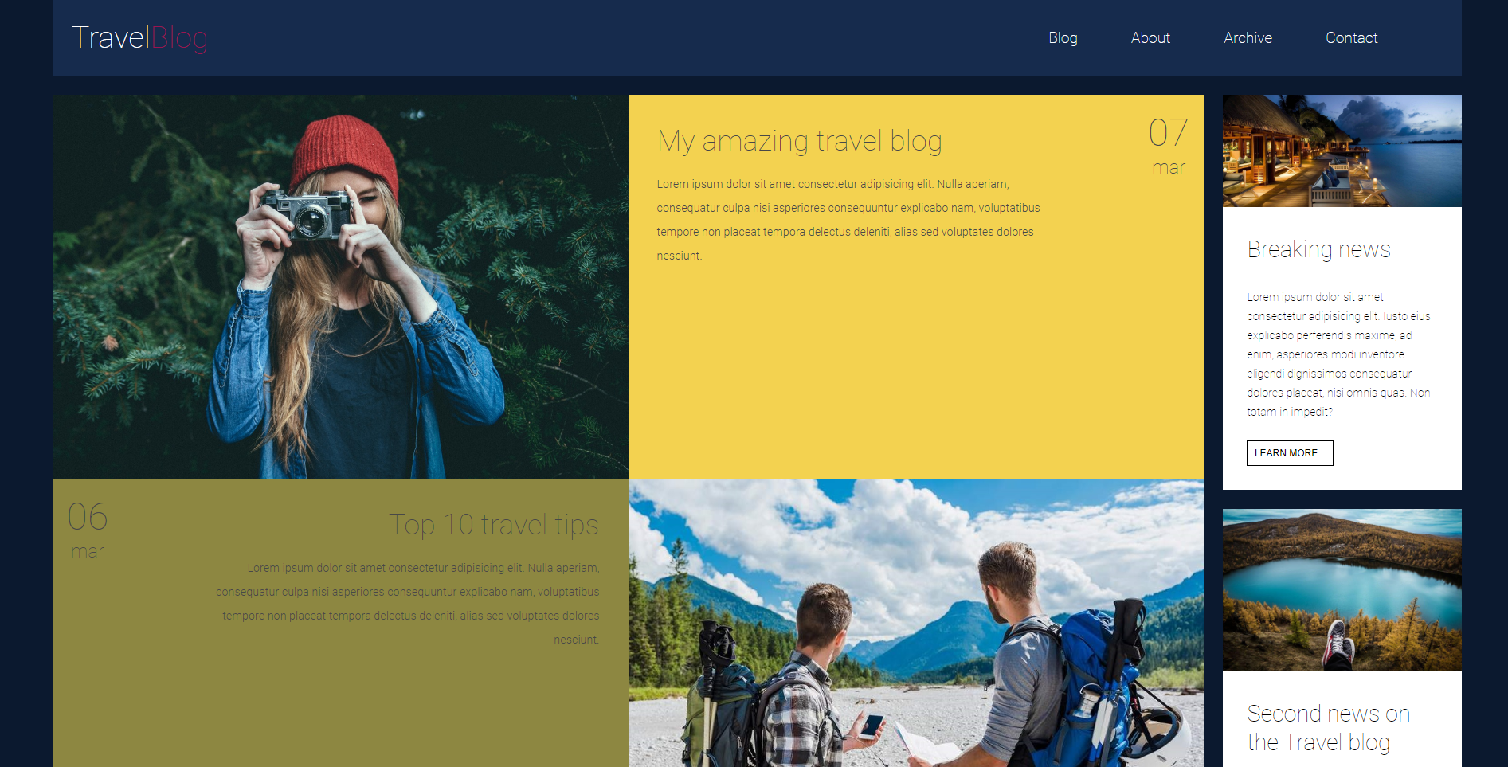
Figure 1 - post elements

- Menu items, post elements (img and description) and “Learn more” buttons should have animated hover effects as shown in image 2:

Figure 2 - menu items and post elements hover effects
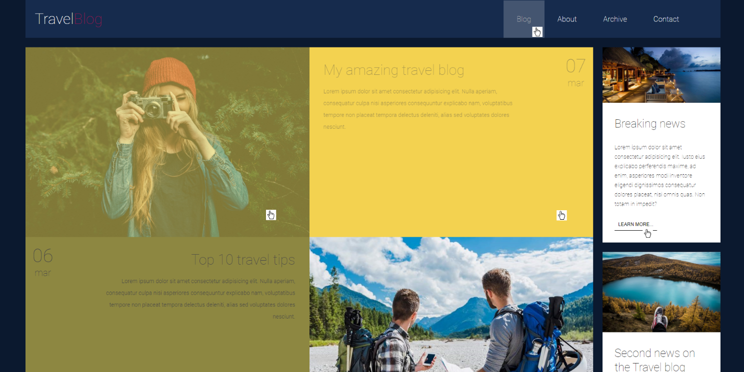

The last post (post-5) doesn`t have date and hover effect on it.

- The sandwich button which appears in tablet and phone mode shouldn’t do anything, just replace the menu from desktop view (image 3):
to

Figure 3 - menu transformation

- You can use mobile first or desktop first approach. It’s up to you;
- You could format existing code in styles.css file if needed.

RESTRICTIONS
- Please use pure CSS only, without any preprocessors;
- Don’t use any 3rd party tools or libs (e.g. Bootstrap);
- Use only styles.css file for your CSS code without splitting it;
- Usage of JavaScript is forbidden;
- Adding task/ and examples/ folders is forbidden. Do not push it to repository (only homework/ folder should be pushed);
- No requirements for browser support (should work properly in Google Chrome last version).

