Control flow

TASK

Task #1. Check the user
Write the code which verify user rights.

Step 1. Check login
- Ask user for a login // use prompt()
- If the input is an empty line or Esc – show “Canceled.” // for showing - use alert()
- If the input length less than 4 symbols - show “I don't know any users having name length less than 4 symbols”.
- If it’s another string – then show “I don’t know you”.
- If the visitor enters "User" or "Admin", then prompt for a password.

Step 2. Check password:
- For an empty string or cancelled input, show “Canceled.”
- For login “User” correct password is “UserPass”, for “Admin” correct password is “RootPass”. In other case, show “Wrong password”.

Step 3. Greets the user appropriately:
- If the current time in hours is less than 20: // current hours – new Date().getHours()
  - For “User” show “Good day, dear User!”
  - For “Admin” show “Good day, dear Admin!”
- If the current time in hours is more or equals 20
  - For “User” show “Good evening, dear User!”
  - For “Admin” show “Good evening, dear Admin!”

Task #2. Guessing game
Your task is to write a simple simulator of casino roulette.

Requirements:
Step 1:
- Create a prompt window (use confirm()). Show the message inside the window ‘Do you want to play a game?’.
- In case the user clicks the 'Cancel' button, the message 'You did not become a billionaire, but can.' should be shown (use alert).
Step 2:
- If user clicked ‘Ok’ – start a game: randomly (use Math.random()) choose an integer number in range [0; 5] (including 0 and 5) and ask user to enter a number of pocket on which the ball could land (use prompt()).
- User has 3 attempts to guess a number.
- If user guessed the number on which ball landed, on 1-st attempt prize is 100$ (maximum prize for current numbers range), 2-nd attempt – 50$, 3-rd attempt – 25$.
- If user did not guess a number show the message ‘Thank you for your participation. Your prize is: … $’ (Use alert) and ask if he wants to play again (use confirm).
Step 3:
- If user did guess - Show the message ‘Congratulation, you won! Your prize is: … $. Do you want to continue?’.
- If user does not want to continue – show the message ‘Thank you for your participation. Your prize is: … $’ (Use alert) and ask if he wants to play again (use confirm).
- If user does want to continue, make number range bigger at 5 as the previous one (for example [0; 5] -> [0; 10]), and two times bigger maximum prize (for example on 1-st attempt prize will be 200$, 2-nd attempt – 100$, 3-rd attempt – 50$). Prize must be added to the previous one and number of attempts should be set to 3 (user should have 3 attempts to guess a number for each numbers range)
- Each time you ask user to enter a number you should show him a range of cells, how much attempts he has left, his total prize and possible prize on current attempt. See Figure 1:

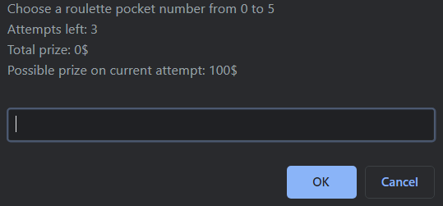
Figure 1 – The prompt window

- All these stuffs should be repeated until user lose or decide to quit

