**System and Network**

**Assignments 1 Report**

Huang Junhao

20233006334

**Task1:**

The assignment1.py file give the default setting like the numbers of machines and printers, so we use it to add all the machines and printers to the list, then to start it.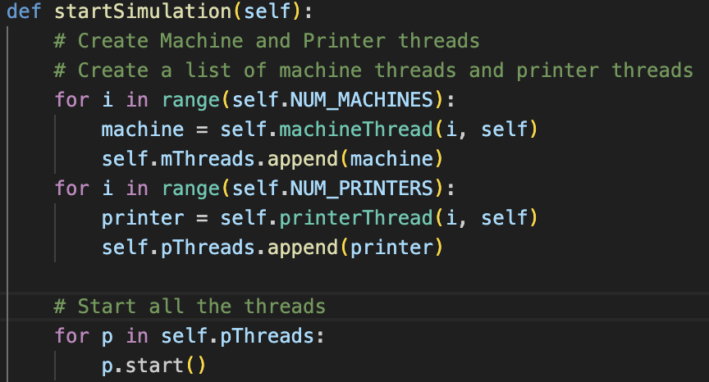

Then we look at the class of printer and machines. It has printDox and printerSleep function, so in the run function, after the printer take some time to print the document, we start it using self.printDoc function. The machine class is same to the printer. However, there’s one more special to printer class. After the we stop the simulation, the file list still has some unprinted file in it. So, we should change the while loop, let the print stop running until the file list is empty.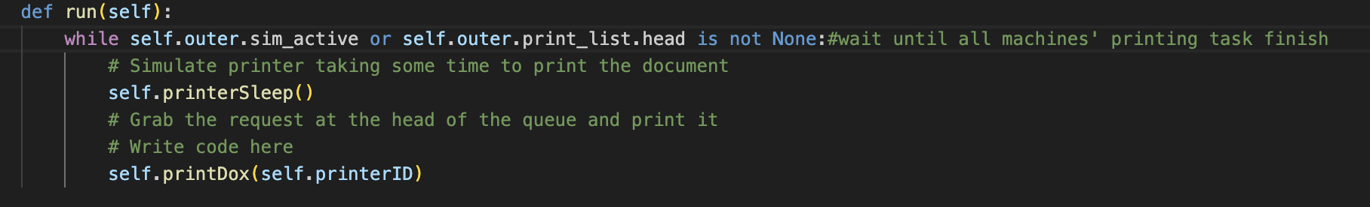

**Task2:**

The initial method first creates 2 semaphore, printers semaphore and binary semaphore. So, before the printer or machine run, we should check the semaphore if it’s safe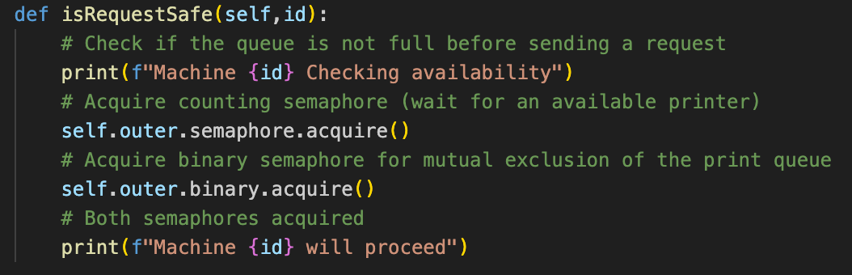

Then after finishing sending request, machine release the binary semaphore to other machines一張含有 文字, 螢幕擷取畫面, 字型 的圖片

AI 產生的內容可能不正確。

When queue has printing task, the printer call printDox method, rather than the task1’s printDox, it requires binary semaphore to make sure no other printer do its task, after finishing printing job, it releases the semaphore一張含有 文字, 螢幕擷取畫面, 字型 的圖片

AI 產生的內容可能不正確。