**数字均衡器说明**

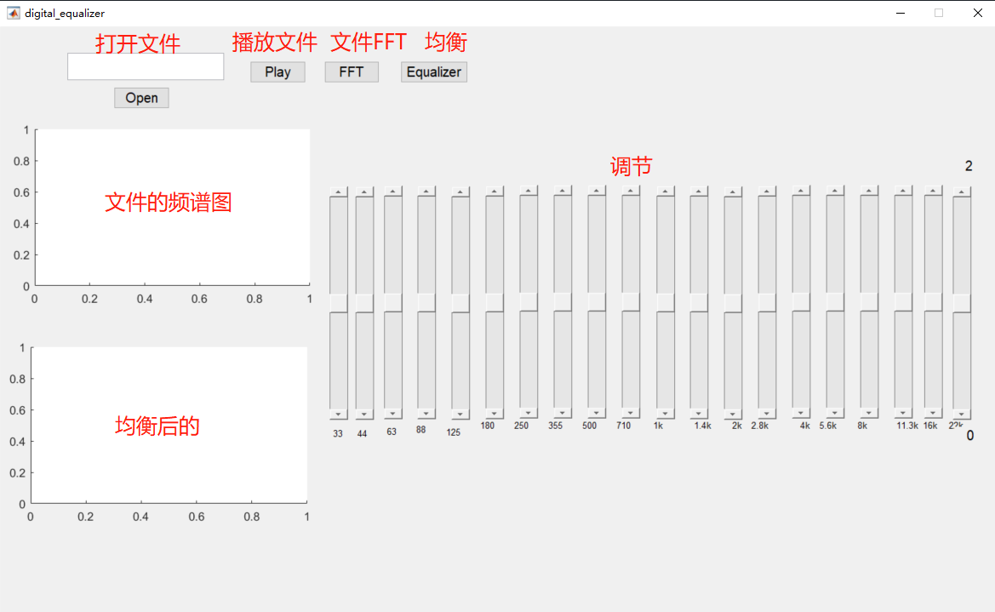

实现方法：

1. 通过按钮打开文件的路劲，并打开文件；
2. 将文件的路径显示在可编辑文本框内；
3. 将所有滑动条的初始值设为中间值；
4. 调用编写的IIR带通滤波器：

function [ Y ] = fx_FIR( fs, wc1 ,wc2 , signal)

%===============IIRÉè¼ÆÂË²¨Æ÷===============

Wn=[wc1*2 wc2*2]/fs;

[b,a]=butter(1,Wn);

Y=filtfilt(b,a,signal);

%===============FIRÉè¼ÆÂË²¨Æ÷===============

%b = fir1(50, [wc1*2/fs wc2*2/fs]);

%Y = filtfilt(b,1,signal);

end

1. 对每个滑动条调用带通滤波函数：

audio_33=fx_FIR(Fs,1,33,audio);

audio_44=fx_FIR(Fs,34,44,audio);

audio_63=fx_FIR(Fs,45,63,audio);

audio_88=fx_FIR(Fs,64,88,audio);

audio_125=fx_FIR(Fs,89,125,audio);

audio_180=fx_FIR(Fs,126,180,audio);

audio_250=fx_FIR(Fs,181,250,audio);

audio_355=fx_FIR(Fs,251,355,audio);

audio_500=fx_FIR(Fs,356,500,audio);

audio_710=fx_FIR(Fs,501,710,audio);

audio_1000=fx_FIR(Fs,711,1000,audio);

audio_1400=fx_FIR(Fs,1001,1400,audio);

audio_2000=fx_FIR(Fs,1401,2000,audio);

audio_2800=fx_FIR(Fs,2001,2800,audio);

audio_4000=fx_FIR(Fs,2801,4000,audio);

audio_5600=fx_FIR(Fs,4001,5600,audio);

audio_8000=fx_FIR(Fs,5601,8000,audio);

audio_11300=fx_FIR(Fs,8001,11300,audio);

audio_16000=fx_FIR(Fs,11301,16000,audio);

audio_22000=fx_FIR(Fs,16001,22000,audio);

1. 获取各个滑动条的值并*2（使得滑动条的值为0-2，中间值为1）

%»ñÈ¡¸÷¸ö»¬¶¯ÌõµÄÎ»ÖÃ

a = 2*get(handles.slider33 , 'Value');

b = 2*get(handles.slider44 , 'Value');

c = 2*get(handles.slider63 , 'Value');

d = 2*get(handles.slider88 , 'Value');

e = 2*get(handles.slider125 , 'Value');

f = 2*get(handles.slider180 , 'Value');

g = 2*get(handles.slider250, 'Value');

h = 2*get(handles.slider355 , 'Value');

i = 2*get(handles.slider500 , 'Value');

j = 2*get(handles.slider710 , 'Value');

k = 2*get(handles.slider1000 , 'Value');

l = 2*get(handles.slider1400, 'Value');

m = 2*get(handles.slider2000 , 'Value');

n = 2*get(handles.slider2800, 'Value');

o = 2*get(handles.slider4000 , 'Value');

p = 2*get(handles.slider5600, 'Value');

q = 2*get(handles.slider8000 , 'Value');

r = 2*get(handles.slider11300 , 'Value');

s = 2*get(handles.slider16000, 'Value');

t = 2*get(handles.slider22000 , 'Value');

1. 合成新的声音，将滤波后的声音相加

audio_new=a*audio_33+b*audio_44 +c*audio_63 +d*audio_88 +e*audio_125 +f* audio_180+g*audio_250 +h*audio_355 +i* audio_500+j*audio_710 +k*audio_1000 +l*audio_1400+m* audio_2000+n*audio_2800 +o*audio_4000 +p*audio_5600 +q*audio_8000 +r*audio_11300 +s*audio_16000 +t*audio_22000;

1. 对声音信号进行傅里叶变换，画出滤波后的图；
2. 播放新的声音信号

play=audioplayer(audio_new,Fs);

playblocking(play);