FYP 1 Mid Student Evidence Worksheet
Preparation for the supervisory presentation demo and report evaluations
Complete as a group and submit with the FYP 1 mid report at least 48 hours before the evaluation meeting
Purpose. This worksheet helps the group prepare verifiable evidence for the two handbook instruments used at the FYP-1 mid stage: Form 2 for the presentation and live demo, and Form 3 for the mid report. It supports the official forms; it does not replace the prescribed mid report or the supervisor's official assessment.
What the handbook now requires. The presentation/demo and the report are each assessed on a separate 100-mark rubric. Do not treat this worksheet as a request for extra features. Use it to show that the approved scope, current implementation, design, tests, repository history and report agree with one another.
Use of GenAI and other tools. You may use GenAI to support literature search, coding, design, report drafting, testing and related work. For every materially assisted artefact, disclose the applicable assistance level, identify what entered the project, distinguish the student's own contribution, explain how the output was verified or corrected, and retain evidence. Every member must be able to explain and modify the work attributed to them.

Submission package
☐ Completed editable worksheet | ☐ FYP 1 mid report in the prescribed format
☐ Proposal panel comments and action register | ☐ Supervisor has repository access
☐ Stable evaluation commit or release tag | ☐ Runnable live prototype or build
☐ Design artefacts connected to implementation | ☐ Tests or validation outputs for the completed module
☐ Task log and member ownership evidence | ☐ GenAI register, prompt journal and external dependency disclosures

Project identification
Project ID | 186
Project title | F26-186-TraceLearn
Panel number | 3
Supervisor | Dr. Ali Zeeshan Ijaz
Evaluation date | 12th October, 2026
Repository | https://github.com/Rayaan-Raza/TraceLearn
Evaluation version | 12c3c26
Runnable artifact | https://trace-learn.vercel.app

Group members
Member | Registration number | Repository identity | Current technical ownership
Member 1: Rayaan Raza | i23-0535 | Rayaan (GitHub: Rayaan-Raza) | Evidence extraction, diagnosis and the learner-state model; the C++ diagnostic problem bank; the dataset audit and ingestion
Member 2: Umaima Zeeshan | i23-0790 | Umaima Zeeshan | The execution sandbox and security; the authentication changes and the classroom API; submission logging; the student and teacher frontend; CI/CD
Member 3: Eman | i23-0530 | eman06 | The first RBAC (JWT, student and teacher roles); the C++ mode of the Monaco editor; the server-side C++ compile and run pipeline

1 Official evaluation map
Use these tables as a preparation map. Students do not award marks. The supervisor scores the official criteria after reviewing the report and observing the live evaluation.

Form 2 Presentation and Demo Evaluation
Official criterion | CLO | Max | Evidence the student submission must make easy to verify
Previous proposal actions addressed | FYP1-CLO6 | 10 | Panel action register shows each required change, status and evidence link.
Iteration plan and work breakdown progress | FYP1-CLO2 | 10 | Planned milestone completed, or delay is justified with a recovery plan.
Live prototype with core module demo | FYP1-CLO4 | 25 | Meaningful module works live; not only screenshots or video. Edge/failure case shown if possible.
Requirements and acceptance criteria quality | FYP1-CLO2 | 10 | User interactions, FRs/NFRs and acceptance checks are technically correct and aligned with scope.
Design artefacts and design evolution | FYP1-CLO3 | 15 | Architecture plus data/process/behavior artefacts connect to implementation; changes since proposal are justified.
Repository, milestone and member evidence | FYP1-CLO6 | 10 | Tagged code, commit timeline, task log and member ownership are visible. Commit count alone is not enough.
Testing and early validation | FYP1-CLO4 | 10 | Tests/validation checks exist for the current module; one failure/edge case is discussed.
Team dynamics and tool ownership | FYP1-CLO5 | 10 | Team coordination and tool-assisted outputs are defended.
Total |  | 100 | Prepare traceable evidence for every criterion.

Form 3 Report Evaluation
Official criterion | CLO | Max | Evidence the student submission must make easy to verify
Report format and required artefacts present | FYP1-CLO2 | 5 | Prescribed format followed; required sections and artefacts included.
Problem formulation, R&D and existing solution analysis | FYP1-CLO1 | 15 | Report shows what was studied, what gap remains and what complex challenge is addressed.
Project vision, scope, modules and success criteria | FYP1-CLO2 | 10 | Scope, modules, success criteria and feasibility are clear and consistent with approval.
Requirements and acceptance criteria | FYP1-CLO2 | 15 | User interactions, FRs/NFRs and acceptance checks are precise and testable.
Architecture and component/interface design | FYP1-CLO3 | 15 | Architecture, components, dependencies and interfaces are clear and justified.
Data/process/behavior design | FYP1-CLO3 | 10 | Appropriate ERD/schema/data flow/activity/sequence/state diagram included and explained.
Implementation documentation of completed module | FYP1-CLO4 | 15 | Completed module described with setup, main files/classes/functions and technical decisions.
Testing/validation plan and tool/risk disclosure | FYP1-CLO5 | 15 | Test plan, early results, external dependency disclosure, risk/security/privacy and limitations documented.
Total |  | 100 | Prepare traceable evidence for every criterion.

2 Proposal action register
Include every required modification from the proposal decision. Do not list only the changes that are already complete.
Panel comment or required change | Decision and rationale | Owner | Status | Evidence link | Next action and date
“Try to think how you can also use LLM to enhance user experience.” (Proposal decision: Approved, 14 Sep 2026) | Adapted. An LLM will make the be used to generate hints for the students from the evidences. Furthermore, LLM integration will be used to help teachers grade student submissions. | Rayaan (hints/diagnosis), Umaima (UI) | Open | None | Make a prototype that uses an LLM to write the template hints in iteration 2. Add grading feature In iteration 3.

Proposal response summary
Actions completed | The team has not completed the one panel action. After approval, the team made the C++ vertical slice. The LLM feature will use this slice.
Actions still open | Row 1 (use an LLM to make the user experience better) is open. It is necessary to have stable C++ hint templates first. Completion date: the FYP-1 final evaluation (date to confirm).
Scope consequence | The approved scope did not change. Clarification: the LLM only gives the words of the hints and grading. The LLM does not make the diagnosis
Supervisor-approved exceptions | None

3 Iteration plan and work breakdown progress
Planned milestone or work package | Owner | Planned date | Current state | Evidence | Variance and recovery action
RBAC: student and teacher roles, protected API and routes | Eman, Umaima | Oct 2026 | Complete | Commits be7897b, fc16065, af1ce9b; tests/test_security.py | None
The Monaco C++ editor and the student and teacher UI, connected to the API | Eman, Umaima | Oct 2026 | Complete | Commits 5619739, 136b384, 4102ed2, 179f325, fd15a4b | None
Server-side C++ execution in a sandbox with limits | Eman, Umaima | Oct 2026 | Complete | Commits 8ef0efb, c30e5aa; execution/sandbox.py; test_sandbox_timeout_and_output_limits | None
Submission logging, test results and storage in the database | Umaima | Oct 2026 | Complete | Commit b88a962; submissions and test_results tables | None
Evidence extraction pipeline and C++ misconception detection | Rayaan | Oct 2026 | Complete | analysis/pipeline.py, cpp_static.py; C++ bank CP01–CP08 | None
The C++ diagnostic problem bank with verified tests | Rayaan | Oct 2026 | Complete | 8 problems, 77 tests, 149/149 checks (docs/PROBLEM_VERIFICATION_REPORT.md) | None
The CI/CD pipeline and the tagged evaluation build | Umaima | Oct 2026 | Complete | .github/workflows/ci.yml, cd.yml (branch feature/umaima-ci-cd) | None

Iteration objective | Show a live C++ vertical slice. An authenticated student submits C++. The sandbox compiles and runs it. The system runs the visible, hidden and diagnostic tests. Then it gives evidence, a diagnosis, a learner state and a hint. CI checks each change
Objective status | Completed
Critical blocker | None
Recovery plan | N/A
Next iteration outcome | FYP-1 final: C++ evidence for the 8 bank misconceptions operates in the live path. The team shows the teacher correction loop. The team shows the first LLM prototype that writes hints

4 Live prototype and core module
Core module | C++ submission diagnosis pipeline: sandboxed execution → evidence extraction → evidence-fusion diagnosis (current-only and history-aware) → learner-state update
Why it is meaningful | The module changes one C++ attempt into structured, auditable evidence of a possible misconception. It also records this evidence over time. The editor and the dashboards show the results.
Input | C++17 source (maximum 64 KB) and a problem ID from an authenticated student (JWT cookie and CSRF token). The system rejects source that is too large. It also rejects #include of host files.
Processing | g++ compiles the code in bubblewrap with CPU, memory and file limits. Each test case runs with a wall-clock limit. The system compares the outputs token by token. Five analyzers (runtime, test, static, diff, history) make evidence items. Weighted fusion (config/evidence_weights.yaml, poc-v1) gives two diagnoses. The rules in learner_model/updater.py update the learner state.
Output | Execution status, the result of each test (the system hides hidden outputs), evidence items, two diagnoses with confidence and uncertainty, and a learner-state history row. The system stores all of these in the database. The student result page and the teacher submission page show them.
Dependencies | g++ (C++17), SQLite via SQLAlchemy, FastAPI, React + Monaco, config/evidence_weights.yaml
Known limitations | The team set the evidence weights, to be validated. The C++ static analysis uses patterns and g++ warnings, not a full AST. Isolation operates only on Linux with bubblewrap. All data is synthetic.

Implementation boundary
Component | Implemented and integrated | Mocked or substituted | Evidence | Plan to remove substitute
Client or interface | Yes. React student and teacher pages with Monaco, connected to the API | None | frontend/src/pages/student, pages/teacher; commits 179f325, fd15a4b | Not applicable
Backend or service | Yes. FastAPI authentication, classrooms, submissions and teacher review | Demo endpoints and synthetic students are available for the experiment. They are off in production (ENABLE_DEMO_ENDPOINTS=false) | backend/app/api; tests/test_security.py | Not applicable
Core algorithm or model | Yes. Evidence extraction, rule-based fusion and learner-state rules | Fixed evidence weights, set by the team, replace a trained XGBoost classifier | config/evidence_weights.yaml; diagnosis/confidence.py | Use XGBoost when labelled data is available in iteration 2
Data or external dependency | Yes. SQLite database and a C++ bank of problems | Synthetic demo sequences replace real student data | data/cpp_problems; data/exports/experiment_summary.json | FYP-I student testing with 5–10 students

Live demonstration plan
Step | Action | Expected result | Evidence visible | Presenter
1 | Log in as a student | The student dashboard opens. The system blocks the teacher pages | UI= | Eman
2 | Open an assigned C++ problem | Only the statement and the visible tests. The hidden tests do not show | UI. The API response does not contain hidden outputs | Umaima
3 | Submit incorrect C++ (for example, an index that is equal to the vector size) | The code compiles. Some tests fail. The execution status shows | Result page and test_results rows | Umaima
4 | Open the evidence and diagnosis panel | Evidence items, the current-only and history-aware diagnoses with confidence, and a hint | Result page; evidence_items and diagnoses rows | Rayaan
5 | Submit corrected code | The system stores attempt 2. The tests pass. The learner-state history changes | Submissions list; learner_state_history row | Rayaan
6 | Submit an infinite loop. Then show CI | The status is timeout at the time limit. The API continues to operate. The CI run passes | Result page; GitHub Actions run and pytest report | Umaima

Normal edge and failure cases
Case | Input or condition | Expected behavior | Latest result | Evidence
Normal | The reference C++ solution for each of the 40 problems | The code compiles. All visible, hidden and diagnostic tests pass. The diagnosis is NO_MISCONCEPTION. The attempt does not go to teacher review. | Pass: 40 of 40 solutions pass all tests. 40 of 40 get NO_MISCONCEPTION. 0 go to review. The verifier passes 77 of 77 test cases on CP01–CP08. | test_security.py::test_cpp_correct_solution_passes; docs/PROBLEM_VERIFICATION_REPORT.md; bank_e2e_results.json
Edge | Hard negative: code that passes all tests but contains a misconception pattern, for example i <= n | All tests pass. The system does not give a misconception. | Pass: 4 of 4 hard negatives pass all tests. 4 of 4 get NO_MISCONCEPTION. | data/cpp_problems/variants/*HARDNEG*; docs/PROBLEM_VERIFICATION_REPORT.md; test_iteration1_regressions.py; bank_e2e_results.json
Failure | Recursion that does not move toward the base case (CP07 variants a and b) | The system stops the program at the 2,000 ms wall-clock limit. The status is timeout. The API keeps working. | Pass: the status is timeout and the return code is -9. The verifier shows 5 of 9 tests fail. In the app, 2 tests pass, 1 times out, and the rest do not run. The next submissions run with no change. | docs/PROBLEM_VERIFICATION_REPORT.md (variant table); bank_e2e_results.json

5 Requirements scope and acceptance evidence
Problem and primary users | Beginner C++ students: their failed submissions look the same but come from different misconceptions. Teachers: they must know which student has which misconception, and if it continues
Current scope | Iteration 1: authenticated C++ practice with sandboxed execution; visible, hidden and diagnostic tests; evidence extraction; current-only and history-aware diagnosis; learner state; teacher review; CI/CD
Explicit exclusions | No XGBoost classifier yet. No LLM diagnosis. No support for more than one language. No plagiarism detection, leaderboards or mobile application. No claim that the system helps real students
Success criteria | All automated tests pass in CI. The team verified 8 C++ problems (149/149 checks). A live C++ submission gives stored evidence and a diagnosis. The system processes a timeout or a compile error safely.
ID | User interaction or requirement | Type | Acceptance criterion | Status | Evidence
FR-01 | The student signs in and gets access that agrees with the role | FR | A student cannot use a teacher-only endpoint. A teacher cannot make a submission. | Met | test_research_endpoints_teacher_only; test_teachers_cannot_create_submissions; test_every_endpoint_requires_auth
FR-02 | The student opens an assigned C++ problem | FR | The statement and the visible tests come from the API. The API never sends the hidden test input or output. | Met | test_custom_problem_visibility_and_assignment; test_students_never_see_hidden_expected_outputs
FR-04 | The student submits code to the backend | FR | POST /api/submissions stores the source, the problem ID and the attempt number. It sends back an ID. | Met | test_concurrent_submissions_get_distinct_attempt_numbers; api_qa.py (source stored, attempt numbers 1, 2, …)
FR-05 | The backend compiles and runs C++ with limits | FR | Code that passes → success. Code that does not compile → syntax_error. Wrong output → wrong_answer. Infinite loop → timeout at the 2,000 ms test limit. | Met | test_cpp_correct_solution_passes; test_cpp_program_runs_without_bubblewrap; docs/PROBLEM_VERIFICATION_REPORT.md (2,003 ms); bank_e2e_results.json
FR-06 | The system runs the visible, hidden and diagnostic tests | FR | Each stored result has a link to a test case with a type. No diagnostic test is public. | Met | test_results.test_case_id foreign key in models.py; test_no_diagnostic_test_is_public; test_students_never_see_hidden_expected_outputs
FR-08 | The system extracts evidence from each submission | FR | A minimum of 3 evidence families give the same output each time on the fixtures. | Met | 5 families give evidence: test, static, execution, sequence, history (bank_e2e_results.json). No test runs the same input twice and compares the output.
FR-10 | CI checks each change | FR | A pull request with a test that fails does not pass its required checks. | Met | .github/workflows/ci.yml runs on each pull request, and the job fails when a test fails. main has no branch protection, so no check is required, and a pull request with a failed test can still be merged.
FR-11 | The learner state changes and the system records the reason | FR | One failure never makes a PERSISTENT state. Two or more supports on different problems can make it. Each change writes a history row. | Met | test_single_failure_not_automatically_persistent; test_cross_problem_recurrence_can_create_persistent_state; data/exports/state_transitions.csv
NFR-01 | The system processes failures safely | NFR | Compile, runtime, timeout and output-limit cases give a status. The API does not stop. It does not show internal data. | Met | Compile error → syntax_error with no server paths. Null pointer → runtime_error. Infinite loop → timeout. Too much output → OutputLimitExceeded (Linux only). /health answers after each case. Sources: api_qa.py, bank_e2e_results.json, test_validation_errors_do_not_echo_input
NFR-02 | The system isolates student code from the host | NFR | The code cannot read host files, use the network or read environment variables. | Met | test_sandbox_blocks_files_network_and_env (Python code); sandbox_probe.py (C++ code). Windows has no isolation.

Requirement traceability

Requirement | Design element | Implementation | Test or validation | Demo step | Owner
FR-01 | Activity A1; architecture: Student UI and Teacher decision UI  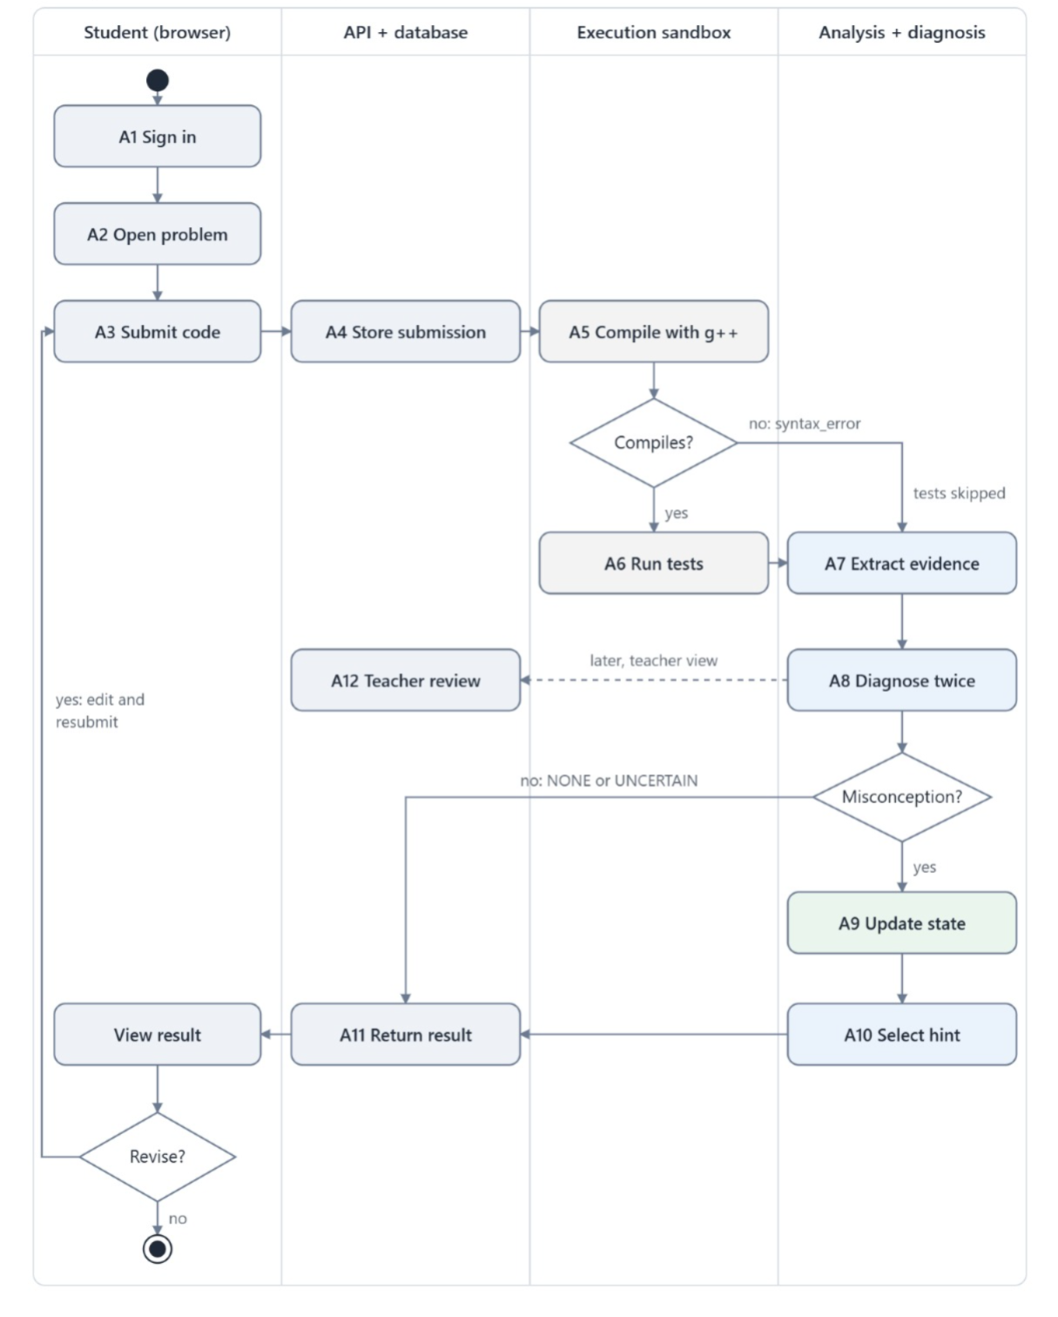 | api/auth.py; auth/access.py; auth/dependencies.py | test_every_endpoint_requires_auth; test_teachers_cannot_create_submissions; test_research_endpoints_teacher_only | Step 1 | Eman, Umaima
FR-02 | Activity A2;  ERD: problems, test_cases, assignments  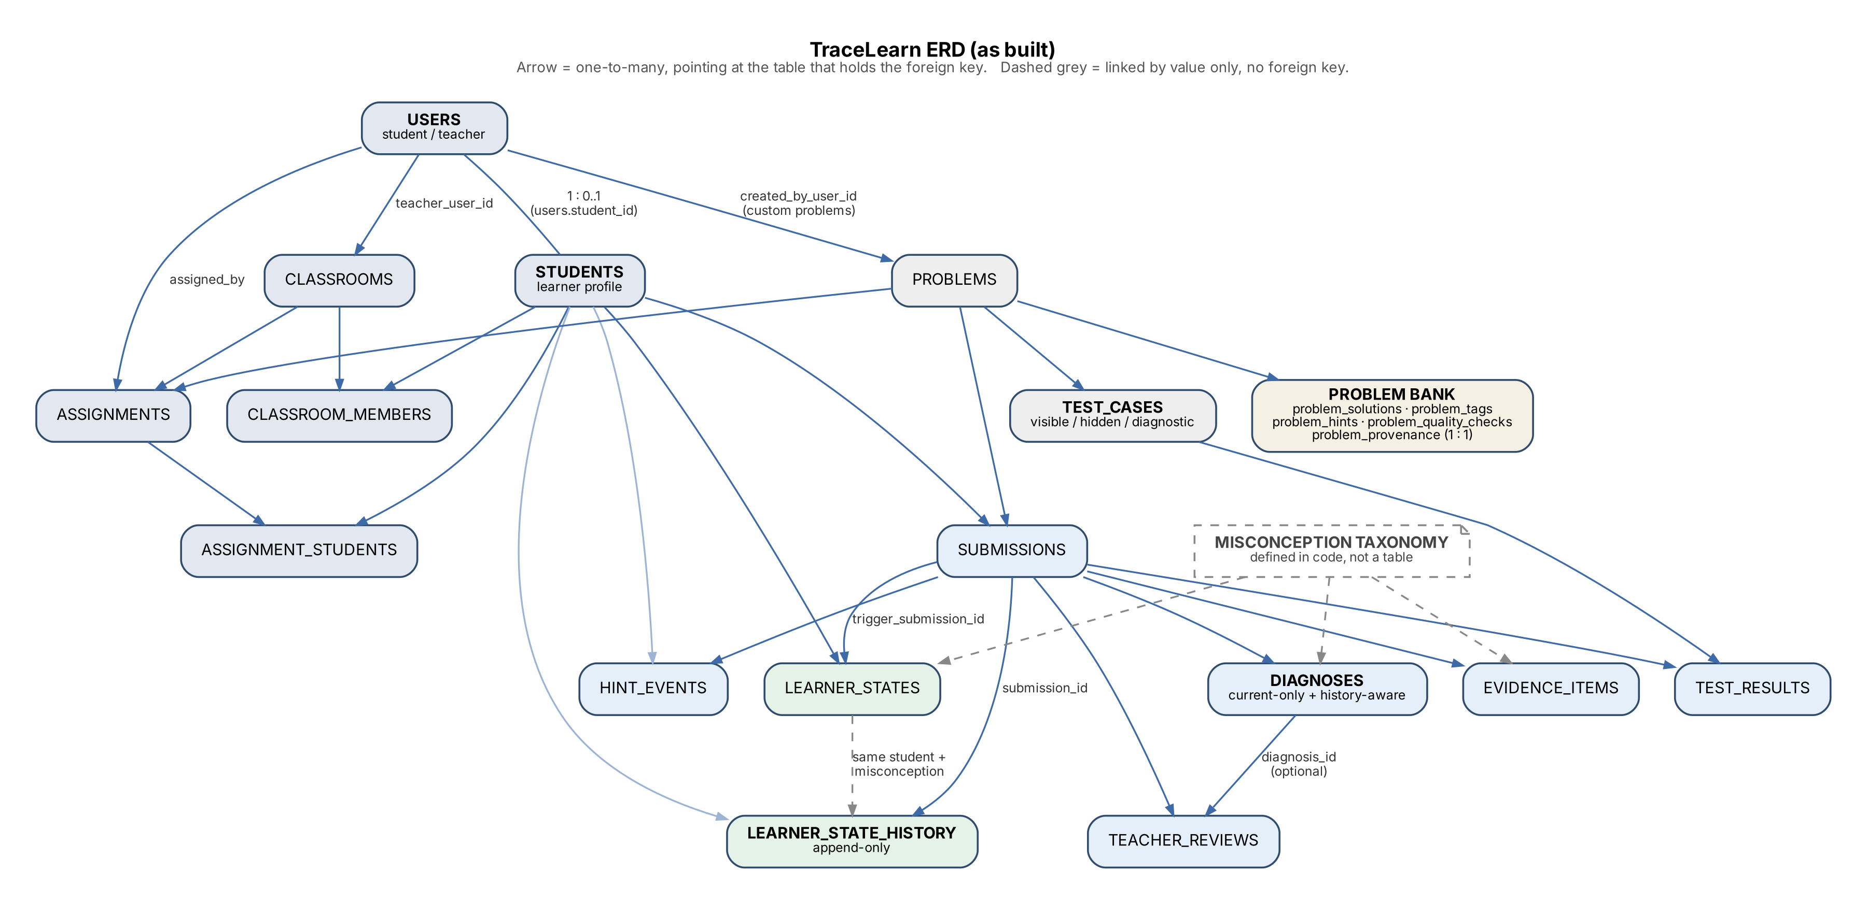 | api/problems.py; api/classrooms.py; frontend/src/pages/student/Problem.tsx | test_custom_problem_visibility_and_assignment; test_students_never_see_hidden_expected_outputs | Step 2 | Umaima, Rayaan
FR-04 | Activity A3–A4;  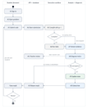ERD: submissions (unique student, problem, attempt)  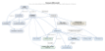 | api/submissions.py; services/submission_service.py (create_submission) | test_concurrent_submissions_get_distinct_attempt_numbers | Step 3 | Umaima, Eman
FR-05 | Activity A5; architecture: Sandbox + test runner | execution/cpp_runner.py; execution/sandbox.py; execution/test_runner.py | test_cpp_correct_solution_passes; test_cpp_program_runs_without_bubblewrap | Steps 3 and 6 | Eman, Umaima, Rayaan
FR-06 | Activity A6; ERD: test_cases, test_results | execution/test_runner.py; db/models.py (TestResult.test_case_id); data/cpp_diagnostics | test_no_diagnostic_test_is_public; test_students_never_see_hidden_expected_outputs | Step 3 | Rayaan, Eman
FR-08 | Activity A7; architecture: Evidence extractor + fusion; ERD: evidence_items | analysis/pipeline.py; analysis/test_analyzer.py; analysis/cpp_static.py; analysis/runtime_analyzer.py; analysis/diff_analyzer.py; analysis/history_analyzer.py; diagnosis/cpp_mapping.py | test_cpp_end_to_end.py (test_cpp_variant_submission_reaches_diagnosis_end_to_end) | Step 4 | Rayaan, Umaima, Eman
FR-10 | CI/CD pipeline (docs/CI_CD.md) | .github/workflows/ci.yml | CI run 38052478077 (all 3 jobs pass) | Step 6 | Umaima
FR-11 | Activity A9; ERD: learner_states, learner_state_history | learner_model/updater.py; learner_model/history.py | test_single_failure_not_automatically_persistent; test_cross_problem_recurrence_can_create_persistent_state | Step 5 | Rayaan
NFR-01 | Activity A5: the failure branches | execution/cpp_runner.py; execution/sandbox.py; security/middleware.py | test_validation_errors_do_not_echo_input; test_sandbox_timeout_and_output_limits | Step 6 | Umaima, Eman
NFR-02 | Architecture: the sandbox boundary  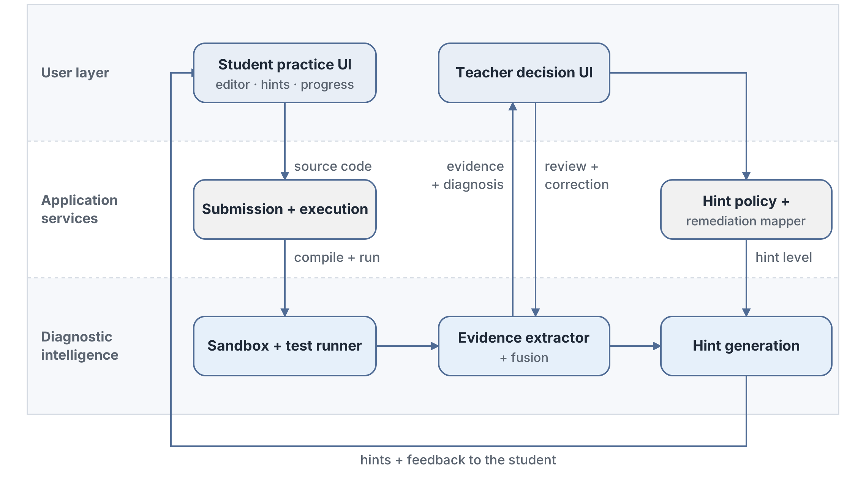 | execution/sandbox.py | test_sandbox_blocks_files_network_and_env | Step 6 | Umaima

6 Design artefacts and design evolution
Artefact | Purpose | Version or date | Implementation connection | Change since proposal | Rationale
Architecture | Show the three layers. Show how a submission becomes evidence, a diagnosis and a hint | v2 Oct 2026 | Student UI: frontend/src/pages/student; Submission + execution: api/submissions.py, services/submission_service.py; Sandbox: execution/sandbox.py, cpp_runner.py; Evidence + fusion: analysis/, diagnosis/; Hints: hints/; Teacher UI: pages/teacher, api/teachers.py | None | N/A
Data/schema/ERD | Show how the stored data connects | Oct 2026 | backend/app/db/models.py (21 tables); DBML in tracelearn_schema.dbml | A separate students table. The team added classroom, assignment and problem-bank tables. The misconception taxonomy is in the code, not in a table | This keeps login identity separate from learner data. RBAC must have classroom assignments. The bank tables keep provenance and quality checks
Process/data flow | Show the steps of one submission across the student, the API, the sandbox and the analysis | Oct 2026 | Steps A1–A12 agree with POST /api/submissions and then /run-and-analyze (SubmissionService.execute → analyze → diagnose) | The team added the compile-error branch (no tests run) and the 'no misconception' branch (no state change) | The diagram agrees with the code, so the panel can follow it in the live demonstration
Behavior/state/sequence  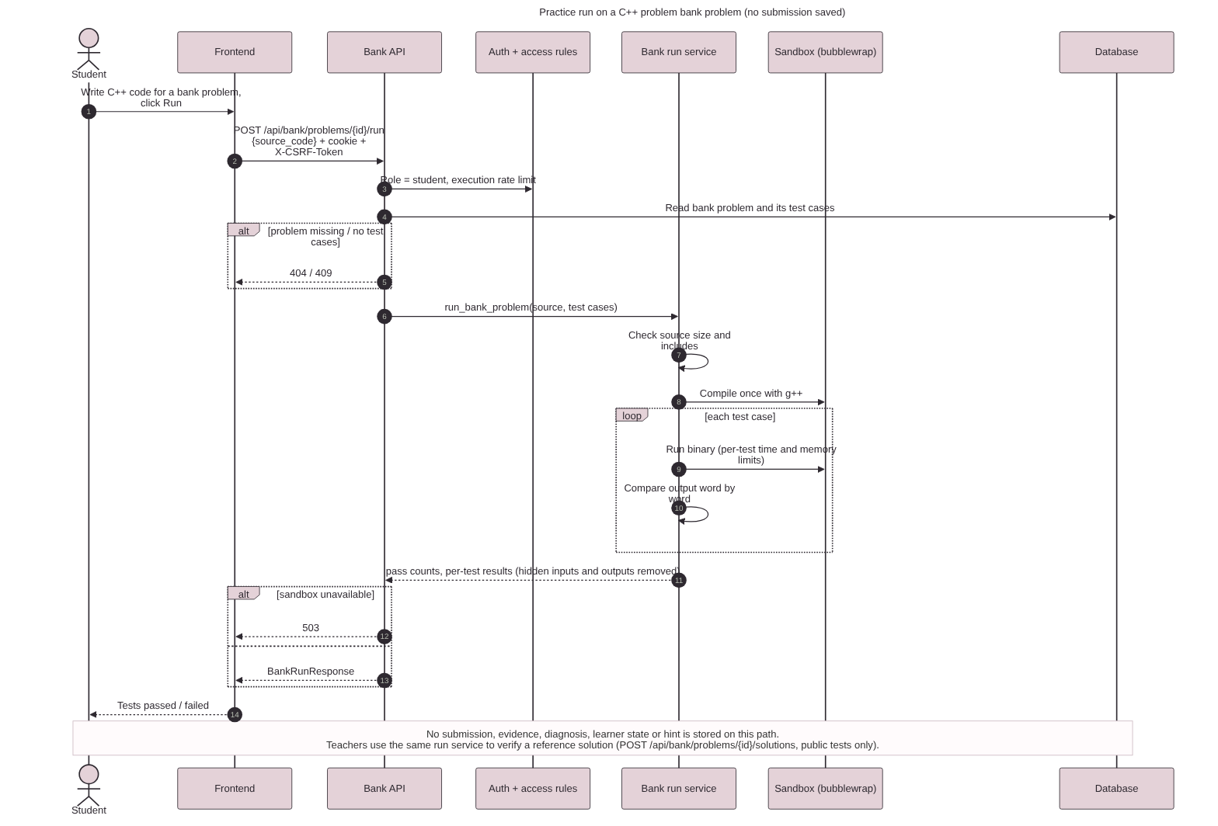 | Show how the misconception state of a student changes over time | Oct 2026 | learner_model/updater.py _compute_state; learner_states and learner_state_history tables | The code sets NEW, PERSISTENT, IMPROVING, RECURRED and TEACHER REVIEW. RESOLVED is defined, but the code cannot set it yet | The diagram shows the code as it is, so it agrees with the demonstration.
Project-specific artefact  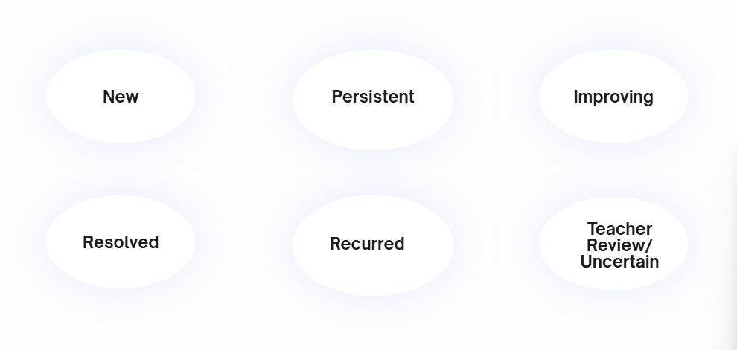 | C++ misconception diagnostic bank: 8 problems for the misconceptions CPP-M01…M08, with variants and hard negatives | Oct 2026 | data/cpp_problems; docs/CPP_MISCONCEPTION_TEST_PLAN.md; scripts/verify_cpp_reference.py | None | N/A

Architecture and interface decisions
Decision | Alternatives considered | Chosen option | Trade-off | Evidence
How the system runs student C++ code | Trusted subprocess (Blueprint POC); Docker; browser execution | g++ in bubblewrap namespaces, with CPU, memory and file limits and a wall-clock stop. In production, the system does not run code without the sandbox | Real isolation without a container daemon. Other development computers use only the limits, which is not safe for untrusted code | execution/sandbox.py; commit c30e5aa; test_sandbox_blocks_files_network_and_env
How the system finds a misconception | Rule-based, XGBoost, LLM | Rule-based (iteration 1)  XGBoost (iteration 2) | Clear and repeatable.. XGBoost must wait for labelled data. LLM not used due to hallucinations | analysis/pipeline.py; diagnosis/confidence.py; config/evidence_weights.yaml
Use of the student history | One model with history features | Two engines, current-only and history-aware. Both run on each submission | A direct comparison for the main research question. The team must keep two code paths | diagnosis/current_only.py; history_aware.py; test_no_future_history_leakage
How the system makes hints | Hints that an LLM writes; one fixed hint for each error | Template hints at 3 levels. The diagnosis confidence selects the level. A hint for a specific problem replaces the general hint. If the diagnosis is uncertain, the student gets a general hint | The hint never shows the solution. The system records each hint. The words are fixed. Each new misconception must have new templates (the planned panel action uses an LLM to write the hints again) | hints/hint_policy.py; hints/templates.py; commit 77518fc
How the system stores teacher corrections | Write over the system diagnosis | Add a teacher_reviews row. The system never changes the original diagnosis | A full audit trail and a measure of agreement. Each read must join two tables. | api/teachers.py; test_teacher_correction_preserves_original_prediction

7 Repository milestone member and team evidence
Commit count alone is not enough. Show what each member designed, implemented, tested, reviewed or integrated and how the work relates to the iteration plan.
Work item | Owner | Task or issue | Commit PR or tag | Files or artefact | Review/test evidence | State
RBAC and authentication changes | Eman, Umaima | None yet (make P1-01) | be7897b, fc16065, af1ce9b | api/auth.py, auth/*, security/* | test_security.py (50 cases) | Done
Monaco C++ editor and UI | Eman, Umaima | None yet (P1-02) | 5619739, 136b384, 4102ed2, 179f325, fd15a4b | frontend/src/* | npm run build; manual check | Done
C++ execution pipeline | Eman | None yet (P1-04) | 8ef0efb | execution/cpp_runner.py, test_runner.py | test_cpp_correct_solution_passes | Done
The execution sandbox and the limits | Umaima, Rayaan | None yet (P1-05) | c30e5aa, 8f0ec5e, e76e6bc | execution/sandbox.py | test_sandbox_timeout_and_output_limits | Done
Submission logging and the classroom API | Umaima | None yet | b88a962, 5e276a3, af1ce9b | api/submissions.py, api/classrooms.py, db/models.py | test_submission_isolation | Done
Evidence, diagnosis and the learner model | Rayaan | None yet (P1-07, P1-08) | bc22b0a, 77518fc | analysis/, diagnosis/, learner_model/, hints/ | test_history_model.py, test_state_transitions.py | Done
The C++ diagnostic problem bank | Rayaan | None yet (P1-09) | be29457 → f6fd216 (12 commits) | data/cpp_problems, scripts/verify_cpp_reference.py | 149/149 checks; test_cpp_problem_bank.py | Done
CI/CD pipeline | Umaima | None yet (P1-13, P1-14) | c983924 → e6b0807 (9 commits), merge 3235c00 | .github/workflows/ci.yml, cd.yml, docs/CI_CD.md | actionlint. The first GitHub run is not complete | Done

Evaluation tag or commit | v0.1.0-mid at main fb94119
Task tracking method | The Git commit history and this worksheet.
Review practice | One team member must review each pull request before the merge
Large or late commits | The initial commit bc22b0a (23 Aug) added 186 files. These files are the proposal-stage POC. AI-assisted scripts in scripts/ made them. The Oct commits are the C++ bank work, divided into small steps. Some commits are seconds apart because the team committed them together after one work session.
Integration responsibility | Umaima connected the frontend to the backend (4102ed2, 179f325, fd15a4b) and added CI/CD. Rayaan connected the problem-bank router (1a5bbeb). There were no merge conflicts.
Team coordination evidence | Regular Google meet and Whatsapp chat communication

8 Testing and early validation
Test or validation ID | Requirement/module | Method and data | Expected result | Actual result | Evidence | Owner
T1 | FR-01 RBAC | pytest backend/tests/test_security.py (50 cases) | All pass | Pass | Test report | Umaima
T2 | FR-05 C++ execution | test_cpp_correct_solution_passes | Reference solution passes | Pass | pytest output | Eman, Umaima
T3 | NFR-01 timeout | test_sandbox_timeout_and_output_limits (infinite loop) | The status is timeout. The system limits the output | Pass | pytest output | Umaima
T4 | NFR-02 isolation | test_sandbox_blocks_files_network_and_env | No access to files, the network or environment variables | Skipped on the local computer (no bubblewrap). It runs in CI | CI run | Umaima
T5 | FR-06 C++ bank | python scripts/verify_cpp_reference.py (77 tests, each run 3 times, with variants and sanitizers) | All checks pass | Pass: 149/149 checks. Median 4.63 ms, maximum 10.34 ms | verification_report.json | Rayaan
T6 | FR-11 learner state | test_state_transitions.py; test_mandatory_contracts.py | One failure does not make PERSISTENT. Two or more supports on different problems make PERSISTENT | Pass | pytest output | Rayaan
T7 | NFR-03: no future information | test_no_future_history_leakage; test_current_only_cannot_access_history | The diagnosis uses only events that occurred before it | Pass | pytest output | Rayaan
T8 | Frontend | npm run lint && npm run build | No lint errors. The build is successful | Pass (5 lint warnings) | CI frontend job | Umaima

Required failure or edge case discussion
Case selected | A student submits a recursive factorial that never changes its argument
Why it matters | Code that does not stop can block the server for all students. It is also evidence for the misconception CPP-M07 (the recursion progresses but the state does not change)
Observed behavior | The system stops the process at the 2,000 ms wall-clock limit (return code -9). The status is timeout. 5 of 9 tests fail. The API continues to operate. The result is the same on 3 runs
Interpretation | This shows that execution fails safely and gives a timeout signal. It does not prove that the student has the misconception. A timeout is one signal that supports it. It is not a diagnosis
Corrective action | No change to the runner is necessary.

Validation quality
Area | Current evidence | Limitation | Next validation action
Functional correctness | 118 backend tests; 77/77 reference tests; 149/149 bank checks | No end-to-end test covers the live C++ path yet | Add an integration test: C++ submission → evidence → diagnosis
Performance/resource use | Reference runs: median 4.63 ms, maximum 10.34 ms, with a 2,000 ms limit | One computer only. No test of parallel runs | Do a load test with 4 parallel executions (the configured maximum)
Model/algorithm quality | N/A | N/A | XGBoost in Iteration 2- dataset prepared for now
User/field validation | Not applicable yet | There are no real students yet | FYP-I student testing: 5–10 students, 10–15 problems (Blueprint section 12.4)
Security/privacy/safety | 50-case security test set; bubblewrap sandbox; production startup checks | The data retention policy is not written | Write the retention and consent policy before the pilot

9 Mid report preparation record
Official report criterion | What the report contains | Section/page | Primary artefact or evidence | Owner | Ready
Report format and required artefacts present | Report structure, front matter, repository link, and mid-report content are included. The evaluation commit and tag references still need reconciliation. | Front matter, pp. 1–5; Section 1, p. 6 | This worksheet; the repository link | Umaima | yes
Problem formulation, R&D and existing solution analysis | The problem, McMining and other tools, the research gap, and the complex challenge are discussed. The knowledge-tracing comparison requires a citation check. | Sections 1.1–1.2, pp. 6–7 | Blueprint section 2; section 9 of this worksheet | Rayaan | Yes
Project vision, scope, modules and success criteria | The project vision, scope, modules, success criteria, and Iteration 1 plan are documented. The roadmap should be checked against the approved proposal. | Sections 1.3–1.5, pp. 7–11 | Section 5 scope table | Eman | yes
Requirements and acceptance criteria | The functional and non-functional requirements, use cases, acceptance checks, and traceability are documented. FR-08 and FR-10 remain partially satisfied. | Sections 2.1–2.4, pp. 13–17 | Section 5 tables | Umaima | Yes
Architecture and component/interface design | The architecture diagram, components, interfaces, and design decisions are documented. | Section 3.1, pp. 18–20 | tracelearn_architecture.png; section 6 decisions | Rayaan | Yes
Data/process/behavior design | The ERD, the activity diagram and the state diagram, with explanations | Sections 3.2–3.4, pp. 20–23 | tracelearn_erd.png; tracelearn_activity.png; state diagram | Umaima | Yes
Implementation documentation of completed module | The setup, main files and functions, implementation decisions, algorithms, and limitations of the core module are documented. | Sections 4.1–4.4, pp. 25–28 | README sections 21–23; section 4 | Eman | Yes
Testing/validation plan and tool/risk disclosure | The test plan and results, dependencies, tools, risks, security/privacy considerations, and GenAI disclosure are documented. Real-student consent and data-retention procedures remain to be established before student testing. | Sections 4.5–4.8, pp. 28–32 | Sections 8 and 10 | All | Yes

Problem formulation R and D and existing solutions
Problem evidence | Beginners give similar incorrect outputs for different reasons. The same false belief also shows in different code over time. Pass/fail grading cannot find the difference
Existing solutions reviewed | McMining (Al-Hossami and Bunescu, EACL 2026): an LLM finds misconceptions in student code. Also pass/fail autograders, and knowledge-tracing work on CSEDM 2019 / ITAP data
Remaining gap | No system uses execution, test and static evidence together with a persistent misconception state for each student. In TraceLearn, this state can improve, become resolved and occur again. A teacher can also correct it
Complex computing challenge | The system must find and update a hidden misconception state from evidence that is incomplete, mixed and sometimes in conflict. It must not use future information. It must explain its result. One submission or one simple rule is not sufficient
Investigative work completed | A synthetic experiment that compares current-only and history-aware diagnosis; an audit of Project CodeNet, PROGpedia and CodeStream; a C++ diagnostic bank of 8 problems, with misconception variants and hard negatives, verified in a sandbox
Claims not yet proven | The team did not prove these claims yet: history improves the diagnosis for real students; the evidence weights are correct; the patterns that the system finds are real misconceptions. Plan: FYP-I student testing, human labelling, then the FYP-II pilot

Implementation documentation checklist
☐ Clean setup and execution instructions
☐ Dependencies and versions
☐ Main files classes functions or modules
☐ Configuration and data requirements
☐ Technical decisions and trade-offs
☐ Known limitations and failure behavior
☐ Link to evaluation commit or tag
☐ Steps allow another person to reproduce the completed module

10 GenAI use external dependencies and research ownership
Classify the effect of GenAI on each materially assisted artefact. Classification is by artefact, so different parts of the same project may have different levels.
Level | Meaning | Student responsibility
L1 Supportive | Grammar, formatting, brainstorming, minor debugging hints or documentation polish. | Student led the work and can explain the result.
L2 Assisted | Significant code, tests, diagrams or report sections were generated with GenAI. | Review, modify, integrate, test and fully explain the output.
L3 Core assist | GenAI produced a major module or central feature. | Demonstrate ownership through design reasoning, testing, correction and modification.
L4 Substituted | GenAI effectively completed work the student cannot independently explain or modify. | Do not present substituted work as independently completed work; disclose it accurately.

GenAI artefact register
Artefact or module | Tool model and level | Assistance and output used | Student contribution | Verification corrections and evidence | Owner
The initial POC | Cursor; L2 | Interface designed by the LLM, UI design | Design improved according to HCI principles, unnecessary clutter removed, functionality iteratively defined. | N/A | Rayaan
The frontend + backend integration | Claude; L3 | Created API calls for the UI and connected them to the functioning backend | Replaced the hardcoded data with the real API, the sign-in and the role routing | npm run build; DEMO_SCRIPT.md procedure | Umaima
The dataset audit and ingestion | OpenCode; L2 | Created scripts to normalize the data | Explained the dataset schema, used the scripts to iteratively normalize data according to requirements | verify_normalized.py; SOURCE_AUDIT_REPORT.md | Rayaan
The C++ diagnostic bank | OpenCode; L3 | Created scripts to make the diagnostic bank | Explained requirements, used the scripts to fix data schema and table structure iteratively | 149/149 checks; 4/4 hard negatives | Rayaan
The sandbox and the security test set | Claude; L2 | sandbox.py and the security tests | Manual testing, Rigorous and iterative QA, initial failed test cases, now passing | All test cases pass after iterative QA | Eman
README and technical documents in ASD-STE100 | Chatgpt; L1 | Text written again in Simplified Technical English | The content and the measured numbers come from the team's runs | Numbers match verification_report.json | All
Planning documents | ChatGPT (confirm); L1 | Architecture, taxonomy, requirements, demonstration script | Diagrams created manually, structure corrected by students when AI misunderstood | The team compared the documents with the approved proposal | All
Worksheet drafts, diagrams and CI/CD workflows | Claude; L2 | Draft tables, diagrams and the CI/CD workflow files | CI/CD pipeline ran multiple times. Changes had to be added till success | Each cell gives a file, a commit or a test; actionlint | Umaima

Prompt journal for significant use
Record significant interactions that materially affected the project. Routine spelling, formatting or trivial lookups do not require exhaustive logging.
Date | Task | Prompt or interaction reference | Output retained | Student review modification or rejection | Evidence
23 Aug 2026 | Generate POC | “I need a POC for TraceLearn, mostly front-end-facing for now — a student can write C++ in Monaco, hit submit, and see test results plus a detected misconception with a hint. Walk me through every use case in detail first (what happens on a correct submission, a syntax error, a repeated mistake, etc.) before you build anything, since the diagnosis logic depends on getting those scenarios exactly right.” | backend/app modules | The owner must write this. The fix_*.py scripts show generated code that failed and that the team corrected | Cursor chat not exportable
5 Oct 2026 | Frontend UI | “Build out the student and teacher dashboards, but this isn’t just UI it needs to actually talk to the backend. Help me wire up the API calls and set up proper endpoints so the frontend isn’t sending raw student code somewhere unsafe or exposing stuff it shouldn’t.” | Layout, components, CSS | The team rejected an overcomplicated UI and focused on ensuring all functionalities were shown and clearly navigated | https://claude.ai/chat/68b644f9-4afc-4a35-9c47-82de27a77de1
7 Oct 2026 | Dataset audit | “Can you go through the C++/programming datasets out there CodeNet, CodeContests, PROGpedia, MC-Miner, that kind of thing and tell me which ones actually have misconception labels vs. which ones just have code, and which would work for training our classifier vs. just tracking attempts over time.” | AUDIT_INVENTORY.md, ingestion scripts | The member had to ensure that the dataset fields were normalized according to the accepted schema accepted during proposal defense | https://claude.ai/chat/812f805e-a40b-47be-aeed-c0b3784565f0
10 Oct 2026 | Mid-evaluation artefacts | “Audit our presentation and blueprint the way a skeptical faculty panel would, then produce a defensible viva Q&A bank and a full speaker script that never overstates planned work as achieved results. Also discuss the various artifacts required for the worksheet” | Diagrams, tables, workflows | The team worked together to scrutinise each diagram given by the AI. Some the ERD and dataset schema diagrams initially faultily joined student and teacher tables together wih wrong relationship. This was resolved. | This worksheet; .github/workflows
4-10 Oct 2026 | Sandbox, security tests, C++ bank | “Define the execution security boundary for untrusted student C++ (isolation, timeouts, resource/filesystem/network limits, abuse tests) and build a C++ problem bank with visible, hidden, diagnostic, and transfer test cases per misconception.” | Accepted test results and more advanced security and RBAC rules | The team had to add a teacher code component after realizing any student could hypothetically create a teacher account without authorization. | https://claude.ai/chat/9199ed24-c591-8152-abb5-efe6583a7a70

Research and citation verification
Claim or research task | Original source | How GenAI assisted | Verification against source | Correction, rejection or outcome | Owner
McMining: automated discovery of misconceptions in student code | Al-Hossami & Bunescu, EACL 2026, pp. 160–178: https://aclanthology.org/2026.eacl-short.10/ | Summarized by AI | 2 LLM tools (McMiner-S, McMiner-M). 67 misconceptions, 1,675 samples (1,063 with a misconception). Samples were made by injecting misconceptions into correct code. Python only | Corrected: “Automated” in the title; 1,063 is not the total. Use as related work only, not as C++ data | Rayaan
McMiner benchmark data and licence | https://github.com/taisazero/mcminer | Summarized by AI | MIT license. JSON files: 501 problems, 67 misconceptions. Python | Confirmed. Reusable with the MIT notice; needs a mapping to the C++ taxonomy | Rayaan
Project CodeNet as a C++ code corpus | https://github.com/IBM/Project_CodeNet | Claude read the README and searched for the license | 13,916,868 submissions, 4,053 problems. C++: 8,008,527 (57%). Judge verdicts only, no misconception labels. Code: Apache-2.0. Data: CDLA-Permissive-2.0 (IBM, 2021) | Corrected: the data license is not Apache-2.0. Use for C++ code only | Umaima
PROGpedia student submissions | https://zenodo.org/records/7449056; doi:10.1016/j.dib.2023.108887 | Summarized by AI | 9,117 submissions, 16 exercises. Java, C, C++, Python. Labels: Accepted, Wrong Answer, Runtime Error. CC BY 4.0 | Corrected: the labels are verdicts, not misconceptions. No attempt order, so no history tests | Umaima
CodeStream: C/C++ attempts in sequence | doi:10.1016/j.dib.2026.112843; https://data.mendeley.com/datasets/n77t7z9zcr/1 | Summarized by AI | 5,482 submissions, 202 students, 46 problems. C 2,112, Java 2,086, C++ 1,284. Has attempt number and verdict sequence. Public download, CC BY 4.0 | Corrected: it also has Java. Use to test the history-aware mode; the team must add the labels | Eman

External tool and dependency record
Tool service library dataset model or hardware | Purpose | Validation performed | Risk or limitation | Fallback | Owner
g++ (C++17) | Compile student code | 77/77 reference tests | The version is different on different computers | Write the version in the README. Use the verified computer for the demonstration | Eman, Umaima
FastAPI, SQLAlchemy, SQLite, Pydantic | API and storage | 118 backend tests | SQLite: only one write operation at a time | The models also operate with PostgreSQL | Umaima, Rayaan
python-jose, passlib (bcrypt) | Sessions and password hashes | test_forged_and_tampered_tokens_rejected | The python-jose project receives few updates | Replace it with PyJWT in auth/core.py | Eman, Umaima
React 19, Vite 8, Monaco 0.52 | The student and teacher UI | npm run build in CI | Fast-moving major versions | Lockfile and npm ci | Umaima
Project CodeNet, PROGpedia, CodeStream | C++ data for ingestion | File-level audit; verify_normalized.py | No misconception labels. Confirm the licences | The team's own C++ variants and labels | Rayaan

Sensitive data handling | The application database on the server stores the student email, display name and submitted code. Research data uses separate synthetic students. The team must write the consent, retention and deletion policy before tests with real students
Security controls | JWT in an httpOnly cookie; a CSRF token on each write; bcrypt hashes; logout cancels the tokens (token_version); rate limits; security headers; a CORS allow-list; production startup checks (SECRET_KEY of 32 or more characters, demo endpoints off);
Licensing and attribution | Open-source libraries under their own licences (FastAPI, React, Monaco: MIT). McMiner: MIT. Confirm the licences of CodeNet, PROGpedia and CodeStream. The report gives credit to all datasets
External availability risk | The system uses no external API at runtime. If the frontend host stops, run the frontend on a local computer. If bubblewrap is missing, the server does not run code. It does not run code in an unsafe mode
Responsible GenAI use | Highest level: L3 (initial POC backend). The team verified the code with automated tests. Mistakes found: the code cannot set the RESOLVED state, this has been fixed; the C++ build still has Python hint templates; the generated planning documents had a Python scope, which the team changed to C++

11 Individual evidence Member 1
Complete this section individually. The supervisor may ask the member to locate, explain, test or modify any claimed contribution during the meeting.
Name and registration number | Rayaan Raza, i23-0535
Repository identity | Rayaan-Raza
Primary technical ownership | Evidence extraction, diagnosis, the learner-state model and the C++ diagnostic bank
Most substantial contribution | The C++ diagnostic problem bank: 8 problems, 77 tests, misconception variants, hard negatives and a sandbox verifier (149/149 checks)
Problem personally resolved | The C++ problems were not reachable by a student. At the time of my first bank, data/cpp_problems held 8 curated problems, but nothing wrote them into the problems table. The README stated it plainly: "No loader writes them to the problems table. A student cannot practice on them." The bank was research data with no path to the practice site.  I traced the gap to three places that had to agree. The bank schema needed request and response models (backend/app/schemas/bank.py). The bank rows needed a loader that turns the JSON into problems, test_cases, problem_hints and p roblem_solutions rows (scripts/load_problem_bank.py, later scripts/seed_cpp_diagnostics.py). The API needed endpoints that expose the bank and run a reference solution without ever sending problem_solutions to a student (backend/app/api/bank.py). I also added per-test execution limits, because a diagnostic test for CPP-M07 must be allowed to run to the timeout, while a normal test should stop sooner.  I verified this end to end from a clean database. python scripts/seed_database.py loaded 6 problems and 36 test cases. python scripts/seed_cpp_diagnostics.py loaded 40 problems, 305 test cases, 120 hints and 40 reference solutions, giving 46 problems total. I then registered a real student, submitted a correct C++ solution to CP01, and ran it through POST /api/submissions/{id}/run-and-analyze. The pipeline compiled it with g++ -O2 -std=c++17, ran all 9 test cases, returned execution_status: "success", and wrote the test_results and evidence_items rows. Every foreign-key check reported zero orphans. Commits f117bc4, 649ed3a, 0fcaa27, 1a5bbeb, 8f0ec5e, e76e6bc. agnosis, reasoning and result
Highest GenAI assistance level | L4 for one artefact, L2 for the rest — and the boundary is clean.  - L4: the bulk content of data/cpp_problems and data/cpp_diagnostics. The 40 problems, their 305 test cases, the 32 misconception variants and the 120 scaffolding hints were written by a generator script (scripts/build_cpp_diagnostics.py) that I directed and reviewed. I did not hand-author that content.  - L2: everything I claim as engineering. scripts/verify_cpp_reference.py, scripts/verify_cpp_diagnostics.py, backend/tests/test_cpp_problem_bank.py, backend/tests/test_cpp_diagnostics_bank.py, backend/tests/test_cpp_end_to_end.py, backend/app/diagnosis/cpp_mapping.py, backend/app/api/bank.py, scripts/load_problem_bank.py, scripts/seed_cpp_diagnostics.py, backend/app/execution/cpp_runner.py and the per-test limits. For these I specified the requirement, wrote or rewrote the logic myself, and checked every result against an independent source.  Affected artefact for the L4 disclosure: data/cpp_diagnostics/problems.json, data/cpp_problems/problems.json, and the files under data/cpp_problems/variants/ and data/cpp_diagnostics/variants/.
AI-generated output reviewed | Material output: the 305 expected-output files in the diagnostic bank.  A generated expected output is useless if it is wrong in a way that the generator also believes. I therefore built a second, independent model and made the tests compare against it rather than against the bank file directly.  backend/tests/test_cpp_diagnostics_bank.py::test_expected_output_matches_an_independent_model recomputes the expected output for every test case from the problem statement alone, reads the committed .out file, and asserts byte equality. backend/tests/test_cpp_problem_bank.py holds a third model for the original 8 problems. Three independent paths must agree.  How I evaluated it, and what it caught. The check failed on the first run: data/cpp_diagnostics/tests/public/CP11/03.out held "" where the independent model produced "\n". A whole class of generated files had lost its trailing newline during normalisation. I traced it to the normaliser, fixed it in 60f6ffe ("compare variant lines by multiset and normalize model output"), and re-ran. 48 passed for the diagnostics bank, 58 passed for the diagnostics bank and the end-to-end suite together. The SHA-256 manifest checksums in data/cpp_diagnostics/manifest.json and data/cpp_problems/tests/manifest.json are verified by test_manifest_checksums_match_the_files, so a silent file edit cannot pass either.
Error or limitation identified | The C++ evidence never reached a diagnosis. This was the most serious defect I found, and it was mine.  The bank was complete, the runner worked, the evidence was extracted — and every single C++ submission was diagnosed UNCERTAIN with confidence 0.2. I found the cause by running the real variant files through the live API and reading the evidence_items rows.  backend/app/diagnosis/rules.py::aggregate_scores built its score dictionary from ALL_MISCONCEPTIONS, which held only the three Python codes. So every C++ evidence record fell through the if mid and mid in scores test and was silently dropped. Four more gaps compounded it: apply_evidence_weights had no mapping for any CPP_* code, so they all took the 0.05 default; LearnerStateUpdater.update_from_diagnosis returned early for anything outside ALL_MISCONCEPTIONS, so no learner state was ever written; TestAnalyzer.TAG_TO_MIS recognised only four diagnostic tags, none of which the C++ bank emits; and the taxonomy module had no CPP-M01 to CPP-M08 codes at all.  Measured before the fix: 8 of 8 misconception variants diagnosed UNCERTAIN, learner_states 0 rows, learner_state_history 0 rows, and no diagnosis ever naming a C++ misconception.  How I handled it. I added backend/app/diagnosis/cpp_mapping.py as the single module that knows both vocabularies — the bank's CPP-M01…CPP-M08 and the backend's CPP_* codes — with an explicit table that states why each row exists. I extended the taxonomy with CPP_RANGE_CHECK and CPP_STALE_EXIT, two beliefs that had no backend code, and added SCORED_MISCONCEPTIONS as the list the diagnosis, the aggregator and the learner model all read. I added backend/tests/test_cpp_end_to_end.py, whose mapping tests read the bank at run time and fail if a new tag or misconception has no entry, so this cannot fail silently again.  Measured after the fix, from the live API: CP01 → CPP_LOOP_BOUNDARY at 1.0, CP02 → M02_INDEX_VALUE at 1.0, CP03 → M03_MISSING_RETURN at 1.0, CP04 → CPP_ARRAY_BOUNDS at 0.7, CP05 → CPP_RANGE_CHECK at 0.7, CP06 → CPP_ASSIGN_VS_COMPARE at 0.95, CP07 → CPP_MISSING_BASE_CASE at 0.35, CP08 → CPP_STALE_EXIT at 0.7. learner_states and learner_state_history now receive rows. Commit 12c3c26.
Substantive modification made | I changed how the diagnostic tag is resolved, because the old lookup was wrong in a way that produced no evidence at all.  TestAnalyzer resolved a failing diagnostic test through a single flat dictionary, TAG_TO_MIS, that knew four tag names. The C++ bank emits a different set — inclusive_upper_bound, value_not_position, print_in_place_of_return, index_equal_to_size, chained_comparison, assignment_in_condition, no_progress, exit_condition_not_updated. None of them were in the table, so a failed diagnostic test produced an evidence record with misconception_id: None and direction: "neutral". The test had fired correctly and then thrown the result away.  The tag names are also genuinely ambiguous across languages: upper_boundary means an M01 test in the Python bank and a CPP-M01 test in the C++ bank. A flat table cannot be correct for both.  I replaced it with a language-keyed table, TAG_TO_CODE["python"] and TAG_TO_CODE["cpp"], resolved through one function, code_for_diagnostic_tag(language, tag). I also caught a concrete data bug while writing it: the Python bank emits the tag index_value, but the old table held index_vs_value, so four Python diagnostic tests were silently producing no evidence. Both spellings are now mapped. test_every_cpp_bank_tag_maps_to_a_scored_code and test_every_python_bank_tag_maps_to_a_scored_code read the banks at run time and fail if a tag used in data has no mapping.
Task demonstrable without GenAI | I can run the evidence extraction pipeline on a faulty C++ submission and explain every record it produces, live, without any AI tool.  I can open backend/app/analysis/pipeline.py and walk the stages in order: static analysis (Python ast module, or C++ regex plus g++ -Wall -Wextra -fsyntax-only warnings in a subprocess with a 3-second budget), test analysis, runtime analysis, diff analysis against the previous attempt on the same problem, then history analysis. I can explain why extraction and interpretation are separate modules, and why apply_evidence_weights and fuse_diagnosis sit on the interpretation side.  Then I can demonstrate it. On the off-by-one loop for (int i = 0; i <= n; i++), the pipeline emits CPP_LOOP_LE_BOUND with misconception_id: CPP_LOOP_BOUNDARY, direction: support, weight 0.3. I can show the test_results rows holding the actual and expected output per test case, the evidence_items rows that were written, and the two diagnoses rows for current_only and history_aware. I can also run test_no_future_history_leakage, which proves the history-aware mode cannot read a submission that happens after the current one.
Live modification readiness | I am prepared to add a ninth C++ misconception end to end, during the meeting.  I would do it in four steps, each immediately checkable. Add the code to SCORED_MISCONCEPTIONS in backend/app/diagnosis/taxonomy.py so the aggregator and the learner model both see it. Add a row to BANK_TO_BACKEND and the required entries to TAG_TO_CODE["cpp"] in backend/app/diagnosis/cpp_mapping.py. Add a detector in backend/app/analysis/cpp_static.py, following the existing pattern of a compiled regex in a module-level function so it runs inside the worker subprocess and inherits the 3-second budget. Then run backend/tests/test_cpp_end_to_end.py, which reads the bank at run time and fails if the new tag is unmapped, and backend/tests/test_cpp_diagnostics_bank.py for the bank shape.  I can equally explain the alternative I rejected: mapping the new belief onto an existing near-neighbour code instead of adding one. That keeps the label set small but it makes the diagnosis answer a question the student was not asked, which defeats the purpose of a diagnostic bank.
Next committed work | Build a machine-readable misconception registry. The taxonomy is currently bare string constants in two vocabularies joined by a mapping table. The required fields such as unique code, short title, plain-language description and category tag , exist only as prose in docs/TraceLearn_Dataset_Agent_Brief.md.md lines 786 to 793 and docs/CPP_MISCONCEPTION_TEST_PLAN.md section 5.1 to 5.8. I will add backend/app/diagnosis/registry.py (or a JSON file plus a misconceptions table) holding ID, title, description and category for M01 to M03 and CPP-M01 to CPP-M08, with a test that fails if a scored code has no registry entry. Target: 31 October 2026.

Contribution | Repository or artefact | Commit PR issue or version | Test or result | Role
C++ diagnostic bank | data/cpp_problems | be29457, 846c26f, 93ffdc0 | 149/149 checks | Designed, implemented, tested
The bank verifier and test set | scripts/verify_cpp_reference.py; tests/test_cpp_problem_bank.py | ec9b8a0, ffde987 | 21 tests pass | Implemented, tested
The problem bank API and loader | api/bank.py; scripts/load_problem_bank.py | f117bc4, 649ed3a, 0fcaa27, 1a5bbeb | test_problem_bank.py | Implemented, integrated
Per-test execution limits | execution/cpp_runner.py | 8f0ec5e, e76e6bc | test_sandbox_timeout_and_output_limits | Implemented
Initial POC: evidence, diagnosis and the learner model | backend/app/analysis, diagnosis, learner_model | bc22b0a | test_history_model.py | Designed, implemented

Member declaration
☐ I can explain the architecture and data flow relevant to my work.
☐ I can locate and explain my implementation and tests.
☐ I can explain a design decision and its alternatives.
☐ I have accurately disclosed material GenAI and external tool assistance.
☐ I checked citations and research claims against the original sources.
☐ I reviewed, tested and corrected generated outputs before retaining them.
☐ I can modify the work attributed to me during technical questioning.
☐ I have not represented L4 substituted work as independently completed work.
☐ The evidence above accurately represents my contribution.

Technical growth record
Record three technical questions you cannot yet answer confidently. These questions may be revisited at a later evaluation to assess growth.
Technical question | Why it matters to my work | Learning and evidence plan | Target date
- How can I obtain a real C++ AST for evidence extraction without adding a native libclang dependency to the container? Is clang -Xclang -ast-dump=json parseable robustly, and what does the regex approach actually miss in both directions? | My evidence extractor claims to find ForStatement and BinaryOperator: <= nodes. It cannot — it is a regex. A supervisor will ask what a real AST would find that mine does not, and I cannot yet answer with a measured false-positive and false-negative count. | Prototype both parsers against the 32 misconception variants and the 120 hard negatives. Count the disagreements. Decide from the measurement, not from preference. Record the result in docs/. | 7 Nov 2026
- What is the correct verdict vocabulary for a stdin/stdout judge, and how should the current 5-value ExecutionStatus map onto it? | Right now a link failure (no main) is reported as syntax_error, and a wrong answer is reported as runtime_error. So the status field cannot distinguish "did not compile" from "compiled and crashed" from "compiled, ran, and was wrong". The teacher review page and the evidence weighting both read this field. | Read the standard competitive-judge verdict set (AC, WA, CE, RE, TLE, MLE, OLE). Map each to the pipeline's internal states. Add a diagnostic test that produces a wrong answer and asserts the new verdict. | 7 Nov 2026
- Is cross-language misconception identity consistent? CPP-M02 maps to M02_INDEX_VALUE and CPP-M03 to M03_MISSING_RETURN, so a C++ and a Python error can share one learner state. But CPP-M01 maps to CPP_LOOP_BOUNDARY, not to M01_LOOP_BOUNDARY, so the same belief cannot be seen across languages. What is the actual rule? | The research claim is that recurrence across different problems indicates a persistent misconception. If the identity rule is arbitrary, the cross-problem evidence in HistoryAnalyzer is measuring an artefact of my mapping choices rather than the student's knowledge. | Write down the criterion for when a C++ and a Python belief are the same misconception. Test it against all 8 bank codes. If the criterion does not justify the current asymmetric mapping, change the mapping and re-run the end-to-end suite. | 14 Nov 2026

Member confirmation | Date
Mohammad Rayaan Raza | 10 October 2026

11 Individual evidence Member 2
Complete this section individually. The supervisor may ask the member to locate, explain, test or modify any claimed contribution during the meeting.
Name and registration number | Umaima Zeeshan, i23-0790
Repository identity | maima2024
Primary technical ownership | The execution sandbox and security, the frontend connection, CI/CD
Most substantial contribution | The bubblewrap execution sandbox and the 50-case security test set. These protect the full API
Problem personally resolved | The backend did not start on FastAPI 0.115. The startup error came from the routes that send status 204 (logout and remove-member). FastAPI 0.115 does not accept a 204 route that declares a response body. I set response_class=Response on these routes and made them return an empty Response(status_code=204). The backend then started, and logout and remove-member worked. Commit 1a0ecc4.
Highest GenAI assistance level | L3: the CI/CD pipeline (.github/workflows/ci.yml, cd.yml, docs/CI_CD.md). Claude wrote the workflow files. I gave the requirements, then reviewed, merged and pushed them.
AI-generated output reviewed | The CI workflow that Claude wrote. I checked it in three ways: actionlint (a workflow checker), a local run of the packaging and smoke-test steps, and the first real GitHub run. Run 38052478077 passed all 3 jobs (frontend, backend on Python 3.11, backend on Python 3.12).
Error or limitation identified | The sandbox isolation operated only on Linux with bubblewrap. On Windows there was no isolation, and one sandbox test failed when bubblewrap is missing. To handle this: in production, REQUIRE_SANDBOX stops execution when bubblewrap is missing, and CI runs the sandbox tests on Ubuntu with user namespaces turned on. Later Eman ensured that the project works entirely on Windows, so we removed the need for Linux env. I also found that the CI checks are not required, because main has no branch protection. I recorded this in the FR-10 evidence.
Substantive modification made | The UI prompt for Cursor said “everything hardcoded”. I did not keep that. I wrote the API client, the sign-in, the role-based routing and the real data calls for all student and teacher pages (4102ed2, 179f325, fd15a4b).
Task demonstrable without GenAI | I can explain the four layers of the sandbox: bubblewrap namespaces, resource limits, the wall-clock stop and the concurrency limit. I can also run test_sandbox_blocks_files_network_and_env and explain each check in it.
Live modification readiness | I can change the execution limits in backend/app/config.py (execution_timeout_seconds, max_output_bytes), then run test_sandbox_timeout_and_output_limits and explain the result.
Next committed work | - Change the hint policy (hints/hint_policy.py) from 3 template levels to the 5 levels in Blueprint section 13.1. The policy selects the level from the diagnosis confidence, the learner state and the earlier hints.  - Add a first LLM step that writes the template hints again in clear words. It must not show the solution. This closes the panel action.  - Complete the platform and UI work: show the hint level and the learner state on the student result page (Gantt: Platform & User Interface, ends Dec).

Contribution | Repository or artefact | Commit PR issue or version | Test or result | Role
Execution sandbox | backend/app/execution/sandbox.py | c30e5aa | test_sandbox_* cases | Designed, implemented, tested
The authentication changes and the classroom API | auth/*, security/*, api/classrooms.py | fc16065, af1ce9b, 5e276a3 | test_security.py | Implemented, tested
Submission logging with evidence capture | analysis/pipeline.py; api/submissions.py | b88a962 | test_submission_isolation | Implemented
The frontend connected to the backend | frontend/src/api, pages/student, pages/teacher | 4102ed2, 179f325, fd15a4b | npm run build | Implemented, integrated
CI/CD pipeline | .github/workflows/ci.yml, cd.yml | c983924 → e6b0807; merge 3235c00 | actionlint; the first run is not complete | Designed, implemented

Member declaration
☐ I can explain the architecture and data flow relevant to my work.
☐ I can locate and explain my implementation and tests.
☐ I can explain a design decision and its alternatives.
☐ I have accurately disclosed material GenAI and external tool assistance.
☐ I checked citations and research claims against the original sources.
☐ I reviewed, tested and corrected generated outputs before retaining them.
☐ I can modify the work attributed to me during technical questioning.
☐ I have not represented L4 substituted work as independently completed work.
☐ The evidence above accurately represents my contribution.

Technical growth record
Record three technical questions you cannot yet answer confidently. These questions may be revisited at a later evaluation to assess growth.
Technical question | Why it matters to my work | Learning and evidence plan | Target date
Question 1: How can Windows limit the memory and CPU of a student program? Windows has no resource limits, so the runner only stops a program at the wall-clock limit. | A program that allocates too much memory can stop the demonstration computer. On Windows the system has no memory limit now. | Read the Windows Job Object documentation. Put the student process in a Job Object with a memory and process limit. Test with a C++ program that allocates 2 GB. Record the result. | 24 Oct 2026
Question 2: What can student code read on Windows when it runs without isolation? Can it open the database file or .env? | NFR-02 says that the code cannot read host files. On Windows this is not true now, and the panel can ask. | Write a C++ probe that tries to open tracelearn.db and .env on Windows. Record the result. Change the NFR-02 evidence to agree with the result, and use only trusted fixtures in the demonstration. | 31 Oct 2026
Question 3: Must execution move to a separate Linux worker behind one stable contract, so that development stays on Windows and production stays isolated? | Blueprint section 6.4 asks for a stable execution contract. The Railway deployment must have real isolation. | Read Blueprint section 6.4. Make a small prototype of an execution worker in the Linux container. Measure the time that one test run takes through the worker. | 7 Nov 2026

Member confirmation | Date
Umaima Zeeshan | 10th October, 2026

11 Individual evidence Member 3
Complete this section individually. The supervisor may ask the member to locate, explain, test or modify any claimed contribution during the meeting.
Field | Entry
Name and registration number | Eman Ihsan, i23-0530
Repository identity | eman06
Primary technical ownership | The first RBAC version (JWT, student and teacher roles), the C++ mode of the Monaco editor, and the server-side C++ execution pipeline (cpp_runner.py, test_runner.py).
Most substantial contribution | The server-side C++ execution pipeline . It compiles the code with g++ once, runs each test case through stdin, compares the output token by token and maps the result to a status.
Problem personally resolved | Candidate: C++ submissions failed on Windows with “Execution failed to start”.This was because in windows a relative program path is looked up from the server’s folder, not from the folder the program was compiled into. Fix: make the path absolute when bubble wrap is not used (in sandbox.py). Result: C++ runs on Windows; 189 tests pass.
Highest GenAI assistance level | L2, for security testing- repetitive and edge cases were fetched by Claude.
AI-generated output reviewed | The change that marks a submission as NO_MISCONCEPTION when every test passes. I checked it three ways: (1) the full test suite passed ; (2) all C++ reference solutions and all 4 hard negatives were run through the live app; (3) the synthetic experiment was run before and after the change. Diagnosis accuracy went from 0.47 to 0.87.
Error or limitation identified | A GenAI change stopped sending attempts to teacher review when diagnostic tests disagreed. It broke the team’s labelled case SYN005, which must go to review. I rejected the change and kept the original rule and recorded it as an open design decision.
Substantive modification made | In RBAC I designed the role model myself: UserRole on the User table, JWT tokens that carry the role, and two FastAPI dependencies, get_current_user (401 for a missing or bad token) and require_teacher (403 for students). Each endpoint uses these to check the role. In Monaco I switched the editor from Python mode to C++ mode, with C++ starter text, so it matches the C++ execution pipeline I built. In the Iteration 1 QA I did not accept the generated output as it was. I rejected a scoring change that broke the labelled SYN005 case. I chose to hide the Python problems and remove the Language column and the explanation text. I rewrote the traceability and FR/NFR tables, so that each piece of evidence matches the test it names.
Task demonstrable without GenAI | I can explain the RBAC flow without help. Sign-in checks the bcrypt password hash and issues an HS256 JWT with sub and role. Each protected route depends on get_current_user, which decodes the token and returns 401 if it is bad, and teacher routes add require_teacher, which returns 403 for a student. I can show this live with test_teachers_cannot_create_submissions and test_research_endpoints_teacher_only. I can also trace one C++ submission: Monaco in C++ mode → POST /api/submissions → compile_cpp → CppCompileSession.run for each test → the status (syntax_error, timeout, runtime_error or wrong_answer).
Live modification readiness | I can change the per-test time limit or the compile flags in cpp_runner.py, or add a new status. For example, report MemoryLimitExceeded as its own status, then run the C++ tests to show it works.
Next committed work | Add C++ tests for the output limit and the timeout (now they are tested only with Python code), and protect the main branch so CI must pass before a merge. Due: November 20

Contribution | Repository or artefact | Commit | Test or result | Role
Server-side C++ execution pipeline | execution/cpp_runner.py; execution/test_runner.py | 8ef0efb | test_cpp_correct_solution_passes | Designed, implemented
RBAC with JWT and student and teacher roles | api/auth.py; auth/core.py; auth/dependencies.py; screens/Auth.tsx | be7897b | test_security.py | Implemented
Monaco editor in C++ mode | StudentSubmission.tsx at the time; now components/CodeEditor.tsx | 5619739 | Manual check: typing and submitting C++ in the browser on 10 Oct | Implemented
Iteration 1 QA fixes | Backend, frontend, tests (40 files) | fb94119 | 191/191 tests on Linux; CI run 38061789808 passed | Directed and reviewed (GenAI L3)

Member declaration
☐ I can explain the architecture and data flow relevant to my work.
☐ I can locate and explain my implementation and tests.
☐ I can explain a design decision and its alternatives.
☐ I have accurately disclosed material GenAI and external tool assistance.
☐ I checked citations and research claims against the original sources.
☐ I reviewed, tested and corrected generated outputs before retaining them.
☐ I can modify the work attributed to me during technical questioning.
☐ I have not represented L4 substituted work as independently completed work.
☐ The evidence above accurately represents my contribution.

Technical growth record
Record three technical questions you cannot yet answer confidently. These questions may be revisited at a later evaluation to assess growth.
Why does g++ -O2 remove loops and allocations, and how does that affect timeout and memory tests? | It broke the memory-limit test | Compile small programs at -O0 and -O2 and compare them | 29/Sep/26
How does Monaco load C++ syntax highlighting, and can it show g++ compile errors inside the editor? | I set Monaco to C++ mode. Showing errors in the editor would help students fix code faster. | Read the Monaco markers API; show one g++ error as a marker in CodeEditor.tsx | 25/Sep/26
How do I make attempt numbers safe when submissions arrive at the same time? | Submission logging depended on this race | Read the SQLAlchemy docs on unique constraints; extend race.py | 1/Oct/26

Member confirmation | Date
Eman Ihsan | 10/10/26

12 Evidence index and final check

Form 2 evidence index
Official criterion | Where addressed | Primary evidence | Owner
Previous proposal actions addressed | Worksheet section 2 | Panel email (14 Sep 2026) | All
Iteration plan and work breakdown progress | Worksheet section 3 | The commits in sections 3 and 7 | Umaima
Live prototype with core module demo | Worksheet section 4; live demonstration | The build at tag v0.1.0-mid; verification_report.json | All
Requirements and acceptance criteria quality | Worksheet section 5 | The requirement and traceability tables; backend/tests | Eman
Design artefacts and design evolution | Worksheet section 6 | tracelearn_architecture.png, tracelearn_erd.png, tracelearn_activity.png, state diagram | Umaima
Repository, milestone and member evidence | Worksheet section 7 | The commit history; tag v0.1.0-mid; GitHub issues | All
Testing and early validation | Worksheet section 8 | The pytest report artifact; the CI run; the verification report | Rayaan, Eman
Team dynamics and tool ownership | Worksheet section 10–11 | The GenAI register, the prompt journal, the individual sections | All

Form 3 evidence index
Official criterion | Where addressed | Primary evidence | Owner
Report format and required artefacts present | Mid report; worksheet | The report and this worksheet | Umaima
Problem formulation, R&D and existing solution analysis | Mid report, problem section; worksheet section 9 | Blueprint section 2; the cited papers (after verification) | Rayaan
Project vision, scope, modules and success criteria | Mid report, scope section; worksheet section 5 | The scope table; the success criteria | Eman
Requirements and acceptance criteria | Mid report, requirements section; worksheet section 5 | The FR/NFR and traceability tables | Umaima
Architecture and component/interface design | Mid report, architecture section; worksheet section 6 | tracelearn_architecture.png; decision table | Rayaan
Data/process/behavior design | Mid report, design section; worksheet section 6 | tracelearn_erd.png; tracelearn_schema.dbml; the activity and state diagrams | Umaima
Implementation documentation of completed module | Mid report, implementation section; worksheet section 4 | README sections 21–23; the core module files | All
Testing/validation plan and tool/risk disclosure | Mid report, testing section; worksheet sections 8 and 10 | The test table; the dependency record; the GenAI register | All

Group confirmation
☐ The live prototype is available and uses the stated evaluation version.
☐ Every proposal action is recorded, including incomplete actions.
☐ The mid report and worksheet match the repository and current design.
☐ Acceptance criteria are measurable and traceable to evidence.
☐ At least one edge or failure case is ready for discussion.
☐ Member ownership is supported by more than commit counts.
☐ Every materially GenAI-assisted artefact has an L1-L4 classification and named owner.
☐ Significant prompts, retained outputs, verification and corrections are recorded.
☐ Research claims and citations have been checked against original sources.
☐ External dependencies, tools, risks, fallbacks and limitations are disclosed.
☐ Each member has recorded three technical growth questions.
☐ Each member is prepared to defend and modify their claimed work.
Role | Confirmation | Date
Member 1 | Umaima Zeeshan | 10th October, 2026
Member 2 | Rayaan Raza | 10th October, 2026
Member 3 | Eman Ihsan | 10th October, 2026

