TraceLearn
Misconception-Aware Programming Practice Platform
FYP MASTER DESIGN AND IMPLEMENTATION BLUEPRINT

Contents
1. Executive Summary 5
2. Problem Definition, Research Gap, and Contribution 6
2.1 Problem statement 6
2.2 Why a database alone is insufficient 6
2.3 Why XGBoost is useful compared with simple descriptive statistics 6
2.4 Research and engineering contribution 6
2.5 Relation to McMining 7
3. Full FYP Scope and Product Capabilities 7
3.1 In scope 7
3.2 Explicitly not the core scope 7
3.3 Product roles 7
4. End-to-End Student, Teacher, and System Workflows 8
4.1 Classroom lifecycle 8
4.2 Student flow 8
4.3 Teacher flow 8
5. Full System Architecture 9
5.1 Layer responsibilities 9
5.2 Model responsibility separation 10
6. Browser Code Editor and Server-Side Code Execution 10
6.1 Monaco Editor 10
6.2 Execution location 11
6.3 Current no-Docker assumption 11
6.4 Product execution target 11
6.5 Test taxonomy 11
7. Evidence Extraction and Representation 11
7.1 Evidence categories 11
7.2 Evidence item contract 12
7.3 Evidence fusion principles 12
8. Misconception Taxonomy 13
8.1 Label misconceptions as false beliefs, not only error names 13
8.2 Proposed initial taxonomy structure 13
9. XGBoost Misconception Classifier 13
9.1 Role in the final system 13
9.2 Feature design 14
9.3 What should be excluded from the first XGBoost model 14
9.4 Training strategy 14
9.5 Baselines 14
10. Persistent Temporal Learner Model 15
10.1 One shared algorithm, individual student states 15
10.2 State semantics 15
10.3 Inputs to temporal update 15
10.4 Example update formulation 16
10.5 Transition safeguards 16
10.6 Optional learned temporal extension 16
11. Database Architecture and Data Contracts 16
11.1 Core tables 17
11.2 Data immutability and auditability 18
11.3 PostgreSQL vs SQLite 18
12. Dataset Strategy and Data Engineering 18
12.1 What data is needed for each subsystem 18
12.2 McMining as a labelled misconception source 19
12.3 Public Python longitudinal sources 19
12.4 Local TraceLearn data targets 19
12.5 Common normalized schema 20
12.6 Splitting and leakage prevention 20
12.7 C/C++ contingency datasets 20
13. Adaptive Hints, Remediation, and Transfer 21
13.1 Minimum useful intervention 21
13.2 Remedial and transfer problem graph 21
13.3 LLM boundary 21
14. Teacher Decision Support and Human Correction 21
14.1 Evidence-first dashboard 21
14.2 Human correction semantics 22
15. Evaluation and Experimental Methodology 22
15.1 Research questions 22
15.2 Experiments and baselines 22
15.3 Temporal evaluation labels 23
15.4 Metrics beyond accuracy 23
16. Security, Privacy, Reliability, and Deployment 23
16.1 Security boundary 23
16.2 Privacy 23
16.3 Reliability and observability 24
16.4 Deployment architecture 24
17. Scaling to Real Classrooms 24
17.1 Scaling the temporal model to 100+ students 24
17.2 Concurrency strategy 24
18. Proposal-Stage POC as a Project Milestone 24
18.1 POC objective 25
18.2 POC scope 25
18.3 Why not train XGBoost on only the POC data 25
18.4 POC comparison 25
18.5 POC success criteria 25
19. Full Development Roadmap 26
19.1 Phase plan 26
19.2 Gating rules 26
20. Risks, Fallbacks, and Scope Control 27
21. Three-Person Work Distribution 27
22. Deliverables and Acceptance Criteria 27
22.1 Required by December 27
22.2 Required by mid-April / final 28
23. Defense-Ready Positioning 28
Appendix A. Proposed Database Tables 29
Appendix B. Initial XGBoost Feature Dictionary 29
Appendix C. Temporal Transition Rules (Initial, to Validate) 30
Appendix D. External Dataset Register 30
Appendix E. API / Service Outline 31
Appendix F. Terminology 31
References and Source Basis 32

1. Executive Summary
TraceLearn is a classroom-based programming practice platform for beginner Python students (can be shifted to cpp based on stakeholder analysis, however the main process still remains the same). It is designed to move beyond pass/fail grading by converting each programming attempt into structured evidence about what the learner may misunderstand, how strongly that interpretation is supported, whether the pattern persists across time and related problems, and what intervention should happen next.
The complete FYP consists of a student coding environment, backend code execution and testing, multi-source evidence extraction, an XGBoost-based misconception classifier, a persistent temporal learner model, adaptive hint/remediation logic, a teacher evidence and correction workflow, a longitudinal data store, and a controlled evaluation framework. The platform is necessary infrastructure; the technical and research contribution lies in the diagnosis and learner-modelling workflow rather than in the editor or dashboard alone.
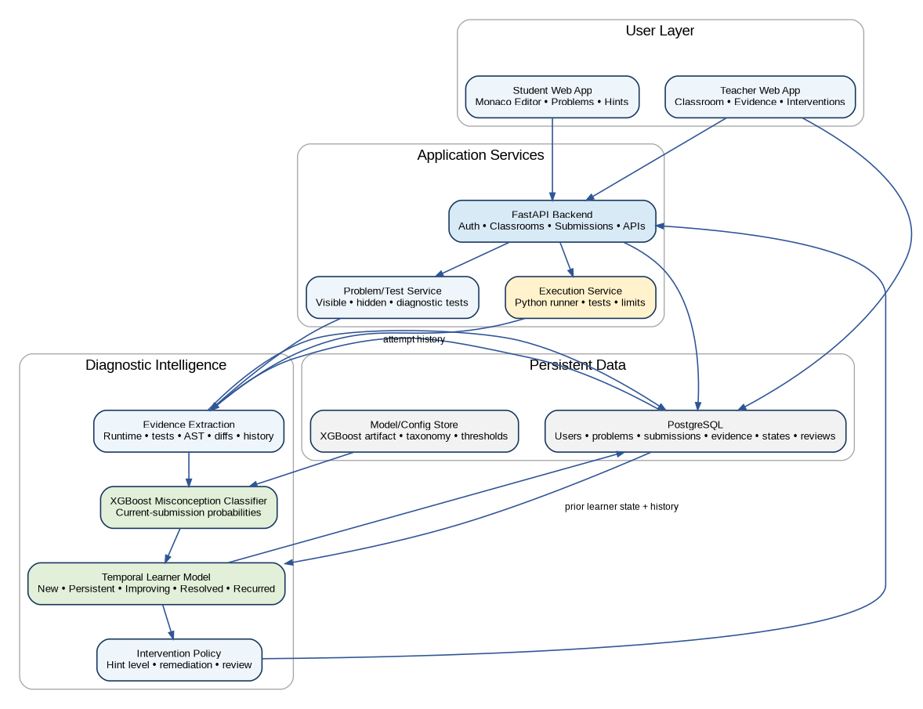
Figure 1. Full TraceLearn product architecture. The POC implements only a vertical slice of this larger system.
Central distinction: XGBoost answers “what misconception best explains the current submission?” The temporal learner model answers “what does the current evidence mean in the context of this student’s prior evidence?” The database stores the history and per-student state; it does not itself perform the inference.

Project dimension | Target
Language scope | Python, introductory programming through basic data structures.
Misconception scope | Approximately 8–12 well-defined misconception beliefs for the integrated prototype; expand only if data quality permits.
Problem bank | 30–40 integrated problems by the December prototype; 40–60 by the final product target.
Learner states | New, Persistent, Improving, Resolved, Recurred, plus Teacher Review/Uncertain where needed.
Evidence | Execution, visible/hidden/diagnostic tests, AST/static patterns, attempt diffs, prior history, hint response, and problem context.
Evaluation | Classifier performance, evidence ablations, temporal-state validity, hint effectiveness/transfer, teacher agreement/usefulness, reliability.

2. Problem Definition, Research Gap, and Contribution

2.1 Problem statement
Beginner programmers can produce similar incorrect outputs for very different reasons, while the same conceptual weakness can manifest in different code across multiple attempts and problems. A single failed submission therefore does not provide enough evidence to decide whether the learner made a transient implementation mistake or holds a persistent false belief about a programming construct.
TraceLearn addresses the computing problem of inferring and continually revising a learner’s latent misconception state from incomplete, heterogeneous, and sometimes conflicting evidence. The system must remain explainable, must lower confidence when later evidence contradicts earlier evidence, must avoid turning one failure into a permanent label, and must support intervention without immediately revealing the full solution.

2.2 Why a database alone is insufficient
Updating a database after every submission is necessary for persistence, but it does not solve the reasoning problem. A database can store that a student failed three loop problems; it cannot, by itself, determine whether those failures are evidence of the same misconception, unrelated mistakes, problem difficulty, insufficient prerequisite knowledge, or a pattern that is already improving. The temporal learner model interprets the stored sequence; the database preserves it.

2.3 Why XGBoost is useful compared with simple descriptive statistics
Descriptive statistics such as failure counts, average attempts, or error frequencies are useful evidence but do not naturally learn nonlinear interactions among runtime signals, diagnostic-test failures, AST patterns, and problem context. XGBoost is suitable as a supervised tabular classifier because TraceLearn’s evidence can be represented as structured features, the model works well on mixed sparse/nonlinear feature relationships, provides feature-importance tools, and does not require the scale of data normally expected by large neural models.
The project should still retain simple statistical/rule baselines. The contribution is strengthened if XGBoost is shown to improve over transparent baselines rather than being assumed superior by default.

2.4 Research and engineering contribution
Contribution layer | What TraceLearn owns | What is not claimed as novelty
Methodological | Definition and evaluation of a longitudinal misconception-diagnosis workflow that fuses structured evidence and revises learner state over time. | The existence of XGBoost, temporal modelling, databases, AST parsing, or code editors.
System architecture | Integration of execution, evidence provenance, classifier output, temporal state, intervention, teacher correction, and audit history into one closed diagnostic cycle. | Building a web interface, REST API, or dashboard by itself.
Data/evaluation | A normalized longitudinal dataset schema, controlled synthetic trajectories, mapped public data, local pilot data, annotation protocol, student/problem-aware splits, and temporal evaluation. | Claiming that synthetic data alone represents real student learning.
Educational workflow | Minimum useful intervention, transfer tasks, and teacher correction linked directly to diagnosis confidence/state. | An unrestricted LLM tutor or answer generator.

2.5 Relation to McMining
McMining (Al-Hossami and Bunescu, 2026) is highly relevant prior work because it mines potential programming misconceptions from one or multiple student code samples using LLMs. Its multi-instance result supports the idea that multiple samples can provide stronger evidence than a single sample. TraceLearn must therefore not claim that using multiple code samples is itself novel. The stronger project distinction is the complete operational cycle: structured execution/test/static evidence, learned current-submission diagnosis, persistent temporal state, uncertainty, adaptive intervention, teacher correction, and longitudinal evaluation.

3. Full FYP Scope and Product Capabilities

3.1 In scope
- Python-only browser coding environment for beginner programming and basic data structures.
- Classrooms, assignments, problem metadata, visible tests, hidden tests, and diagnostic tests.
- Server-side execution with execution status, stdout/stderr, timeout handling, and per-test outcomes.
- Static code analysis using Python AST and targeted structural checks.
- Attempt-sequence analysis and code-diff features.
- Current-submission misconception classification using rules/baselines and XGBoost when trained data is ready.
- Persistent learner modelling for each student–misconception pair.
- Adaptive hints, remedial problems, and transfer problems.
- Teacher evidence view, class trends, intervention prioritization, and teacher correction/audit.
- Public-data ingestion, local pilot data collection, annotation, evaluation, and reproducibility tooling.

3.2 Explicitly not the core scope
- Multi-language IDE support in the first version.
- Competitive-programming leaderboards, plagiarism detection, full LMS replacement, mobile apps, real-time collaboration, or video-course delivery.
- Open-ended grading of arbitrary free-form programs.
- An LLM that directly decides the learner state without structured evidence.
- Training a deep temporal model simply to make the project look more “AI-heavy” when the data does not support it.

3.3 Product roles
Role | Core capabilities
Student | Join classroom; open assigned problem; write/run/submit Python; view test feedback; request hints; receive remediation; see limited learner-progress information.
Teacher | Create classroom/assignment; author or select problems/tests; inspect evidence; review student and class trends; confirm/reject/correct diagnoses; assign intervention.
Administrator/Researcher | Manage taxonomy/configuration, model versions, data exports, anonymization, evaluation runs, and system monitoring.

4. End-to-End Student, Teacher, and System Workflows

4.1 Classroom lifecycle
1. Teacher creates a classroom and assigns a set of Python problems with concept tags, prerequisites, visible tests, hidden correctness tests, and diagnostic tests.
2. Student opens a problem in the browser-based Monaco editor and writes code.
3. Run/Submit sends the code to the backend; execution occurs server-side, not inside Monaco.
4. The execution service returns stdout, stderr, runtime status, timeout status, and per-test results.
5. Evidence extractors analyze runtime results, diagnostic test categories, AST/static structure, the difference from the previous attempt, problem context, and prior student history.
6. The current-submission classifier produces misconception probabilities and evidence attribution.
7. The temporal learner model combines those probabilities with prior state/history to update the student–misconception state and confidence.
8. The intervention policy selects the least revealing useful hint, a remedial problem, a transfer problem, or teacher review.
9. All artifacts are persisted with provenance so the teacher can see why a diagnosis/state changed.
10. Future attempts produce new evidence; the learner state can strengthen, weaken, improve, resolve, or recur.
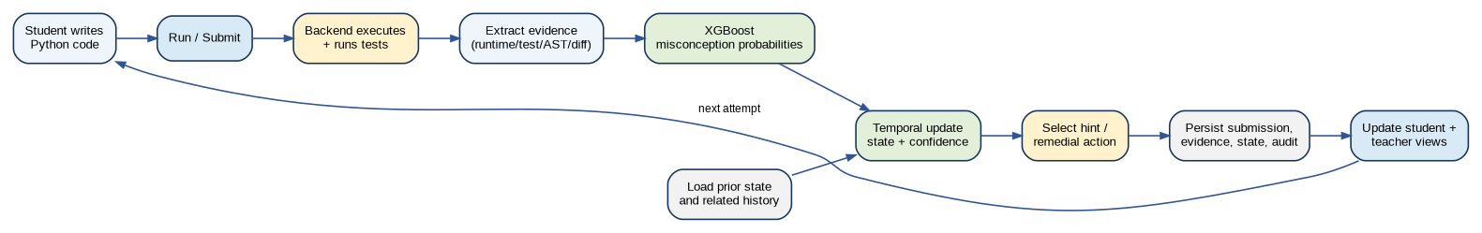
Figure 2. Per-submission closed diagnostic and learning loop.

4.2 Student flow
- Before submission: Problem statement, examples, constraints, concept-neutral instructions, editor, Run/Submit, and optional hint request.
- After Run: Visible execution result, visible tests, syntax/runtime feedback, but no hidden-test answers.
- After diagnosis: A hint matched to confidence and persistence state; low-confidence cases should use generic guidance rather than a strong label.
- After improvement: The system records whether the relevant evidence weakened, whether the hint appeared useful, and whether transfer to a related problem occurs.

4.3 Teacher flow
- View class-level misconception prevalence and change over time.
- Drill down from class trend → student → misconception → evidence → exact submissions/test failures/static signals.
- See system confidence and alternative explanations instead of only a categorical label.
- Confirm, reject, correct, or mark a diagnosis uncertain; corrections are appended as human labels rather than overwriting system history.
- Use intervention-priority views to identify students with persistent/recurred high-confidence patterns.

5. Full System Architecture
The complete architecture is layered so that UI, execution, intelligence, and persistence can evolve independently. The execution runner should expose a stable contract to the diagnostic layer; similarly, the temporal learner model should consume classifier probabilities and historical evidence through data contracts rather than querying UI-specific objects.
Figure 3. Full system architecture and major service boundaries.

5.1 Layer responsibilities
Layer | Responsibilities | Primary technologies / design
User layer | Student problem/editor experience; teacher classroom/evidence experience. | React; Monaco Editor; charts/tables for evidence and trends.
Application services | Auth, classrooms, assignments, submissions, problem metadata, API orchestration. | FastAPI; REST; Pydantic; service layer.
Execution | Run Python, invoke tests, collect stdout/stderr/status/resource data. | Current POC: subprocess for trusted data. Product target: isolated execution worker.
Evidence extraction | Runtime parser, test categorizer, AST/static detectors, sequence diff, history/context features. | Python ast, difflib/structured diff, deterministic feature extractors.
Current diagnosis | Misconception probabilities from current evidence. | Rules/statistical baseline + XGBoost.
Temporal learner model | Interpret current diagnosis in student history; maintain persistent state/confidence. | Explicit state/update engine first; optional probabilistic learned extension if data supports it.
Intervention | Select hint level, remediation/transfer, teacher review. | Policy based on state, confidence, attempt/hint history.
Persistence | Store operational data, evidence provenance, predictions, state history, human reviews. | PostgreSQL; migrations; model/config version IDs.

5.2 Model responsibility separation
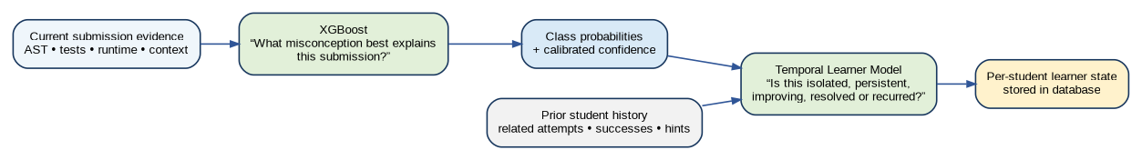
Figure 4. XGBoost, temporal learner model, and database have separate responsibilities.
Design rule: Do not feed future information into the diagnosis at time t. The system may only use the current submission and events that occurred before it. This applies to feature generation, state updates, dataset creation, and evaluation.

6. Browser Code Editor and Server-Side Code Execution

6.1 Monaco Editor
The in-browser editor should use Monaco Editor (for example through @monaco-editor/react). Monaco provides the editing experience such as syntax highlighting, line numbers, indentation, bracket matching, and code text access but it is not the compiler or execution engine. The source code is sent to the backend when the student runs or submits.
Editor capability | POC / product setting
Language | Python
Line numbers | Enabled
Syntax highlighting | Python mode
Automatic indentation | Enabled
Bracket matching | Enabled
Minimap | Disabled initially to reduce clutter
Run / Submit | Calls backend API with source, problem ID, and attempt metadata
Execution | Never delegated to Monaco

6.2 Execution location
Compilation/execution occurs on the server side. For Python, the relevant runtime is CPython: code may be byte-compiled internally, but the product should describe the operation as server-side Python execution rather than as a browser compiler.
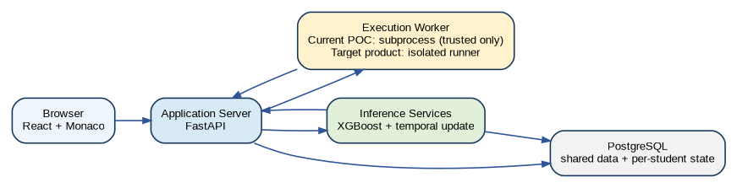
Figure 5. Runtime/deployment boundary: the browser edits code; the backend executes and reasons over it.

6.3 Current no-Docker assumption
For the proposal POC, the backend may execute trusted synthetic/demo submissions using subprocess.run or subprocess.Popen in a temporary working directory with captured stdout/stderr and a hard timeout. This is acceptable only for controlled code and must not be described as secure sandboxing. Arbitrary student code should not be exposed to this runner on a public deployment.

6.4 Product execution target
The final product requires an isolated execution boundary. The exact technology can remain an implementation decision—container, restricted worker VM, OS sandbox, or a separate execution service—but the contract should remain stable: source code + test bundle + limits → execution status + test results + resource information. This lets security hardening occur without changing the diagnosis, database, or UI architecture.

6.5 Test taxonomy
Test type | Purpose | Student visibility
Visible tests | Basic correctness and examples; immediate formative feedback. | Inputs/expected outcomes can be shown.
Hidden tests | Prevent hard-coding and assess general correctness. | Outcome only; details limited.
Diagnostic tests | Target misconception-sensitive edge cases or behaviors. | Usually outcome/category, not necessarily full expected answer.
Transfer tests/problems | Check whether understanding transfers to a related but non-identical task. | Presented as later practice/evaluation.

7. Evidence Extraction and Representation
TraceLearn should treat every inference as evidence-backed. A prediction must be reproducible from stored evidence items, each with a source, direction, strength/weight, affected misconception, extractor/model version, and timestamp. This protects the system from becoming a black box and lets teachers audit why state changed.

7.1 Evidence categories
Evidence source | Examples | Role
Execution | SyntaxError, IndexError, timeout, return code, stdout/stderr mismatch. | Strong behavioral signals but often non-specific by themselves.
Diagnostic tests | Boundary case failed, empty-list case failed, return-value-specific test failed. | Problem-aware evidence designed to distinguish hypotheses.
Static AST | range bound form, use of loop variable as index, missing return path, boolean structure, recursion progress. | Structural explanation independent of output alone.
Attempt sequence | Lines/AST nodes changed, same suspicious pattern retained, error type changed, number of attempts. | Shows debugging behavior and whether the relevant behavior improves.
Historical | Same belief on another related problem, prior state/confidence, related successes, recurrence after resolution. | Primary input for temporal persistence and decay.
Context | Concept tags, prerequisites, problem difficulty/category. | Constrains which misconceptions are plausible.
Teacher/hint | Teacher correction, hint level used, response after hint. | Human supervision and intervention-response evidence.

7.2 Evidence item contract
Field | Example
evidence_id | EV_20481
submission_id | SUB_8451
source_type | diagnostic_test / static_ast / runtime / sequence / history
misconception_id | M01_RANGE_UPPER_BOUND
direction | support / conflict
strength | 0.35 (configuration value or learned feature attribution)
description | Boundary diagnostic fails when n is expected to be excluded.
extractor_version | diag-tests-v3
created_at | timestamp

7.3 Evidence fusion principles
- No single weak signal should force a persistent diagnosis.
- Supporting and conflicting evidence must both be preserved.
- Current code correctness does not necessarily erase a prior misconception immediately; sustained success is more informative.
- Repeated same-problem failure can strengthen suspicion but cross-problem recurrence is stronger evidence of persistence.
- Correct related performance should reduce confidence and can move Persistent → Improving → Resolved.
- When top hypotheses are close or evidence conflicts, output uncertainty/teacher review rather than a false precise answer.

8. Misconception Taxonomy

8.1 Label misconceptions as false beliefs, not only error names
The McMining paper provides a useful taxonomy-writing lesson: a misconception should state the learner’s incorrect belief about a programming construct in a concise, generalizable form. “Off-by-one error” is a symptom; “the student believes range(n) includes n” is a misconception hypothesis.

8.2 Proposed initial taxonomy structure
ID | Area | Belief-style misconception statement | Typical evidence
M01 | Loops / range | Student believes that range(n) includes n as the final generated value. | Boundary diagnostic failure; loop-bound AST; recurrence across loop problems.
M02 | Iteration / lists | Student believes that the loop variable in “for x in values” represents the index of x. | Subscript using loop value; IndexError; wrong element selection.
M03 | Functions | Student believes that printing a computed value is equivalent to returning it from a function. | print present; missing return; return-specific diagnostic fails.
M04 | Indexing | Student believes valid positive list indices include len(list). | IndexError at boundary; n/len used directly as last index.
M05 | Conditionals | Student believes “x == a or b” compares x against both a and b. | AST boolean structure; diagnostic branches.
M06 | Assignment/comparison | Student believes assignment and equality comparison are interchangeable in conditions. | Syntax/AST pattern depending on formulation.
M07 | Recursion | Student believes recursive calls progress automatically without changing the state/argument. | Recursive call with unchanged parameter; timeout/RecursionError.
M08 | Base cases | Student believes recursive functions do not require a terminating base condition for finite input. | Missing/ineffective base case; recursion diagnostic.

9. XGBoost Misconception Classifier

9.1 Role in the final system
XGBoost is the planned learned model for current-submission misconception classification. It receives a feature vector describing the current attempt and outputs a probability distribution over the supported misconception classes plus NONE/NO_MISCONCEPTION (and, depending on the evaluation design, an uncertainty threshold handled outside the classifier). It should not directly own the persistent learner-state lifecycle.
Figure 6. XGBoost makes the current-submission diagnosis; the temporal model interprets it longitudinally.

9.2 Feature design
Feature group | Illustrative features
Execution | syntax_error_type, runtime_error_type, timeout, output_type_mismatch, exception_family
Test | visible_pass_rate, hidden_pass_rate, diagnostic_boundary_fail, diagnostic_return_fail, empty_input_fail, min/max_input_fail
Static AST | has_return, return_path_count, print_without_return, range_stop_expression_type, loop_value_used_as_index, suspicious_boolean_or, recursive_call_argument_change
Current-attempt context | problem_concepts, prerequisite tags, difficulty, attempt_number, code_length/AST counts
Optional derived statistics | number of changed AST nodes, error-family indicators, code complexity measures only if justified and stable

9.3 What should be excluded from the first XGBoost model
- Future attempts or future learner-state information.
- Ground-truth misconception/state labels as features.
- Student IDs or problem IDs used in a way that encourages memorization instead of generalization.
- History-derived features in the primary current-only model. A second history-augmented classifier can be evaluated later, but the main comparison should preserve a clean boundary between current diagnosis and temporal reasoning.

9.4 Training strategy
1. Map selected McMining misconception labels to the TraceLearn belief taxonomy where the mapping is semantically defensible.
2. Run TraceLearn’s feature extractors on the code rather than copying labels into features.
3. Add negative/no-misconception examples and local annotated examples.
4. Freeze the feature definition and label mapping before final holdout evaluation.
5. Use student-aware and, where possible, problem-aware splits to reduce identity/problem leakage.
6. Handle class imbalance with class/sample weights, targeted data collection, macro-F1 reporting, and per-class metrics rather than accuracy alone.
7. Tune hyperparameters only on training/validation data; never tune after viewing the final holdout.
8. Calibrate confidence (for example using held-out validation calibration) if raw probabilities are used for intervention thresholds.

9.5 Baselines
Baseline | Purpose
Majority / simple frequency | Sanity check; shows class imbalance.
Rule-only evidence engine | Transparent engineering baseline and fallback.
Logistic regression / shallow statistical model | Tests whether nonlinear XGBoost interactions are actually needed.
XGBoost current-only | Primary learned classifier.
Optional history-augmented XGBoost | Ablation/extension only; do not confuse with the persistent state model.
McMining-style LLM baseline | External comparison if API cost/privacy permits; not the core production diagnosis path.

10. Persistent Temporal Learner Model

10.1 One shared algorithm, individual student states
The product does not train or maintain a separate temporal model for every learner. There is one shared state-update algorithm (and, if a learned temporal extension is later added, one globally trained temporal model). The database stores a separate state record for each student–misconception pair. For 100 students and 10 misconceptions, this is roughly 1,000 current state rows plus history—trivial for PostgreSQL.
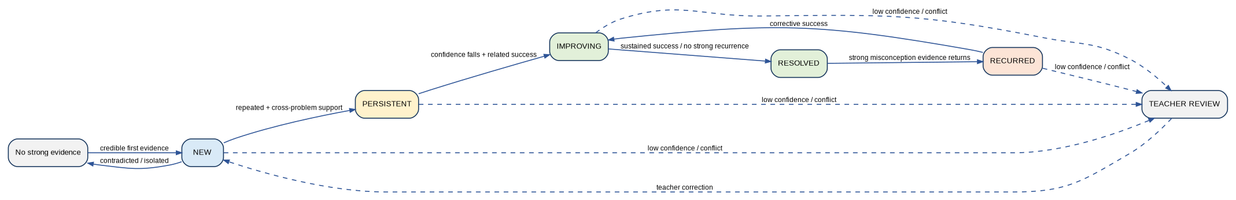
Figure 7. Proposed learner-state lifecycle. Exact thresholds are configuration values to be validated, not fixed truths.

10.2 State semantics
State | Meaning
New | Credible evidence has appeared, but there is not yet enough longitudinal support to call it persistent.
Persistent | Strong repeated evidence, preferably across related problems or clearly repeated conceptual behavior.
Improving | Previously persistent evidence is weakening and recent related successes support conceptual progress.
Resolved | Sustained related success and absence of strong supporting evidence reduce the active misconception confidence below the resolution threshold.
Recurred | A previously resolved misconception is supported again by strong new evidence.
Teacher Review / Uncertain | Evidence is conflicting, confidence is low, or top hypotheses are too close for a reliable automated state.

10.3 Inputs to temporal update
- Current XGBoost misconception probability and current evidence strength.
- Previous learner state and previous confidence for the same misconception.
- Number and recency of supporting events.
- Whether support comes from the same problem or different related problems.
- Related successful attempts and transfer performance.
- Hint exposure and whether the relevant evidence changed after hints.
- Teacher corrections or confirmed labels.
- Time/attempt distance since previous evidence, used for decay where appropriate.

10.4 Example update formulation
A transparent starting formulation can maintain a confidence value C_t for each student–misconception pair. One possible design is:
Cₜ = clip( d·Cₜ₋₁ + α·Pₜ + β·Rₜ − γ·Sₜ − δ·Qₜ , 0, 1 )
where d is evidence decay, Pₜ is the current classifier/evidence support, Rₜ captures cross-problem recurrence, Sₜ captures related successful evidence, and Qₜ captures conflicting/uncertain evidence. The values are design parameters to be validated; the final report must not present arbitrary thresholds as learned truths.

10.5 Transition safeguards
- One submission must never directly create a high-confidence Persistent state.
- Repeated failures on the same problem strengthen suspicion but should generally not be as strong as recurrence on a different related problem.
- Future information is prohibited when computing the state at time t.
- After Resolution, strong evidence can trigger Recurred; the system should preserve the prior resolved episode in history rather than overwriting it.
- Teacher corrections append an audit event and can change the active state, but the original automated prediction remains preserved for evaluation.

10.6 Optional learned temporal extension
If enough real longitudinal labels are eventually available, the team can compare the explicit state engine with a probabilistic/learned temporal model such as a calibrated transition model, Bayesian/Markov approach, or other interpretable learner model. A deep LSTM is not required and should not be introduced unless the sequence volume and research question justify it.

11. Database Architecture and Data Contracts
The database is the system’s longitudinal memory. It stores raw attempts, derived evidence, model predictions, temporal state history, hint events, and human corrections. The model logic remains shared; only the state/data are individualized.
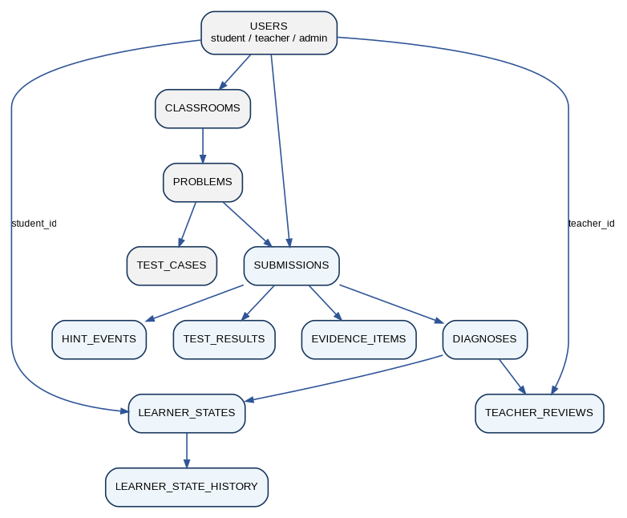
Figure 8. Simplified database/entity relationship view.

11.1 Core tables
Table | Purpose | Representative fields
users | Student/teacher/admin identity and role. | id, role, pseudonymous_research_id
classrooms | Teacher-owned classroom and memberships. | id, owner_id, term/status
problems | Problem statement, concepts, prerequisites, difficulty. | id, title, concept_tags, prerequisite_tags
test_cases | Visible, hidden, diagnostic test definitions. | problem_id, type, category, input/expected, visibility
submissions | Immutable source attempt record. | student_id, problem_id, attempt_no, source_code, created_at
test_results | Per-test outcome for a submission. | submission_id, test_id, passed, actual, error_type
evidence_items | Explainable diagnostic evidence. | submission_id, source_type, misconception_id, support/conflict, strength, version
diagnoses | Classifier/baseline outputs. | submission_id, model_version, class probabilities, primary/alternative label, confidence
learner_states | Latest state per student–misconception. | student_id, misconception_id, state, confidence, updated_at
learner_state_history | Every state transition and reason. | old_state, new_state, trigger_submission_id, confidence_before/after
hint_events | Hint exposure and response context. | submission_id/problem_id, level, misconception_id, delivered_at
teacher_reviews | Human confirm/reject/correct/uncertain action. | diagnosis_id, teacher_id, action, corrected_label, notes

11.2 Data immutability and auditability
- Submissions are immutable; corrections produce new attempts, not edits to historical rows.
- Diagnoses carry model/config versions so predictions remain reproducible after retraining.
- Learner state history is append-only for audit/evaluation.
- Teacher reviews do not delete system predictions.
- Research exports use pseudonymous IDs and omit direct identifiers.

11.3 PostgreSQL vs SQLite
SQLite is acceptable for a single-machine POC because it minimizes setup. The integrated product should use PostgreSQL to support concurrent classrooms, indexing, robust transactions, JSON metadata where useful, migrations, backups, and operational monitoring. There is still one shared application database; do not create a separate database per student.

12. Dataset Strategy and Data Engineering
The dataset plan should not assume the team can manually collect or label thousands of examples. Different public and local sources answer different research questions. The key is to normalize them into a common TraceLearn schema and keep provenance explicit.
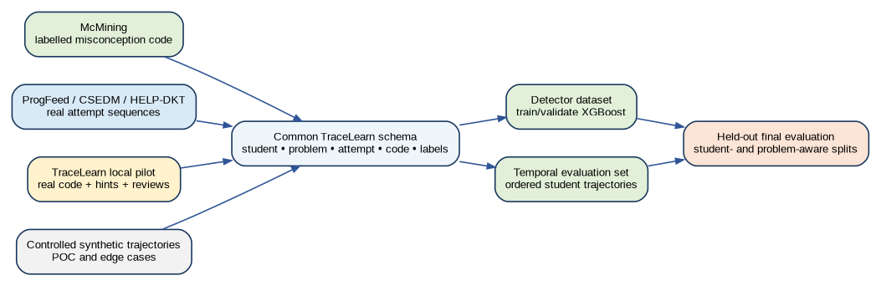
Figure 9. Multi-source dataset strategy for current diagnosis, temporal evaluation, and final holdout testing.

12.1 What data is needed for each subsystem
Subsystem / question | Required data | Best sources
Misconception classifier | Code + problem context + misconception/no-misconception label; ideally tests. | McMining benchmark + local human labels + controlled synthetic edge cases.
Temporal learner model | Ordered attempts by stable student ID, problem relations, correctness/evidence, ideally human state labels. | ProgFeed, CSEDM 2019, HELP-DKT, FalconCode where accessible, plus TraceLearn pilot.
Hint effectiveness | Hint event + pre/post attempts + time/order + success/transfer. | ProgFeed for behavior patterns; TraceLearn pilot for system-specific hint policy.
Final validity | Real TraceLearn student trajectories with human-reviewed misconception/state labels. | Local pilot/research deployment.

12.2 McMining as a labelled misconception source
The 2026 McMining benchmark is especially valuable because it includes a misconception bank and code samples explicitly designed to exhibit those misconceptions. The repository reports 67 misconceptions and 1,063 code samples exhibiting them, along with correct/no-misconception examples and multi-code bags. TraceLearn should select only the subset that maps cleanly to its own 8–12 belief taxonomy, then run its own feature extractors on the code.

12.3 Public Python longitudinal sources
Dataset | Useful properties for TraceLearn | Primary role
ProgFeed | De-identified introductory-programming submissions, per-submission code/autograder data, feedback condition/text, problem descriptions. | Attempt/hint-response analysis and external temporal behavior data.
CSEDM 2019 / ITAP | ProgSnap-style ordered events, stable student IDs, code states, correctness, hint requests; explicit knowledge-tracing framing. | Temporal modelling, chronology/leakage methodology, student-held-out evaluation patterns.
HELP-DKT | 9,119 Python source codes with buggy/correct flag, challenge ID, stable student ID, and submission number. | Repeated-attempt sequence experiments and representation testing.
FalconCode | Over 1.5M Python programs from >2,000 students and >800 assignments; prompts/tests/skills metadata; access depends on distribution route. | Large-scale external code/evidence experiments and transfer/generalization studies.

12.4 Local TraceLearn data targets
The project’s own collection remains important because public datasets will not contain TraceLearn’s exact misconception labels, temporal states, intervention policy, and teacher review workflow. A realistic target remains a pilot rather than a thousand manually labelled examples.
Stage | Target | Purpose
Initial controlled data | Synthetic/controlled examples for every supported misconception; positive and negative examples. | Technical testing and rule/feature development only.
FYP-I student testing | Approximately 5–10 students solving 10–15 selected problems. | Refine taxonomy, diagnostics, UI, annotation handbook, and failure cases.
FYP-II pilot | Approximately 15–40 participants where feasible; 15–25 evaluated problems; 300–800 total submissions if recruitment permits. | Real longitudinal evaluation and system usability.
Human-labelled subset | Approximately 150–300 submissions/trajectory segments where achievable; substantial double annotation. | Final precision/recall/F1, state validity, disagreement analysis.

12.5 Common normalized schema
Field | Description
dataset_source | MCMINING / PROGFEED / CSEDM / HELP_DKT / FALCONCODE / TRACELEARN_SYNTHETIC / TRACELEARN_REAL
student_id | Stable pseudonymous learner ID within source.
problem_id | Normalized problem ID with source-specific mapping.
attempt_order | Chronological order within learner/problem and global learner history where available.
source_code | Raw/normalized source with provenance.
correct/test_results | Outcome evidence where available.
concept_tags | Normalized concepts/prerequisites if available or mapped.
misconception_label | Nullable; only populated when supported by source or human annotation.
state_label | Nullable; populated only for real/controlled trajectory annotations.
hint_event | Nullable; level/type/text identifier when available.
source_split | development / validation / holdout; never infer from row order after analysis.

12.6 Splitting and leakage prevention
- Never random-split individual attempts from the same student across train and final test if the model can exploit student history.
- Primary generalization split: hold out students (GroupKFold/leave-one-student-out where scale allows).
- Problem-held-out experiment: train on some problems and test on unseen related problems to measure whether the model learned the misconception rather than the exercise template.
- Temporal split within a student must respect time: no future event may generate a feature for an earlier event.
- Keep synthetic/demo trajectories separate from holdout evaluation trajectories.
- Freeze taxonomy mappings, evidence extraction, and final feature definitions before the true holdout is evaluated.

12.7 C/C++ contingency datasets
Python remains the primary product language. C/C++ datasets are a contingency if Python data access becomes insufficient for a particular methodological experiment. The most useful backups discussed are CodeStream (iterative C/C++/Java attempt histories), PROGpedia (student submissions plus code property graphs), and Project CodeNet (very large C++ corpus with submission metadata). If used, their role must be stated as external methodological validation rather than silently changing the product scope.

13. Adaptive Hints, Remediation, and Transfer

13.1 Minimum useful intervention
TraceLearn should not reward every failure with a full explanation. Intervention depends on diagnosis confidence, learner state, previous hint exposure, and evidence of improvement. The objective is to give the least revealing support that can move the learner toward conceptual progress.
Level | Intervention | When appropriate
1 | Guiding question | Low/medium confidence or early attempt; prompts reflection without naming the exact fix.
2 | Concept reminder | Likely misconception; reminds relevant semantics (e.g., range behavior) without rewriting code.
3 | Code-region focus | Points to the relevant construct/region and asks the learner to inspect a specific relationship.
4 | Partial logical correction | High confidence and repeated unsuccessful attempts; explains the conceptual correction without providing full final code.
5 | Full explanation / worked teaching response | Escalation after repeated failure or teacher-approved remediation; should be logged and evaluated for answer leakage/dependency.

13.2 Remedial and transfer problem graph
- Each problem should carry concept and prerequisite tags.
- Each supported misconception should map to at least one simpler remedial task and one related transfer task.
- Remedial tasks test the exact concept with reduced problem complexity.
- Transfer tasks alter surface structure so success is evidence of conceptual learning rather than memorized patching.
- The learner model should use transfer success as stronger conflicting evidence against persistence than same-problem correction alone.

13.3 LLM boundary
An LLM may be used to realize teacher-approved hint templates or explain already-structured diagnoses, but it should not be the hidden source of the diagnosis itself. Inputs should include the selected misconception, evidence summary, permitted hint level, and “do not reveal solution” constraints. The produced text should not alter the learner state unless new student evidence is generated afterward.

14. Teacher Decision Support and Human Correction

14.1 Evidence-first dashboard
The teacher dashboard should lead with instructional decisions and evidence, not decorative charts. Every class trend should be drillable to supporting submissions and every student-level alert should explain confidence, evidence, and a recommended next action.
View | Key content
Class overview | Misconception prevalence, newly persistent/recurred cases, improvement/resolution trends, students needing review.
Student evidence profile | Current state/confidence per misconception, timeline, related submissions, hints, successes, teacher actions.
Diagnosis inspector | Current code, test outcomes, AST/static evidence, classifier probabilities, alternative hypothesis, supporting/conflicting signals.
Intervention queue | Prioritized students based on persistence, recurrence, confidence, repeated unsuccessful attempts, and review flags.
Correction/audit | CONFIRM, REJECT, CORRECT, MARK_UNCERTAIN; reason/notes; correction feeds future evaluation and model-development datasets.

14.2 Human correction semantics
- Teacher labels are stored separately from automated predictions.
- Corrections can update the active learner state but must preserve the original model result and prior state history.
- For training/evaluation, only agreed/quality-controlled teacher labels should become ground truth.
- Teacher disagreement should be reportable rather than forced into a single false label.

15. Evaluation and Experimental Methodology

15.1 Research questions
RQ | Question
RQ1 | Can structured execution/test/static evidence identify supported beginner-programming misconceptions better than simple single-source/rule/statistical baselines?
RQ2 | Does XGBoost improve current-submission misconception classification over transparent baselines on held-out students/problems?
RQ3 | Does longitudinal history improve identification of persistent misconception states compared with treating each submission independently?
RQ4 | Can the temporal model correctly represent improvement, resolution, and recurrence without permanently labelling learners after isolated mistakes?
RQ5 | Do confidence/state-aware hints and remedial/transfer tasks improve attempts-to-success and transfer compared with fixed/static feedback?
RQ6 | Does the teacher evidence/correction workflow provide useful, trustworthy intervention support?

15.2 Experiments and baselines
Experiment | Comparisons | Main metrics
Current diagnosis | Runtime-only vs test-only vs static-only vs rule-fusion vs logistic/statistical vs XGBoost. | Macro precision/recall/F1, per-class F1, confusion matrix, false-positive rate on no-misconception cases.
History value | Current-only diagnosis/state vs history-aware temporal model on same chronological events. | State accuracy/agreement, false-persistent rate, missed-persistent rate, correct history-induced changes.
Ablation | Full evidence vs remove one source at a time. | Δ macro-F1, calibration, state agreement.
Transfer | Seen problem families vs held-out related problems. | Performance drop, transfer success after remediation.
Hinting | Fixed hint baseline vs confidence/state-aware policy. | Attempts to success, time to success, repeated misconception frequency, transfer performance.
Teacher workflow | System prediction vs teacher review and usefulness survey/task timing. | Agreement, correction frequency, time saved, perceived usefulness/trust.

15.3 Temporal evaluation labels
A temporal-state label should be assigned to an ordered trajectory segment, not to an isolated code file without context. Annotators should see only information that would be available at that point in time. Recommended labels are Isolated/No persistent misconception, New, Persistent, Improving, Resolved, Recurred, and Uncertain/Teacher Review. For final evaluation, two annotators should label a substantial subset and disagreement should be measured and adjudicated.

15.4 Metrics beyond accuracy
- Macro-F1 and per-class precision/recall/F1 for imbalanced misconception classes.
- False-positive rate on correct/no-misconception submissions.
- False-persistent rate: isolated behavior incorrectly escalated to Persistent.
- Missed-persistent rate: repeated/cross-problem patterns not recognized.
- Calibration metrics/reliability plot if confidence probabilities drive interventions.
- Inter-annotator agreement for misconception/state labels.
- Transfer performance on unseen related problems.
- Teacher correction frequency and actionability/usefulness measures.

16. Security, Privacy, Reliability, and Deployment

16.1 Security boundary
Executing student code is the highest operational security risk. The current subprocess POC is explicitly restricted to trusted demo data. Before public/student deployment, the execution service must enforce isolation, hard timeouts, memory/CPU/process limits, restricted filesystem access, blocked or tightly controlled network access, and cleanup of temporary resources. Abuse tests should be part of acceptance.

16.2 Privacy
- Use pseudonymous research identifiers for exports and model-development data.
- Separate operational identity information from research datasets.
- Do not send student code to third-party LLM APIs without explicit governance/approval; prefer structured local processing for diagnosis.
- Log teacher corrections and model versions but avoid collecting unrelated personal data.
- Define data retention/deletion policy before the pilot.

16.3 Reliability and observability
- Execution timeouts and worker failure must produce explicit status, not hang the submission flow.
- Model inference failure should fall back to test/runtime feedback and mark diagnosis unavailable/uncertain.
- Database migrations and backups are required before pilot deployment.
- All model/config versions used for a diagnosis should be logged.
- Provide an offline/local backup demo for final defense reliability.

16.4 Deployment architecture
Figure 10. Deployment architecture and replaceable execution boundary.

17. Scaling to Real Classrooms

17.1 Scaling the temporal model to 100+ students
TraceLearn uses shared inference logic with per-student state data. A class of 100 students does not require 100 XGBoost models or 100 temporal algorithms. The same XGBoost model classifies each current submission, and the same temporal update function reads that learner’s prior state/history before updating only that learner’s records.
Example scale | Approximate records / implication
100 students × 10 misconceptions | ≈1,000 current learner_state rows.
100 students × 20 problems × 4 attempts | ≈8,000 submission rows plus per-test/evidence rows; ordinary relational-database scale.
Model artifacts | One active XGBoost artifact per model version, not per student.
Temporal logic | One shared update implementation; state is keyed by (student_id, misconception_id).

17.2 Concurrency strategy
- API requests should be stateless beyond database/model-store access.
- Execution is the expensive workload and should be separable into workers if concurrent demand increases.
- Inference is lightweight compared with execution and can typically run in the application service initially.
- Use indexes on student_id, problem_id, submission time/order, misconception_id, and active learner state.
- Cache read-only problem/test metadata where appropriate, but do not cache mutable learner state without consistency rules.

18. Proposal-Stage POC as a Project Milestone
POC positioning: The POC is a small vertical slice used to validate feasibility and expose design failures early. It is not the final architecture, not the entire FYP focus, and not sufficient evidence for claims about real-world educational effectiveness.

18.1 POC objective
The proposal POC should demonstrate the complete information path from actual Python source code through execution/tests, evidence extraction, current-only diagnosis, history-aware state update, hint selection, teacher review, and calculated evaluation outputs. The POC exists to make the core idea concrete before full FYP development.

18.2 POC scope
Area | POC implementation
Misconceptions | 3 belief-style classes: range/loop boundary, index-vs-value, print-vs-return; plus NONE/UNCERTAIN.
Problems | Approximately 6 related Python problems with visible/hidden/diagnostic tests.
Learners | 5–15 controlled synthetic/demo trajectories; separate demo and holdout sequences.
Execution | Backend subprocess, trusted code only, hard timeout; clearly marked non-secure.
Diagnosis | Rule-based weighted evidence baseline. XGBoost training is not required for the tiny synthetic POC.
Temporal model | Explicit state machine with strict no-future-leakage rules.
Database | SQLite acceptable for POC if SQLAlchemy schema remains PostgreSQL-compatible.
Frontend | Monaco-based student submission plus evidence inspector, current-vs-history comparison, learner timeline, teacher/evaluation view.
Metrics | Generated from database/exports; no hard-coded accuracy.

18.3 Why not train XGBoost on only the POC data
A few dozen synthetic submissions are sufficient to demonstrate plumbing but not to validate a supervised classifier. Training XGBoost on the same tiny trajectories used to design the rules would produce misleadingly optimistic results. XGBoost enters the main FYP once the selected McMining/public/local labelled data has been mapped, feature-extracted, split, and quality-checked.

18.4 POC comparison
Mode | Inputs | Question answered
Current-only | Current execution/tests/static evidence. | What misconception does this submission suggest without history?
History-aware | Current diagnosis + prior related evidence/state/successes. | Does history justify changing confidence or learner state?

18.5 POC success criteria
- An isolated failure is not automatically marked Persistent.
- Cross-problem recurrence can strengthen persistence.
- Related success can lower confidence and move a learner toward Improving/Resolved.
- A resolved misconception can recur when strong later evidence appears.
- Current-only and history-aware outputs can differ for a defensible reason.
- Every output is traceable to actual execution/test/static/history evidence.
- No future event or ground-truth label is accessible to diagnosis code.
- Demo and holdout sequences are separated and evidence weights are frozen before holdout evaluation.
Figure 11. The POC is the first validation stage within the full FYP roadmap.

19. Full Development Roadmap
Figure 12. Full FYP development sequence from proposal validation to final deployment/evaluation.

19.1 Phase plan
Period | Primary outcome | Key work
July–August: proposal validation | Defensible problem, architecture, data plan, and POC. | Literature/competitor mapping; taxonomy v1; public dataset verification; POC vertical slice; evaluation design; scope freeze.
September–October: FYP-I Iteration 1 | Integrated platform foundation. | Auth/classrooms; Monaco; server execution; problem/test authoring; submission logging; runtime/test/static evidence; initial teacher view; 4–6 misconceptions.
November–December: FYP-I Iteration 2 | Complete December prototype. | 30–40 problems; 8–12 classes; dataset ingestion; XGBoost baseline/training if data ready; temporal learner model; evidence decay; five hint levels; teacher correction; initial metrics.
January–February: FYP-II pilot preparation | Evaluation-ready system and recruitment. | 40–60 problem bank; stable deployment; annotation handbook; pilot instruments; model freeze candidate; reliability/security hardening.
March–April: pilot and evaluation | Real-student and teacher evidence. | Collect pilot trajectories; double-label subset; run detector/temporal/hint/teacher experiments; ablations; transfer tests; error analysis.
Late April–May: finalization | Complete FYP submission. | Fixes; reproducibility package; final report; user/admin guides; demo video; final presentation; viva material; backup demo.

19.2 Gating rules
- Do not delay the end-to-end December prototype for optional deep-learning or multi-language features.
- Do not train final models before taxonomy/data mappings are frozen enough to support reproducible labels.
- Do not call a subprocess runner “secure” during the POC.
- Do not use the local pilot only for training; reserve a true final evaluation subset.
- If XGBoost does not beat transparent baselines reliably, report that result and keep the more defensible method rather than forcing an ML claim.

20. Risks, Fallbacks, and Scope Control
Risk | Why it matters | Mitigation / fallback
Insufficient real data | Temporal/ML claims may rely too heavily on synthetic examples. | Use McMining + public sequence datasets for development; recruit early; preserve a smaller high-quality local pilot; state limitations.
Ambiguous misconception labels | Ground truth becomes unreliable. | Belief-style taxonomy; annotation handbook; two annotators; allow multi-label/uncertain; report agreement.
Class imbalance | Accuracy hides minority failure. | Macro-F1, per-class metrics, class weights, targeted problem/data selection.
History does not help | Core temporal value may be weaker than assumed. | Run current-only vs history-aware comparison early; narrow temporal claims if improvement is only class-specific.
XGBoost overfits problem templates | Apparent accuracy does not transfer. | Student-held-out + problem-held-out tests; avoid raw IDs; inspect feature dependence.
Execution security | Arbitrary code can harm host. | Trusted-only POC; isolated execution service before public deployment; limits and abuse tests.
LLM overreach | Hints leak answers or create unsupported diagnoses. | Structured diagnosis first; constrained hint realization only; output validation; teacher review.
Scope creep | Editor/dashboard features consume research time. | Freeze core/supporting/optional hierarchy; POC is not product scope; multi-language remains contingency only.
Teacher dashboard decorative | Low educational/engineering contribution. | Tie every view to evidence, uncertainty, and an actionable intervention/review workflow.

21. Three-Person Work Distribution
Workstream | Primary responsibility | Shared integration obligations
Platform + execution | Frontend, Monaco, backend APIs, classrooms, problem/test management, execution service, database operational layer, deployment. | Problem-bank integration, logging contracts, security tests, end-to-end demo.
Diagnosis + learner model | Taxonomy, AST/runtime/test/sequence feature extraction, XGBoost pipeline, confidence/calibration, temporal model, model evaluation. | Annotation review, API/data contracts, evidence visualization, failure analysis.
Adaptive support + evaluation | Hint/remediation/transfer policy, teacher decision support, study instruments, annotation protocol, reporting. | Problem bank, pilot recruitment, evaluation scripts, dashboard requirements, final analysis.

The work should not be split into three disconnected mini-projects. All team members must contribute to problem-bank design, dataset review, integration testing, documentation, and the final end-to-end demonstration.

22. Deliverables and Acceptance Criteria

22.1 Required by December
- Working student and teacher platform with browser code editor.
- Server-side Python execution and visible/hidden/diagnostic test workflow.
- 30–40 integrated problems and approximately 8–12 supported misconception beliefs.
- Multi-source evidence extraction with provenance.
- Rule/statistical baseline and XGBoost integration/training pipeline; trained XGBoost included if mapped labelled data is ready and validated.
- Persistent temporal learner model with state history and no-future-leakage tests.
- Five-level adaptive hint/remediation policy.
- Teacher evidence and correction workflow.
- Normalized external/public data ingestion and initial local data collection.
- Initial labelled evaluation and reproducible metrics.
- Complete classroom → submission → execution → evidence → diagnosis → state → hint → teacher demonstration.

22.2 Required by mid-April / final
- 40–60 problem bank and stable deployed system.
- Completed core diagnostic and learner-model modules with model/config versioning.
- Pilot data collection and human-labelled evaluation subset.
- Current diagnosis results and evidence-source ablations.
- Temporal-state validity and recurrence/improvement/resolution analysis.
- Hint effectiveness and transfer evaluation.
- Teacher usefulness/agreement/correction evaluation.
- Security/reliability testing appropriate to deployment mode.
- Complete source, dataset documentation, technical report, user/admin guides, demo video, presentation, viva question bank, and offline backup demo.

23. Defense-Ready Positioning
Question | Defensible answer
What is the project? | An end-to-end classroom programming system that converts code attempts into structured misconception evidence, current diagnosis, persistent learner state, adaptive support, and teacher intervention.
What is technically new? | The project contribution is the designed and evaluated evidence-fusion + longitudinal learner-state workflow and its intervention/audit integration—not XGBoost, databases, Monaco, or an LLM by themselves.
Why not just store history in a database? | The database stores events; the temporal learner model interprets how current and previous evidence should change confidence/state.
Why XGBoost? | Evidence is structured/tabular, dataset scale is moderate, nonlinear feature interactions matter, and XGBoost provides a strong practical learned baseline that can be compared against simple rules/statistics.
Why not an LLM like McMining? | McMining is a valuable baseline/prior work for misconception mining. TraceLearn’s production reasoning uses execution/test/static evidence, a learned/tabular classifier, longitudinal state, uncertainty, intervention, and human correction.
Are there 100 temporal models for 100 students? | No. One shared algorithm/model is applied to each learner; only per-student/per-misconception state and history are individualized in the database.
What if you cannot collect 1,000 examples? | The plan does not require that. Use labelled McMining data for detector development, public longitudinal datasets for sequence methods, and a smaller high-quality local pilot with an annotated subset for final validity.
What does the POC prove? | That the full information path is technically feasible and that history can legitimately change a diagnosis/state in controlled cases; it does not prove real-world effectiveness.

Appendix A. Proposed Database Tables
Table | Primary key / relationship | Notes
users | user_id | Operational identity; research export uses pseudonymous ID.
classrooms | classroom_id; teacher_id FK | Class membership table may be separate.
problems | problem_id | Concept/prerequisite tags; version problems if tests change.
test_cases | test_id; problem_id FK | type ∈ visible/hidden/diagnostic/transfer where applicable.
submissions | submission_id; student_id + problem_id | attempt_no and chronological timestamp/order.
test_results | result_id; submission_id + test_id | Store category and error/output evidence.
evidence_items | evidence_id; submission_id | source, misconception, support/conflict, strength, extractor version.
diagnoses | diagnosis_id; submission_id | mode/model_version, probability vector, primary/alternative, confidence.
learner_states | (student_id, misconception_id) | Latest state only.
learner_state_history | history_id | Append-only transitions and triggers.
hint_events | hint_event_id | Level, rationale, misconception/state snapshot.
teacher_reviews | review_id; diagnosis_id | Human action and corrected label/state where appropriate.

Appendix B. Initial XGBoost Feature Dictionary
Feature | Type | Source | Notes
syntax_error_family | categorical/one-hot | execution | None when syntax succeeds.
runtime_error_family | categorical/one-hot | execution | IndexError, TypeError, RecursionError, etc.
timeout | binary | execution | Important for non-progress/infinite behavior.
visible_pass_rate | numeric | tests | Current submission only.
hidden_pass_rate | numeric | tests | Do not show details to student.
diag_boundary_fail | binary | diagnostic test | Maps to misconception-sensitive boundary category.
diag_return_fail | binary | diagnostic test | Return-vs-print and missing return evidence.
has_return | binary | AST | Function-level.
print_without_return | binary | AST | Only when function expected to return.
range_stop_pattern | categorical | AST | e.g. n, n+1, len(x), len(x)+1.
loop_value_as_index | binary | AST | Context-aware detector.
suspicious_or_comparison | binary | AST | Pattern such as x == a or b.
recursive_arg_changes | binary/numeric | AST | Whether recursion progresses.
attempt_number | numeric | current metadata | Can be used carefully; not sufficient for state.
problem_concept_tags | multi-hot | problem metadata | Use normalized concept set.
code_size_ast_nodes | numeric | AST | Control for extreme structure only; avoid relying on style.
NONE label | target class | annotation | Essential to control false positives.

Appendix C. Temporal Transition Rules (Initial, to Validate)
From | Condition (illustrative) | To
No active state | Credible first current evidence above new threshold. | NEW
NEW | Repeated support plus cross-problem recurrence / strong independent evidence. | PERSISTENT
NEW | Later evidence contradicts/isolated and confidence falls below active threshold. | No active / weak record
PERSISTENT | Recent related successes + declining confidence. | IMPROVING
IMPROVING | Sustained related/transfer success and no strong supporting evidence. | RESOLVED
RESOLVED | Strong later support returns on related context. | RECURRED
RECURRED | Corrective success weakens support. | IMPROVING
Any active | Low confidence, top hypotheses close, teacher disagreement, or conflicting evidence. | TEACHER REVIEW / UNCERTAIN

Appendix D. External Dataset Register
Dataset | Language | Use in TraceLearn | Important limitation
McMining / McMiner | Python | Misconception taxonomy and labelled detector development. | Synthetic benchmark bags; not genuine learning-state trajectories.
ProgFeed | Python | Real attempt/autograder/feedback behavior and hint-response analyses. | Misconception ground truth is not TraceLearn-native.
CSEDM 2019 / ITAP | Python | Chronological programming knowledge/attempt modelling. | Requires DataShop access; labels are correctness/knowledge-tracing oriented.
HELP-DKT | Python | 9,119 code submissions with stable student/problem/submission order. | Buggy/correct, not misconception labels.
FalconCode | Python | Large external code/assignment/test/skill data. | Access/distribution and exact fields must be verified before use.
CodeStream | C/C++/Java | Backup longitudinal attempt histories with verdict traces. | Not Python; external methodological contingency.
PROGpedia | Multiple incl. C++ | Backup source code + code-property-graph data. | Older/multi-year exercise context; label semantics differ.
Project CodeNet | Many; C++ dominant | Very large backup code/status corpus. | Online-judge population, not necessarily novice classroom learners; no misconception labels.

Appendix E. API / Service Outline
Endpoint / service | Purpose
POST /api/submissions/run | Execute current code without finalizing attempt if product distinguishes Run from Submit.
POST /api/submissions | Persist submission, execute tests, extract evidence, generate current diagnosis, update temporal state, select intervention.
GET /api/problems/{id} | Problem metadata and student-visible tests/examples.
GET /api/students/{id}/learner-state | Authorized learner-state summary.
GET /api/students/{id}/timeline | State/evidence history for teacher/research view.
POST /api/teacher-reviews | Confirm/reject/correct/mark uncertain.
GET /api/classrooms/{id}/analytics | Class misconception trends and intervention queue.
POST /api/evaluation/run | Offline/admin evaluation run against frozen dataset/model version.
ExecutionService.run(source, tests, limits) | Stable internal boundary independent of subprocess/container/worker implementation.
DiagnosisService.predict(evidence) | Current-only rules/XGBoost interface.
TemporalService.update(student, misconception, current, history) | State update with causal history only.

Appendix F. Terminology
Term | Meaning in this project
Error | Observed incorrect behavior/syntax/runtime outcome; may or may not reflect a misconception.
Misconception | A hypothesized false belief about a programming-language construct or semantic rule.
Evidence | A structured observation that supports or conflicts with a misconception hypothesis.
Current diagnosis | Prediction about the present submission, primarily produced by rule/XGBoost classifier.
Learner state | Persistent longitudinal interpretation for a student–misconception pair.
Temporal model | Shared logic that updates learner state from current evidence plus prior causal history.
Confidence | Degree of support assigned to a diagnosis/state; not equivalent to certainty or truth.
Remediation | Targeted practice/support intended to address the diagnosed concept.
Transfer | Performance on a related but non-identical problem used to test generalization of learning.
POC | Proposal-stage technical vertical slice; not the full FYP scope.

References and Source Basis
Project documents used as the primary scope basis: “Ideas we like” / TraceLearn concept documents, the FAST FYP alignment guide, the updated TraceLearn FYP scope and timeline, the TraceLearn presentation, and the latest POC implementation plan. Public references below support the dataset/research positioning; exact license/access conditions should be re-checked before final dataset ingestion.
[1] Al-Hossami, E. & Bunescu, R. (2026). McMining: Automated Discovery of Misconceptions in Student Code. EACL 2026 Short Papers. https://aclanthology.org/2026.eacl-short.10/
[2] McMiner repository and benchmark data (MIT). https://github.com/taisazero/mcminer
[3] ProgFeed public dataset repository (CC BY 4.0). https://github.com/umass-ml4ed/progFeed-dataset-public
[4] CSEDM 2019 Data Challenge / ITAP dataset documentation. https://github.com/thomaswp/CSEDM2019-Data-Challenge
[5] HELP-DKT repository and dataset. https://github.com/liangyubuaa/HELP-DKT
[6] FalconCode: A Multiyear Dataset of Python Code Samples from an Introductory Computer Science Course. https://doi.org/10.1145/3545945.3569822
[7] Project CodeNet repository. https://github.com/IBM/Project_CodeNet
[8] CodeStream dataset article / Mendeley Data. https://doi.org/10.1016/j.dib.2026.112843
[9] PROGpedia dataset. https://zenodo.org/records/7449056
[10] Monaco Editor. https://github.com/microsoft/monaco-editor
[11] XGBoost documentation. https://xgboost.readthedocs.io/

