Interview with the customer

Our customer is a person who wants to play backgammon live with his friends behind the same computer despite the location (which computer used), how good is the computer and without no installment.

Customer: “Hi, I would like to receive software, a game called backgammon in goal to play with my friends. Deadline would be in 1.5 weeks.”

Interviewer:”Hey, we would like to develop your software but first we should discuss about the requirements in goal to make sure that time which is given is reasonable and doable.”

Customer:”No problem, I’m ready for the discussion.”

Interviewer:”Firstly, which are the technological constraints? Do you have any specific plans where to use the software?”

Customer: “I would like to play the game through the browser, I would like to host it on the web page and it could be playable in every computer which has Internet connectivity.”

Interviewer:” Do you have any technological demands?”

Customer:” No, I am not very sure what do you mean by that question; computer technologies are very confusing for me. I just want to have a home page so I can play everywhere with my friends etc. Just no downloading.”

Interviewer: “We suggest in this case technologies like Javascript and HTML/CSS. Every modern browser supports these technologies.”

Customer:” Very good.”

Interviewer:”Secondly, does the software have some sort of extra functionality in terms of game play?”

Customer: “No, but there should be limitation, because the software isn’t meant for the tournament play then doubling cube isn’t necessary.”

Interviewer: “Basic backgammon rules without doubling cube functionality?”

Customer: “Yes.”

Interviewer: “Do you have any ideas how you would like the software look in the final solution?”

Customer: “Yes, I would like to have a board like it is in real life and on the right side of the board should be buttons.”

Interviewer: “Do you have any ideas what kind of buttons do you want there?”

Customer:” Maybe a menu button. Also I would like to have button like ‘Undo’ because friends often would like to take back some actions. Also for that I guess we need some sort of turn ending move as well. In the board game players but their dice into the special container…”

Interviewer: “Maybe for example there should be some sort of extra button, for example ‘Submit’ and this way player gives his turn right over to the opponent, is it acceptable?”

Customer:”It’s a great idea. Also another feature which would be cool would be chat.”

Interviewer:”But you want to play behind one computer with your friend, how do you see the chat functionality profitable to you?”

Customer:” Basically it wouldn’t be just chat, it would be a log, but where players can add their remarks in goal for later analysis.”

Interviewer:”I will mark this feature down. Logging possibility text area with input and ‘Send’ button.”

Customer: “Sounds good. Another feature could be players’ names near to bearing off containers with their checker color type and minimal move counts until they could possibly finish the game. For example checker has 6 points to go home then the counter value should be 6.”

Interviewer: “Is it acceptable if checker color type will be shown as a checker symbol and it will be colored as the checkers which player is using?”

Customer: “Yes.”

Interviewer: “Could you describe very briefly how you imagine the software. Describe it as you are using it currently.”

Customer:”Okay, I go to the home page, home page shows to me at the beginning the menu with two player name fields where I can put my name and friend can put his. After that I would like to push ‘Start game’. After that there is the game board and everything is nicely setup. Now before the match I would like to push ‘Start’ button and game automatically rolls both of our dice, one of each...”

Interviewer: “You described the menu button, what do you want that button to do?”

Customer: “It should give me an option of starting new game or resume the game.”

Interviewer: “So you basically want easily portable backgammon game for playing with friends behind the same computer, not very difficult to understand, not many buttons, without many widgets.”

Customer:”Yes.”

Interviewer:”I will send you in couple of hours a GUI prototype and requirements document and if you don’t like anything then you let us know.”

Customer:”Sure.”

\*Delivered GUI prototype and requirements document\*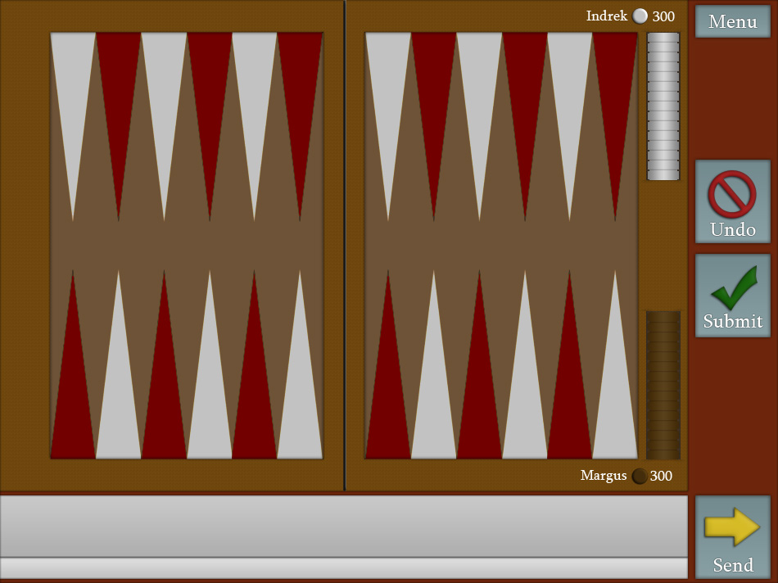

Interviewer:”Do you have anything to add to the documents?”

Customer:”No, everything is perfect as I imagined, being honest, even better. I would like to make it official and order the software.”

Interviewer:”Thank you for picking us for the job.”