Backgammon computer game requirements

## Game setup requirements:

1. Backgammon is a game which is being played between two players.
2. Each player has **15 checkers** of his own color.
3. Each player has **two dice**.
4. Backgammon’s game board is divided into two parts with **the bar**. The bar separates player’s **home board** side from **outer board** side. Both players have their respective home and outer board sides. Each home and outer board sides consist of six triangles which are called by the term **points**. In total there are 24 points in the game.

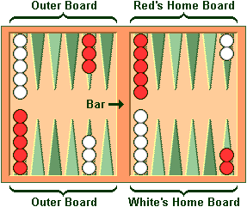

*Figure 1: Board of Backgammon*

Points are numbered in the following fashion:

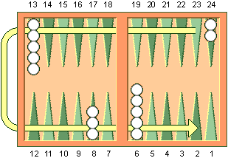

*Figure 2: Shows how points are labeled and shows white player’s movement direction*

From figure 2 we can see that points are being counted from the down right side in clockwise method for white player. Number 1 point is white’s last possible point where to move before checkers could be beared off into the container, meanwhile this is also red’s point number 24 and white’s point 24 is red’s number 1 point. According to current stated logic red’s counting is opposite to white’s. Odd numbered points are marked with one color and even numbered points with another color.

1. On the side of the number 1 point, in players’ perspective of view, is **the container**. The container is used for containing beared off checkers.
2. Players setup their checkers as it is described in figure 1. This is the starting formation for both players: two on each player's twenty-four point, five on each player's thirteen point, three on each player's eight point, and five on each player's six point.

Game functional requirements:

1. At the beginning of the game both players roll their one die. Player who rolls more, gets the right to make first moves within the value which are currently on the board. Example player 1 rolls 3 and player 2 rolls 6 then player 2 starts with dice values 3 and 6. And then the opponent gets the turn right.
2. During the player’s turn, the player rolls with his two dice. Every die symbols a move where the die value symbols the length of the move. Two dice equals with two moves. Move is an action where player moves his or her checker towards home board. Player can’t move his or her checker on the point where opponent has two or more checkers. If point has one opponent checker on it then it is possible to move the checker into the point. During this action, opponent’s checker will be put onto the bar.
3. If player gets during the roll dice with the same value then it will be doubled. For example player rolls 3 and 3 then it will be doubled to 3, 3, 3 and 3.
4. During the player’s turn, the player has one or more checkers on the bar, the player is bound to remove all the checkers from the bar before he can move other checkers in the board. If he doesn’t have any possible moves then he has to give turn over to the opponent. To escape the bar, the player has to roll the dice which equals with any of free points in the opponent’s home board. If it equals then player could move his or her checker off the bar to the point.
5. If player has all his or her checkers in the home board then starts the **bearing off** phase. Bearing off is the function where player gets his or her checkers into the container from the home board. For example if player has his checkers in the point number 6 then he or she needs die with value 6 to get the checker into the container. For other checkers in points 5 and smaller, there are needed die with value point value or higher.
6. Player wins the game if he or she doesn’t have more checkers on the board.

Graphical user-interface requirements (watch f**igure 3**):

1. Start game popup:
   1. Two input text fields for player names;
   2. “Start game” button.
2. Menu popup:
   1. “Continue” button;
   2. “New game” button;
3. Game page:
   1. Game board;
   2. Labels on the board for showing player names;
   3. Next to player names are symbolized their checker color and move counter which shows how much you have to move your checkers to get to the container;
   4. From the right of the game board is a buttons’ container, with following buttons:
      1. Button “Menu” for going into the menu;
      2. Button “Undo” provides a possibility to take moves back within ongoing turn;
      3. Button “Submit” end the turn.
      4. Button “Send” sends the inserted message into chat.
   5. Bottom from the game board is the chat which contains of text area and text input.
4. Board:
   1. The bar is colored as brown with black line which imitates the game’s real life possibility to pack the game;
   2. Odd numbered(according figure 2 point of view) points are colored as gray;
   3. Even numbered(according figure 2 point of view) points are colored as dark red;
   4. Background of the board is colored as light brown;
   5. Surrounding of the board is brown.
   6. Player 1 checkers are brown.
   7. Player 2 checkers are light gray.
   8. Dice, both players have two dice each.

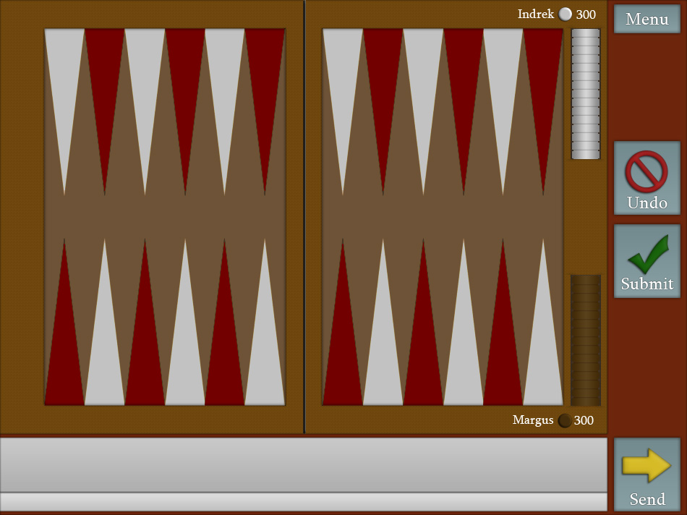

*Figure 3: Games graphics example*

Environmental requirements:

1. Should be working best in Google Chrome, other browsers aren’t prioritized.