**Abstract**

There are many popular problems in different practical fields of computer sciences, database applications, Networks and Artificial intelligence. One of these basic operations and problems is sorting algorithm; the sorting problem has attracted a great deal of research. A lot of sorting algorithms has been developed to enhance the performance in terms of computational complexity. there are several factors that must be taken in consideration; time complexity, stability, memory space. This project aims to visualize all the elementary and advanced sorting algorithms suitable for different situations. It displays the time and space complexity and the time taken for each sorting function to run.

**Introduction**

Sorting is the process of arranging a set of data in sequenced increasing or descending order based on common properties among the data items. Language Dictionary, Telephone directories, point table in any sport, posts in social media, waste sorting, etc. are a few examples of sorting in action in daily life. It is desirable to use an algorithm to perform the task for efficiency, consistency, and quality of the result. This project focuses on visualization of various sorting algorithms that can be used to sort a set of random numbers as a data set and visualize the sorting process using a web application.

**Programming Design**

The programming design of the project includes HTML, CSS and Bootstrap for the creation of user interface and JavaScript was used at the back to visualize the data bars and calculate the time taken for each function to run

****. ** **

**Block Diagram representing the flow of application:**

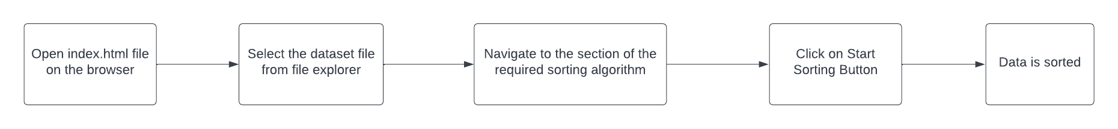

**Experimental Setup**

The code editor used to build this project was Visual Studio code and the version control system used to coordinate with the team members was Git for better understanding of the changes made by each member and making a clear label on the work done by each member.

** **

**Results and Discussion**

**Conclusion**

The goal and main objective of the thesis were to bring sorting algorithms and visualization together. The concept of sorting algorithm mostly expressed through codes and syntax was still abstract. Thus, this project was an attempt to eliminate that by creating a tool that can visualize the process and steps of sorting algorithms. project was successful in delivering the idea of visualization of sorting algorithm through a web application and providing a separate look into the algorithm apart from lines of code and syntaxes.

**References**

1. <https://www.ijsr.net/get_abstract.php?paper_id=SR211114140358>
2. <https://ieeexplore.ieee.org/document/5987184>
3. <https://www.researchgate.net/publication/259911982_Review_on_Sorting_Algorithms_A_Comparative_Study>
4. <https://papers.ssrn.com/sol3/papers.cfm?abstract_id=3329410>
5. <https://www.theseus.fi/bitstream/handle/10024/507342/Bikram_Karki.pdf;jsessionid=108FBC779B80D2AEC143B89C985B68F4?sequence=2>