

**College of Engineering and Information Technology**

Database Administration – INT321

Lab # 5 Model Answer

Use the company database below to answer the following questions

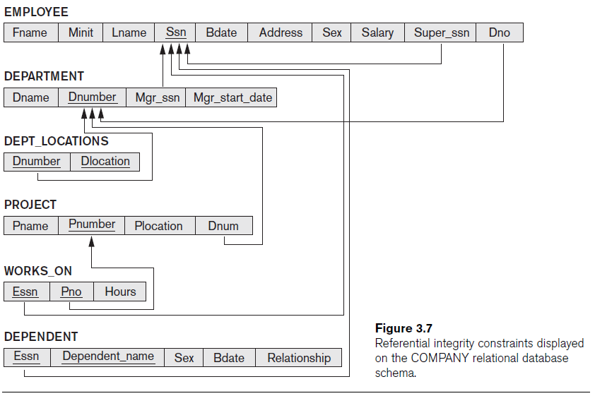

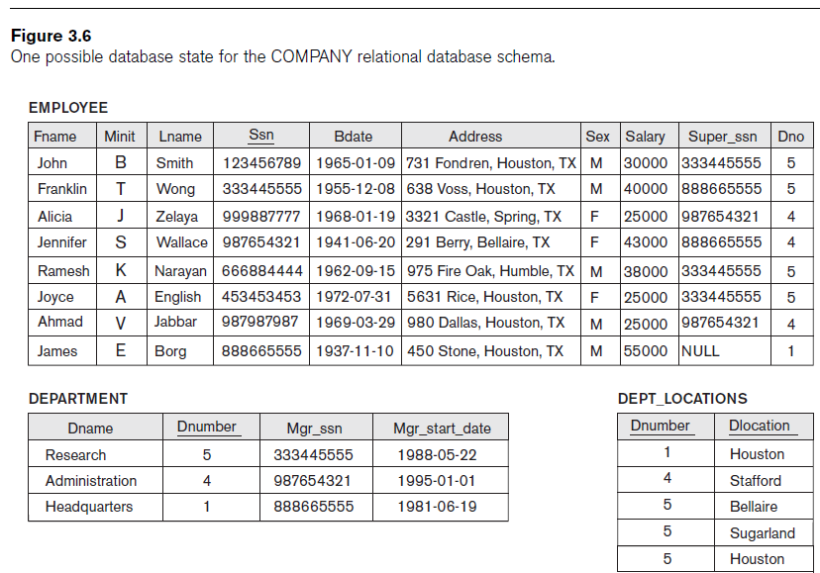

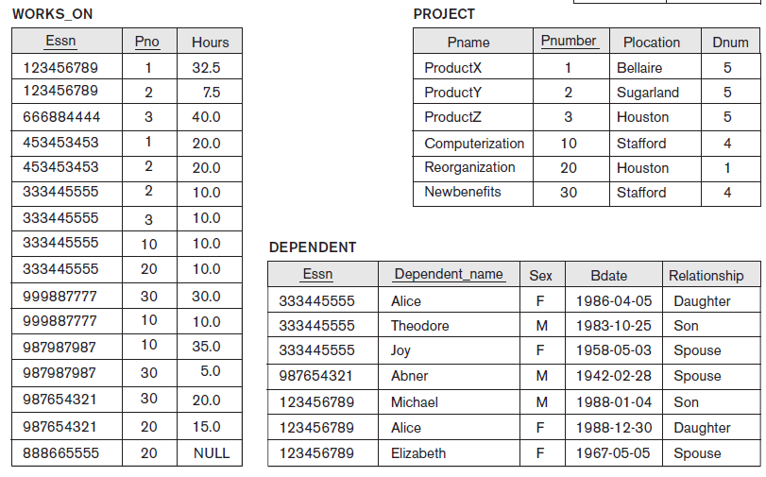

1. Write an SQL statement to create a view named department_Detail that retrieve Dnumber, Dname, and department location for all departments.

**Answer:**

CREATE VIEW DEPARTMENT_DETAIL AS SELECT DNAME, DEPARTMENT.DNUMBER, DLOCATION

FROM DEPARTMENT, DEPT_LOCATIONS

WHERE DEPARTMENT.DNUMBER = DEPT_LOCATIONS.DNUMBER;

1. Write an SQL statement to create a view named Employee_Dependent that retrieves FName, LName, SSN, Dependent Name, and relationship for all employees who have dependents.

**Answer:**

CREATE VIEW EMPLOYEE_DEPENDENT AS SELECT FNAME, LNAME, SSN, DEPENDENT_NAME, RELATIONSHIP

FROM EMPLOYEE, DEPENDENT

WHERE DEPENDENT.ESSN = EMPLOYEE.SSN

ORDER BY SSN, DEPENDENT_NAME;

1. Write an SQL statement to create a view named Employee_Project that retrieves employee SSN, employee first name, employee last name, Department number, Department Name, project name, number of hours worked for all employees who work in any project.

**Answer:**

CREATE VIEW EMPLOYEE_PROJECT AS SELECT SSN, FNAME, LNAME, DNO, DNAME, PNAME, HOURS

FROM EMPLOYEE, WORKS_ON, PROJECT, DEPARTMENT

WHERE EMPLOYEE.SSN = WORKS_ON.ESSN

AND WORKS_ON.PNO = PROJECT.PNUMBER

AND EMPLOYEE.DNO = DEPARTMENT.DNUMBER;

1. Write an SQL statement to create a view named Department_Manager that retrieves Dname , Dnumber, Department manager last name, and department location for all departments.

**Answer:**

CREATE VIEW Department_Manager AS SELECT DNAME, DEPARTMENT.DNUMBER, LNAME, DLOCATION

FROM EMPLOYEE, DEPARTMENT, DEPT_LOCATIONS

WHERE EMPLOYEE.SSN=DEPARTMENT.MGRSSN

AND DEPARTMENT.DNUMBER=DEPT_LOCATIONS.DNUMBER;

5. Write an SQL statement to create a view named Employee_Supervisor that retrieves Employee first name, employee last name, Employee SSN, Employee salary, Supervisor SSN, Supervisor First name, and supervisor last name for all employees.

Answer:

CREATE VIEW EMPLOYEE_SUPERVISOR AS SELECT WORKER.FNAME AS EMPLOYEEFIRSTNAME,WORKER.LNAME AS EMPLOYEELASTNAME,WORKER.SSN AS EMPLOYEESSN, WORKER.SALARY AS EMPLOYEESALARY, MANAGER.SSN AS SUPERVISORSSN, MANAGER.FNAME AS SUPERVISORFIRSTNAME, MANAGER.LNAME AS SUPERVISORLASTNAME

FROM EMPLOYEE WORKER, EMPLOYEE MANAGER

WHERE WORKER.SUPERSSN = MANAGER.SSN;

6. Write an SQL statement to create a view named Employee_Salary that retrieves the employee SSN, Employee first name, employee salary, and employee department number of all employees who have salary greater than the average salaries of their department.

Answer:

CREATE VIEW EMPLOYEE_SALARY AS SELECT SSN, FNAME, LNAME, SALARY, DNO FROM EMPLOYEE E WHERE SALARY >(SELECT AVG(SALARY) FROM EMPLOYEE D WHERE E.DNO = D.DNO);

7. For every employee who has dependent, write an SQL statement to create a view named Emp_Dependent that retrieves employee SSN, Fname, Lname, total number of dependent.

**ANS:**

CREATE VIEW EMP_DEPENDENT AS SELECT SSN, FNAME, LNAME, COUNT (*)  
FROM EMPLOYEE, DEPENDENT  
WHERE ESSN = SSN

GROUP BY SSN, FNAME, LNAME;

8. For every employee who works on more than one project, write an SQL statement to create a view named Emp_projects that retrieves the employee SSN, Fname, Lname, address, and the total number of projects in which he work on. Name the total number of projects in which he works as totalProjects.

ANS:

CREATE VIEW EMP_PROJECTS AS SELECT SSN, FNAME, LNAME, ADDRESS, COUNT (*) AS TOTALPROJECTS  
FROM EMPLOYEE, WORKS_ON

WHERE ESSN = SSN  
GROUP BY SSN, FNAME, LNAME, ADDRESS

HAVING COUNT (*) >1;

9. Use view concept to perform the following task. Create three users. Grant the first user select on all columns of employee table for employee working in department 1. Grant the second user select on all columns of employee table for employees working in department 3. Grant the third user select on all columns of male employee.

Answer:

Create user userlab5_1 identified by lab5;

Grant connect to userlab5_1;  
Create user userlab5_2 identified by lab5;

Grant connect to userlab5_2;

Create user userlab5_3 identified by lab5;

Grant connect to userlab5_3;

Create view emp_dept1 as select * from employee where dno = 1;  
Create view emp_dept3 as select * from employee where dno = 3;

Create view Male_emp as select * from employee where sex = ‘M’;

Grant select on emp_dept1 to userlab5_1;

Grant select on emp_dept to userlab5_2;

Grant select on Male_emp to userlab5_3;