

**College of Engineering and Information Technology**

Database Administration – INT321

Lab # 6

Use the company database below to answer the following questions

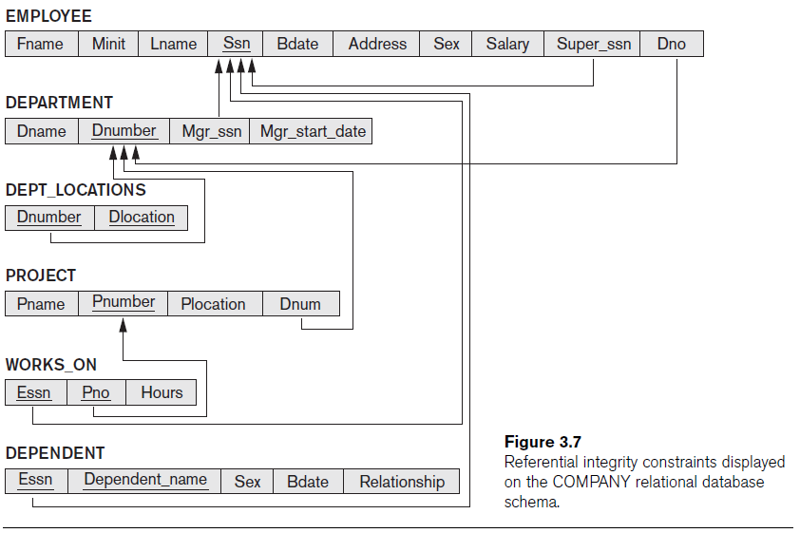

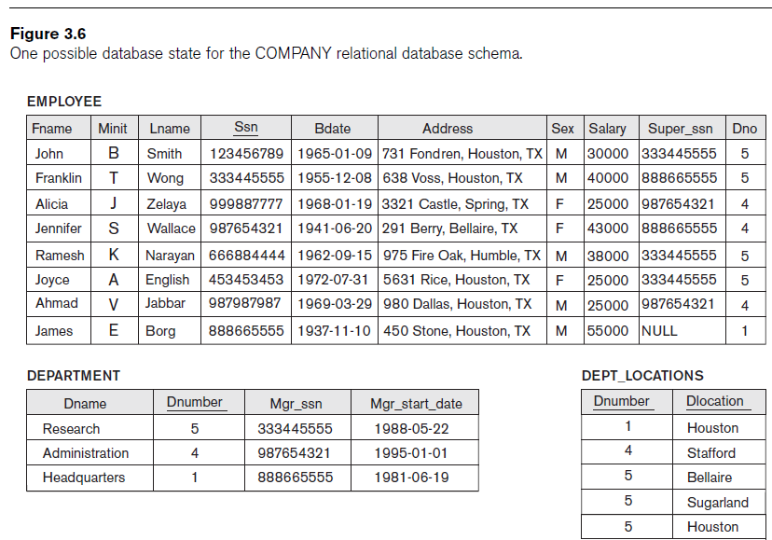

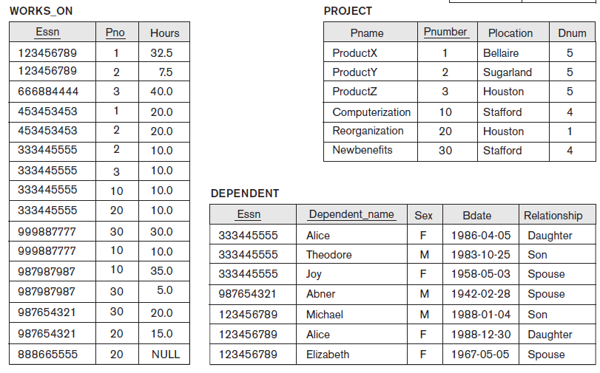

1. Write an SQL statement to create an index on DNO column of the employee table. The name of the index is DNO_Index.
2. Write an SQL statement to create an index on salary column of the employee table. The name of the index is Salary_Index.
3. Write an SQL statement to create bitmap index on sex column of the employee table. The name of the index is gender_Index.
4. Write an SQL statement to create unique index on PNAME column of the PROJECT table. The name of the index is Pname_Index.