

College of Engineering and Information Technology

**INT302 Database Management Systems**

1st Summer semester 2022/2023

Model Answer for Lab # 1

Consider the following company database

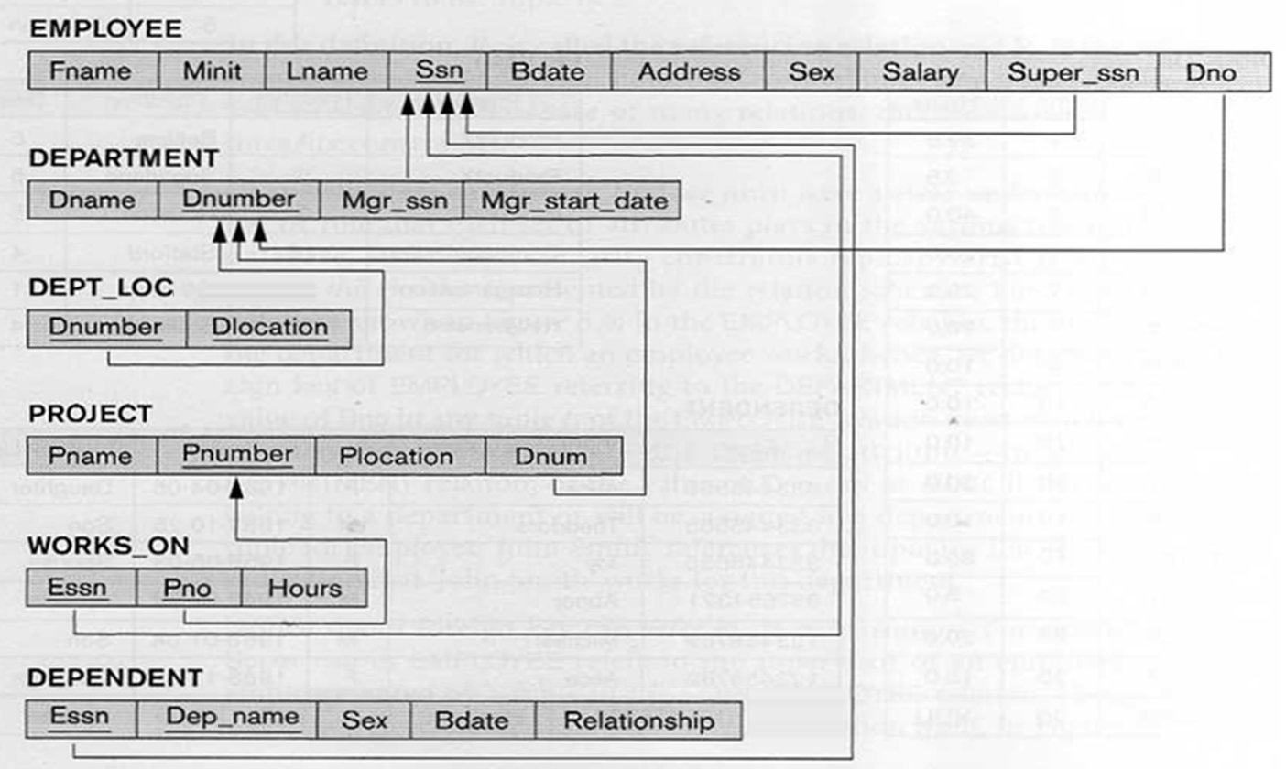

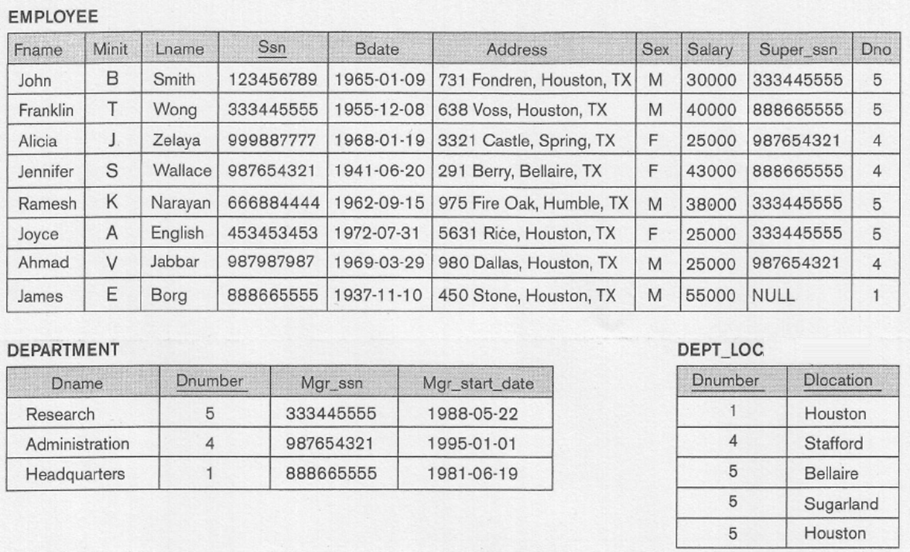

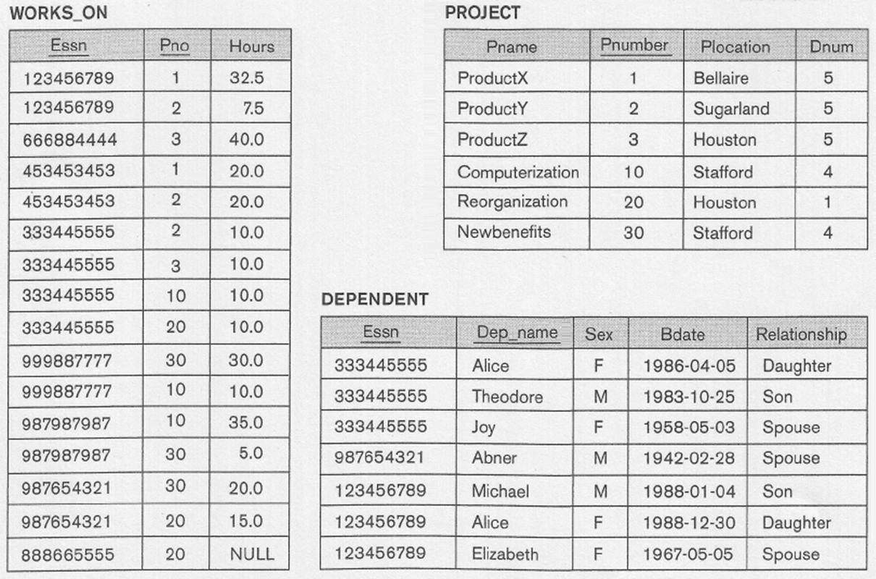

1. Write SQL query that list the last name (Lname), Address, and the salary of all employees with a salary less than 40,000

**Answer:**

**Select Lname, Address, Salary**

**From Employee**

**Where Salary < 40000;**

2. Write SQL query that list the last name (Lname) and address of all employees who work for the Administration department.

**Answer:**

**Select Lname, Address**

**From Employee, Department**

**Where Dno = Dnumber and Dname = 'Administration';**

3. Write SQL query that list the last name (Lname), first name (Fname) and salary of all Male employees who work for the Research department.

**Answer:**

**Select Lname, Fname, Salary**

**From Employee, Department**

**Where Dno = Dnumber and Dname = 'Research' and Sex = ‘M’;**

4. Write SQL query that list the last name (Lname) of all employees and the name of department (Dname) they work for.

**Answer:**

**Select Lname, Dname**

**From Employee, Department**

**Where Dno = Dnumber;**

5. For each department, write SQL query that list the name of the department (Dname) and the last name of the manager.

**Answer:**

**Select Dname, Lname**

**From Department, Employee**

**Where Ssn = Mgr_ssn;**

6. For the employee whose last name is Wong, write SQL query that list the name of all projects he worked on for 10 or more hours.

**Answer:**

**Select Pname**

**From Project, Works_On, Employee**

**Where Pnumber = Pno AND Ssn = Essn AND**

**Lname ='Wong' AND Hours >=10;**

7. For any employee who has a spouse, write SQL query that list the last name of the employee and the name of his spouse.

**Answer:**

**Select Lname, Dep_name**

**From Employee, Dependent**

**Where Ssn = Essn AND Relationship = 'Spouse';**

8. For each dependent, write SQL query that list the name of the dependent, the name of employee with whom they are related, and the name of the department in which the employee works.

**Answer:**

**Select Dep_name, Lname, Dname**

**From Dependent, Employee, Department**

**Where Essn = Ssn AND Dno = Dnumber;**

9. For project located in Houston, write SQL query that list the project name, controlling department name, and the name of the manager.

**Answer:**

**Select Pname, Dname, Lname**

**From Project, Department, Employee**

**Where Dnum = Dnumber AND Mgr_ssn = Ssn AND**

Plocation = 'Houston';