

College of Engineering and Information Technology

**INT302 Database Management Systems**

1st semester Summer 2022/2023

Model Answer for Lab # 2

Consider the following company database

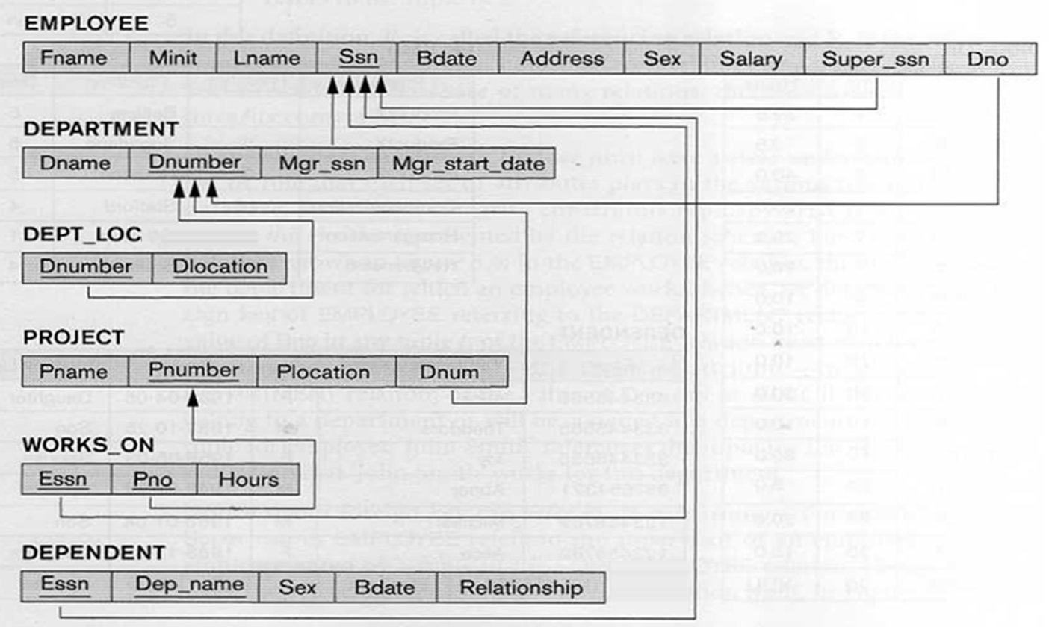

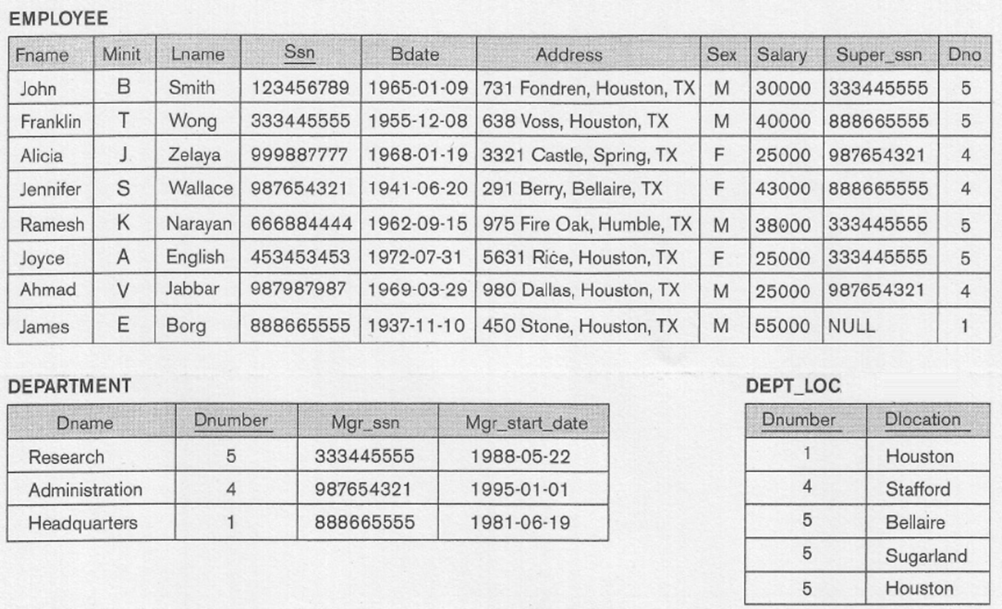

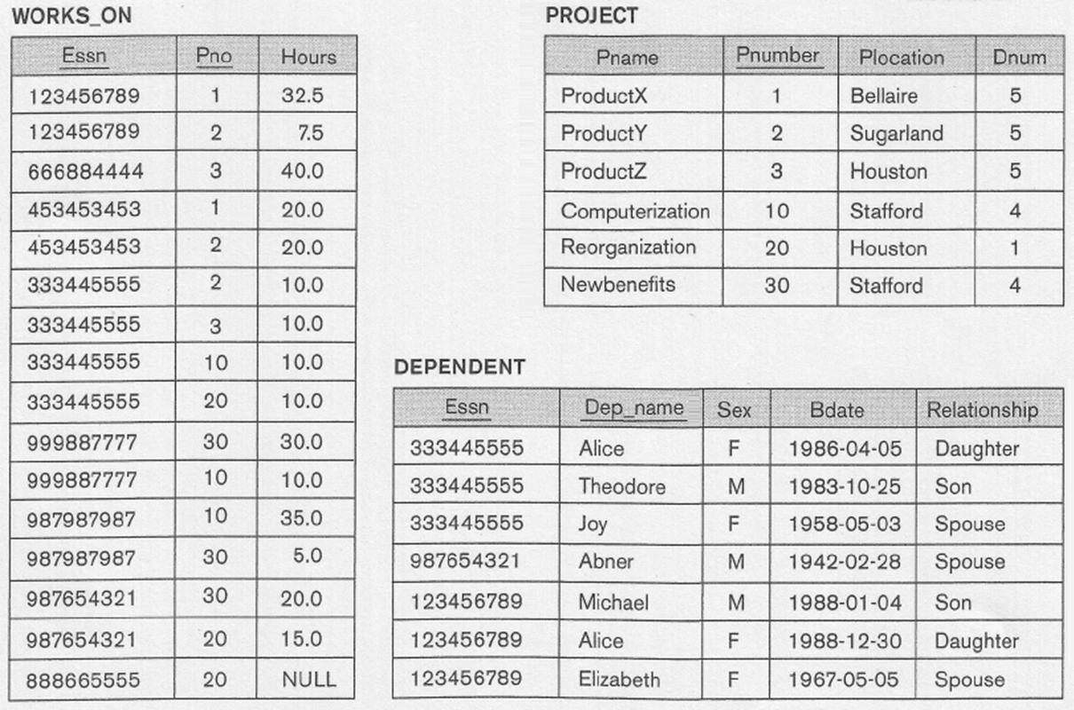

Use set operations to write the following queries

1. Write SQL query that list the last name of employees who work for Research department or has a spouse.

Query should output:

Employee Name

---------------

English

Narayan

Smith

Wallace

Wong

Solution:

(Select Lname AS "Employee Name"

From Employee, Department

Where Dno = Dnumber AND Dname = 'Research')

UNION

(Select Lname AS "Employee Name"

From Employee, Dependent

Where ssn = Essn AND Relationship = 'Spouse');

**2.** Write SQL query that list the last name of all employees who are managers and work on the project Newbenefits.

**Query should output:**

Employee Name

-------------------------

Wallace

**Solution:**

**(Select Lname AS "Employee Name"**

**From Employee, Department**

**Where ssn = Mgr_ssn)**

**INTERSECT**

(Select Lname AS "Employee Name"

**From Employee, Works_On, Project**

**Where ssn = Essn AND Pno = Pnumber AND Pname = 'Newbenefits');**

3. Write SQL query that list the last name and Salary of all employees who work on project ProductY or work for the Administration department.

**Query should output:**

Employee Name SALARY

------------------------ ----------

English 25000

Jabbar 25000

Smith 30000

Wallace 43000

Wong 40000

Zelaya 25000

**Output:**

**(Select Lname AS "Employee Name", Salary**

**From Employee, Works_On, Project**

**Where ssn = Essn AND Pno = Pnumber AND Pname = 'ProductY')**

**UNION**

**(Select Lname AS "Employee Name", Salary**

**From Employee, Department**

**Where Dno = Dnumber AND Dname = 'Administration');**

**4.** Write SQL query that list the last name of an employee and the name of his spouse for employees working in the Research department but not on the Computerization project.

**Query should output:**

Employee Name Spouse

----------------------- ---------------

Smith Elizabeth

**Solution:**

**(Select Lname AS "Employee Name", Dep_name AS "Spouse"**

**From Employee, Dependent, Department**

**Where ssn = Essn AND Dno = Dnumber AND**

Relationship = 'Spouse' AND Dname = 'Research')

**MINUS**

**(Select Lname AS "Employee Name", Dep_name AS "Spouse"**

**From Employee E, Dependent D, Works_On W, Project P**

**Where E.ssn = D.Essn AND E.ssn = W.Essn AND W.Pno = P.Pnumber AND**

D. Relationship = 'Spouse' AND P.Pname = 'Computerization');

5. Write SQL query that list the name of all departments controlling projects located in Houston but not department names that have employees working on project ProductZ.

Query should output:

Department Name

--------------------

Headquarters

Solution:

(Select Dname AS "Department Name"

From Department, Project

Where Dnumber = Dnum AND Plocation = 'Houston')

MINUS

(Select Dname AS "Department Name"

From Employee, Department, WOrks_On, Project

Where Dno = Dnumber AND Dnumber = Dnum AND ssn = Essn

AND Pname = 'ProductZ');

6. Write SQL query that list the name of the dependents of employees working for the Research department but not the dependents of employees working on the Computerization department.

Query should output:

Dependent Name

---------------

Elizabeth

Michael

Output:

(Select Dep_name AS "Dependent Name"

From Employee, Dependent, Department

Where ssn = Essn AND Dno = Dnumber AND Dname = 'Research')

MINUS

(Select Dep_name AS "Dependent Name"

From Employee, Dependent E, Works_On W, Project

Where ssn = E.Essn AND ssn = W.Essn AND Pno = Pnumber

AND Pname = 'Computerization');

7. Write SQL query that list the name of all projects on which an employee with last name Wong works on but projects that are not controlled by the Research department.

Query should output:

Project Name

--------------------------------------------------

Computerization

Reorganiation

Solution:

(Select Pname AS "Project Name"

From Project, Works_On, Employee

Where Pnumber = Pno AND Essn = ssn AND Lname = 'Wong')

MINUS

(Select Pname AS "Project Name"

From Project, Department

Where Dnum = Dnumber AND Dname = 'Research');