

College of Engineering and Information Technology

**INT302 Database Management Systems**

1st semester Summer 2022/2023

Model Answer for Lab # 3

Consider the following company database

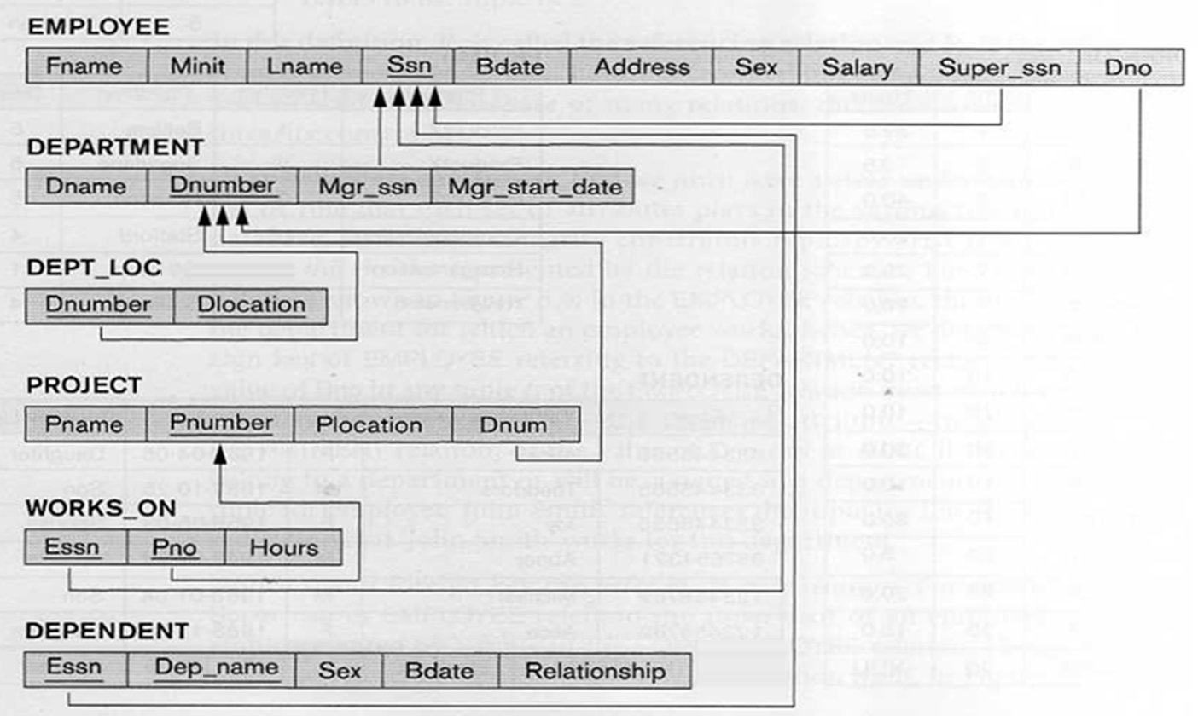

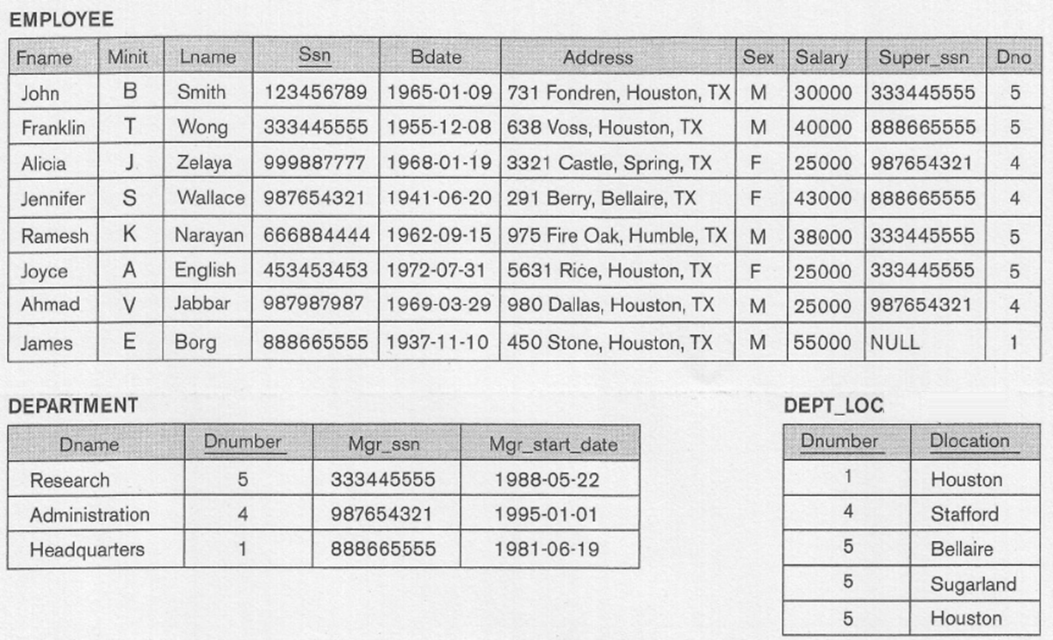

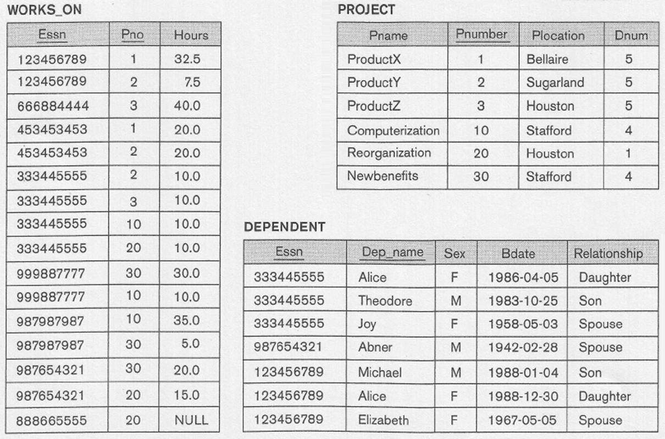

1. Write SQL query that list the last name (Lname) of an employee and the name of the project he is working on for employees who were born in the sixties. Rename the Lname as Employee Name, PName as Project Name.

Query should output:

Employee Name Project Name

----------------------- ----------------------------

Smith ProductX

Smith ProductY

Narayan ProductZ

Jabbar Computerization

Zelaya Computerization

Jabbar Newbenefits

Zelaya Newbenefits

Solution:

Select Lname AS "Employee Name", Pname AS "Project Name"

From Employee, Works_On, Project

Where ssn = Essn AND Pno = Pnumber AND BDATE Like '196_-__-__';

2. Write SQL query that list the last name of each employee who has a spouse, and the name of the spouse for employees who live in Houston. Rename the Lname as Employee Name, Dep_Name as Spouse Name

Query should output:

Employee Name Spouse Name

----------------------- ----------------------

Smith Elizabeth

Wong Joy

Wallace Abner

Solution:

Select Lname AS "Employee Name", Dep_name AS "Spouse Name"

From Employee, Dependent

Where ssn = Essn AND Relationship = 'Spouse'

AND Address Like '%Houston%';

Use set operations to write the following queries

3. Write an SQL statement to display employee name (Fname and lname), SSN, Department Name, and salary for all employees whose Fname starts with the letter J

Answer:

SELECT FNAME,LNAME, SSN, DName, SALARY

FROM EMPLOYEE , Department

WHERE DNO = DNUMBER AND FNAME LIKE ‘J%’;

4. Write an SQL statement to display employee name (FName and LName), SSN, and salary as old salary, and new salary for all employees who work for the research department. The old salary is same as the salary. The new salary is the salary increased by 20%.

Answer:

SELECT FNAME, LNAME, SSN, SALARY AS “OLD SALARY”, SALARY*1.2 AS “NEW SALARY”

FROM EMPLOYEE, Department

WHERE DNO = DNUMBER and DName = ‘Research’;

5. Write an SQL statement to display employee name (FName and LName), SSN, Department Name, and project name for all employees who work on project with project name starts with Product.

Answer:

SELECT FNAME, LNAME, SSN, DName, PName

FROM EMPLOYEE, Department, Works_On, Project

WHERE DNO = DNUMBER and PNO = PNumber and SSN = ESSN and PName Like ‘Product%’;

6. Write an SQL statement to display employee name (FName and LName), Dependent Name, and relationship for all employees with dependent name eds with the letter **e**.

Answer:

SELECT FNAME, LNAME, Dep_Name, Relationship

FROM EMPLOYEE, Dependent

WHERE ESSN = SSN and Dep_Name Like ‘%e’;

7. For each employee who has supervisor and works on project with project name ends with the letter **n**, write an SQL statement to display Employee First Name Employee Last Name, Supervisor First Name, Supervisor Last Name , and Hours.

Answer:

SELECT E.FNAME AS “Employee First Name”, E.LNAME AS “Employee Last Name”, S.FNAME AS “Supervisor First Name”, S.LNAME AS “Supervisor Last Name”, W.Hours

FROM EMPLOYEE E, Employee S, Works_On W, Project

WHERE E.Super_SSN = S.ESSN AND E.SSN= W.ESSN and W.PNO = PNUMBER and PName Like ‘%n’;