

College of Engineering and Information Technology

**INT302 Database Management Systems**

1st semester Summer 2022/2023

Model Answer for Lab # 4

Consider the following company database

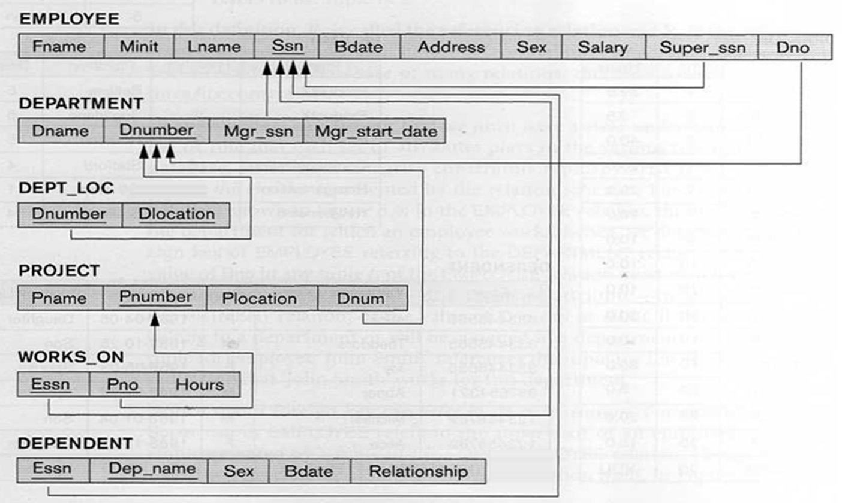

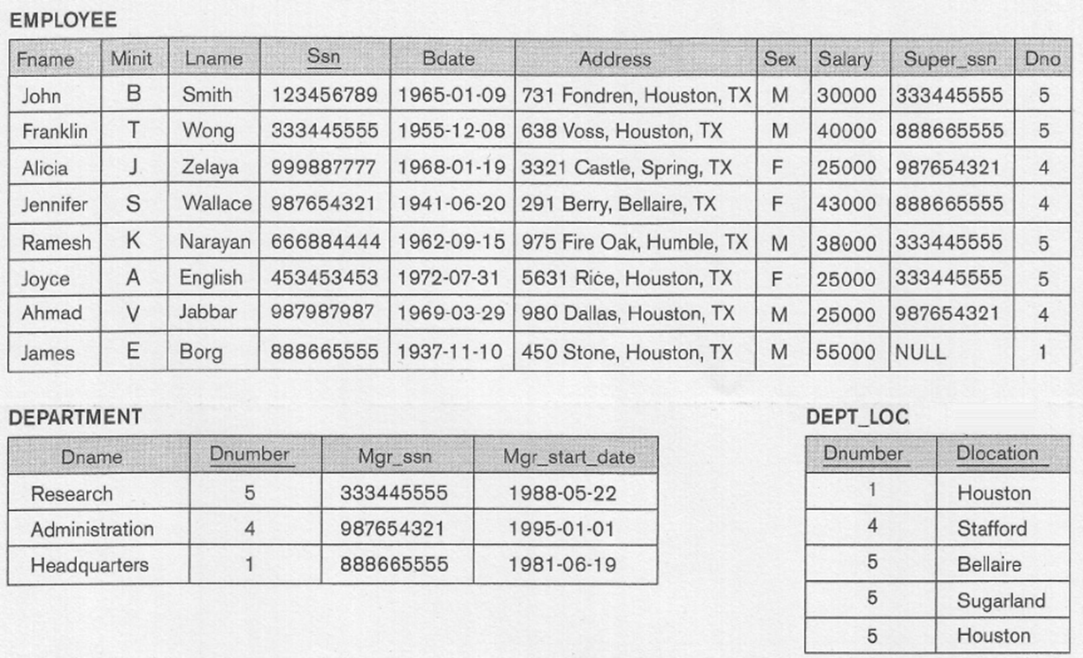

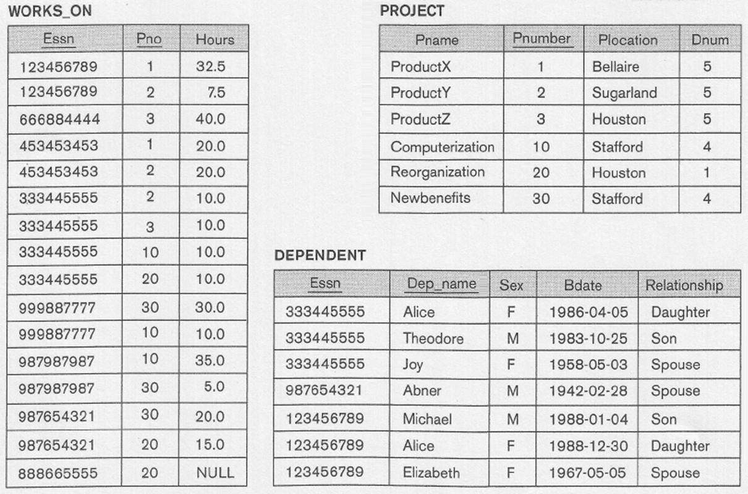

1. Write SQL query that list the First Name and Last Name of all employees who has salary greater than 30,000 and female dependent.

Solution:

SELECT DISTINCT FNAME, LNAME

FROM EMPLOYEE, DEPENDENT

WHERE SSN = ESSN AND SALARY > 30,000 AND DEPENDENT.SEX = ‘F’ ;

2. Write SQL query that list the last name of all employees who has no Spouse.

Query should output:

LNAME

---------------

Wong

Smith

Solution:

Select Distinct Lname

From Employee, Dependent

Where Ssn = Essn AND Relationship NOT LIKE 'Spouse';

3. Write SQL query that list the last name of employees whose salary is greater than the salary of all employees in the Research department.

Hint: Use a subquery

Query should output:

LNAME

---------------

Wallace

Borg

Solution:

SELECT LNAME

FROM EMPLOYEE

WHERE SALARY > ALL (SELECT SALARY

FROM EMPLOYEE, DEPARTMENT

WHERE DNO = DNUMBER AND DNAME = 'Research');

4. Write SQL query that list the last name of employees who work in the Administration department and whose salary is greater than the salary of all employees in the Research department.

Hint: Use a subquery

Query should output:

LNAME

---------------

Wallace

Solution:

SELECT LNAME

FROM EMPLOYEE, DEPARTMENT

WHERE DNO = DNUMBER AND DNAME = 'Administration' AND

SALARY > ALL (SELECT SALARY

FROM EMPLOYEE, DEPARTMENT

WHERE DNO = DNUMBER AND DNAME = 'Research');

5. Write SQL query that list the last name of all employees and the name of the project they are working on for employees working on any project Smith is working on. The result should be ordered in descending order on last name.

Hint: Use a subquery

Query should output:

LNAME PNAME

--------------- --------------------

Wong ProductY

Smith ProductY

Smith ProductX

English ProductY

English ProductX

Solution:

SELECT LNAME, PNAME

FROM EMPLOYEE, WORKS_ON, PROJECT

WHERE SSN = ESSN AND PNO = PNUMBER

AND PNO IN (SELECT PNO

FROM EMPLOYEE, WORKS_ON

WHERE SSN = ESSN AND LNAME = 'Smith')

ORDER BY LNAME DESC, PNAME;

6. Write SQL query that list the name of all departments controlling projects on which an employee with last name Wallace is working on.

Query should output:

DNAME

--------------------

Headquarters

Administration

Solution:

SELECT DISTINCT DNAME

FROM DEPARTMENT, PROJECT

WHERE DNUMBER = DNUM AND

PNUMBER IN (SELECT PNO

FROM EMPLOYEE, WORKS_ON

WHERE SSN = ESSN AND LNAME = 'Wallace');

Another Solution:

SELECT DISTINCT DNAME

FROM DEPARTMENT, PROJECT

WHERE DNUMBER = DNUM AND

PNUMBER = ANY (SELECT PNO

FROM EMPLOYEE, WORKS_ON

WHERE SSN = ESSN AND LNAME = 'Wallace');