

College of Engineering and Information Technology

**INT302 Database Management Systems**

1st semester Summer 2022/2023

Model Answer for Lab # 5

Consider the following company database

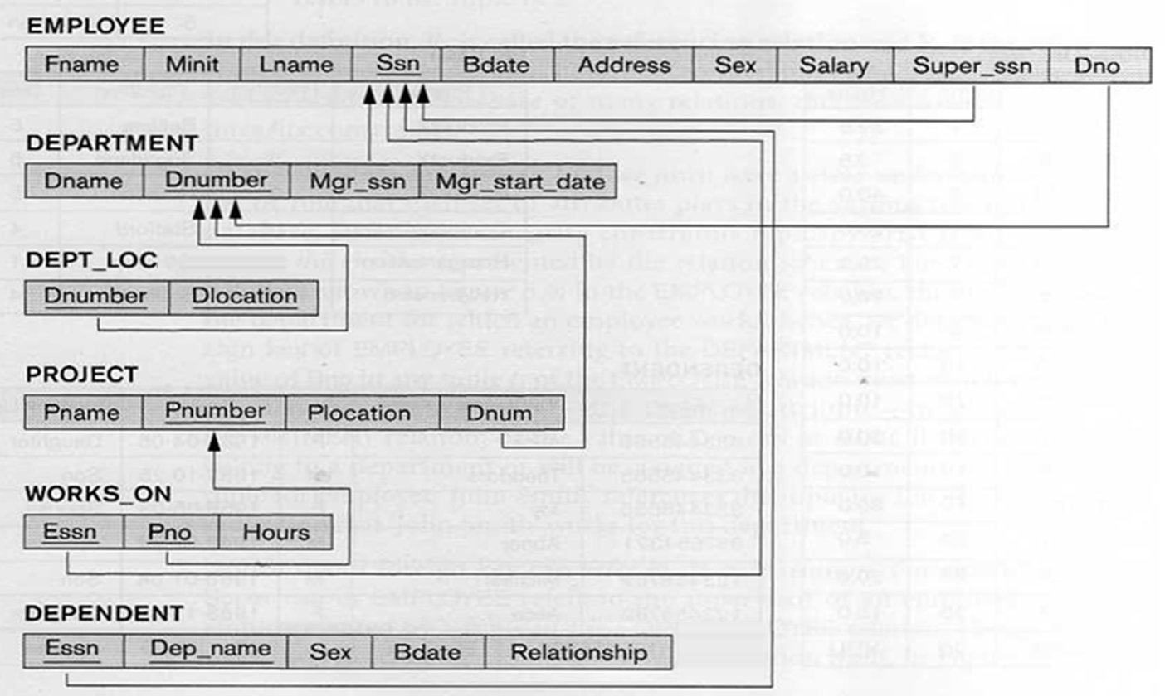

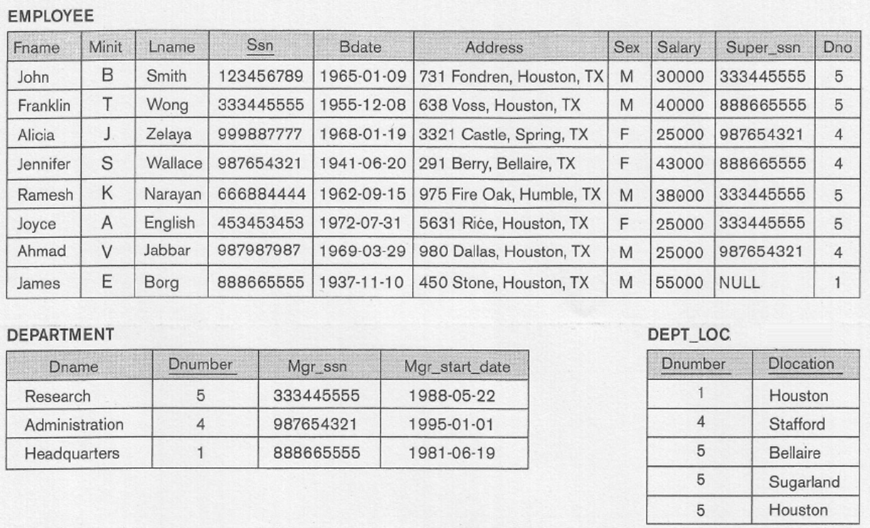

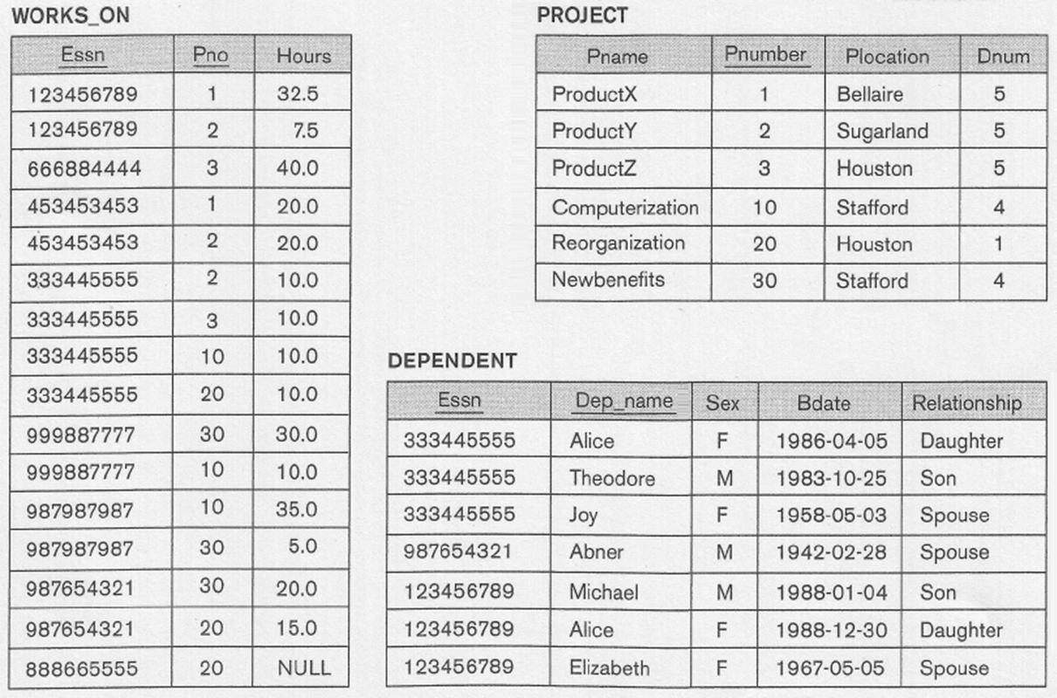

Use subqueries in writing SQL statements for the following:

1. List the last name and salary of all employees who have dependents and work on projects controlled by the research department.

Answer #1 (Using Subqueries)

(SELECT LNAME, SALARY

FROM EMPLOYEE

WHERE EXISTS (SELECT * FROM DEPENDENT WHERE SSN = ESSN))

INTERSECT

(SELECT LNAME, SALARY

FROM EMPLOYEE

WHERE SSN IN (SELECT ESSN

FROM WORKS_ON, PROJECT, DEPARTMENT

WHERE PNO = PNUMBER AND DNUM=DNUMBER AND DNAME='Research'));

Answer #2

(SELECT LNAME, SALARY

FROM EMPLOYEE, DEPENDENT

WHERE SSN = ESSN)

INTERSECT

(SELECT LNAME, SALARY

FROM EMPLOYEE, WORKS_ON, PROJECT, DEPARTMENT

WHERE SSN = ESSN AND PNO = PNUMBER AND DNUM=DNUMBER AND DNAME='Research');

Output

LNAME SALARY

--------------- ----------

Smith 30000

Wong 40000

2. List the last name and date of birth of all employees working for the department controlling the project ProductX and have no dependents.

Answer#1 (Using Subqueries)

(SELECT DISTINCT LNAME, BDATE

FROM EMPLOYEE

WHERE DNO IN (SELECT DNUMBER

FROM DEPARTMENT, PROJECT

WHERE DNUM=DNUMBER AND PNAME = 'ProductX'))

MINUS

(SELECT DISTINCT LNAME, BDATE

FROM EMPLOYEE

WHERE EXISTS (SELECT *

FROM DEPENDENT

WHERE SSN = ESSN));

Answer #2

(SELECT DISTINCT LNAME, BDATE

FROM PROJECT, DEPARTMENT, EMPLOYEE

WHERE DNUM=DNUMBER AND DNUMBER = DNO AND PNAME = 'ProductX')

MINUS

(SELECT DISTINCT LNAME, E.BDATE

FROM EMPLOYEE E, DEPENDENT

WHERE SSN = ESSN);

Output

LNAME BDATE

--------------- ---------

English 31-JUL-72

Narayan 15-SEP-62

3. List the name of all dependents and their birthdate who are related to an employee working on projects controlled by the Research department but not related to employees working as managers.

Answer #1 (Using Subqueries)

(SELECT DISTINCT DEP_NAME, D.BDATE

FROM DEPENDENT D

WHERE D.ESSN IN (SELECT ESSN

FROM WORKS_ON W, PROJECT P, DEPARTMENT DE

WHERE W.PNO = P.PNUMBER AND P.DNUM=DE.DNUMBER

AND DNAME = 'Research'))

INTERSECT

(Select Distinct DEP_NAME, D.BDATE

FROM DEPENDENT D

WHERE ESSN NOT IN (SELECT SSN

FROM EMPLOYEE E, DEPARTMENT D

WHERE SSN = MGR_SSN));

Answer #2

(SELECT DISTINCT DEP_NAME, D.BDATE

FROM DEPENDENT D, WORKS_ON W, PROJECT P, DEPARTMENT DE

WHERE D.ESSN = W.ESSN AND W.PNO=P.PNUMBER AND DNUM=DE.DNUMBER

AND DNAME = 'Research')

MINUS

(SELECT DISTINCT DEP_NAME, D.BDATE

FROM EMPLOYEE E, DEPENDENT D, DEPARTMENT DE

WHERE E.SSN = D.ESSN AND MGR_SSN=SSN);

Output

DEP_NAME BDATE

--------------- ---------

Alice 30-DEC-88

Elizabeth 05-MAY-67

Michael 04-JAN-88

4. For each employee working in the Research department and has no dependents, list the last name and salary of the employee, and the last name of his supervisor.

Answer #1 (Using Subqueries)

(SELECT E.LNAME AS "EMPLOYEE", E.SALARY, S.LNAME AS "SUPERVISOR"

FROM EMPLOYEE E, EMPLOYEE S

WHERE E.SUPER_SSN = S.SSN AND E.DNO IN (SELECT DNUMBER

FROM DEPARTMENT

WHERE DNAME = 'Research'))

MINUS

(SELECT DISTINCT E.LNAME AS "EMPLOYEE", E.SALARY, S.LNAME AS "SUPERVISOR"

FROM EMPLOYEE E, EMPLOYEE S

WHERE E.SUPER_SSN = S.SSN AND EXISTS (SELECT *

FROM DEPENDENT

WHERE E.SSN = ESSN));

Answer #2

(SELECT E.LNAME AS "Employee", E.SALARY, S.LNAME AS "Supervisor"

FROM EMPLOYEE E, EMPLOYEE S, DEPARTMENT D

WHERE E.SUPER_SSN = S.SSN AND E.DNO=DNUMBER AND DNAME = 'Research')

MINUS

(SELECT E.LNAME AS "Employee", E.SALARY, S.LNAME AS "Supervisor"

FROM EMPLOYEE E, EMPLOYEE S, DEPENDENT D

WHERE E.SUPER_SSN = S. SSN AND E.SSN = D.ESSN);

Output

Employee SALARY Supervisor

--------------- ---------- ---------------

English 25000 Wong

Narayan 38000 Wong