

College of Engineering and Information Technology

**INT302 Database Management Systems**

1st Summer semester 2022/2023

Model Answer for Lab # 6

Consider the following company database

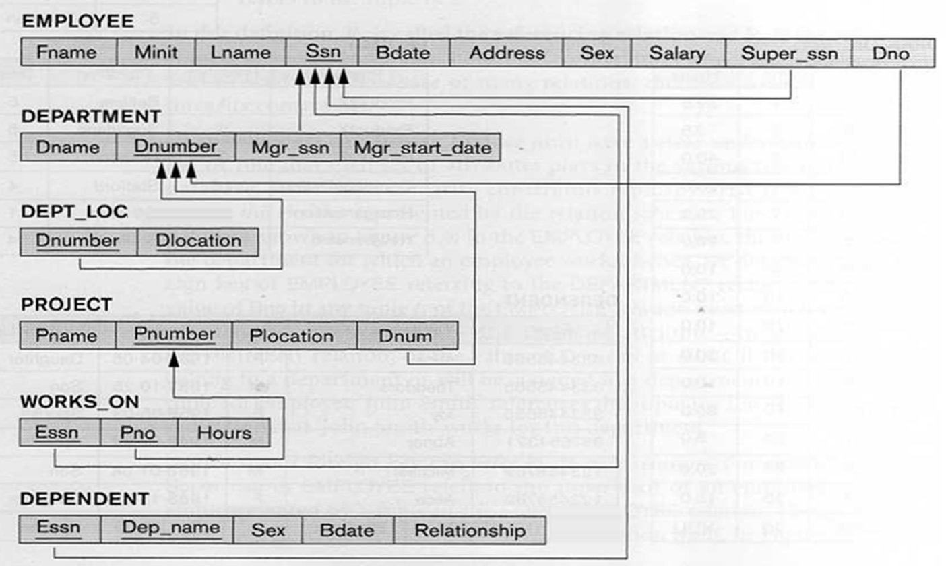

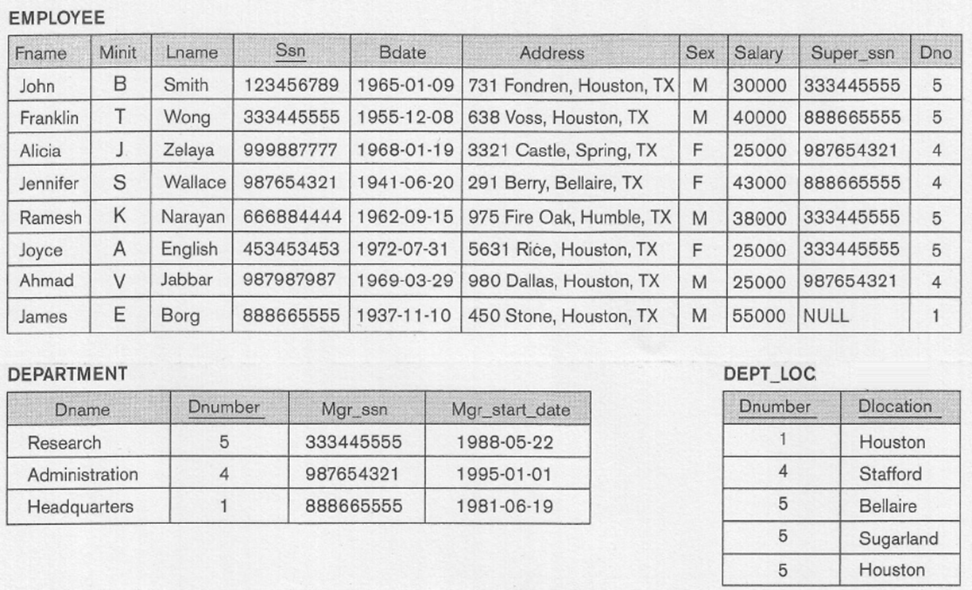

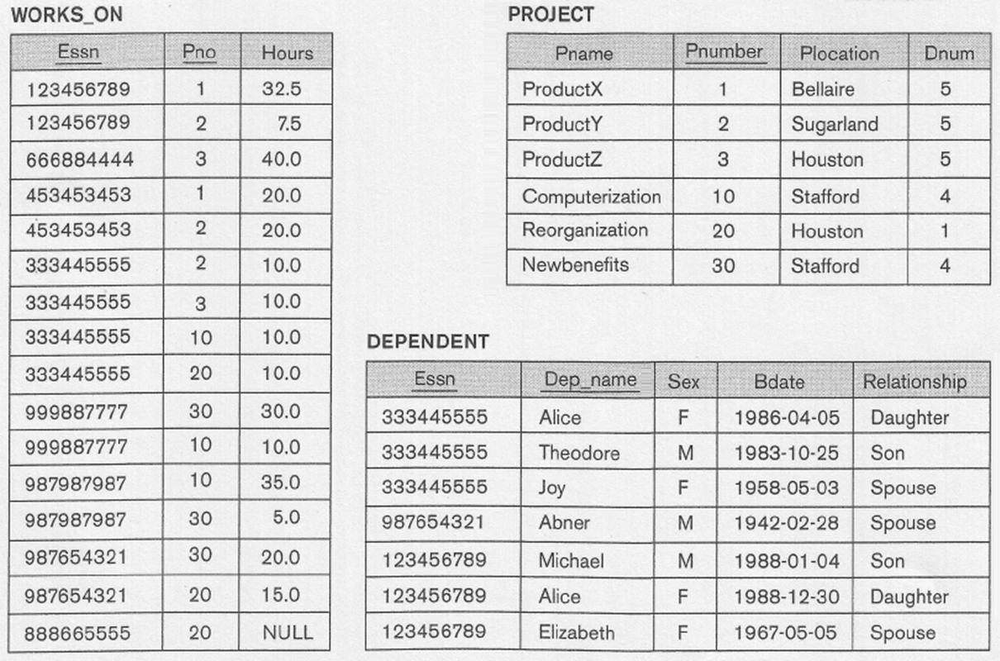

1. For each employee working in the Research department, list his last name, and the last name and salary of his supervisor.

Answer

Select E.Lname, S.Lname, S.salary

From Employee E, Employee S, Department

Where E.super_Ssn = S.ssn AND E.Dno=Dnumber AND Dname = 'Research';

Output

LNAME LNAME SALARY

--------------- --------------- ----------

Smith Wong 40000

Narayan Wong 40000

English Wong 40000

Wong Borg 55000

**Use subqueries in writing SQL statements for the following:**

2. List the name of all dependents and their birthdate who are related to an employee managing the department controlling the ProductZ project or the related to employees working on the Newbenefits project.

Answer

(Select Dep_name, D.Bdate

From Employee E, Dependent D, Department DE, Project P

Where E.Ssn = D.Essn AND Mgr_Ssn=Ssn AND DE.Dnumber = P.Dnum

AND Pname = 'ProductZ')

UNION

(Select Dep_name, D.Bdate

From Employee E, Dependent D, Works_ON W, Project P

Where ssn = D.Essn AND Ssn = W.Essn AND W.Pno = P.Pnumber

AND Pname = 'Newbenefits');

Output

DEP_NAME BDATE

--------------- ---------

Abner 28-FEB-42

Alice 05-APR-86

Joy 05-MAR-58

Theodore 25-OCT-83

3. For each employee working in the Research department and has no dependents, list the last name and salary of the employee, and the last name of his supervisor.

Answer

(Select E.Lname AS "Employee", E.Salary, S.Lname AS "Supervisor"

From Employee E, Employee S, Department D

Where E.Super_ssn = S.ssn and E.Dno=Dnumber AND Dname='Research')

MINUS

(Select E.Lname AS "Employee", E.Salary, S.Lname AS "Supervisor"

From Employee E, Employee S, Dependent D

Where E.Super_Ssn = S. Ssn AND E.Ssn = D.Essn);

Output

Employee SALARY Supervisor

--------------- ---------- ---------------

English 25000 Wong

Narayan 38000 Wong

4. For each employee working on project ProductY and has no Spouse, list the last name and salary of the employee, and the last name of his supervisor.

Answer

(Select E.Lname AS "Employee", E.Salary, S.Lname AS "Supervisor"

From Employee E, Employee S, Works_On W, Project P

Where E.Super_ssn = S.ssn and E.Ssn = W.Essn AND W.Pno = P.Pnumber

AND Pname='ProductY')

INTERSECT

(Select E.Lname AS "Employee", E.Salary, S.Lname AS "Supervisor"

From Employee E, Employee S, Dependent D

Where E.Super_Ssn = S.Ssn AND E.Ssn = D.Essn

AND Relationship NOT LIKE 'Spouse');

Output

Employee SALARY Supervisor

------------ ---------- ---------------

Smith 30000 Wong

Wong 40000 Borg

5. List the first name, last name, and salary for each employee working in department located in Houston or working on project located in Stafford. Sort the result in ascending order based on the first name.

Answer

(Select Fname, Lname, Salary

From Employee E, Department D, Dep_Locations DL

D.Dnumber = E.DNO and D.DNumber = DL.Dnumber and DLocation = ‘Houston’)

UNION

(Select Fname, Lname, Salary

From Employee E, Works_On W, Project P

Where E.ssn = W.Essn AND W.Pno = P.Pnumber AND PLocation = ' Stafford')

Order by Fname;

6. For each male employee whose salary is greater than the salary of all employees working in the research department, list the first name, last name, and salary.

Answer

Select Fname, Lname, Salary

From Employee Where Sex = ‘M’ AND salary > All

(Select Fname, Lname, Salary

From Employee , Department

Where DNO = DNUMBER and DName = ‘Research’);