

College of Engineering and Information Technology

**INT302 Database Management Systems**

1st Summer semester 2022/2023

Model Answer for Lab # 7

Consider the following company database

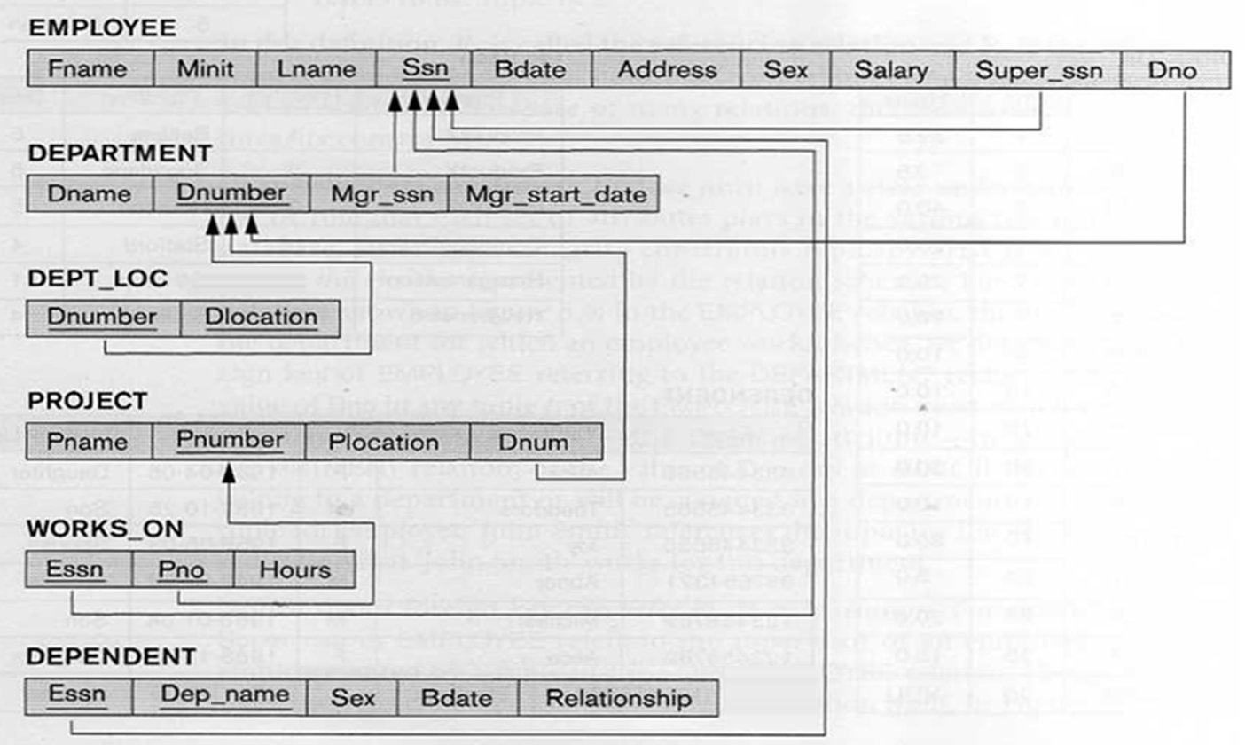

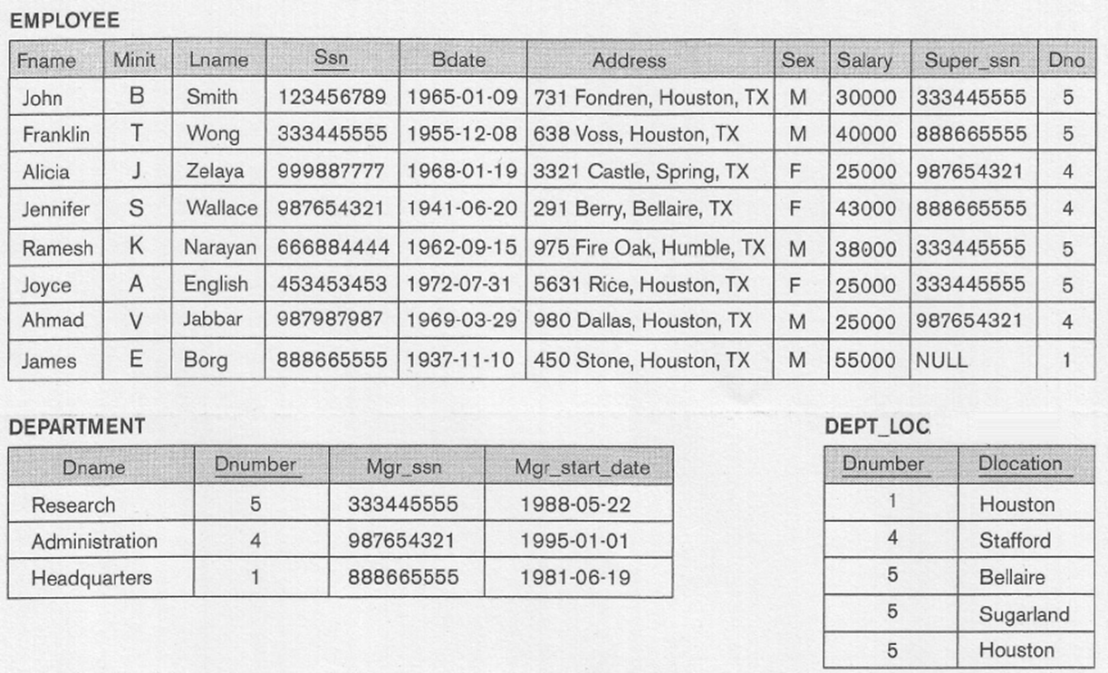

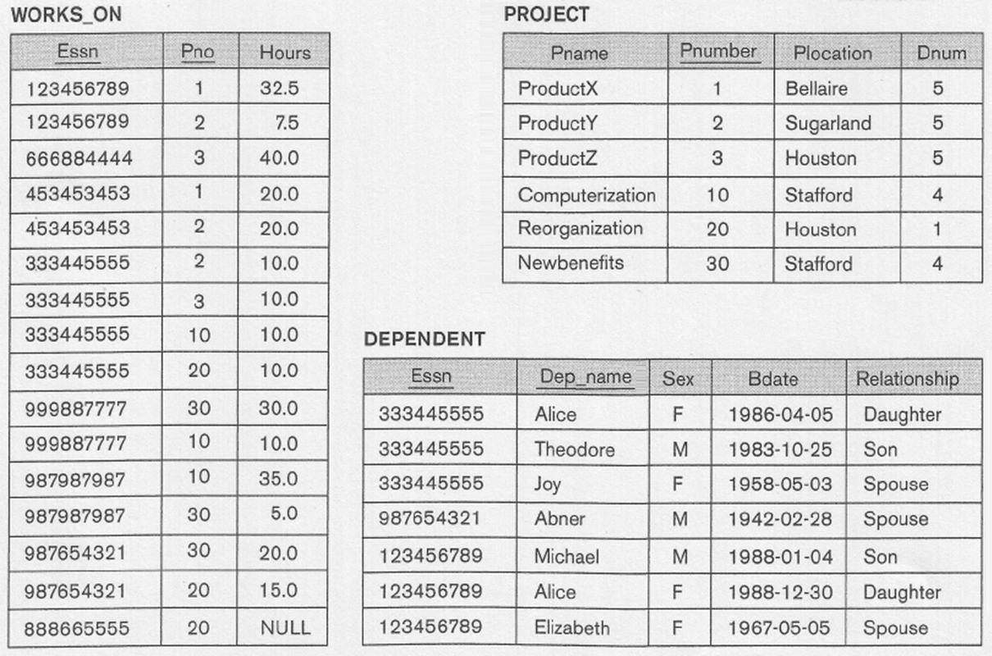

Write SQL statements for the following:

1. For each department, list the name of the department, and the number of employees whose salary greater than 30000.

Answer

Select Dname, count(*) AS "Number of Employees"

From Employee E, Department D

Where Dnumber = Dno AND Salary >30000

Group By Dname;

Output

DNAME Number of Employees

-------------------- -------------------

Research 2

Administration 1

Headquarters 1

2. For each employee working in the Research department, list the last name of the employee and the number of dependents.

Answer

Select Lname, count(*) AS "Number of Dependents"

From Employee, Department, Dependent

Where Dnumber = Dno AND Ssn = Essn and Dname = 'Research'

Group By Lname;

Output

LNAME Number of Dependents

--------------- --------------------

Wong 3

Smith 3

3. For each department controlling more than one project, list the name of the department, the name of the manager, and the number of projects controlled by the department.

Answer

Select Dname AS "Department Name", Lname AS "Manager Name", count(*) AS "Number of Projects"

From Employee, Department, Project

Where Mgr_ssn = Ssn AND Dnumber = Dnum

Group By Dname, Lname

Having count(*)>1;

Output

Department Name Manager Name Number of Projects

-------------------- --------------- ------------------

Administration Wallace 2

Research Wong 3

4. For each project controlled by the Research department with less than three employees working on it, list the project name, number of employees, and total hours.

Answer

Select Pname AS "Projectt Name", count(*) AS "Number of Employees", sum(hours)

From Project P, Works_on W, Department D

Where Pnumber = Pno AND Dnum = Dnumber AND Dname = 'Research'

Group By Pname

Having count(*) < 3;

Output

Projectt Name Number of Employees SUM(HOURS)

------------------------- ------------------- ------------------

ProductX 2 52.5

ProductZ 2 50

5. For each employee with Salary greater than 30000 and having more than one dependent, list the last name of the employee, his salary, and the number of dependents.

Answer

Select Lname, Salary, count(*) AS "Number of Dependents"

From Employee, Dependent

Where Ssn = Essn AND Salary >30000

Group By Lname, salary

Having count(*) >1;

Output

LNAME SALARY Number of Dependents

--------------- ---------- --------------------

Wong 40000 3

6. For each project located in either Houston or Stafford, list the project number, project name, number of employees, and the average of the worked hours. Sort the result in ascending order based on project number.

Answer

Select PNumber as “Project Number”, Pname AS "Projectt Name", count(*) AS "Number of Employees", avg(hours) as “Average worked Hours”

From Project P, Works_on W

Where Pnumber = Pno AND (PLocation = ‘Houston’ OR PLocation = ‘Stafford’)

Group By PNumber, Pname

Order By PNumber;