

College of Engineering and Information Technology

**INT302 Database Management Systems**

1st Summer semester 2022/2023

Model Answer for Lab # 8

Consider the following company database

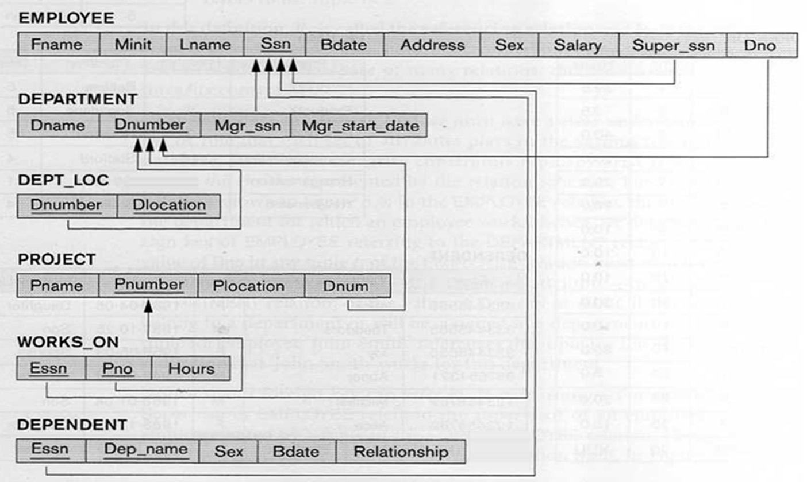

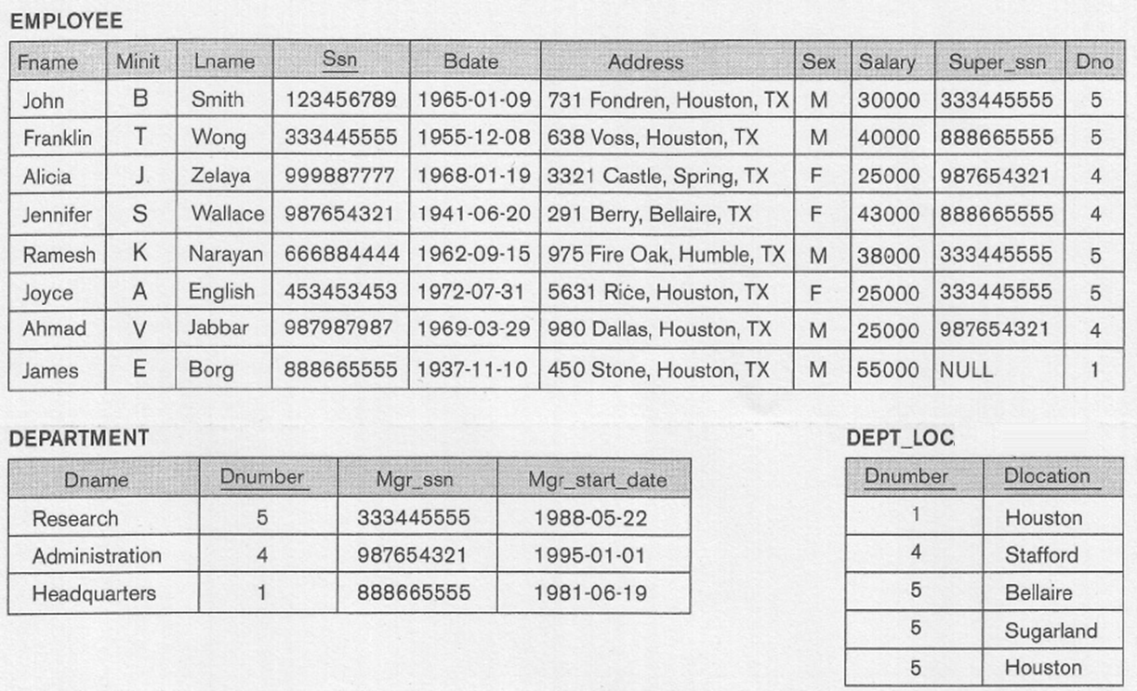

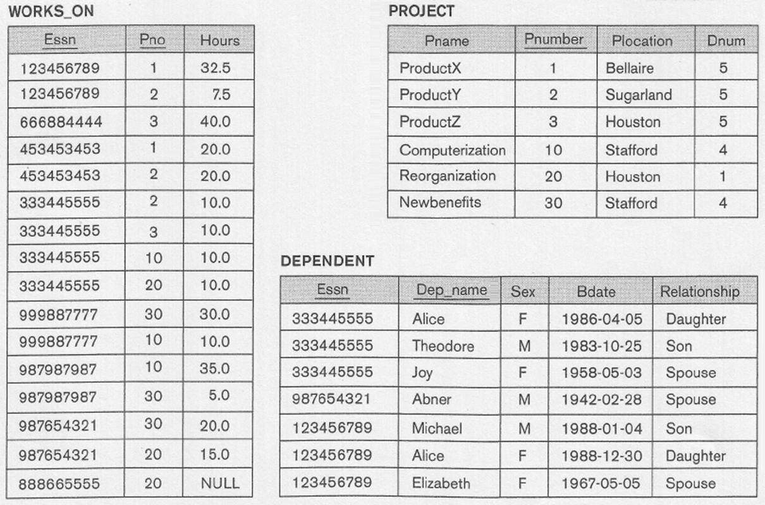

Write SQL statements for the following:

1. For each department, list the name of the department, and the number of employees having a salary greater than the average salary of employees in the Administration department.

Answer

Select Dname, Count(*)

From Employee, Department

Where Dno = Dnumber AND Salary > (Select avg(Salary) From Department, Employee

Where Dno = Dnumber AND Dname ='Administration')

Group by Dname;

Output

DNAME COUNT(*)

-------------------- ----------

Research 2

Administration 1

Headquarters 1

2. For each department, list the name of the department, and the number of employees having a salary greater than or equal the average salary of employees in the same department.

Answer

Select D.Dname, Count(*)

From Employee E, Department D

Where E.Dno = D.Dnumber AND Salary >= (Select avg(Salary)

From Employee EE, Department DD

Where EE.Dno = DD.Dnumber AND DD.Dname =D.Dname)

Group by D.Dname;

Output

DNAME COUNT(*)

-------------------- ----------

Research 2

Headquarters 1

Administration 1

3. For each employee who worked more total hours on all projects than Wallace did, list the last name of the employee and total hours worked on all projects.

Answer

Select Lname, sum(hours)

From Employee E, Works_ON W

Where E.Ssn = W.Essn

Group By Lname

Having sum(hours)> (Select sum(hours) From Employee, Works_On

Where Ssn =Essn AND Lname ='Wallace');

Output

LNAME SUM(HOURS)

--------------- ----------

Wong 40

Zelaya 40

English 40

Jabbar 40

Narayan 40

Smith 40

4. List the last name of each employee and the number of his dependents for employees having more dependents than Wallace.

Answer

Select E.Lname, count(*)

From Employee E, Dependent D

Where E.Ssn = D.Essn

Group By Lname

Having count(*) > (Select count(*)

From Employee EE, Dependent DD

Where EE.Ssn = DD.Essn AND EE.Lname ='Wallace');

Output

LNAME COUNT(*)

--------------- ----------

Wong 3

Smith 3

5. For each department having more than one location and more than one employee working for it, write an SqL statement that List the department number, Department name, and the total number of locations.

Answer

Select D.DNumber, DName, Count(*) as “Number of Location”

From Department D, Dept_Locations DL

Where D.DNumber = DL.DNumber

Group By D.DNumber, DName

Having Count(*) > 1 AND Exists (Select count(*)

From Employee E

Where E.DNO = D.DNumber having count(*) > 1);

Output