

College of Engineering and Information Technology

**INT302 Database Management Systems**

1st Summer semester 2022/2023

Model Answer for Lab # 9

Consider the following company database

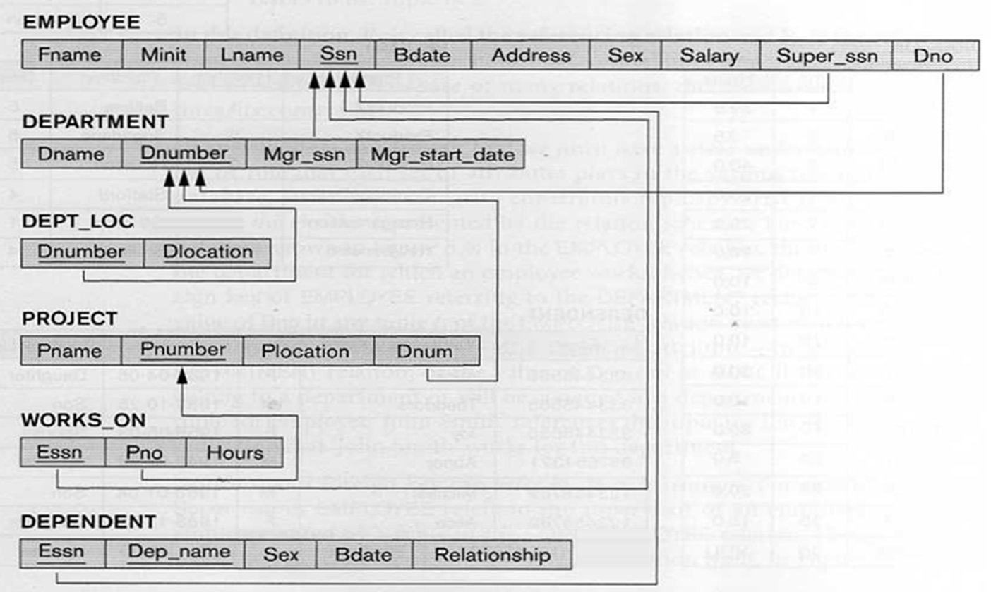

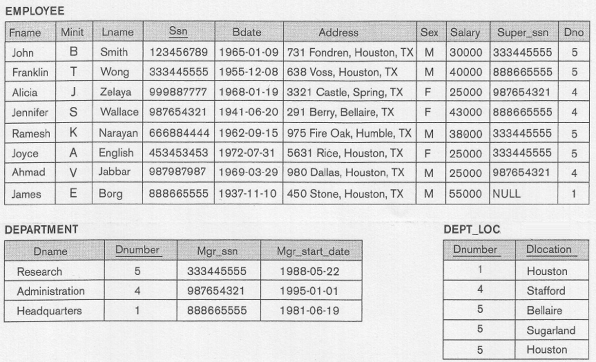

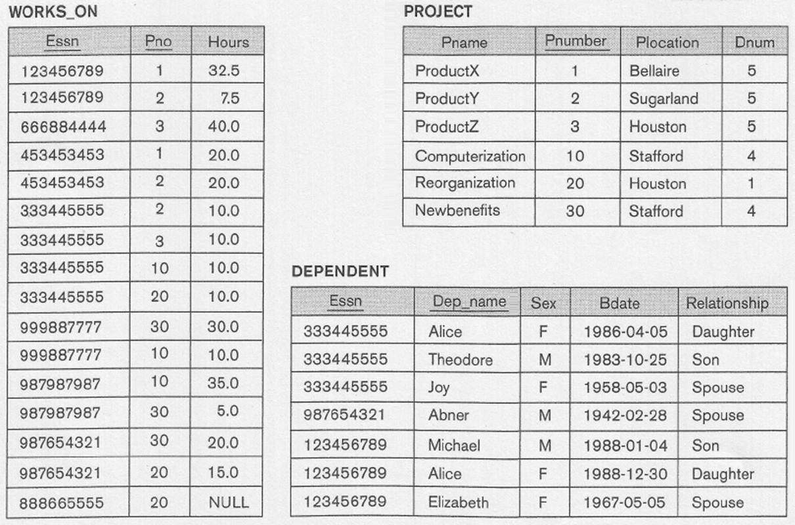

This lab discusses create view concept:

View is a single table derived from other tables called the defining tables. It is considered to be a virtual table that is not necessarily populated

View is a virtual table whose contents are defined by a query

How to create **Views.**

**Views can be created by using the following command:**

**CREATE VIEW** *viewname* [(*viewcolname*,*viewcolname*]...)]

**AS SELECT** *colname* [,*colname*]...

**FROM** *basetablename* [,*basetablename*]...

**WHERE** *condition*;

• Can create a virtual table from one or more actual tables, choosing only certain columns, with no WHERE, called **value-independent** view

• Can choose only certain rows, using WHERE, called **value-dependent** view

• Can use a join of tables to create view of combination

• Can use functions or subqueries in SELECT

**Example 1:**



**Result:**



**Example 2:**



**Result:**



**Create the following views based on the COMPANY Database**

1. Create a view called EMPLOYEE_INFO with the following columns:

employee last name, department name, number of dependents

NOTE: Test the content of your views by using: SELECT * FROM View_Name;

Answer

CREATE VIEW EMPLOYEE_INFO (empLastName, deptName, managerLastName) AS

SELECT Lname, Dname, count (*)

FROM EMPLOYEE, DEPARTMENT, DEPENDENT

WHERE Dno = Dnumber AND Ssn=Essn

GROUP BY Lname, Dname;

If you run: Select * From EMPLOYEE_INFO;

You should get the following output:

EMPLASTNAME DEPTNAME DEPENDENTNUMBER

---------------------- -------------------- -------------------------------

Wong Research 3

Smith Research 3

Wallace Administration 1

2. Create a view called DEPARTMENT_SALARY with the following columns:

department name, number of employees, average salary.

NOTE: Test the content of your views by using: SELECT * FROM View_Name;

Answer:

CREATE VIEW DEPARTMENT_SALARY(deptName, employeesNumber, averageSalary) AS

SELECT Dname, count(*), avg(Salary)

FROM Department, Employee

WHERE Dno = Dnumber

GROUP BY Dname;

If you run: Select * from DEPARTMENT_SALARY;

You should get the following output:

DEPTNAME EMPLOYEESNUMBER AVERAGESALARY

-------------------- ---------------------------- ----------------------

Research 4 33250

Administration 3 31000

Headquarters 1 55000

3. Create a view called EMPLOYEE_SUPERVISOR with the following columns:

employee name, number of projects the employee works on, and employee supervisor last name.

NOTE: Test the content of your views by using: SELECT * FROM View_Name;

Answer:

CREATE VIEW EMPLOYEE_SUPERVISOR (empName, numberProjects, superName) AS

SELECT E.Lname, count(*), S.Lname

FROM Employee E, Employee S, Works_On W

Where E.super_Ssn = S.Ssn AND W.Essn = E.ssn

Group By E.Lname, S.Lname;

If you run the query: Select * From EMPLOYEE_SUPERVISOR;

You get the output:

EMPNAME NUMBERPROJECTS SUPERNAME

--------------- - ------------------------- ------------------

Narayan 1 Wong

Jabbar 2 Wallace

Zelaya 2 Wallace

Wallace 2 Borg

Smith 2 Wong

Wong 4 Borg

English 2 Wong

4. Create a view called DEPARTMENT_PROJECT with the following columns:

department name, number of projects controlled by department, manager last name.

NOTE: Test the content of your views by using: SELECT * FROM View_Name;

Answer:

CREATE VIEW DEPARTMENT_PROJECT(deptName, numberProjects, managerName) AS

SELECT Dname, count(*), Lname

FROM Department, Project, Employee

WHERE Dnumber = Dnum AND mgr_Ssn = ssn

GROUP BY Dname, Lname;

If you run: Select * from Department_Project;

You get the following output:

DEPTNAME NUMBERPROJECTS MANAGERNAME

-------------------- ------------------------- -----------------------

Administration 2 Wallace

Research 3 Wong

Headquarters 1 Borg

5. Create a view called PROJECT_EMPLOYEE with the following columns:

Project Name, Number of Employees, Average Salary, Name of controlling department.

NOTE: Test the content of your views by using: SELECT * FROM View_Name;

Answer:

CREATE VIEW PROJECT_EMPLOYEE(Pname, empNumber, averageSalary, controllingDept) AS

SELECT Pname, count(*), avg(Salary), Dname

FROM Project P, Works_On W, Employee E, Department D

WHERE P.Pnumber = W.Pno AND W.Essn = Ssn AND P.Dnum = D.Dnumber

GROUP BY Pname, Dname;

If you run the query: Select * from Project_Employee;

You should get the following output:

PNAME EMPNUMBER AVERAGESALARY CONTROLLINGDEPT

------------------- ---------- ------------- --------------------

ProductY 3 31666.6667 Research

Computerization 3 30000 Administration

ProductX 2 27500 Research

Reorganiation 3 46000 Headquarters

ProductZ 2 39000 Research

Newbenefits 3 31000 Administration