
IT-SIMPLERA INSTITUTE
Cyber Security Analyst Internship Program

WEEK 02 ASSIGNMENT
Computer Networking Basics & Network Setup

Student Name | Rayan Ayub
Registration No. | REDB01-1766
Role | Red Team Intern
Institute | IT-SIMPLERA SOLUTION
Supervisor | Talal Rehan
Week | Week-02
Submission Date | 11th July, 2026

Table of Contents
Introduction 3
Q1. Understanding Your Network Information 3
Q2. Basic Networking Commands 4
Q3. Router vs Switch 5
Q4. IPv4 vs IPv6 5
Q5. The OSI Model 6
Network Diagram 7
Conclusion 8

Introduction
Networking is how computers talk to each other. Every time we open a website, send an email, or stream a video, our device is using a network to send and receive data. For anyone learning cyber security, understanding how networks work is one of the first and most important steps, because most attacks happen over a network, and most defenses depend on understanding how that network is supposed to behave.
In this assignment, we look at how to read a computer's network settings, try out some basic networking commands, compare routers with switches, compare IPv4 addresses with IPv6 addresses, and go through the seven layers of the OSI Model. These are simple building blocks, but they come up again and again in real cyber security work.

Q1. Understanding Your Network Information
Objective: The goal here is to understand the network settings shown by the command below, which is used on Windows to see all the details about how a computer is connected to a network.
ipconfig /all
IPv4 Address
- Ipv4 consists of 32-bit divided into four 8-bit octet.
- An IPv4 address is like a home address for a device on a network.
- Each device on network has a unique ipv4 address.
Example: 192.168.1.100.
MAC Address
- MAC Address is a unique physical address assigned to a network interface card by the manufacturer.
- A MAC address is 48 bits (6 bytes) long and is typically represented as six pairs of hexadecimal digits separated by colons (:) or hyphens (-).
Example: 00:1A:2B:3C:4D:5E
Default Gateway
- It is a network device that forwards data from a local network to other networks.
- When a device wants to communicate with a destination outside its local network, it sends the data to the default gateway, which routes it to the correct destination.
Example: 192.168.1.1
Snapshots:
Ipconfig/all
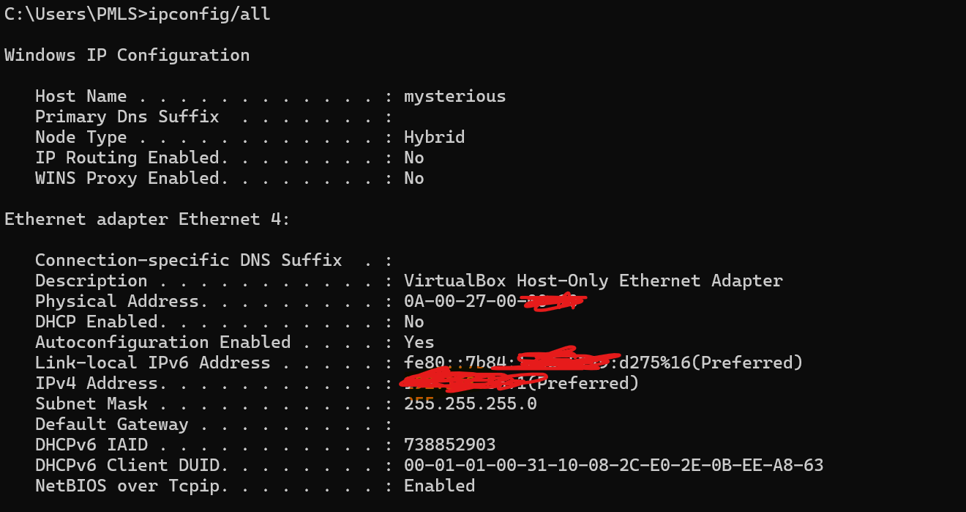
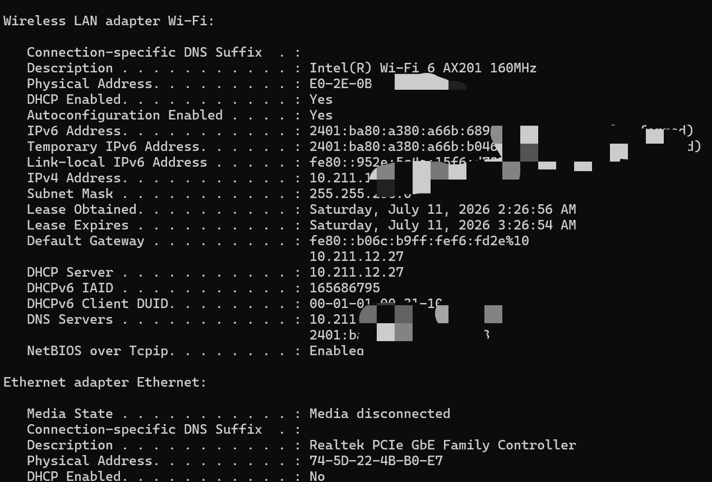

Q2. Basic Networking Commands
Below are five commands that are commonly used to check or troubleshoot a network connection, along with what each one is for and why it matters in cyber security work.
1. ipconfig /all
What it does: Shows all the network details of a computer in one place such as
- IPv4 address
- IPv6 address
- MAC address
- DNS servers
- DHCP status
- default gateway.
Why it matters: This is usually the first command a security analyst runs to check how a machine is set up on the network, in order to check that network is running properly or not.
2. ping google.com
What it does: Sends a few packets (ICMP Echo Requests) to a website or server and waits for a reply, to check the network’s connectivity.
Why it matters: A quick way to check if the internet is working, if a server is online, and how much delay (latency) or data loss there is between the two devices.
Snapshot:
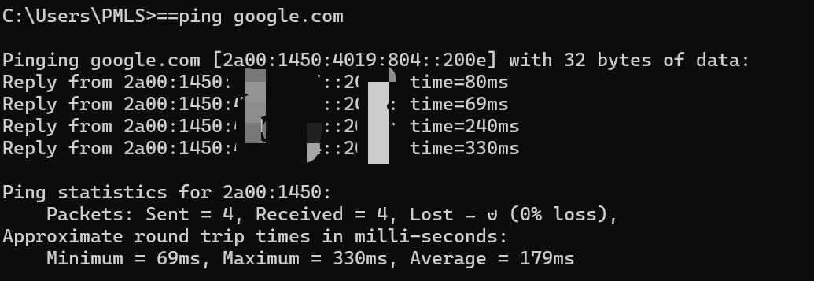
3. tracert google.com
What it does: Shows every router (hop) that a message passes through on its way to a destination, along with how long each hop takes.
Why it matters: Helps find exactly where a connection is slowing down or failing, which is useful when investigating network problems or unusual routing during an incident.
Snapshot:
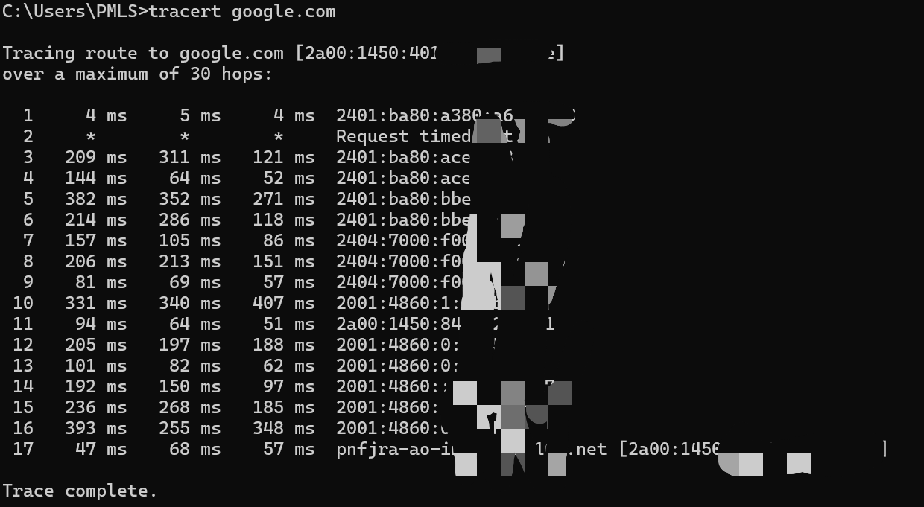

4. nslookup google.com
What it does: Asks a DNS server to translate a website name (like google.com) into its IP address.
Why it matters: Security analysts use this to check whether a domain name is pointing where it should, or to investigate a domain that looks suspicious, such as one used in a phishing attack.
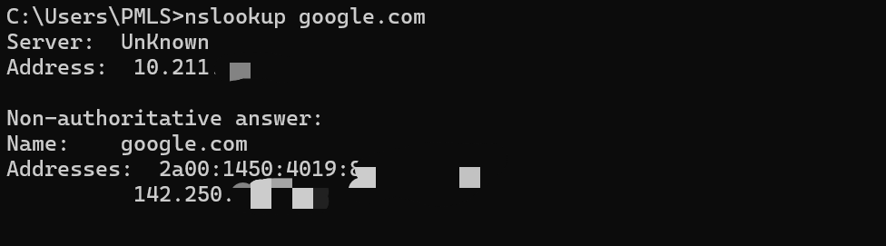

5. arp -a
What it does: Shows the ARP table, which is the list of IP addresses and their matching MAC addresses that a computer already knows about on the local network.
Why it matters: Useful for spotting ARP spoofing (when someone tries to trick a device by faking a MAC address), and for seeing what devices are active on the local network.
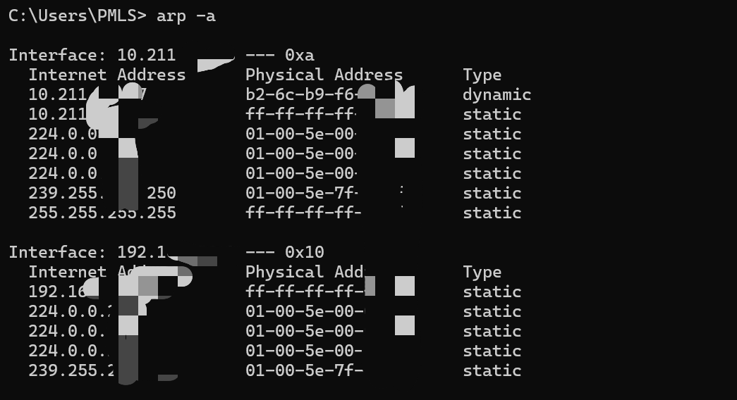

Q3. Router vs Switch
A router and a switch may look similar, but they do very different jobs. In short: a switch connects devices inside one network, while a router connects different networks together.
Feature | Router | Switch
Main Job | Connects two or more different networks | Connects devices that are on the same network
OSI Layer | Layer 3 (Network Layer) | Layer 2 (Data Link Layer)
Address Used | IP address | MAC address
How Traffic Moves | Sends packets between different networks | Sends frames between devices on the same LAN
Internet Access | Gives a network access to the internet | Does not connect to the internet on its own
Typical Use | Home router, office router | Office LAN switch

Q4. IPv4 vs IPv6
IPv4 and IPv6 are simply two different versions of the addressing system used on the internet. IPv6 was created because the world was running out of IPv4 addresses.
Feature | IPv4 | IPv6
Address Length | 32-bit | 128-bit
How It's Written | Numbers, e.g. 192.168.1.10 | Hexadecimal, e.g. 2001:0db8:85a3:0000:0000:8a2e:0370:7334
Total Addresses Available | About 4.3 billion | An extremely large number — 340 undecillion
Security | Encryption is optional | Encryption is built-in
Broadcast | Supported | uses multicast instead
Header Size | More complex | Simpler and faster to process

Example IPv4 address: 192.168.1.10
Example IPv6 address: 2001:0db8:85a3:0000:0000:8a2e:0370:7334
In short: IPv4 is older and running out of space, while IPv6 was built to give every device in the world its own unique address, with better built-in security and simpler setup. As more devices connect to the internet every year, IPv6 is slowly becoming more common.

Q5. The OSI Model
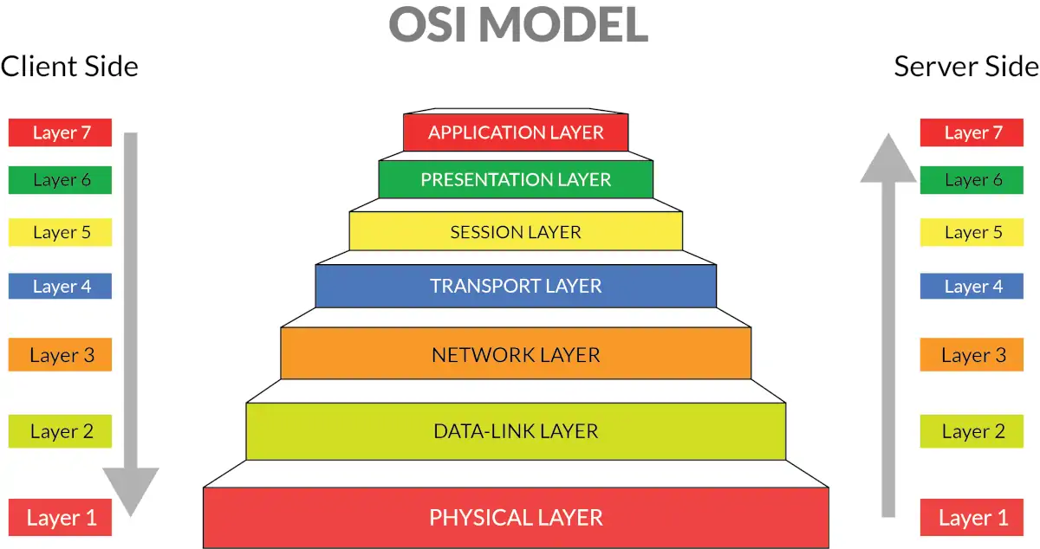
The OSI Model is a way of breaking down everything that happens when two devices communicate into seven simple layers

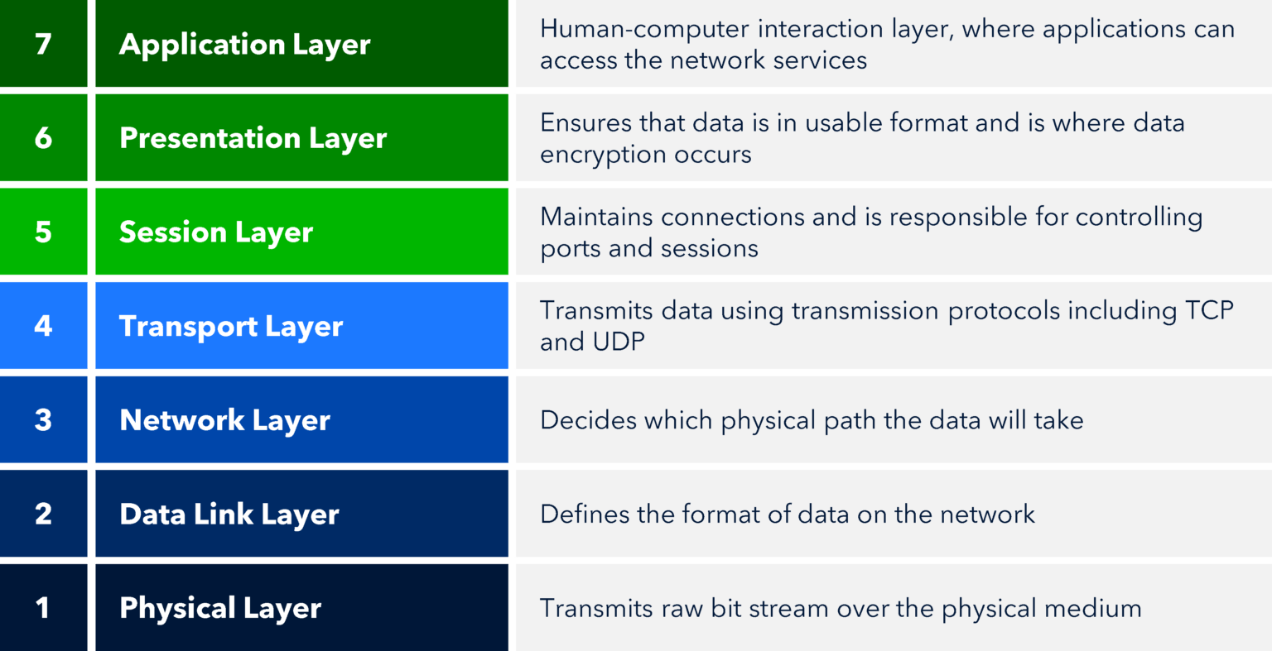

Network Diagram
The picture below shows a simple example of how these pieces fit together: a few computers connect to a switch, the switch connects to a router, and the router connects the whole network to the internet.
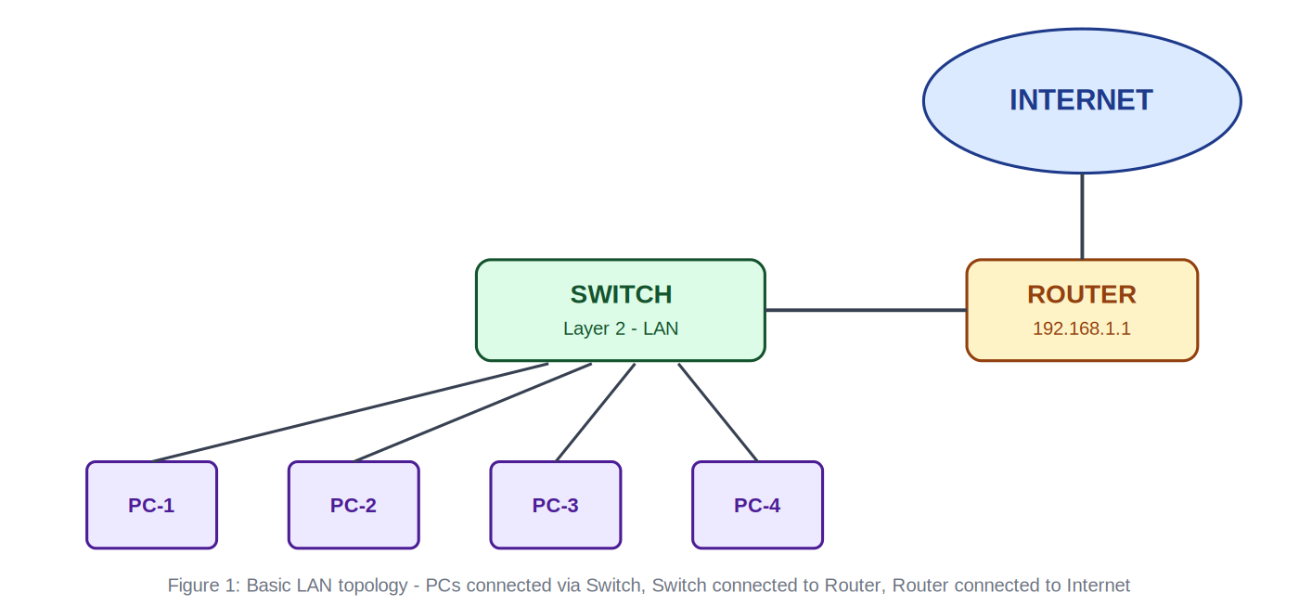

Conclusion
This assignment covered the basic building blocks of networking: reading a device's network settings, using simple commands to check and troubleshoot a connection, understanding the difference between routers and switches, comparing IPv4 with IPv6, and going through the seven layers of the OSI Model. These are simple ideas on their own, but together they form the foundation that almost every cyber security topic.

