Report Of #2
Part1:
The goal of this experiment is to demonstrate a Broken Authentication vulnerability in the DVSA application. The issue exists in the backend API responsible for handling user requests, specifically in the JWT-based authentication mechanism.
The application relies on JSON Web Tokens (JWTs) to identify users but fails to properly verify the token’s signature before trusting its contents. As a result, an attacker can modify identity-related fields such as username and sub within the token payload.
This vulnerability allows an attacker to impersonate another user and gain unauthorized access to sensitive data, such as order information belonging to other users.

Part2:
The JWT token contains user identity information in its payload section. The application decodes this payload and directly uses fields such as username and sub without verifying the token’s signature. As a result, an attacker can modify these fields and impersonate another user.
Part3:
The DVSA application was deployed in the AWS us-east-1 region and accessed using the provided Website URL.
For this experiment, two user accounts were created:
- User B, acting as the attacker
- User C, acting as the victim
Both users registered, logged into the system, and placed at least one order to generate data for testing.
The attack focuses on the Orders API, which uses JWT-based authentication.

Part4:
- Open the DVSA application in the browser and log in as User B (attacker).
- Open the browser Developer Tools (F12), navigate to the Network tab, and access the “Orders” page to capture the API request.
- Select the request to the /order endpoint and extract the Authorization header, which contains the JWT token.
- Repeat the same process while logged in as User C (victim) to obtain a second JWT token.
- Decode the payload of both tokens and extract the victim’s identity for use in the attack.
- A request was sent to the /order API endpoint using the original token of User B in order to confirm normal behavior before performing the attack.
- The payload of User B’s JWT was modified by replacing the username and sub values with the victim’s identity. The modified payload was then re-encoded while keeping the original header and signature, producing a forged token.
- A second request was sent to the same /order endpoint, but this time using the forged token in the Authorization header.
- The response returned the order data of User C (victim) instead of User B, demonstrating successful user impersonation.
- An attempt was made to retrieve full order details using a valid victim order ID and the forged token. However, the backend returned an internal error due to improper handling of input values.
Part5:
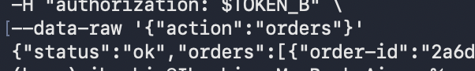
Using the legitimate token of User B, the API returned only User B’s own order data. This confirms the expected normal behavior before token manipulation.
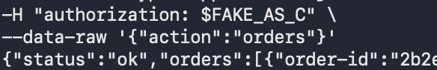
The vulnerability was confirmed by comparing the normal request and the forged request. With the legitimate token, the API returned only User B’s own orders. After modifying the JWT payload and sending the forged token, the same API returned User C’s order data. This shows that the backend accepted attacker-controlled identity claims from the JWT payload without proper signature verification.

Only the JWT payload was modified, while the signature remained unchanged, yet the system still accepted the request.
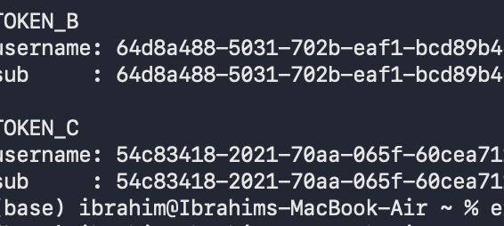
The figure shows the decoded payloads of the JWT tokens for both User B and User C. The username and sub fields directly represent the user identity stored inside the token. This information was extracted to identify the victim’s user ID, which was later used to modify the attacker’s token and perform the impersonation attack.

The request to retrieve full order details resulted in an internal server error, indicating improper backend input handling. Despite this, the vulnerability was already confirmed through successful access to the victim’s order list.

Part6:
The vulnerability exists because the backend application trusts the contents of the JWT payload without verifying its signature. As a result, an attacker can modify identity fields such as username and sub and gain unauthorized access to other users’ data.
To fix this issue, the backend must properly validate the JWT before using any information from it. Specifically, the application should verify the token’s cryptographic signature using a trusted public key provided by the authentication service (e.g., AWS Cognito). In addition, important claims such as the token issuer (iss) and expiration time (exp) should also be validated.
Only after successful verification should the application extract and trust identity information from the token. Any request containing a modified or invalid token must be rejected.

Part7:
The vulnerable JWT parsing logic in DVSA-ORDER-MANAGER/order-manager.js was replaced with proper JWT verification. The updated code validates the token signature and claims before extracting the user identity. As a result, forged or tampered tokens are rejected instead of being trusted.

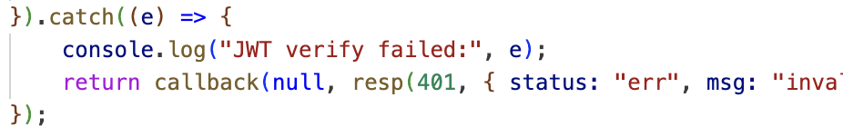

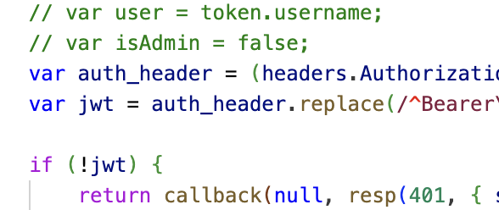
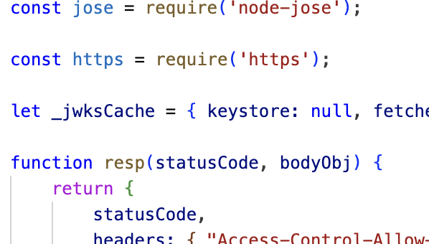
Part8:
After applying the fix, the forged token was rejected by the backend and no longer returned victim data. This demonstrates that the system now properly validates the JWT before trusting its contents.
The previously captured tokens became invalid after the fix due to expiration, which is expected behavior. A valid token would still be accepted if it is correctly signed and verified.
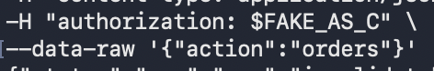

Part9:
Structured Analysis Summary

Table A:

Vulnerability | Intended Rule(s) | Artifacts Used to Infer Rule | Normal Behavior Evidence | Exploit Behavior Evidence
Broken Authentication | Only a valid, cryptographically verified JWT should determine user identity. A user must not access another user’s data | Browser workflow, API request to /order, JWT structure, decoded token payload, API responses | Using the legitimate token (TOKEN_B), the API returned only User B’s own order data | After modifying the JWT payload and using a forged token, the API returned User C’s order data instead of User B’s

Table B:
Vulnerability | Why This Is a Deviation | Deviation Class | Fix Applied (Where) | Post-Fix Verification
Broken Authentication | The backend trusted user identity claims from a JWT without verifying its signature. This allowed attacker-controlled data to be used for authorization, violating the intended security rules | Intentional misuse / security-relevant abuse | JWT verification was implemented in DVSA-ORDER-MANAGER/order-manager.js, ensuring that the token signature and claims are validated before extracting the user identity | After the fix, forged tokens were rejected and no longer returned victim data. Legitimate tokens continued to work correctly for authenticated users

Part10:
This experiment demonstrates that improper JWT validation is a critical security flaw that can lead to user impersonation and unauthorized data access. The main issue was the assumption that the JWT payload could be trusted without verifying its signature.
In a serverless architecture, once an incorrect identity is accepted by the backend, all subsequent operations are performed under that false identity, which significantly increases the impact of the vulnerability.
This highlights the importance of validating all authentication tokens properly and following secure design principles such as verifying signatures, enforcing strict authentication checks, and never trusting user-controlled data without validation.

