ICS344 - Information Security
Course Project: DVSA Vulnerability Discovery and Remediation
Term 252
Lesson 4: Insecure Cloud Configuration
Student Name: Naif Alenizi
Student ID: 202154090
Team: Team 17
Course: ICS344
AWS Region: us-east-1 (N. Virginia)
DVSA URL: http://dvsa-website-test-177914733194-us-east-1.s3-website.us-east-1.amazonaws.com
Date: May 3, 2026

Part 1: Goal and Vulnerability Summary
The goal of this lesson was to find out if the DVSA receipts S3 bucket has insecure permissions that allow anyone to upload files into it. This vulnerability is called Insecure Cloud Configuration, and it affects the receipts S3 bucket (dvsa-receipts-bucket-177914733194-us-east-1) along with the Lambda function (DVSA-SEND-RECEIPT-EMAIL) that automatically processes files from that bucket.
The main issue is that the bucket had "Block all public access" turned OFF. This means an attacker can upload any file into the bucket. After uploading, the Lambda function automatically triggers and processes the attacker-controlled file as if it were a real application-generated receipt. This creates a dangerous situation where untrusted files enter a trusted backend workflow.

Part 2: Why This Works / Root Cause
The vulnerability works because the S3 receipts bucket was configured with insecure permissions:
- Block all public access was set to OFF, allowing external write access.
- The ACL (Access Control List) exposed a broad access model inconsistent with secure receipt storage.
- The Lambda function DVSA-SEND-RECEIPT-EMAIL triggers automatically on any new .raw file placed in the bucket, without verifying the source.
When a .raw file is uploaded into the correct date-based path, Lambda wakes up and processes it exactly like a real receipt. The system trusted the bucket contents without validating where the file came from.

Part 3: Environment and Setup
- DVSA deployed in AWS us-east-1 (N. Virginia) region.
- Receipts bucket: dvsa-receipts-bucket-177914733194-us-east-1
- Lambda function: DVSA-SEND-RECEIPT-EMAIL
- Tools used: AWS Console, AWS CloudShell, CloudWatch Logs

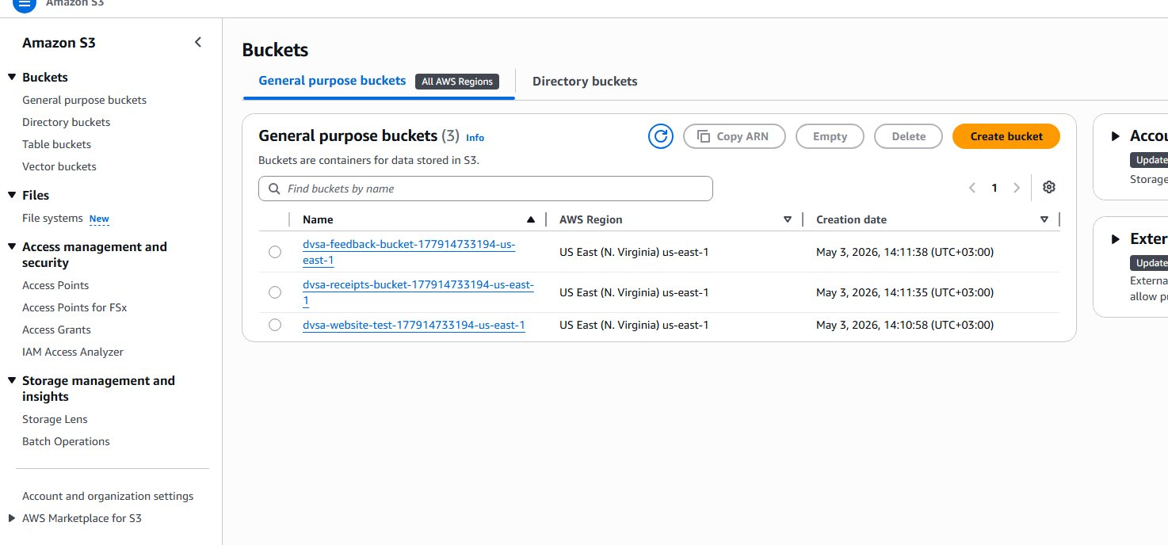
Figure 1: S3 bucket list showing the three DVSA buckets including the receipts bucket.

Part 4: Reproduction Steps
4.1. Opened AWS Console, went to S3, and identified the receipts bucket from the list of DVSA buckets.
4.2. Opened the receipts bucket and clicked on the Permissions tab. Confirmed that "Block all public access" was set to OFF.

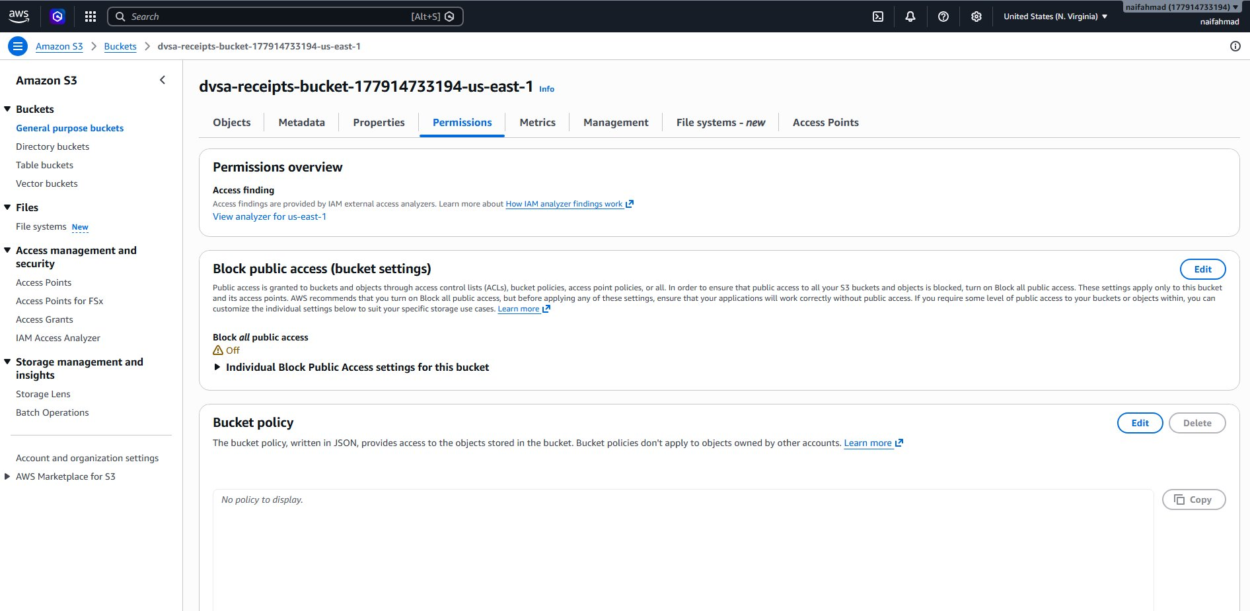
Figure 2: Receipts bucket Permissions tab showing Block all public access = OFF before remediation.
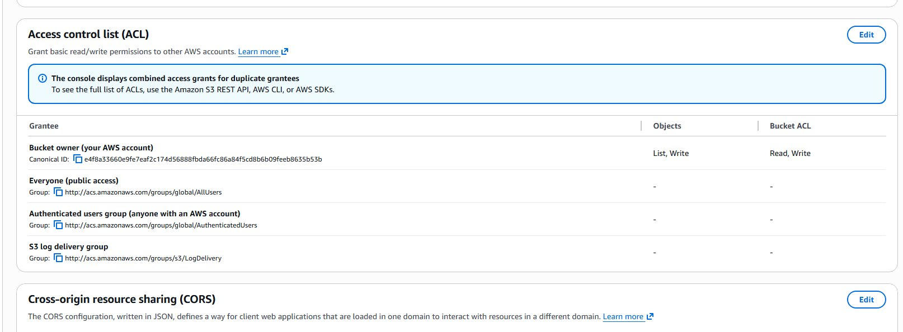
Figure 3: ACL settings showing broad access configuration.
4.3. Opened CloudShell from the AWS Console and ran the following command to upload a test file:
echo "test" > ~/test1.txt && aws s3 cp ~/test1.txt s3://dvsa-receipts-bucket-177914733194-us-east-1/test1.txt
The upload succeeded, confirming write access to the bucket.

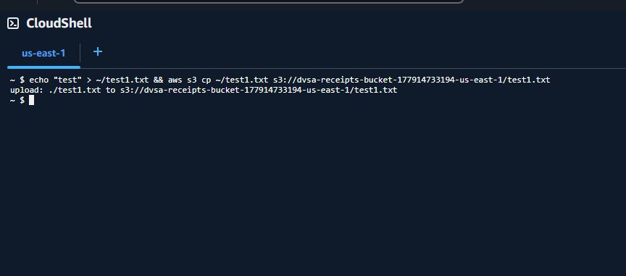
Figure 4: CloudShell output showing successful upload of test1.txt to the receipts bucket.
4.4. Uploaded a .raw file into the date-based receipt path to simulate an attacker-controlled receipt file:
echo "x" > ~/null_test.raw && aws s3 cp ~/null_test.raw "s3://dvsa-receipts-bucket-177914733194-us-east-1/2026/05/03/null_test.raw"

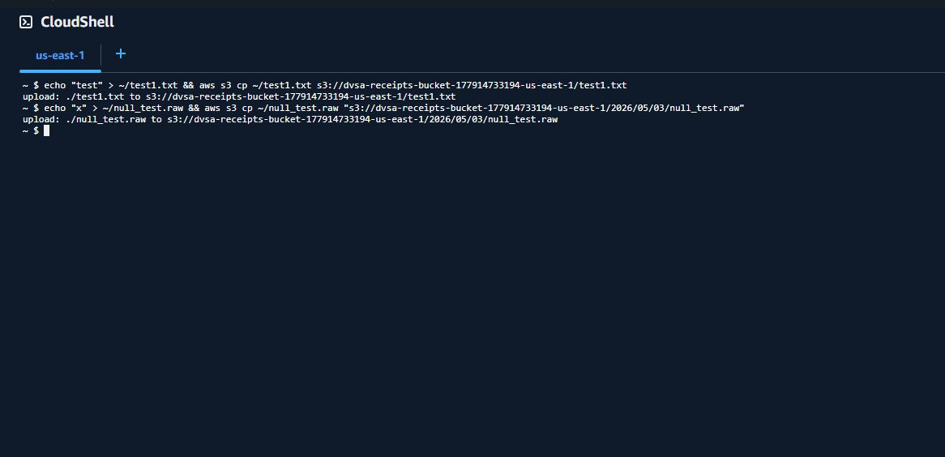
Figure 5: CloudShell showing successful upload of both test files including the .raw file to the date path.
4.5. Returned to S3 and refreshed the bucket. Observed that both test1.txt and the 2026/ folder appeared.

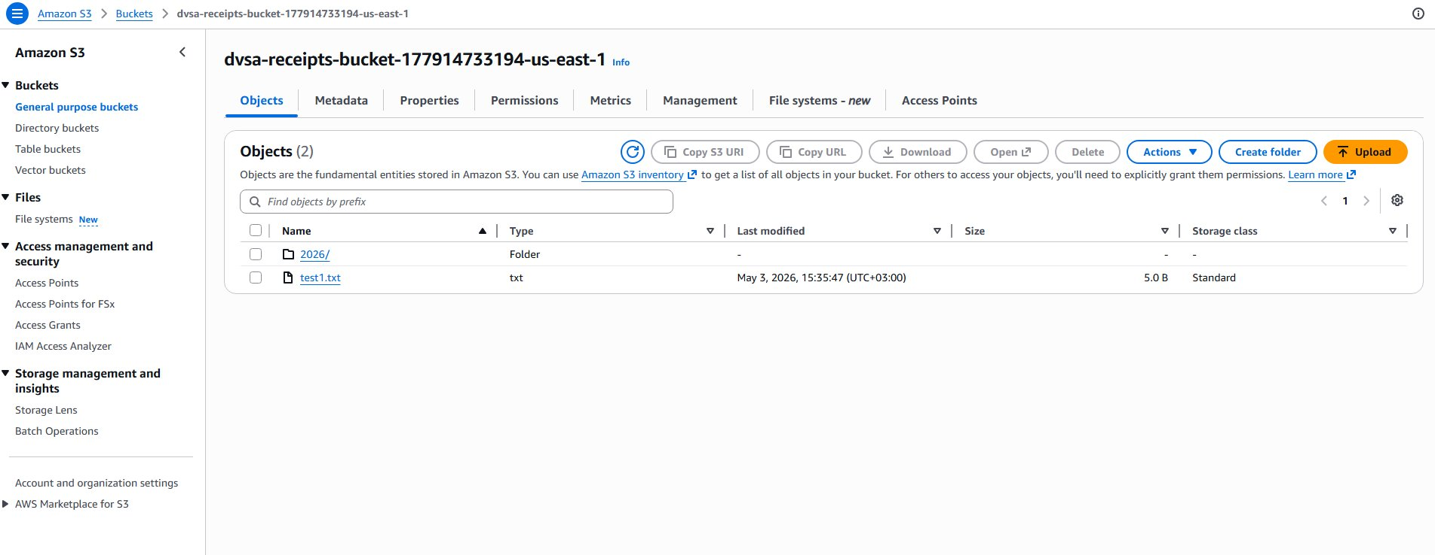
Figure 6: Receipts bucket contents showing the uploaded test1.txt and the 2026/ folder.
4.6. Navigated inside 2026/05/03/ and found that null_test.txt appeared automatically next to null_test.raw. This proves that Lambda was triggered by the uploaded file and processed it.

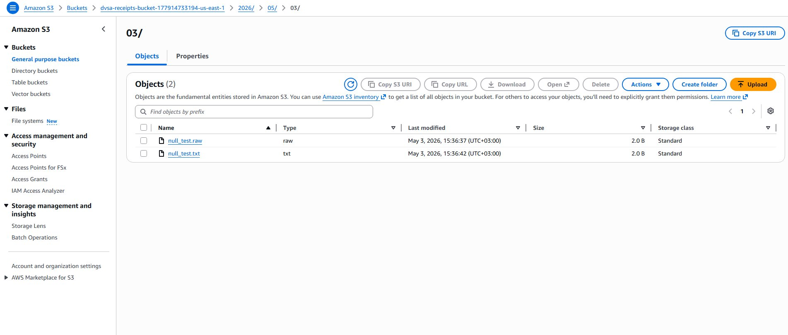
Figure 7: Date-based path 2026/05/03/ showing both null_test.raw (uploaded by attacker) and null_test.txt (generated by Lambda).
4.7. Checked CloudWatch Logs for DVSA-SEND-RECEIPT-EMAIL to confirm Lambda execution.

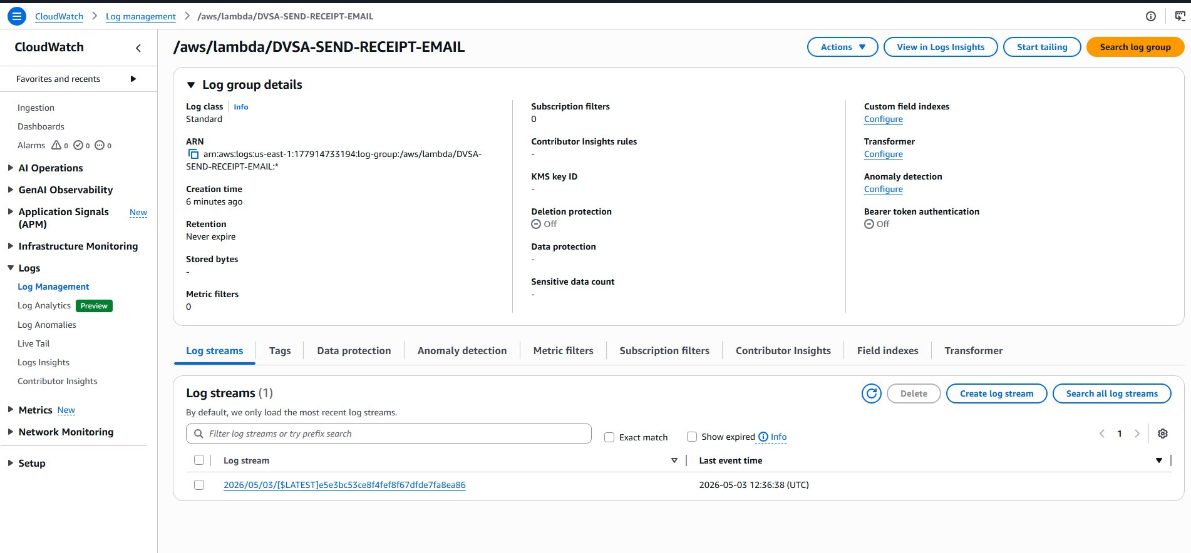
Figure 8: CloudWatch log group for DVSA-SEND-RECEIPT-EMAIL showing a log stream at 12:36:38 UTC.
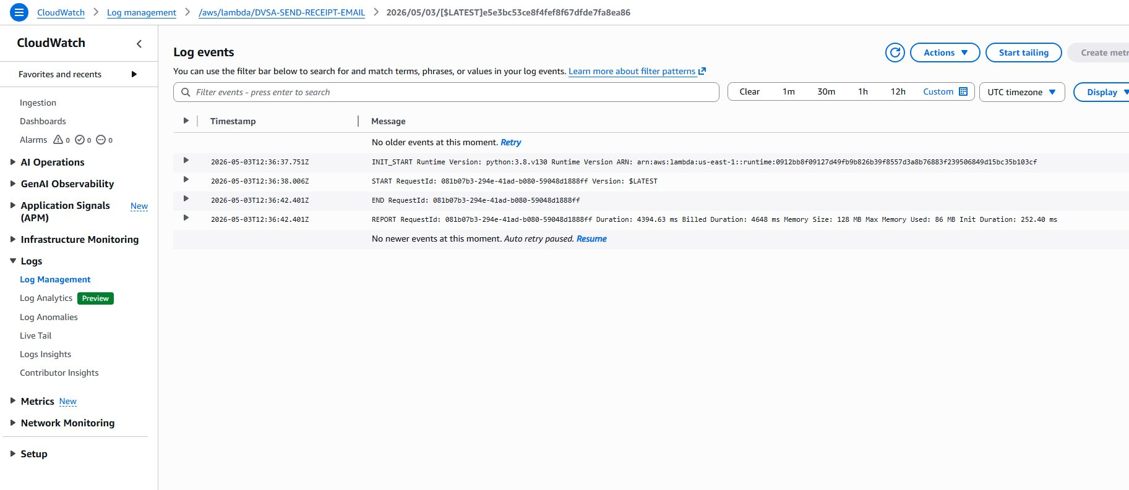
Figure 9: CloudWatch log events confirming Lambda was invoked at the exact time of the upload.

Part 5: Evidence and Proof
The vulnerability was confirmed through multiple sources of evidence:
- The S3 permissions view showed Block all public access = OFF, confirming insecure configuration.
- CloudShell upload of test1.txt to the root of the receipts bucket succeeded, proving external write access.
- CloudShell upload of null_test.raw to the date-based path succeeded.
- null_test.txt appeared automatically in the same folder as null_test.raw, proving Lambda processed the attacker-controlled file.
- CloudWatch logs for DVSA-SEND-RECEIPT-EMAIL confirmed Lambda execution at 12:36:38 UTC, exactly matching the upload time.

Part 6: Fix Strategy / Probable Mitigation
The fix is to enable "Block all public access" on the receipts bucket. This prevents any external party from writing files into the bucket. The receipts bucket should only accept objects created by trusted DVSA application logic, not from external sources.
Additionally, the Lambda backend should validate the source of any file it processes and not blindly trust all content arriving from S3.

Part 7: Code / Config Changes
The following configuration change was applied:
- Resource: dvsa-receipts-bucket-177914733194-us-east-1
- Change: Enabled "Block all public access" under the Permissions tab.
- Before: Block all public access = OFF
- After: Block all public access = ON
Steps: AWS Console > S3 > dvsa-receipts-bucket > Permissions > Edit Block public access > Check "Block all public access" > Save changes > Confirm.

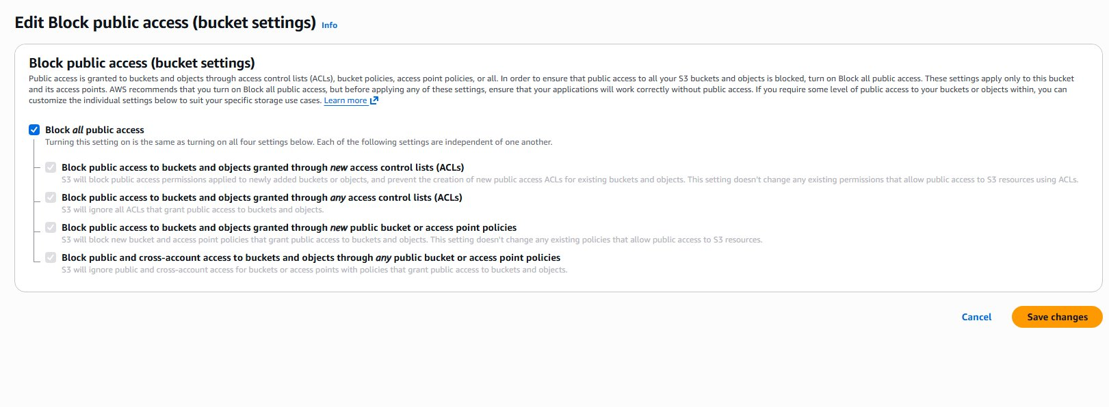
Figure 10: Editing Block public access settings - checkbox enabled before saving.
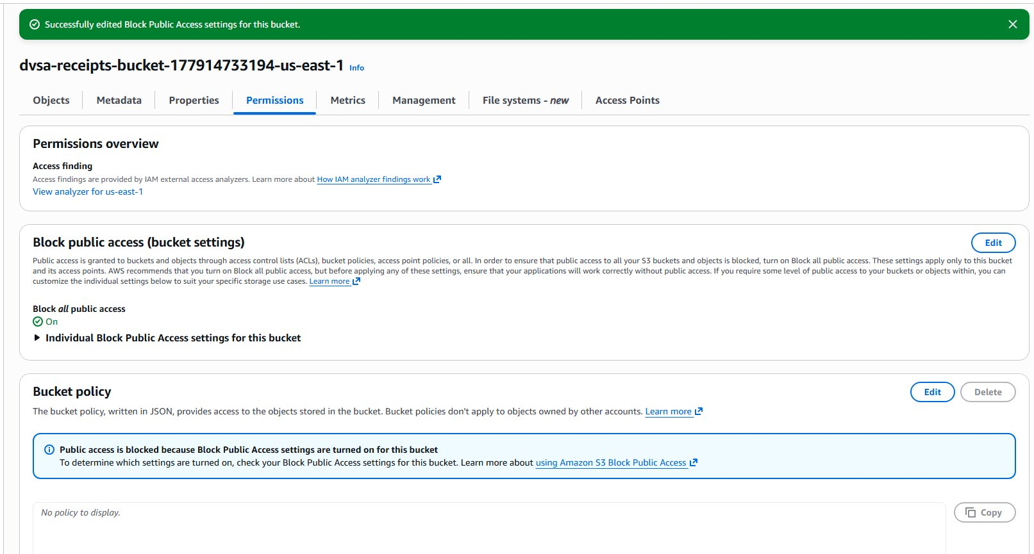
Figure 11: Post-fix state showing Block all public access = ON with success message.

Part 8: Verification After Fix
After enabling Block all public access, the fix was verified by running the upload command with the --no-sign-request flag, which simulates an external user without AWS credentials:
aws s3 cp ~/test1.txt s3://dvsa-receipts-bucket-177914733194-us-east-1/test_external.txt --no-sign-request
The result was:
An error occurred (AccessDenied) when calling the PutObject operation: Access Denied
This confirms that external uploads are now blocked. The fix works as intended.

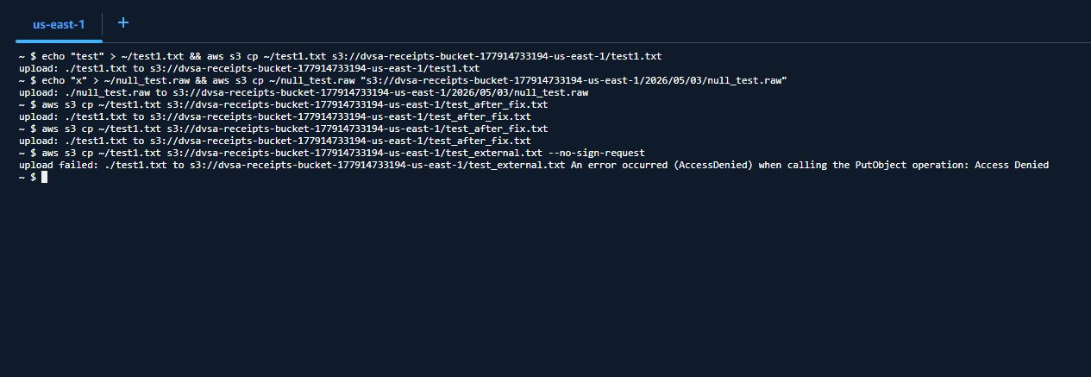
Figure 12: CloudShell showing AccessDenied when attempting upload without credentials after the fix.

Part 9: Structured Operation and Security Analysis

Table A

Vulnerability | Intended Rule(s) | Artifacts Used | Normal Behavior Evidence | Exploit Behavior Evidence
Insecure Cloud Configuration | Only trusted DVSA application logic should write to the receipts bucket. External uploads must not be allowed. | S3 bucket permissions, ACL settings, CloudShell upload result, S3 object list, CloudWatch logs | Receipt files are created only by the DVSA workflow after payment. No external writes should succeed. | We uploaded test1.txt and null_test.raw directly from CloudShell. Lambda triggered automatically and created null_test.txt, proving attacker files entered the trusted backend.

Table B

Vulnerability | Why This Is a Deviation | Deviation Class | Fix Applied | Post-Fix Verification
Insecure Cloud Configuration | The bucket accepted writes from any source, violating the rule that only trusted application logic should place files there. Lambda then processed those files as trusted receipts. | Intentional misuse / security-relevant abuse | Enabled Block all public access on dvsa-receipts-bucket via AWS Console Permissions tab. | Upload attempt with --no-sign-request returned AccessDenied, confirming external access is now blocked.

Part 10: Takeaway / Lessons Learned
This lesson shows that cloud storage configuration is part of the application's security boundary. Even without touching any code, an insecure S3 bucket setting allowed us to inject files into a trusted backend workflow that processed them automatically.
The key lesson is: always enable Block all public access on S3 buckets that are not meant to be public, especially buckets that feed into automated backend processing. In serverless systems, both the code and the cloud configuration around it must be secured.
The principle of least privilege applies here too: the receipts bucket should only accept writes from the specific Lambda functions that are part of the receipt generation workflow, nothing else.

