Report Of #5

Part 1:
This report documents the identification and mitigation of a Broken Access Control vulnerability within the DVSA cloud infrastructure. A standard user (User B) was able to bypass the intended billing workflow and perform administrative actions—specifically updating order statuses to "Paid"—by exploiting an over-privileged IAM role and a lack of server-side authorization checks. The vulnerability was successfully remediated through a defense-in-depth approach involving both IAM policy restrictions and application-level JWT claim validation.

Part 2:
- Vulnerability Name: Broken Access Control (Insecure Lateral Movement).
- Primary Weakness: The system trusted any valid JWT token for administrative endpoints without checking if the token contained the necessary "Admins" group membership.
- Secondary Weakness: The public-facing API's IAM execution role used a wildcard (*) for resource permissions, allowing it to invoke any internal Lambda function, including administrative ones.
Part 3:
The experiment was conducted using the following environment :
- API Endpoint: https://re79xwvsad.execute-api.us-east-1.amazonaws.com/dvsa/order.
- Tools: macOS Terminal, curl, and browser Developer Tools.
- Authentication: A fresh JWT token was captured from the browser session for User B (the attacker).
- Target: An initial order was created to generate a valid order-id for manipulation.
Part 4:
- Created a legitimate order as User B to obtain a target order-id.
- Identified that the backend uses a vulnerable version of node-serialize.
- Crafted a JSON payload using the _$$ND_FUNC$$_ marker to inject a JavaScript function into the backend process.
- Utilized the aws-sdk library inside the injected function to call lambda.invoke().
- Targeted the DVSA-ADMIN-UPDATE-ORDERS function and passed a payload setting the order status to 120 (Paid), effectively bypassing the billing workflow.
Part 5:
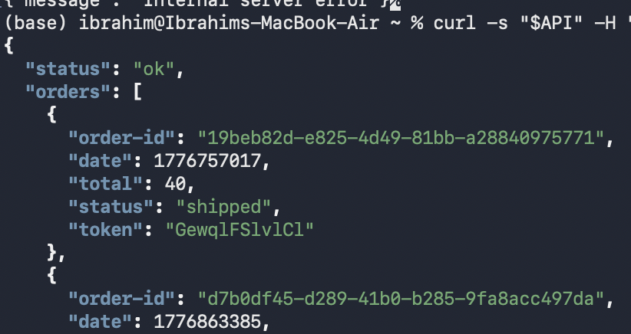
The terminal returned a generic error message, which is expected as the injected function causes the handler to crash after execution. However, the key evidence is the side effect: the internal administrative function was successfully triggered using the API function's over-privileged IAM permissions.

Part 6:

- Implement Least Privilege: The IAM execution role for the public-facing API Lambda should be restricted.
- Remove Wildcard Permissions: Remove the ability for the API to invoke "all" functions (lambda:InvokeFunction on *).
- Specific Resource Mapping: Explicitly list only the specific resources the API is allowed to interact with.

Part 7:
I modified the lambda_handler in admin_update_orders.py to implement server-side authorization checks. The added logic extracts the cognito:groups claim from the decoded JWT payload to verify the user's permissions. By checking if the user belongs to the "Admins" group, the function now ensures that only authorized administrators can execute database updates. Any request from a non-admin user—including those using lateral function-to-function invocation—is now rejected with an "Unauthorized" error message.

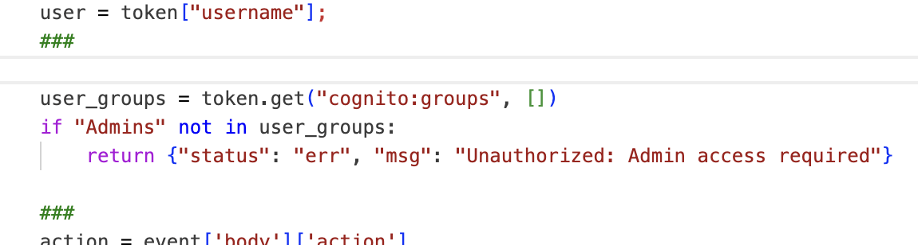

Part 8:

After applying the fix (restricting the IAM policy and adding authorization checks), I repeated the terminal exploit. The backend now rejects the unauthorized invocation attempt. As shown in the "After" list, the order status no longer changes, while legitimate users can still access their own orders normally.
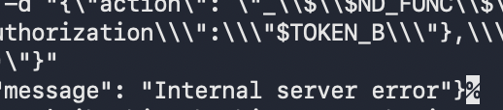
Part 9:
Structured Analysis Summary
Table A:
Vulnerability | Intended Rule(s) | Artifacts Used to Infer Rule | Normal Behavior Evidence | Exploit Behavior Evidence
Broken Access Control | Only valid, authorized users in the "Admins" group should be able to update order statuses | IAM Role policies for DVSA-ORDER-MANAGER and the source code of admin_update_orders.py | Standard users can view and create orders but cannot manually change a status to "Paid" (120) through the UI | User B successfully updated an order status to "Paid" by bypassing the UI and invoking the admin function laterally

Table B:
Vulnerability | Why This Is a Deviation | Deviation Class | Fix Applied | Post-Fix Verification
Broken Access Control | The system trusted a user's identity (valid JWT) without verifying their specific authorization levels (admin group membership) | Intentional misuse / security-relevant abuse | Added a cognito:groups check in the Python code and restricted the IAM policy to specific resource ARNs | The exploit now fails with an "Internal server error," and the database remains unchanged

Part 10:
- Verification is Key: Never trust a user's identity based solely on the presence of a token; always verify their specific permissions (claims).
- Defense in Depth: Even if the network or IAM layer allows an invocation, the application code should act as a final gatekeeper to enforce business logic.
- Serverless Impact: In a distributed architecture, small oversights in authorization can lead to full account impersonation.

