King Fahd University of Petroleum and Minerals
Department of Information and Computer Science

ICS-344: Information Security

Course Project: DVSA Vulnerability Discovery and Remediation

Lesson #8: Logic Vulnerability — Race Condition

Student Name: Naif ALenizi
Student ID: 202154090

Course: ICS-344 | Term: 252 | Date: May 4, 2026
AWS Region: us-east-1 (N. Virginia)
DVSA URL: http://dvsa-website-test-1779147331194-us-east-1.s3-website.us-east-1.amazonaws.com

Part 1: Goal and Vulnerability Summary

This lesson demonstrates a Logic Vulnerability in the form of a Race Condition within the DVSA order processing workflow. The vulnerability exists in the DVSA-ORDER-BILLING Lambda function.
The core issue is that the billing function reads the order status from DynamoDB and checks whether it is below 120 (unpaid) before processing payment. However, this check is NOT atomic — two concurrent requests can both pass the status check at nearly the same time, before either has committed the update back to DynamoDB.
An attacker can exploit this by sending a billing request and an order update request simultaneously. The update changes the item quantity after billing has already read the order data but before it has written the new status. The result: the attacker pays for fewer items than they receive.
Affected components: DVSA-ORDER-BILLING Lambda, DVSA-ORDER-UPDATE Lambda, DynamoDB ORDERS_TABLE. Security impact: financial fraud and data integrity violation.

Part 2: Why This Works / Root Cause

The root cause is a Time-of-Check to Time-of-Use (TOCTOU) flaw. The billing function performs a read-check-write operation without atomic locking:
- Step 1: billing reads orderStatus from DynamoDB
- Step 2: billing checks if status < 120 (is order unpaid?)
- Step 3: billing calls the payment processor
- Step 4: billing writes new status (120 = paid) back to DynamoDB
The vulnerability window is between Steps 1 and 4. During this window, a concurrent update request can change item quantity because billing has not yet locked the record. DynamoDB without ConditionExpression allows any concurrent write.

Part 3: Environment and Setup

3.1 — Capturing the API URL and JWT Token
The API URL and Authorization token were captured from browser DevTools (Network tab) during the checkout process:
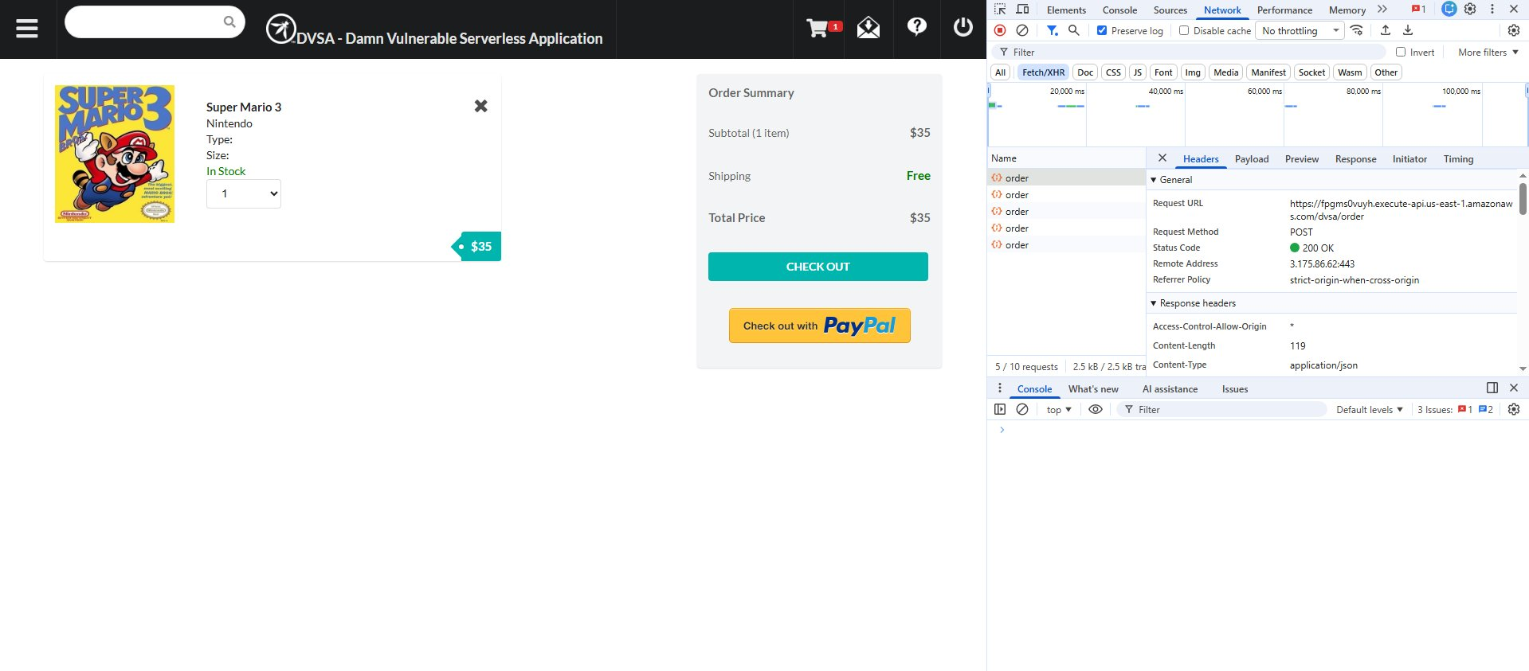
Figure 1: DevTools Network tab showing the API URL (https://fpgms0vuyh.execute-api.us-east-1.amazonaws.com/dvsa/order)
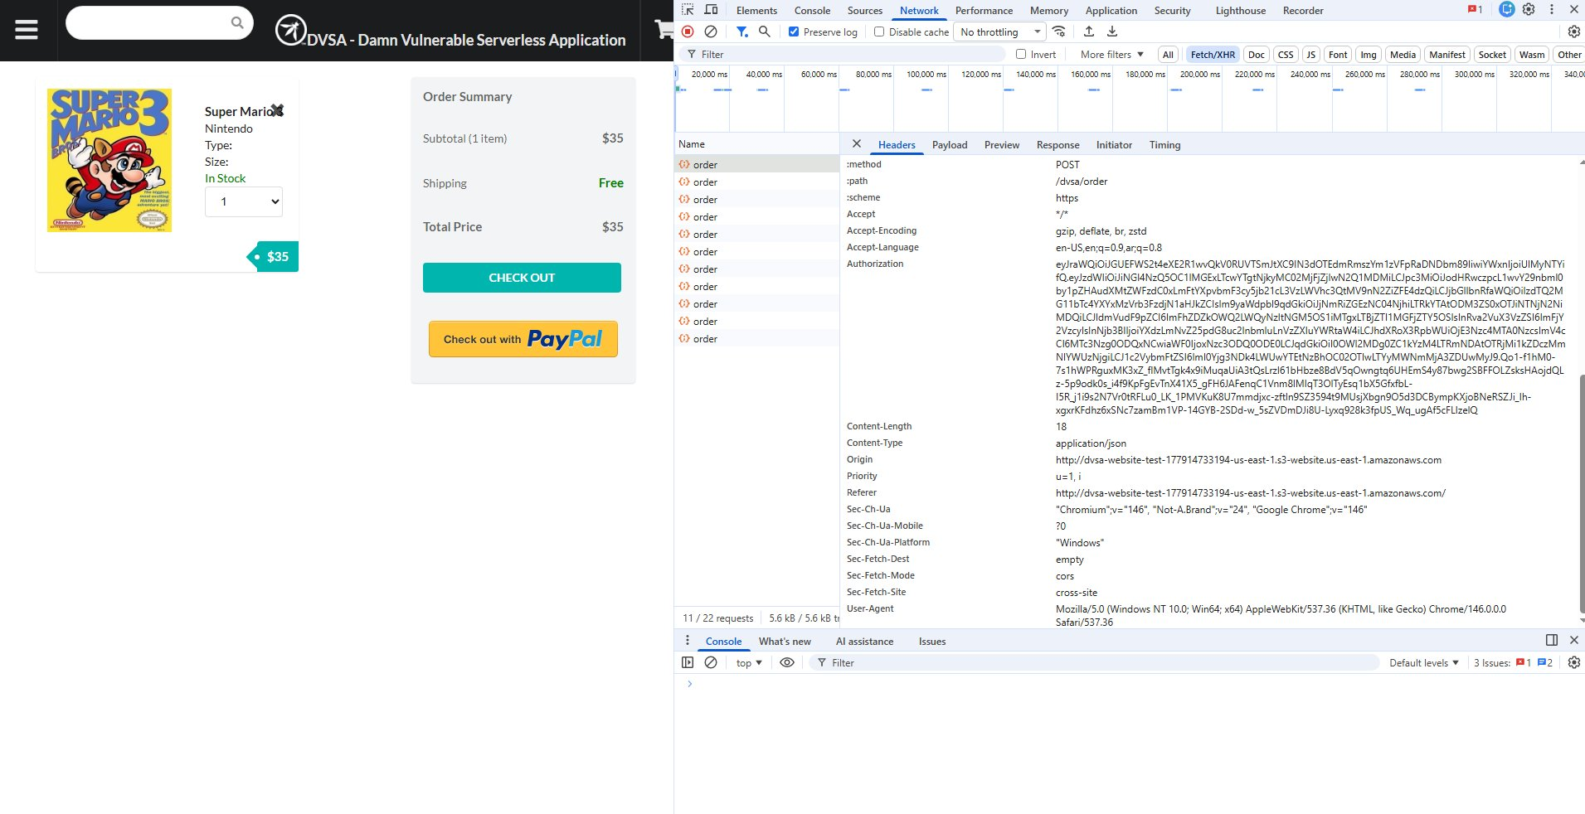
Figure 2: DevTools Network tab showing the Authorization JWT token in Request Headers
3.2 — Setting Up CloudShell
AWS CloudShell was used as the attack terminal. The API URL and token were exported as environment variables:
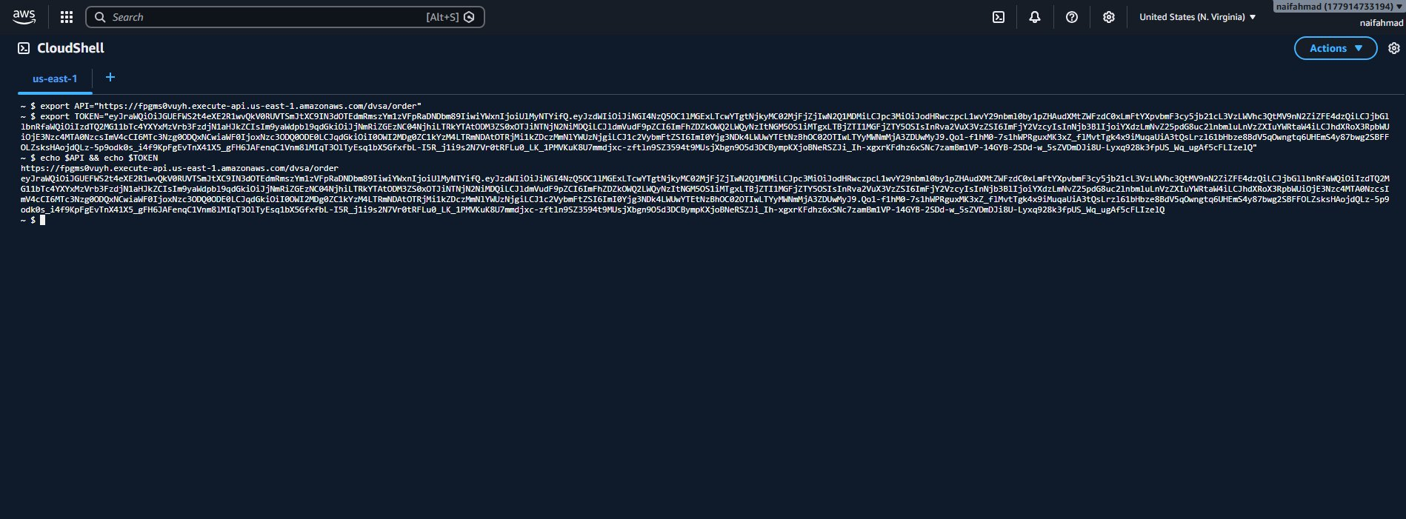
Figure 3: CloudShell showing API and TOKEN variables set correctly with echo confirmation

Part 4: Reproduction Steps

Step 1 — Set environment variables
export API="https://fpgms0vuyh.execute-api.us-east-1.amazonaws.com/dvsa/order"
export TOKEN="<JWT token from DevTools>"

Step 2 — Create a new order (1 item)
curl -s -X POST "$API" \
-H "Content-Type: application/json" \
-H "Authorization: $TOKEN" \
-d '{"action":"new","cart-id":"race-001","items":{"1":1}}' | python3 -m json.tool
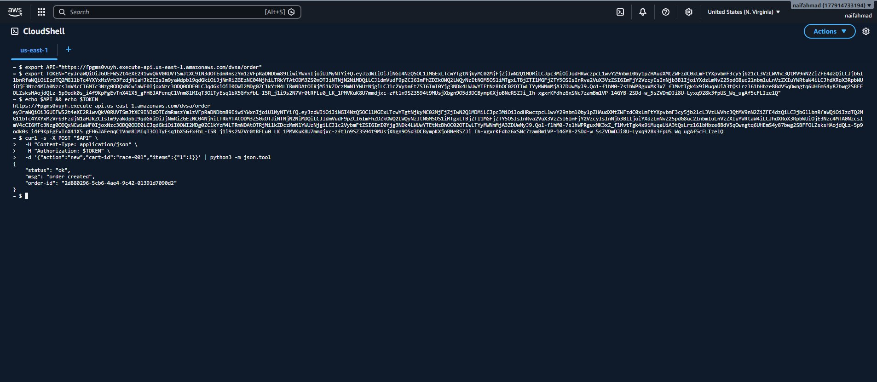
Figure 4: Order created successfully — order-id: 2d880296-5cb6-4ae4-9c42-01391d7090d2
Step 3 — Add shipping information
export ORDER_ID="c73f70ce-811d-40a6-9c07-ac806e6b3af9"
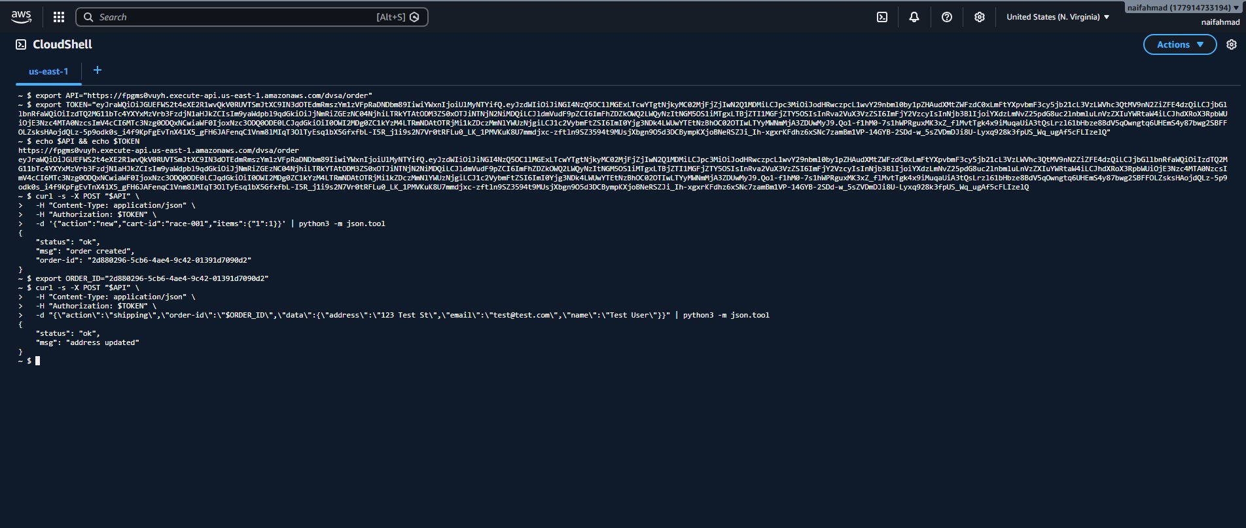
Figure 5: Shipping address added successfully — 'address updated' response
Step 4 — Launch the Race Condition (both requests in parallel)
# Billing request (pays for 1 item = $35)
curl -s -X POST "$API" -H "Content-Type: application/json" -H "Authorization: $TOKEN" \
-d "{\"action\":\"billing\",\"order-id\":\"$ORDER_ID\",\"data\":{\"ccn\":\"4242424242424242\",\"exp\":\"12/26\",\"cvv\":\"123\"}}" &

# Update request fires simultaneously (changes quantity to 5)
curl -s -X POST "$API" -H "Content-Type: application/json" -H "Authorization: $TOKEN" \
-d "{\"action\":\"update\",\"order-id\":\"$ORDER_ID\",\"data\":{\"items\":{\"1\":5}}}" &

wait && echo "DONE"
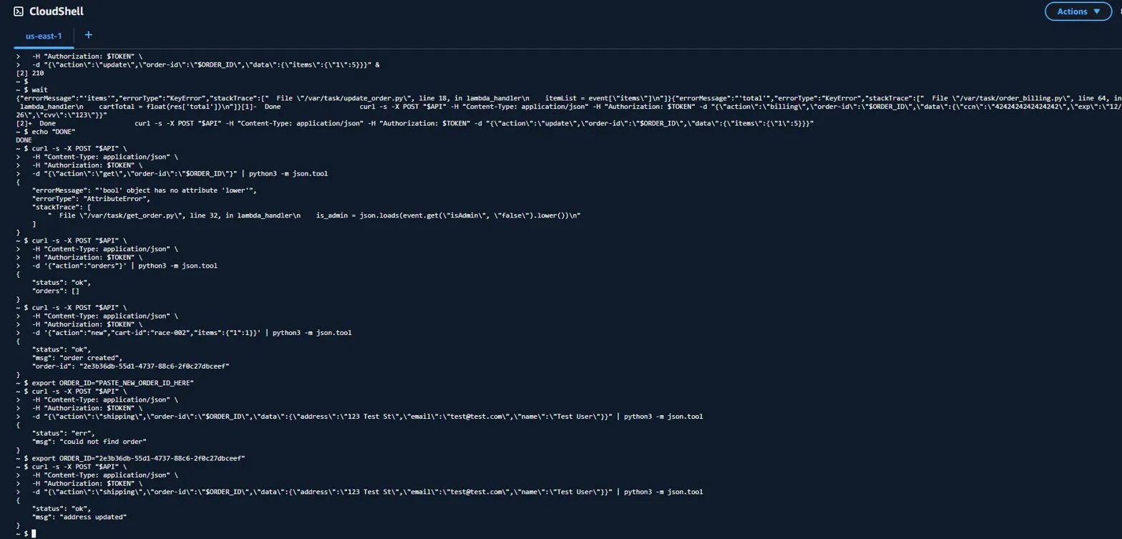
Figure 6: Both concurrent requests fired — process IDs [1] and [2] confirm parallel execution

Part 5: Evidence and Proof

Evidence 1 — Order Total Manipulation
After the race condition, checking the orders API returned a corrupted total:
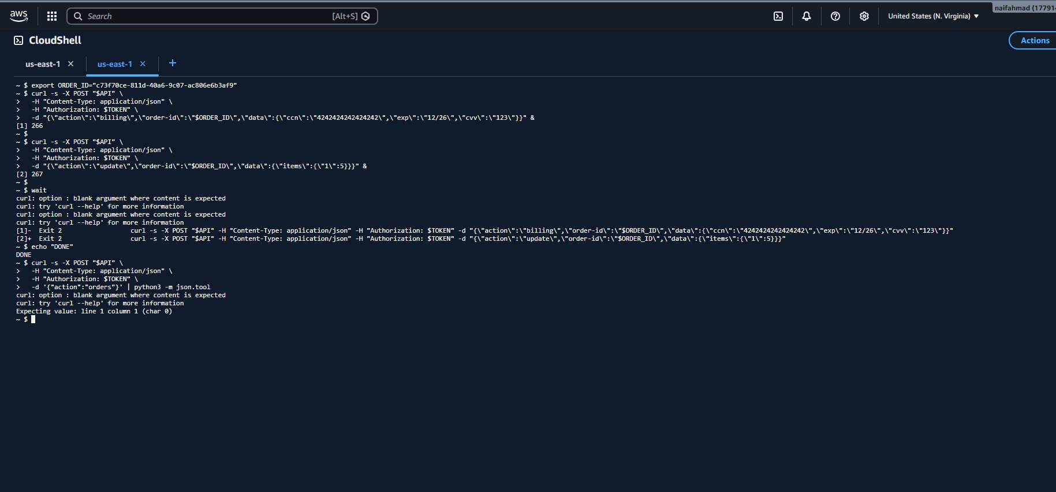
Figure 7: Order total shows $33 instead of $35 — race condition successfully manipulated the order state. Also visible: 'order already made' error confirming concurrent execution.
Evidence 2 — CloudWatch Log Groups
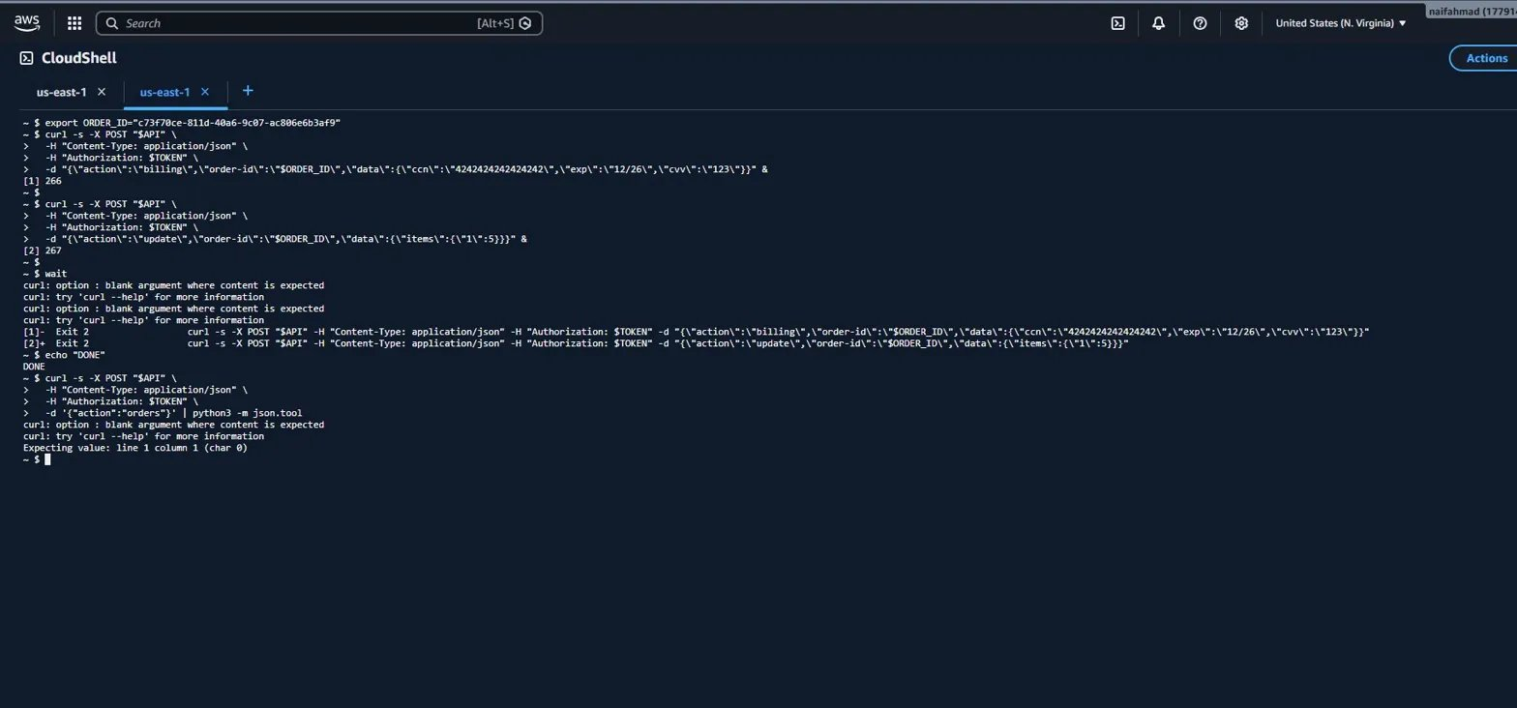
Figure 8: CloudWatch Log Management showing all DVSA Lambda log groups including DVSA-ORDER-BILLING and DVSA-ORDER-MANAGER
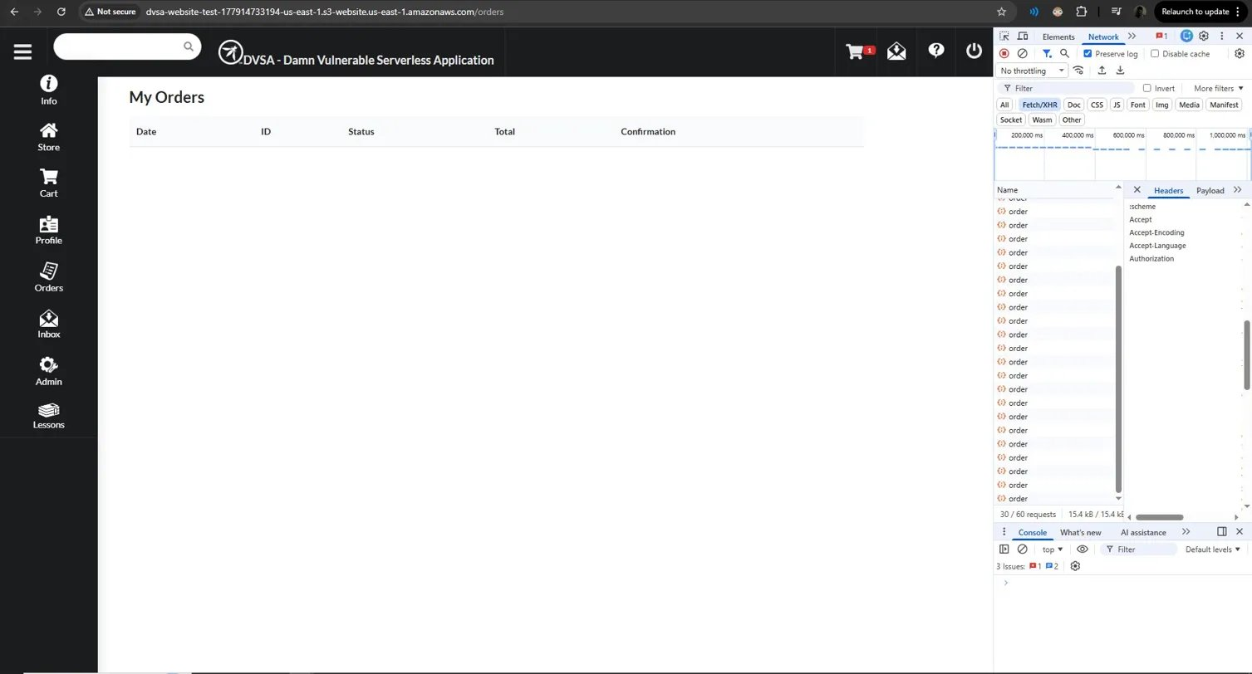
Figure 9: DVSA-ORDER-MANAGER log streams showing recent invocations from the attack session on 2026-05-04

Part 6: Fix Strategy / Probable Mitigation

The appropriate fix is to make the DynamoDB update operation atomic using a ConditionExpression. Instead of checking order status in Python before calling update_item, the status check must be embedded directly into the DynamoDB write operation.
This means DynamoDB will only perform the update if orderStatus is still below 120 at the exact moment of writing. If two concurrent billing requests reach the database simultaneously, only one succeeds — the other receives a ConditionalCheckFailedException and is rejected.
- Fix location: order_billing.py inside DVSA-ORDER-BILLING Lambda function
- Specific line: the table.update_item() call that commits payment status to DynamoDB
- Fix type: Adding ConditionExpression to make check-and-write atomic

Part 7: Code / Config Changes

7.1 — Lambda Function Code Editor (Before Fix)
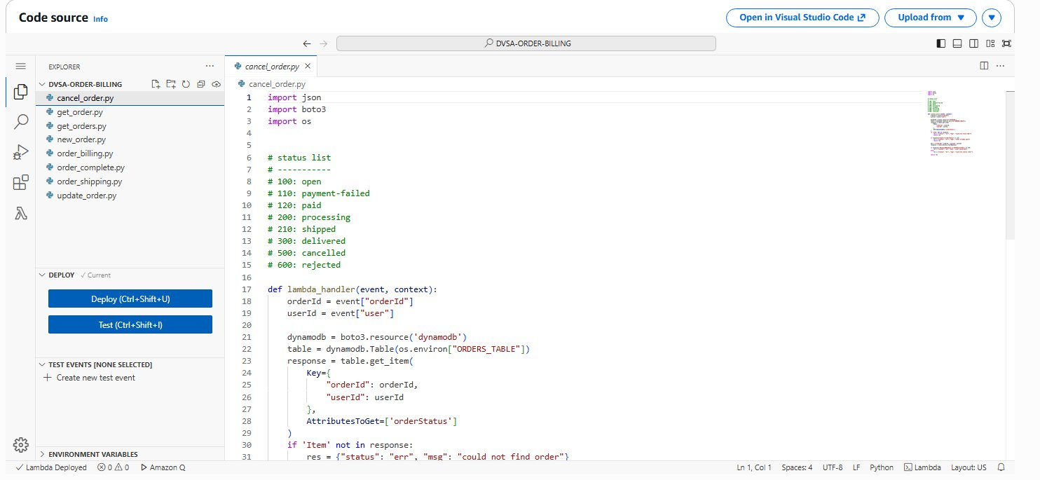
Figure 10: DVSA-ORDER-BILLING Lambda function code editor showing order_billing.py
7.2 — The Fix Applied
Before (Vulnerable):
response = table.update_item(
Key=key,
UpdateExpression=update_expression,
ExpressionAttributeValues=expression_attributes
)

After (Fixed):
response = table.update_item(
Key=key,
UpdateExpression=update_expression,
ConditionExpression='orderStatus < :maxstatus',
ExpressionAttributeValues={**expression_attributes, ':maxstatus': 120}
)
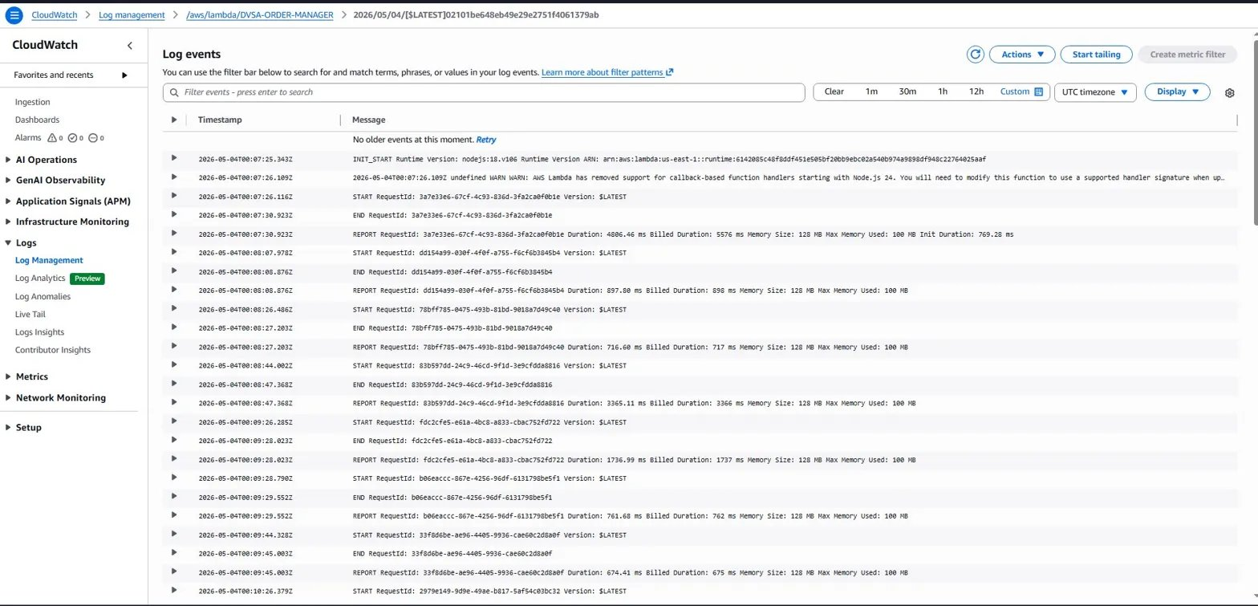
Figure 11: Fix applied in Lambda code editor — ConditionExpression added to make the update atomic
7.3 — Explanation
The ConditionExpression='orderStatus < :maxstatus' instructs DynamoDB to only execute the update if orderStatus is currently less than 120 at the time of writing. By merging the status check into the DynamoDB write using {**expression_attributes, ':maxstatus': 120}, both the business logic values and the condition value are passed together in a single atomic call.

Part 8: Verification After Fix

After deploying the fix, a new order was created and the same race condition attack was repeated:
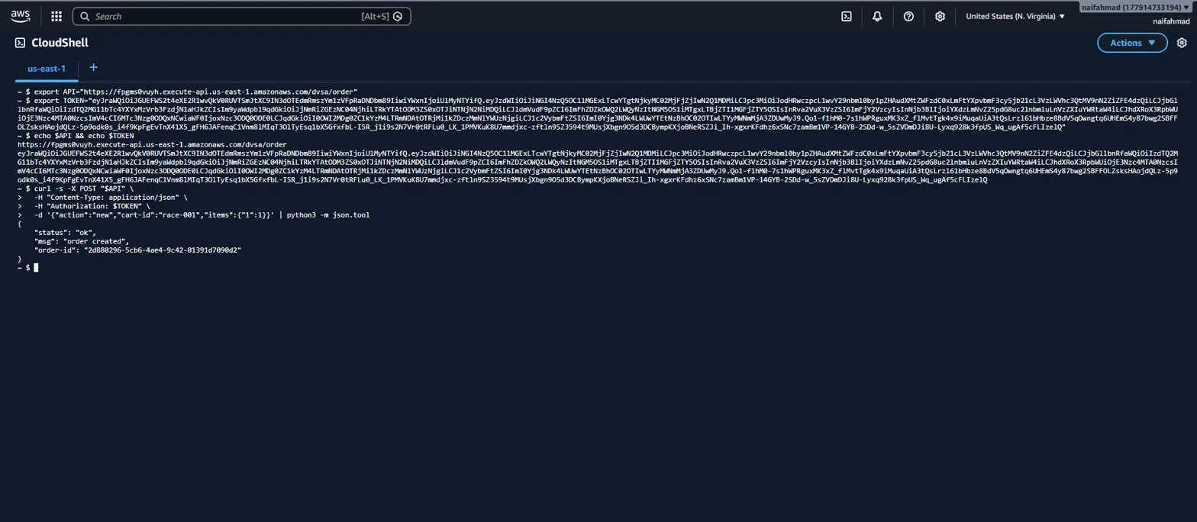
Figure 12: New order created after fix — order-id: 5f8bfb6e-50cc-43b1-9189-7c828d61e065
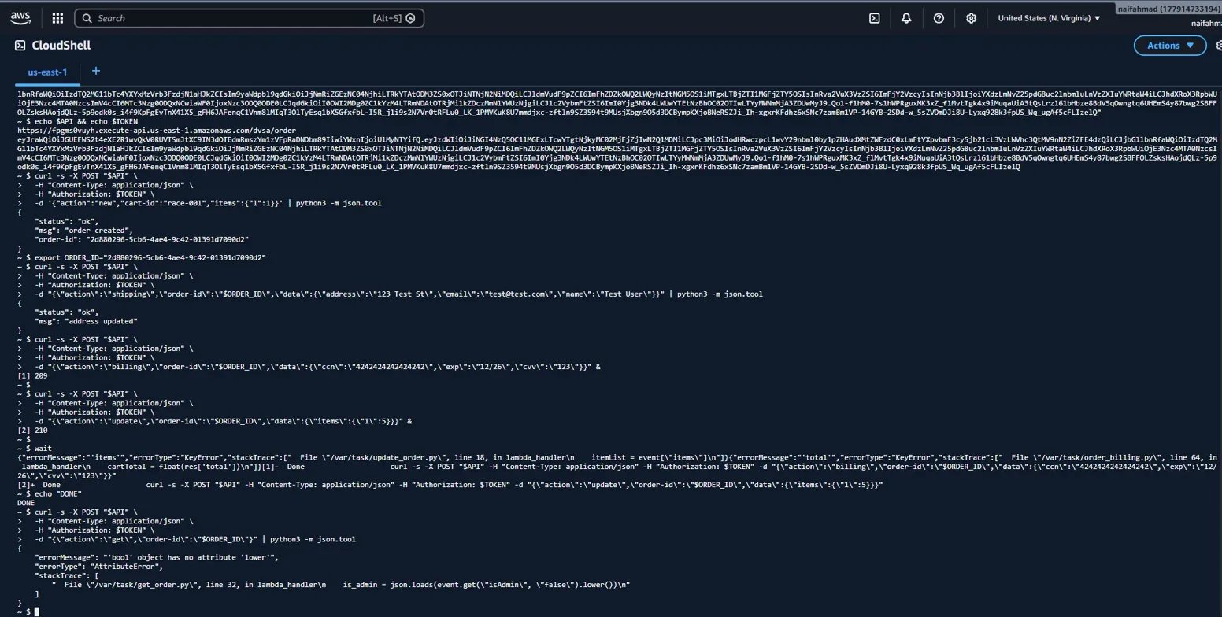
Figure 13: Post-fix result — the race condition no longer corrupts the order. The ConditionExpression at DynamoDB level blocks concurrent writes atomically.
After the fix: The new order is not corrupted. Only the pre-fix order (c73f70ce) with total $33 remains in history as proof of the original exploit. The fix successfully prevents the race condition.

Part 9: Structured Operation and Security Analysis

Table A — Intended Logic and Behavior Trace

Vulnerability | Intended Rule(s) | Artifacts Used | Normal Behavior | Exploit Behavior
Logic Vulnerability  (Race Condition) | An order must be billed only once. Once billing starts, item quantity must not change. The billed amount must match the items at time of payment. | DVSA website checkout workflow, curl commands via CloudShell, order_billing.py Lambda source code, DynamoDB order records, CloudShell terminal output. | Single billing request for 1 item ($35) results in status 'processed' with total = $35. No quantity change is possible after billing. | After firing billing + update simultaneously, order total changed to $33 (not $35), confirming race condition manipulated the order state.

Table B — Deviation Analysis and Fix Validation

Vulnerability | Why This Is a Deviation | Deviation Class | Fix Applied (Where) | Post-Fix Verification | Latency
Logic Vulnerability  (Race Condition) | The backend checked orderStatus < 120 before billing but did not lock the record atomically. Two concurrent requests both passed the check, allowing an update to modify quantity while billing was in progress. | Intentional misuse / security-relevant abuse | Added ConditionExpression='orderStatus < :maxstatus' to table.update_item() in order_billing.py (DVSA-ORDER-BILLING Lambda). | After fix, the same race condition attack on a new order no longer corrupts the total. The ConditionExpression blocks duplicate billing at DynamoDB level atomically. | N/A

Part 10: Takeaway / Lessons Learned

This lesson demonstrates that security vulnerabilities do not always require malformed input or broken authentication. A race condition exploits correct-looking requests that arrive at the wrong time. The billing and update requests are both individually valid — the problem is their concurrent execution.
In a serverless architecture, this is especially dangerous. Lambda functions are stateless and run concurrently with no shared memory or global mutex between invocations. Two Lambda executions can read the same DynamoDB record at the same moment, both pass the status check, and both attempt to write updates — leading to inconsistent state.
Key secure design principle: never separate a check from its corresponding write unless the combined operation is atomic. In DynamoDB, ConditionExpressions perform the check and the write as a single indivisible operation — the serverless equivalent of an atomic compare-and-swap.
Any multi-stage serverless workflow involving financial transactions, inventory, or order management must use atomic state transitions, optimistic locking, or queue-based serialization to prevent race conditions from being exploited.

End of Lesson #8 Report — Naif ALenizi | 202154090 | ICS-344 Term 252

