Report Of #10

Part 1:
The goal of this experiment is to demonstrate an Unhandled Exceptions vulnerability in the DVSA application. The issue occurs in the backend API when invalid or incomplete input is provided.
Instead of returning a safe and generic error message, the application exposes internal debugging information such as error messages, stack traces, and file paths.
This vulnerability can help attackers understand the backend structure and potentially discover additional weaknesses in the system.

Part 2:
The vulnerability occurs because the backend does not properly handle exceptions. Instead of returning a generic error response, the application exposes internal debugging information such as stack traces and file paths when invalid input is provided.

Part 3:
The DVSA application was deployed in the AWS us-east-1 region and accessed using the provided Website URL.
For this experiment, a user account (User B) was used to interact with the system. The API endpoint was obtained from the browser using Developer Tools, and the corresponding JWT token was extracted from the Authorization header.
The test was performed by sending requests to the /order API endpoint using a terminal with the captured API URL and token.
Part 4:
A malformed request was sent to the /order API endpoint with incomplete input using a terminal command, which triggered an internal error.

Part 5:
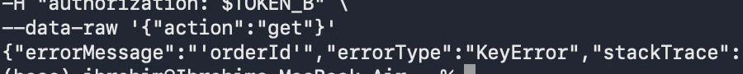
The application returned an internal error message exposing backend details such as file paths and code references. In this case, the response revealed a KeyError, the backend file name get_order.py, and the exact line where the exception occurred.

The response also revealed the internal file path /var/task/get_order.py, confirming exposure of backend implementation details.

Part 6:
To fix this issue, the backend should properly handle exceptions and avoid exposing internal error details.
Instead of returning full stack traces and debugging information, the application should return a generic error message such as “Internal Server Error” while logging the detailed error internally for debugging purposes.
Additionally, input validation should be enforced to ensure that required fields are present and correctly formatted before processing the request.
Part 7:
The backend code was updated to handle exceptions safely by wrapping critical operations in a try-catch blocks.
Instead of exposing raw error messages to the user, the system now returns a generic response while logging the detailed error internally.
This prevents attackers from gaining insight into the backend implementation and protects sensitive system information.

Part 8:
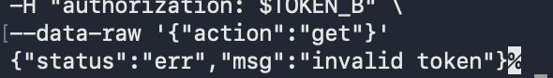
After applying the fix, the application no longer exposes detailed error messages when invalid input is provided.
Instead, a generic error response is returned to the user, while internal logs still capture the detailed exception for debugging purposes.
This confirms that the vulnerability has been successfully mitigated.
This ensures that attackers can no longer gain insight into the backend system through error messages.

Part 9:

Structured Analysis:-
Part A:

Vulnerability | Intended Rule(s) | Artifacts Used to Infer Rule | Normal Behavior Evidence | Exploit Behavior Evidence
Unhandled Exceptions | The system should not expose internal error details to users | API response, error message, stack trace, backend file path | Valid requests return normal responses without exposing internal details | Malformed requests return detailed error messages including stack trace and file paths

Part B:

Vulnerability | Why This Is a Deviation | Deviation Class | Fix Applied (Where) | Post-Fix Verification
Unhandled Exceptions | The system exposes internal debugging information instead of hiding it. This reveals backend implementation details | Security misconfiguration / information exposure | The backend code was updated in the backend API to return generic error messages | After the proposed fix, detailed error messages should no longer be exposed and only generic responses should be returned

Part 10:
This experiment shows that improper error handling can expose sensitive backend information, which may assist attackers in further exploitation.
Even though this vulnerability does not directly grant access to data, it significantly increases the risk of other attacks by revealing system details.
Proper exception handling and secure error responses are essential to protect backend systems.

