Task 1:
TCP
- Three-way handshake (SYN, SYN-ACK, ACK)
- If a packet is lost, it is retransmitted
- Packets are numbered and arranged
TCP

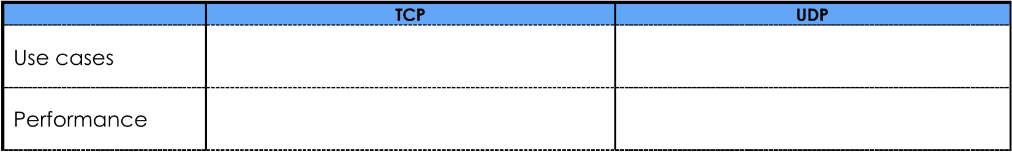
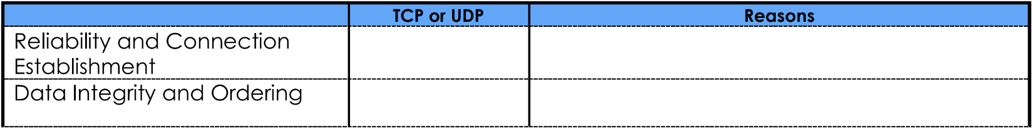
Task 2:
Fast but not guaranteed transfers
Slow but Reliable transfers
Live streaming, Online Games, VoIP
File Transfer, Web Browsing, Email

