Chapter 5 - Testing

5.1 Introduction
This chapter documents the automated testing implemented for the Sunrise Dental Clinic Java project. The tests were added under src/test/java using JUnit 5 and Mockito, and they exercise actual business logic in the existing model and validation utility classes without requiring the production MySQL database.
No TDD claim is made. The repository evidence shows tests were added to the existing implementation.

5.2 Testing Strategy
The strategy is automated unit testing of business rules with mocked DAO dependencies. This verifies success paths, validation failures, duplicate/conflict scenarios, and important billing/treatment rules while keeping the test suite independent from external database state.
Area | Approach | Evidence
Business models | JUnit 5 unit tests with Mockito DAO mocks. | src/test/java/lk/sunrise/dentalclinic/model
Validation utilities | Direct JUnit assertions against static validation methods. | ValidationTest.java
Database integration | Not implemented; DAOs are mocked. | No Failsafe or integration-test profile exists.
Execution | Maven Surefire via mvn test. | target/surefire-reports

5.3 Automated Testing
Tool | Purpose | Actual Use
JUnit 5 | Define and execute automated unit tests. | 33 tests executed.
Mockito | Mock DAO/database dependencies. | Used in model tests.
Maven Surefire | Run tests during Maven test phase. | Final run: 33 tests, 0 failures, 0 errors, 0 skipped.

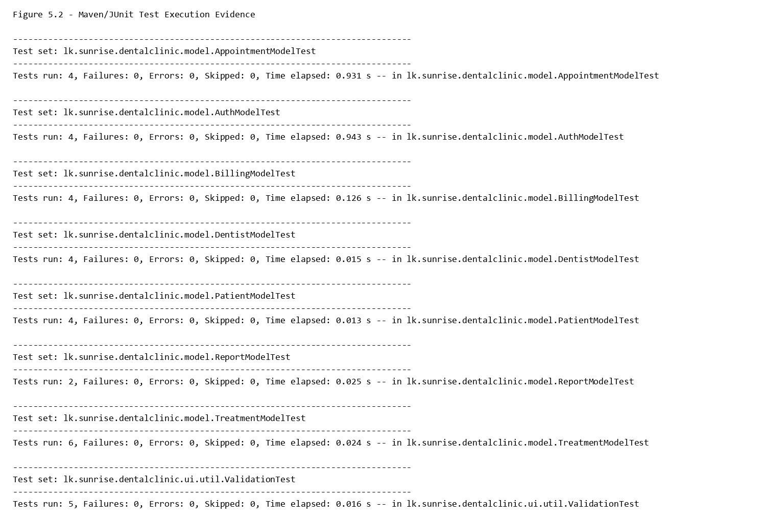
Figure 5.2 - Maven/JUnit Test Execution Evidence

5.4 Test Classes
Test Class | Tests | Failures | Errors | Skipped | Status
AppointmentModelTest | 4 | 0 | 0 | 0 | Passed
AuthModelTest | 4 | 0 | 0 | 0 | Passed
BillingModelTest | 4 | 0 | 0 | 0 | Passed
DentistModelTest | 4 | 0 | 0 | 0 | Passed
PatientModelTest | 4 | 0 | 0 | 0 | Passed
ReportModelTest | 2 | 0 | 0 | 0 | Passed
TreatmentModelTest | 6 | 0 | 0 | 0 | Passed
ValidationTest | 5 | 0 | 0 | 0 | Passed

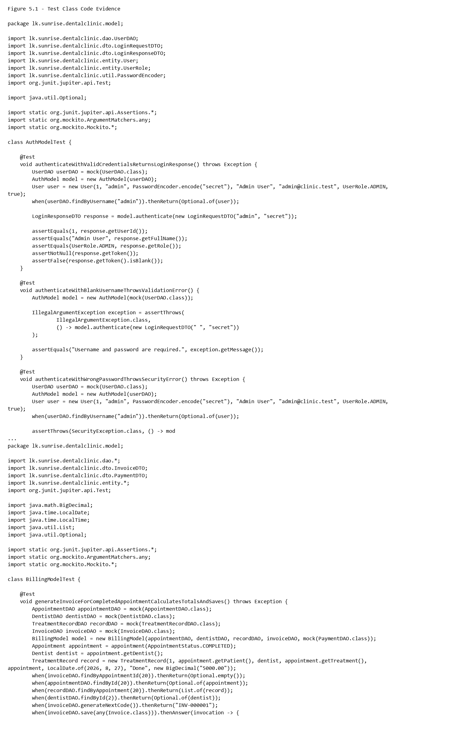
Figure 5.1 - Test Class Code Evidence

5.5 Test Cases
Test ID | Requirement ID | Test Class | Test Method | Test Scenario | Expected Result | Actual Result | Status
TC-AUTH-01 | FR-01 | AuthModelTest | authenticateWithValidCredentialsReturnsLoginResponse | Valid active user credentials produce a login response with token. | LoginResponseDTO contains user ID, full name, role, and generated token. | Executed successfully in final mvn test run. | Passed
TC-AUTH-02 | FR-01 | AuthModelTest | authenticateWithBlankUsernameThrowsValidationError | Blank username is submitted. | IllegalArgumentException is thrown. | Executed successfully in final mvn test run. | Passed
TC-AUTH-03 | FR-01 | AuthModelTest | authenticateWithWrongPasswordThrowsSecurityError | Wrong password is submitted for an existing user. | SecurityException is thrown. | Executed successfully in final mvn test run. | Passed
TC-AUTH-04 | FR-03 | AuthModelTest | registerWithDuplicateUsernameIsRejected | Duplicate username is used during registration. | Registration is rejected and user is not saved. | Executed successfully in final mvn test run. | Passed
TC-PAT-01 | FR-05 | PatientModelTest | registerWithValidPatientGeneratesCodeAndSaves | Valid patient registration details are submitted. | Patient is saved with generated patient code. | Executed successfully in final mvn test run. | Passed
TC-PAT-02 | FR-05 | PatientModelTest | registerWithBlankPatientNameThrowsValidationError | Blank patient name is submitted. | IllegalArgumentException is thrown. | Executed successfully in final mvn test run. | Passed
TC-PAT-03 | FR-08 | PatientModelTest | registerWithDuplicateContactIsRejected | Existing contact number is submitted. | Registration is rejected and patient is not saved. | Executed successfully in final mvn test run. | Passed
TC-PAT-04 | FR-06 | PatientModelTest | updateWithMissingPatientThrowsNotFoundError | Update is requested for a missing patient. | NoSuchElementException is thrown. | Executed successfully in final mvn test run. | Passed
TC-DEN-01 | FR-09 | DentistModelTest | registerWithValidDentistGeneratesCodeAndSaves | Valid dentist registration details are submitted. | Dentist is saved with generated dentist code. | Executed successfully in final mvn test run. | Passed
TC-DEN-02 | FR-12 | DentistModelTest | registerWithDuplicateSlmcIsRejected | Duplicate SLMC number is submitted. | Registration is rejected and dentist is not saved. | Executed successfully in final mvn test run. | Passed
TC-DEN-03 | FR-10 | DentistModelTest | registerWithInvalidWorkingHoursThrowsValidationError | Working-hours end time is before start time. | IllegalArgumentException is thrown. | Executed successfully in final mvn test run. | Passed
TC-DEN-04 | FR-10 | DentistModelTest | registerWithNegativeFeeThrowsValidationError | Negative consultation fee is submitted. | IllegalArgumentException is thrown. | Executed successfully in final mvn test run. | Passed
TC-APP-01 | FR-17 | AppointmentModelTest | createWithValidAppointmentSavesScheduledAppointment | Valid patient, dentist, treatment, date, and time are submitted. | Appointment is saved as SCHEDULED with generated appointment number. | Executed successfully in final mvn test run. | Passed
TC-APP-02 | FR-19 | AppointmentModelTest | createOutsideDentistWorkingHoursIsRejected | Appointment starts outside dentist working hours. | IllegalArgumentException is thrown and appointment is not saved. | Executed successfully in final mvn test run. | Passed
TC-APP-03 | FR-19 | AppointmentModelTest | createWithDentistConflictIsRejected | Dentist already has an appointment in the requested slot. | IllegalArgumentException is thrown and appointment is not saved. | Executed successfully in final mvn test run. | Passed
TC-APP-04 | FR-18 | AppointmentModelTest | updateWithEndBeforeStartIsRejected | Appointment update has end time before start time. | IllegalArgumentException is thrown. | Executed successfully in final mvn test run. | Passed
TC-TRT-01 | FR-13 | TreatmentModelTest | createWithValidTreatmentGeneratesCodeAndSaves | Valid treatment details are submitted. | Treatment is saved with generated treatment code. | Executed successfully in final mvn test run. | Passed
TC-TRT-02 | FR-13 | TreatmentModelTest | createWithDuplicateTreatmentNameIsRejected | Duplicate treatment name is submitted. | Treatment is rejected and not saved. | Executed successfully in final mvn test run. | Passed
TC-TRT-03 | FR-13 | TreatmentModelTest | createWithInvalidDurationIsRejected | Treatment duration is zero. | IllegalArgumentException is thrown. | Executed successfully in final mvn test run. | Passed
TC-TRT-04 | FR-21 | TreatmentModelTest | saveTreatmentRecordForIncompleteAppointmentIsRejected | Treatment record is submitted for a scheduled appointment. | IllegalArgumentException is thrown. | Executed successfully in final mvn test run. | Passed
TC-TRT-05 | FR-21 | TreatmentModelTest | saveTreatmentRecordForCompletedAppointmentPersistsOnce | Treatment record is submitted for a completed appointment with no existing record. | Treatment record is saved. | Executed successfully in final mvn test run. | Passed
TC-TRT-06 | FR-15 | TreatmentModelTest | deleteUsedTreatmentReportsDeactivateMessage | A used treatment is deleted and the DAO reports a foreign-key constraint. | IllegalStateException advises deactivation instead of deletion. | Executed successfully in final mvn test run. | Passed
TC-BIL-01 | FR-22 | BillingModelTest | generateInvoiceForCompletedAppointmentCalculatesTotalsAndSaves | Completed appointment with treatment record is invoiced. | Invoice totals are calculated and invoice is saved. | Executed successfully in final mvn test run. | Passed
TC-BIL-02 | FR-22 | BillingModelTest | generateInvoiceForScheduledAppointmentIsRejected | Scheduled appointment is invoiced. | IllegalArgumentException is thrown. | Executed successfully in final mvn test run. | Passed
TC-BIL-03 | FR-23 | BillingModelTest | recordPaymentRejectsOverpayment | Payment amount exceeds invoice balance. | Payment is rejected and not saved. | Executed successfully in final mvn test run. | Passed
TC-BIL-04 | FR-23 | BillingModelTest | recordPaymentWithValidAmountPersistsPaymentDate | Valid payment amount is submitted. | Payment is saved and payment date is assigned. | Executed successfully in final mvn test run. | Passed
TC-REP-01 | FR-24 | ReportModelTest | dailyDelegatesRequestToReportDao | Daily appointment report request is submitted. | Request is delegated to ReportDAO and appointments are returned. | Executed successfully in final mvn test run. | Passed
TC-REP-02 | FR-24 | ReportModelTest | monthlyDelegatesYearAndMonthToReportDao | Monthly revenue request is submitted. | Year/month are delegated to ReportDAO and revenue DTO is returned. | Executed successfully in final mvn test run. | Passed
TC-VAL-01 | FR-05 | ValidationTest | validSriLankanMobileNumberIsAccepted | Valid Sri Lankan mobile numbers are validated. | No exception is thrown. | Executed successfully in final mvn test run. | Passed
TC-VAL-02 | FR-05 | ValidationTest | invalidSriLankanMobileNumberIsRejected | Invalid phone number is validated. | IllegalArgumentException is thrown. | Executed successfully in final mvn test run. | Passed
TC-VAL-03 | FR-05 | ValidationTest | validEmailIsAcceptedAndInvalidEmailIsRejected | Valid and invalid email addresses are validated. | Valid email passes; invalid email throws IllegalArgumentException. | Executed successfully in final mvn test run. | Passed
TC-VAL-04 | FR-22 | ValidationTest | decimalParsesMoneyValueWithTwoDecimalPlaces | A decimal money value is validated. | BigDecimal value is returned. | Executed successfully in final mvn test run. | Passed
TC-VAL-05 | FR-07 | ValidationTest | invalidPatientCodeIsRejected | Invalid patient code is validated. | IllegalArgumentException is thrown. | Executed successfully in final mvn test run. | Passed

5.6 Test Results
Metric | Actual Result
Maven command used | mvn test
Total tests | 33
Failures | 0
Errors | 0
Skipped | 0
Build result | BUILD SUCCESS

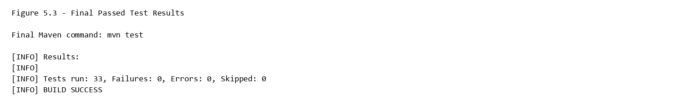
Figure 5.3 - Final Passed Test Results

5.7 Requirement Traceability
Requirement ID | Requirement Description | Module | Test Case ID | Test Result
FR-01 | Authenticate users with username and password. | Authentication | TC-AUTH-01, TC-AUTH-02, TC-AUTH-03 | Passed
FR-02 | Generate and invalidate authentication tokens for sessions. | Authentication | Not covered by automated tests | Not implemented
FR-03 | Register users with unique usernames and role assignment. | Authentication | TC-AUTH-04 | Passed
FR-04 | Render role-based navigation by authenticated role. | Authentication | Not covered by automated tests | Not implemented
FR-05 | Register patients and validate patient input. | Patient Management | TC-PAT-01, TC-PAT-02, TC-VAL-01, TC-VAL-02, TC-VAL-03 | Passed
FR-06 | Update existing patient demographic/contact details. | Patient Management | TC-PAT-04 | Passed
FR-07 | Search and retrieve patients by keyword, ID, or patient code. | Patient Management | TC-VAL-05 | Passed
FR-08 | Prevent duplicate patient contact numbers. | Patient Management | TC-PAT-03 | Passed
FR-09 | Register dentists with generated dentist codes and SLMC details. | Dentist Management | TC-DEN-01 | Passed
FR-10 | Validate dentist fees, availability, and working hours. | Dentist Management | TC-DEN-03, TC-DEN-04 | Passed
FR-11 | Search and retrieve dentists. | Dentist Management | Not covered by automated tests | Not implemented
FR-12 | Prevent duplicate dentist SLMC numbers. | Dentist Management | TC-DEN-02 | Passed
FR-13 | Create treatments with validation and generated codes. | Treatment Management | TC-TRT-01, TC-TRT-02, TC-TRT-03 | Passed
FR-14 | Update treatment details and active state. | Treatment Management | Not covered by automated tests | Not implemented
FR-15 | Delete unused treatments and block constrained deletes. | Treatment Management | TC-TRT-06 | Passed
FR-16 | View active treatments and treatment history. | Treatment Management | Not covered by automated tests | Not implemented
FR-17 | Create appointments for existing patients, dentists, and treatments. | Appointment Management | TC-APP-01 | Passed
FR-18 | Update appointment details and status. | Appointment Management | TC-APP-04 | Passed
FR-19 | Prevent double-booking and outside-hours scheduling. | Appointment Management | TC-APP-02, TC-APP-03 | Passed
FR-20 | List appointments by date range and optional dentist filter. | Appointment Management | Not covered by automated tests | Not implemented
FR-21 | Record treatment only for completed appointments. | Treatment Management | TC-TRT-04, TC-TRT-05 | Passed
FR-22 | Generate invoices for completed appointments after treatment records exist. | Billing | TC-BIL-01, TC-BIL-02, TC-VAL-04 | Passed
FR-23 | Record invoice payments and prevent overpayment. | Billing | TC-BIL-03, TC-BIL-04 | Passed
FR-24 | Generate daily appointment and monthly revenue reports. | Reporting | TC-REP-01, TC-REP-02 | Passed

5.8 Testing Evaluation
The automated test suite now verifies important existing business rules across authentication, patient management, appointment management, dentist management, treatment management, billing, reporting delegation, and validation utilities. DAO dependencies are mocked, so the suite is fast and does not require the production MySQL database.
The remaining gap is database integration and JavaFX UI workflow testing. Requirements that depend mainly on retrieval/listing or UI role rendering are either partially covered by model delegation tests or not covered by automated tests.

5.9 Chapter Summary
Summary Item | Actual Value
Test classes created | 8
Number of tests | 33
Passed | 33
Failed | 0
Errors | 0
Skipped | 0
Maven command | mvn test

