CSS Fonts

The CSS font properties define the font family, boldness, size, and the style of a text.

Difference Between Serif and Sans-serif Fonts

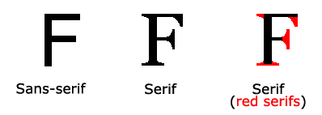

|  |  |  |
| --- | --- | --- |
| **Generic family** | **Font family** | **Description** |
| Serif | Times New Roman Georgia | Serif fonts have small lines at the ends on some characters |
| Sans-serif | Arial Verdana | "Sans" means without - these fonts do not have the lines at the ends of characters |
| Monospace | Courier New Lucida Console | All monospace characters have the same width |

CSS Font Families

In CSS, there are two types of font family names:

* **generic family** - a group of font families with a similar look (like "Serif" or "Monospace")
* **font family** - a specific font family (like "Times New Roman" or "Arial")

**Note:** On computer screens, sans-serif fonts are considered easier to read than serif fonts.

Font Family

The font family of a text is set with the font-family property.

The font-family property should hold several font names as a "fallback" system. If the browser does not support the first font, it tries the next font, and so on.

Start with the font you want, and end with a generic family, to let the browser pick a similar font in the generic family, if no other fonts are available.

**Note**: If the name of a font family is more than one word, it must be in quotation marks, like: "Times New Roman".

More than one font family is specified in a comma-separated list:

Example

Specify the font for three paragraphs:

.serif {  
  font-family: "Times New Roman", Times, serif;  
}  
  
.sansserif {  
  font-family: Arial, Helvetica, sans-serif;  
}  
  
.monospace {  
  font-family: "Lucida Console", Courier, monospace;  
}

Example

Specify the "Impact" font for a paragraph:

p.impact {  
  font-family: Impact, Charcoal, sans-serif;  
}

For commonly used font combinations, look at our [Web Safe Font Combinations](https://www.w3schools.com/cssref/css_websafe_fonts.asp)