002 - Modelling and implementing a distributed system

- Distributed Vote Count
This voting center node is responsible for simulating a vote. A vote is composed of several parties, the same for each center, and a favourability meter. This favourability meter is created in a subclass of the client class and is different for each client. The subclass of the client is also in charge of determining the vote of each voter.

The central tallying node is responsible for receiving the data sent by the clients and aggregating it to obtain the result. The tallying node uses regex and specific words to pick the right information for each center. After that an aggregator puts the result into different forms.

The voting center communicates with the server using text sent via the socket output. The advantage of using text to communicates is that the data sent will be treated only when the server can do it without modifying the order or the content. The server knows the end of a communication because of the word “END” written at the end of each communication. I also used regex to split the results so that the server can recreate the voting result of each center. To capture this communication, I used another thread to capture user input to start the aggregator and stop each center. To differentiate the different centers I pass the center ID in the arguments of the main class alongside the server IP.

To store the vote of each center I used a ConcurrentHashMap [1] this object is thread safe and ensure that only one thread can modify it at once.

The benefit of this design lies in its realism with the favourability meter, which integrate unpredicted result into the simulation, and the use of 10,000 votes each decided independently. But one of the flaws of this design is that the data sent by the client need to be strictly formatted so that the server can understand the right data.

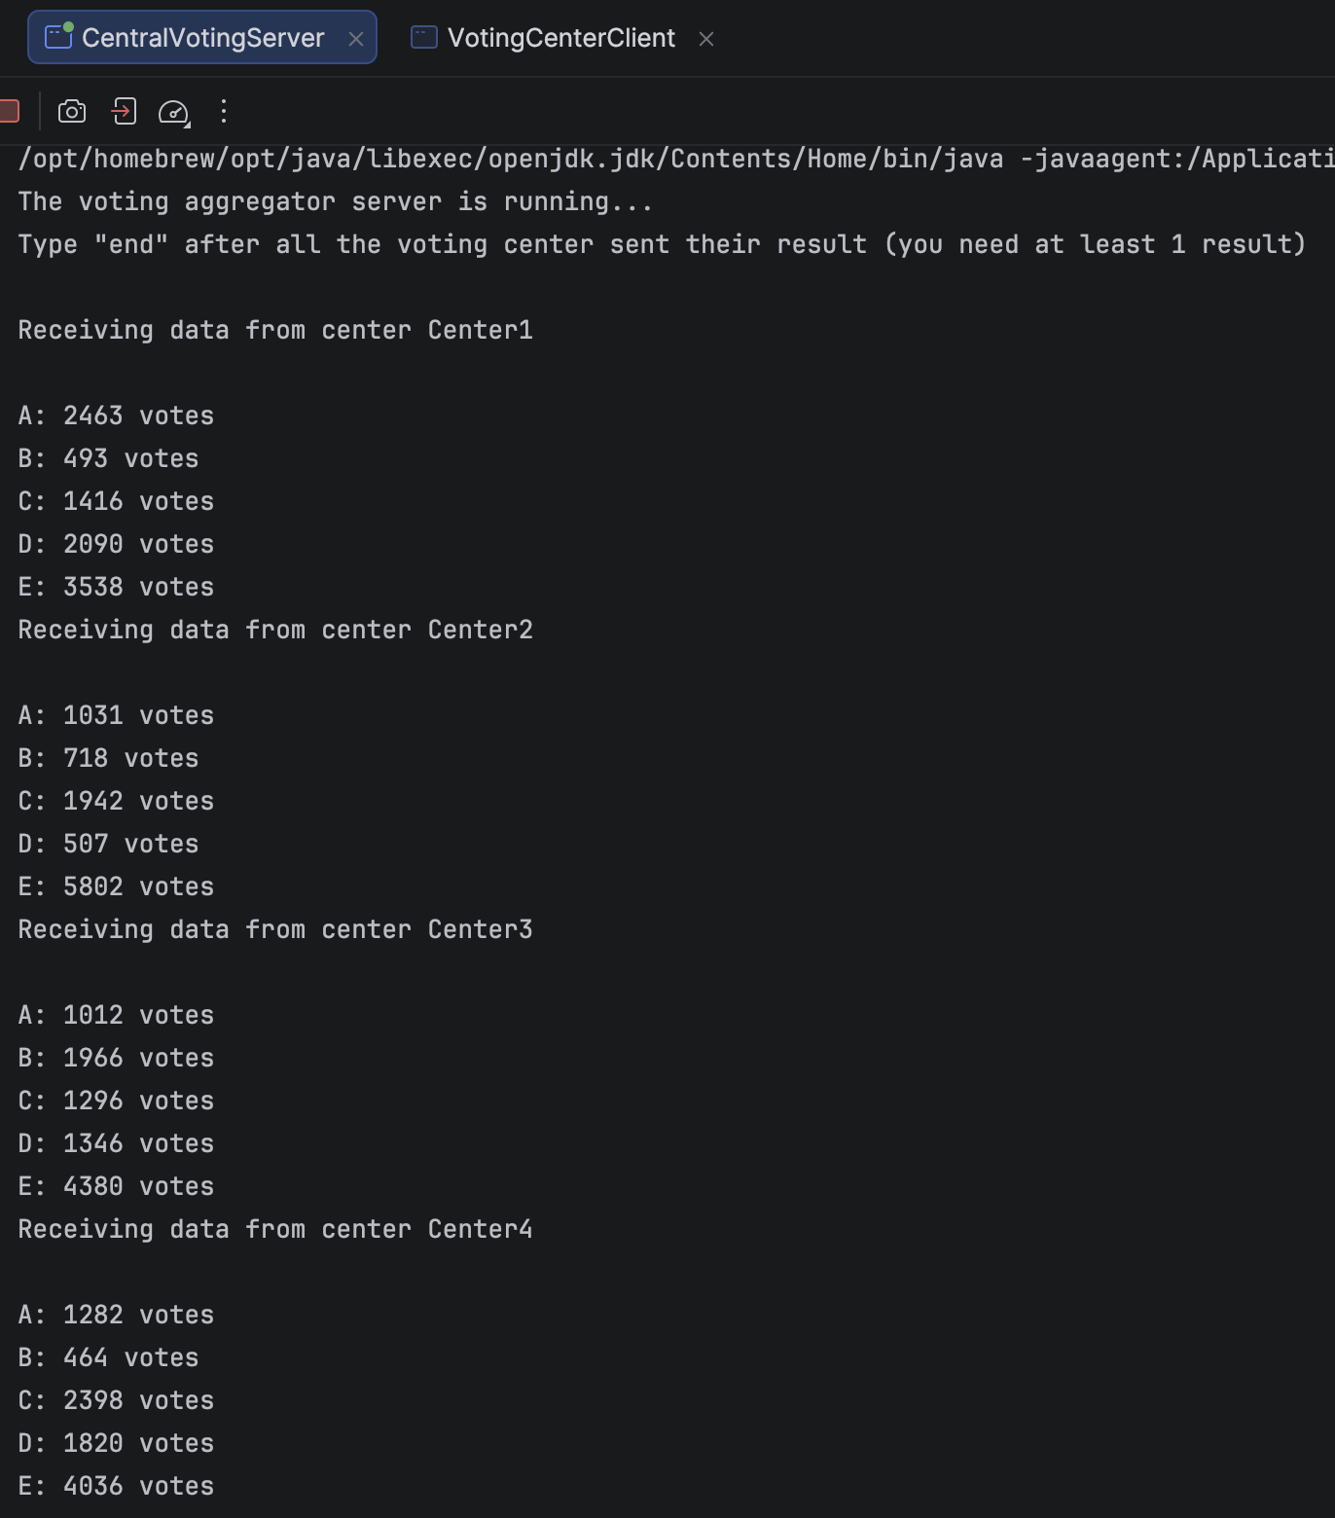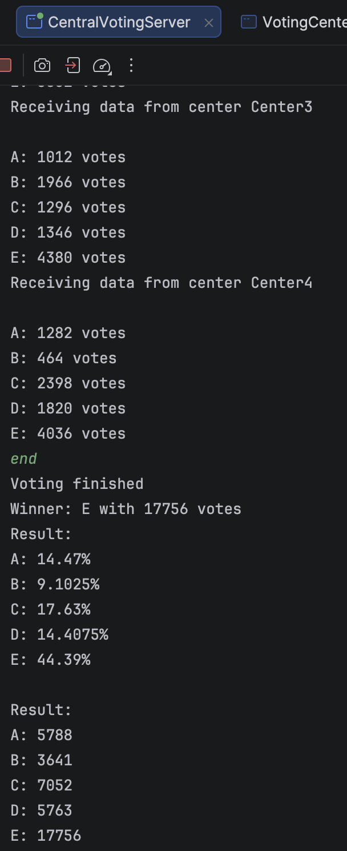
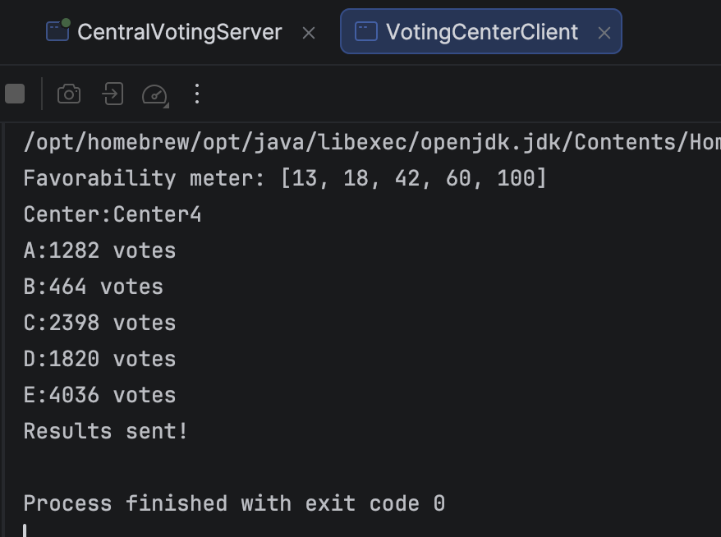
Here is an example of the output for the voting client with the favourability meter, the vote of each party and the center ID.
- Distributed numerical Integration
The integration server is responsible for calling a class to initialize the function, the range and the number of subintervals. This class verifies the input by avoiding inputs where a number isn’t given or when the value of the upper range is less than the lower range. There is also a standard initialization available with ”test” as arguments.
After the initialisation, I wait for 2 clients and assign them the function, the range, the number of subintervals and the name of the method that will be used. Each client is represented by a client manager; the manager can transform and send the function information into readable format for the client After starting 2 threads for the clients, I used a lock to start the threads at the same time. After starting the thread, I send a message to the client that then starts the calculation. When the calculation is finished, the results are sent to the client manager who stores it in a custom class.

The integration client is first calling an IntegrationDoer class, this class takes the data sent by the server and transform it so that those data can be used to compute the result. After transforming the data an IntegrationMethod object is created with the name of the method. After creating the IntegrationMethod the calculations start at the same time as the time counter if the 2 threads are started. After the result is produced, it is sent to the server alongside the duration of execution and the name of the IntegrationMethod.
The integrationMethod class has an abstract function which is overridden by other classes implementing specific integration method and a method to evaluate the value of a function.
To start the threads at the same time I used a synchronized lock and “NotifyAll()” to broadcast the information from the main class of the server. And for the communication mechanisms I used the same as in the previous problem.

The benefit of this design is its maintainability with the strategy pattern for choosing the integration methods and the simplicity of adding new integration methods. But its limitation is the network communication because of the request sent to each client every 0.5 second.
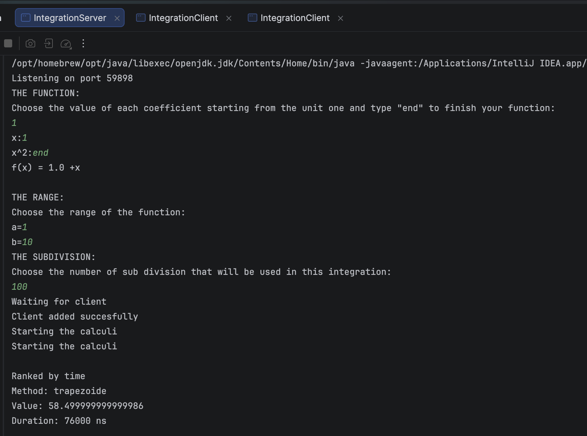
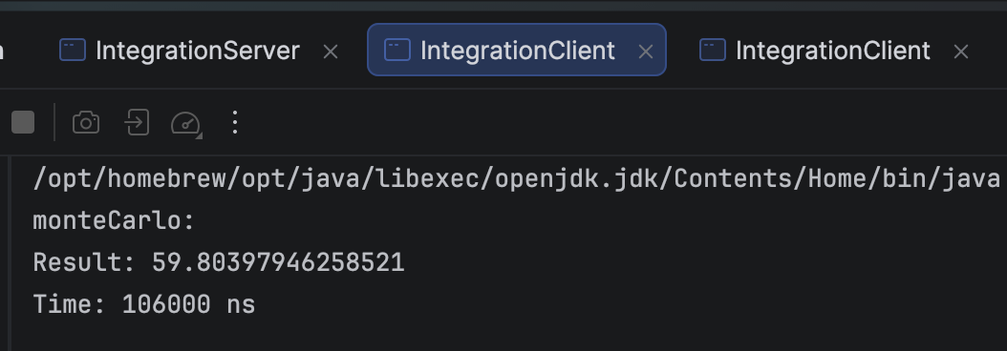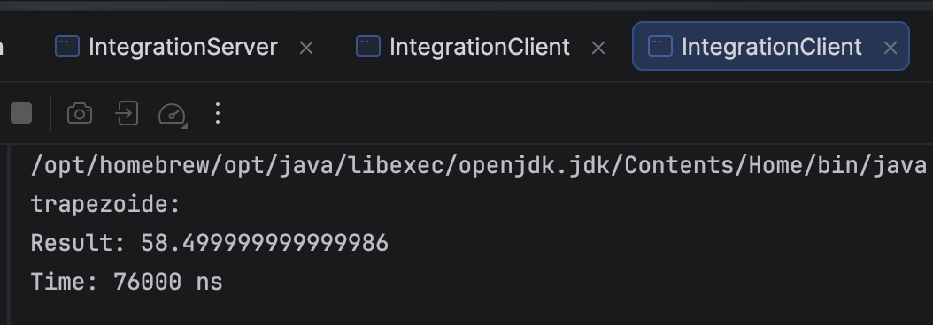
On the previous screenshot we can see the execution on the function f(x)=1+x with a small number of subintervals. We can see that the results are fairly different
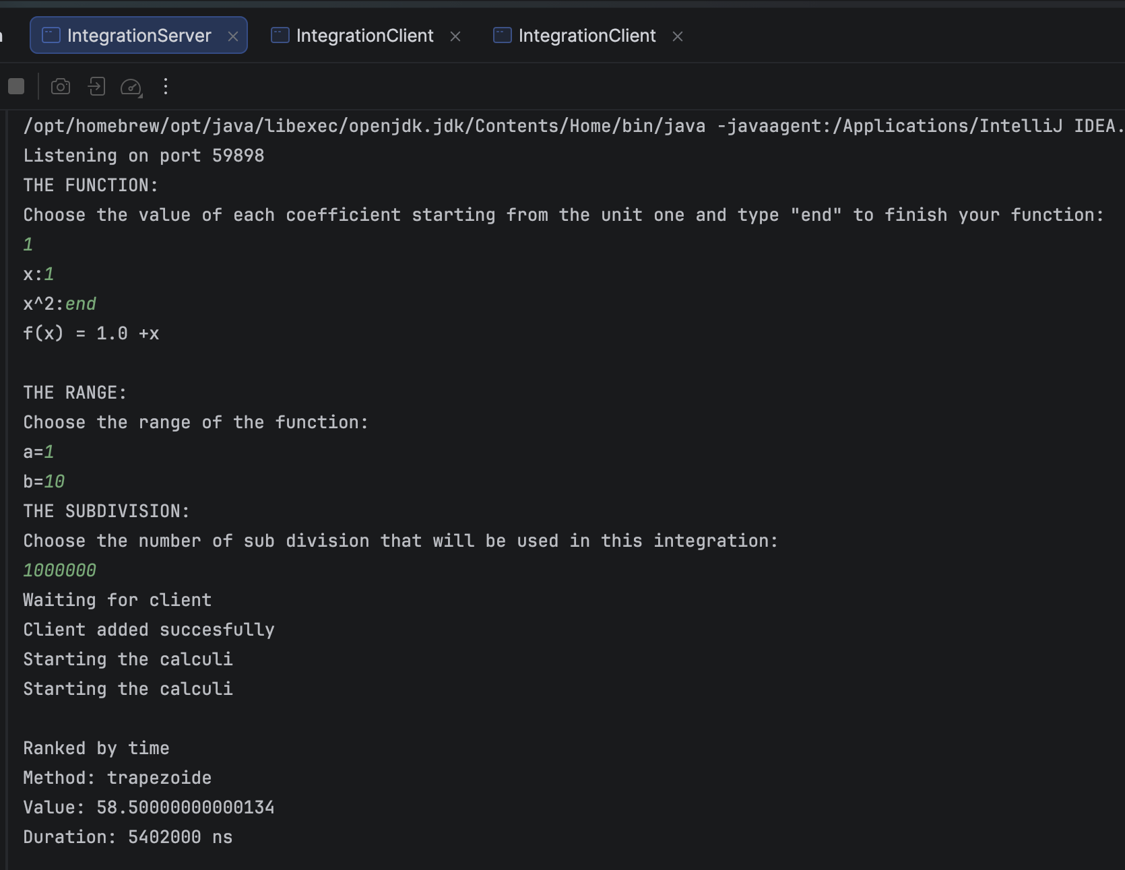
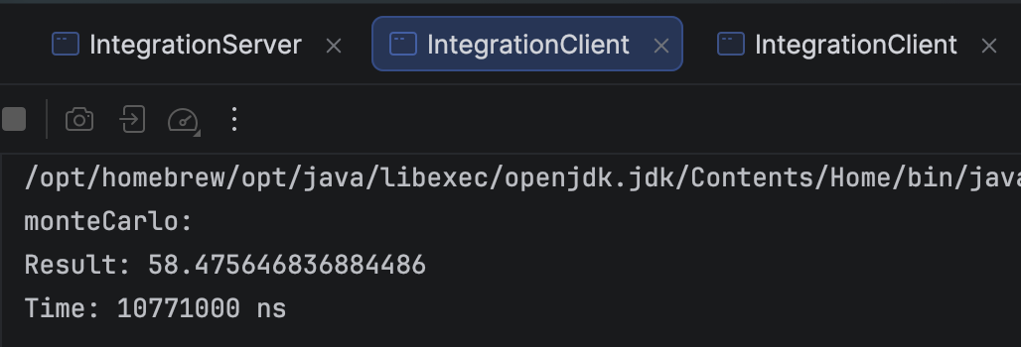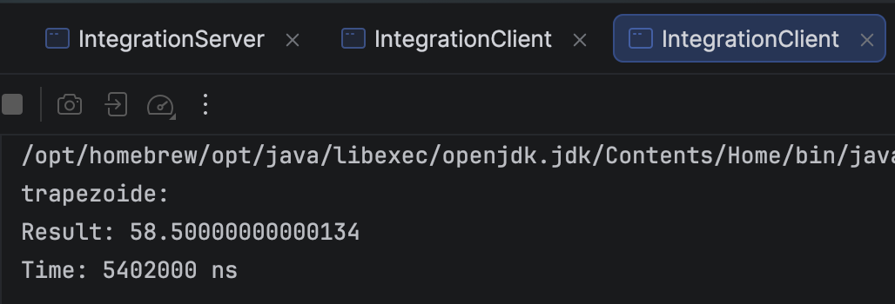
On the previous screenshot we can see the same function but with a lot more of subIntervals so the 2 methods ‘s result are fairly identical.
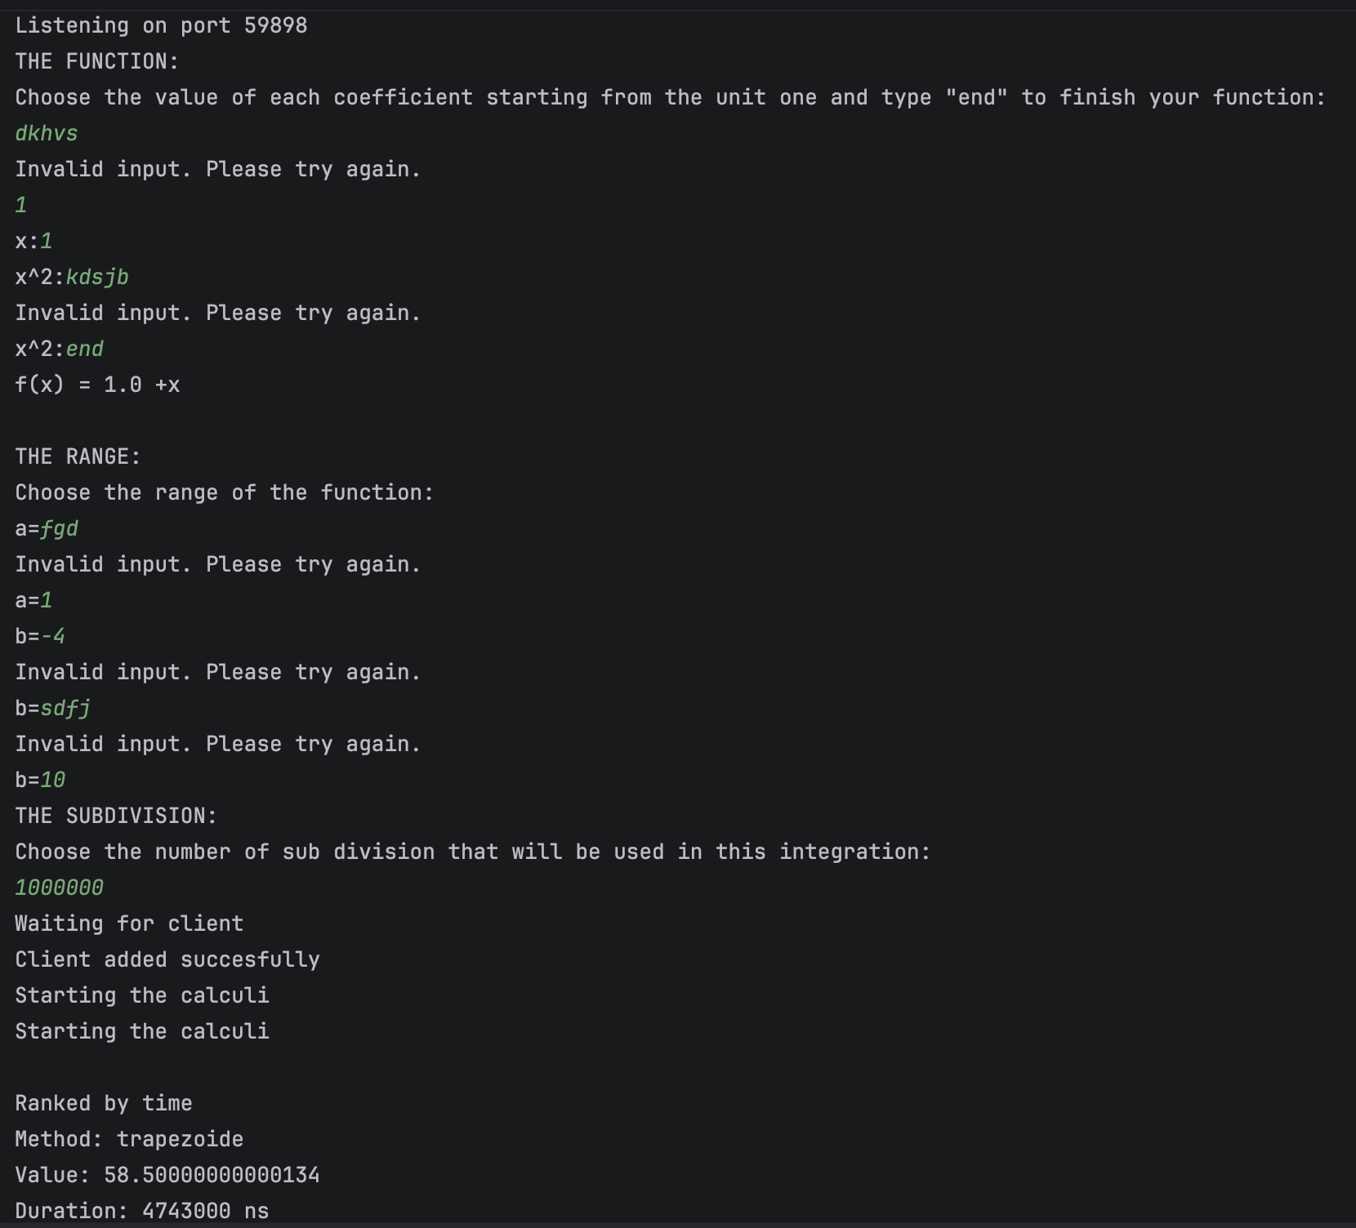
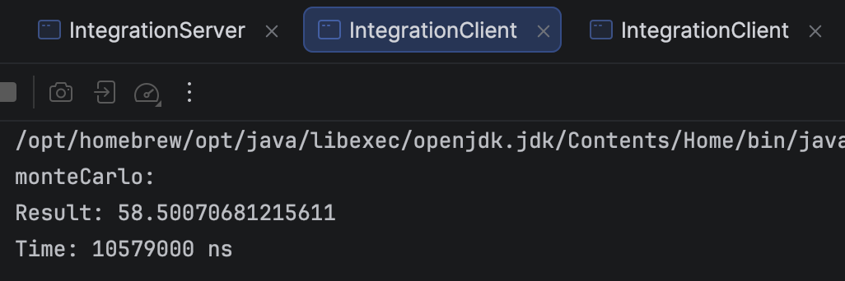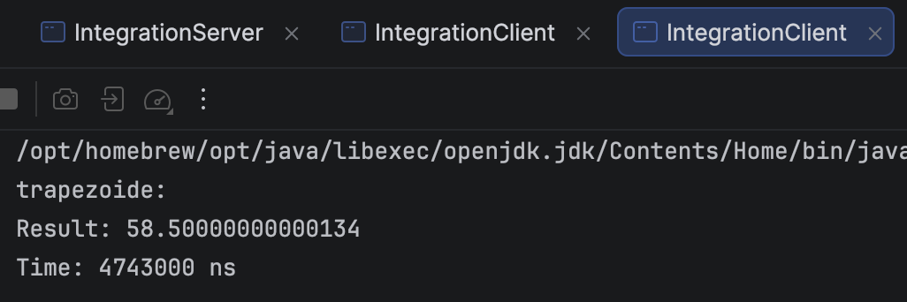
In the previous screenshot we can see how the errors are handled with the same situation as before.
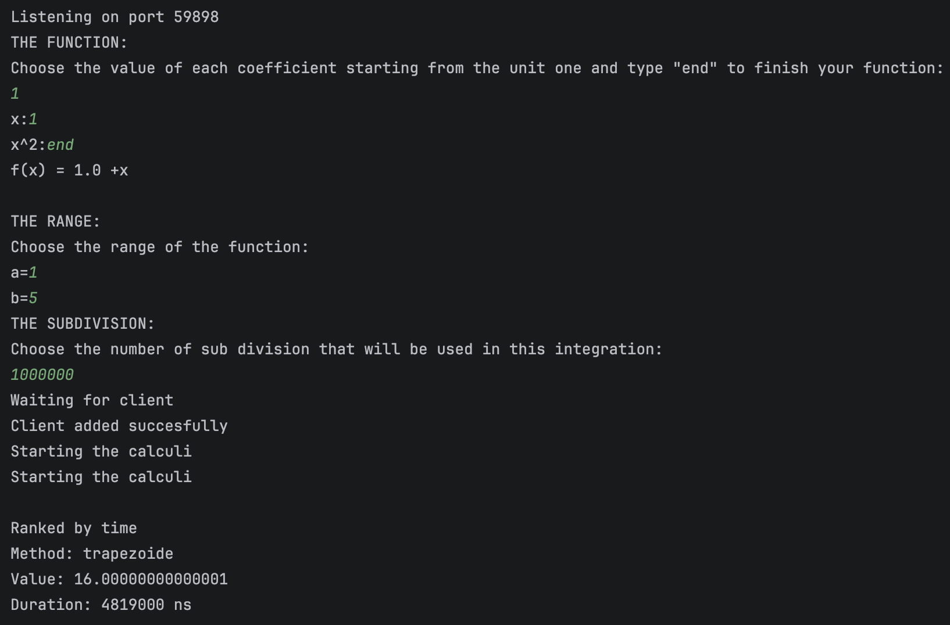
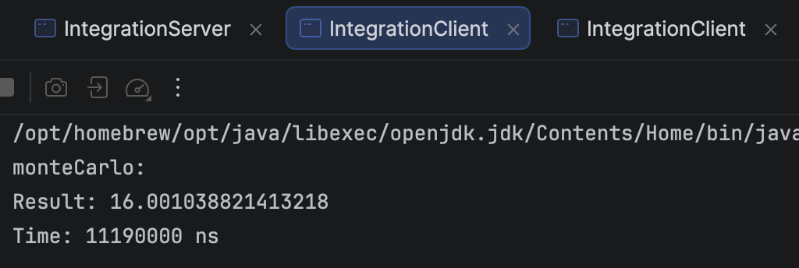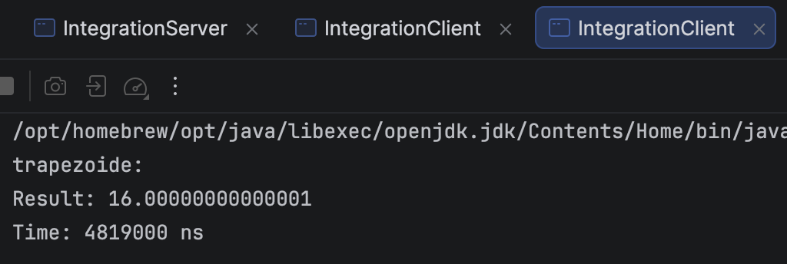
On the previous screenshot we can see the same function with a different range and the same number of subintervals.
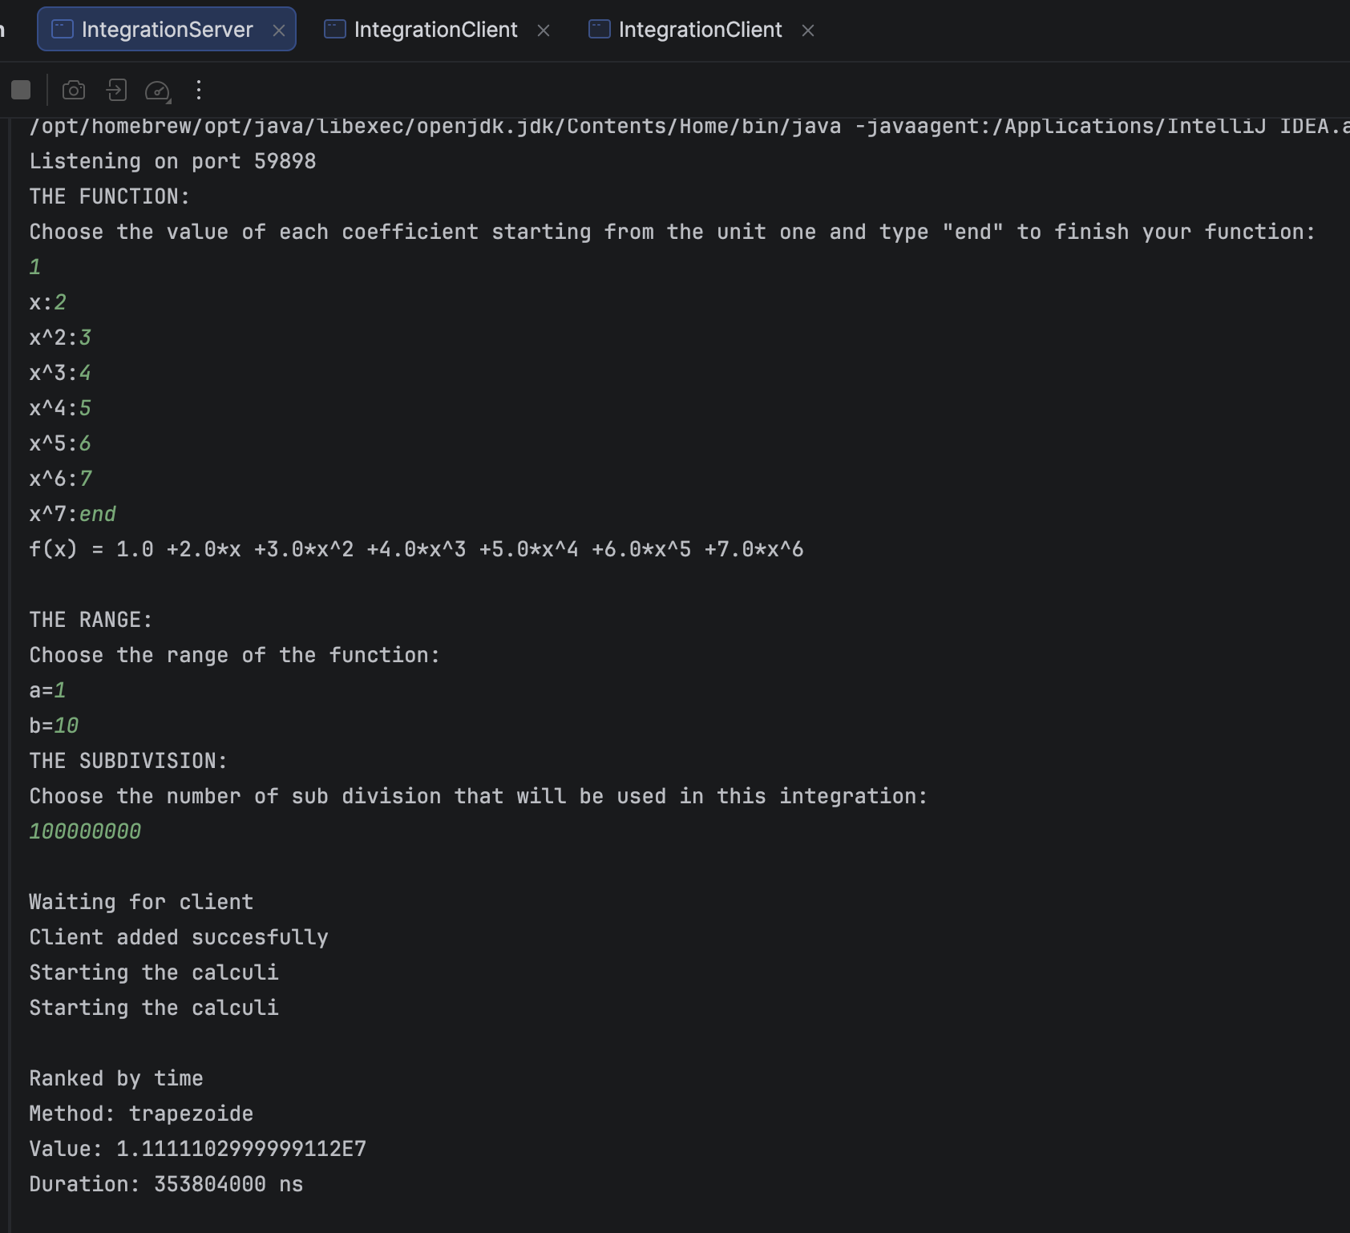
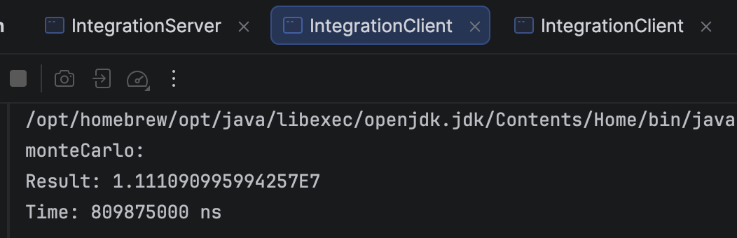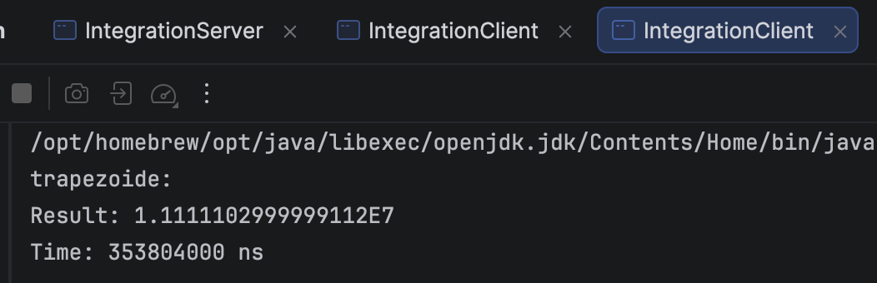
On the previous screenshot we can see another function being integrated.
- Load Balancing

[1]“ConcurrentHashMap (Java Platform SE 8 ).” Accessed: Apr. 14, 2026. [Online]. Available: https://docs.oracle.com/javase/8/docs/api/java/util/concurrent/ConcurrentHashMap.html

