Customer Dataset Analysis
Cleaning, exploration, and findings from the customers-100 dataset

1. Overview
This report documents the cleaning and exploratory analysis of a small customer dataset containing 100 records. The data captures contact details (name, company, phone, email, website) along with geographic location (city, country) and the date each customer subscribed. The analysis below summarizes data quality, distribution across geography, growth over time, and the make-up of email domains and companies represented in the file.

2. Data Cleaning
The cleaning step normalized text fields, parsed dates, validated emails, removed duplicates, and added two derived columns (Subscription Year and Email Domain) for downstream analysis. Each transformation is summarized below:
- Trimmed leading and trailing whitespace on every text column.
- Standardized casing: first name, last name, and city converted to Title Case.
- Parsed Subscription Date as ISO date; any unparseable values are dropped.
- Validated email addresses against a basic pattern (local@domain.tld).
- Removed duplicate rows by Customer Id.
- Added Subscription Year and Email Domain as derived fields.
Outcome: the source file was already well-formed. No duplicates, malformed dates, or invalid emails were detected, so all 100 records carried through cleaning.
Metric | Value
Records loaded | 100
Records after cleaning | 100
Duplicates removed | 0
Invalid dates dropped | 0
Invalid emails flagged | 0
Unique countries | 85
Unique cities | 100
Unique companies | 99
Unique email domains | 98
Subscription date range | 2020-01-13 – 2022-05-26

3. Findings

3.1 Geographic distribution
Customers are spread very thinly across the globe — 100 records map to 85 distinct countries and 100 distinct cities. No single country dominates: the leading country, Solomon Islands, accounts for only 4 customers. This is consistent with a randomly generated or globally seeded sample rather than a real customer book with regional concentration.
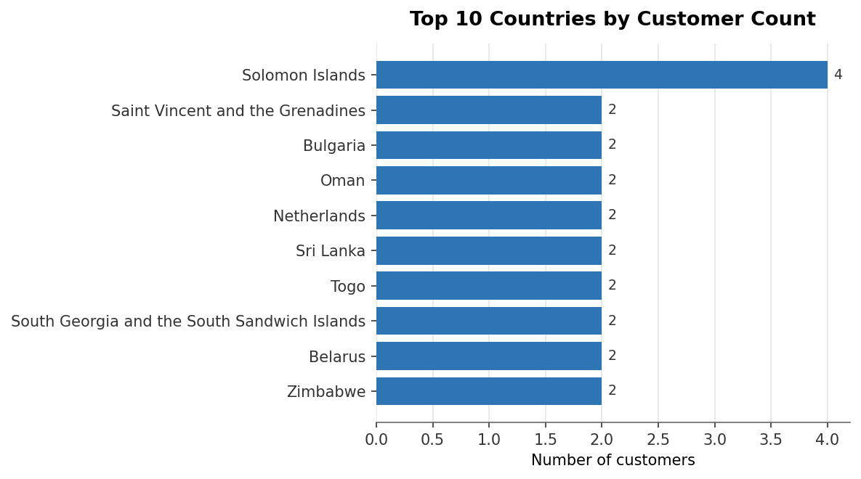
Figure 1 — Top 10 countries by customer count.

3.2 Subscription growth over time
Subscriptions span 2020-01-13 to 2022-05-26. Activity peaked in 2021 with 43 new subscriptions, followed by a sharp drop in the partial year 2022. The 2022 figure reflects only data captured up to 2022-05-26 and should not be read as a year-over-year decline.
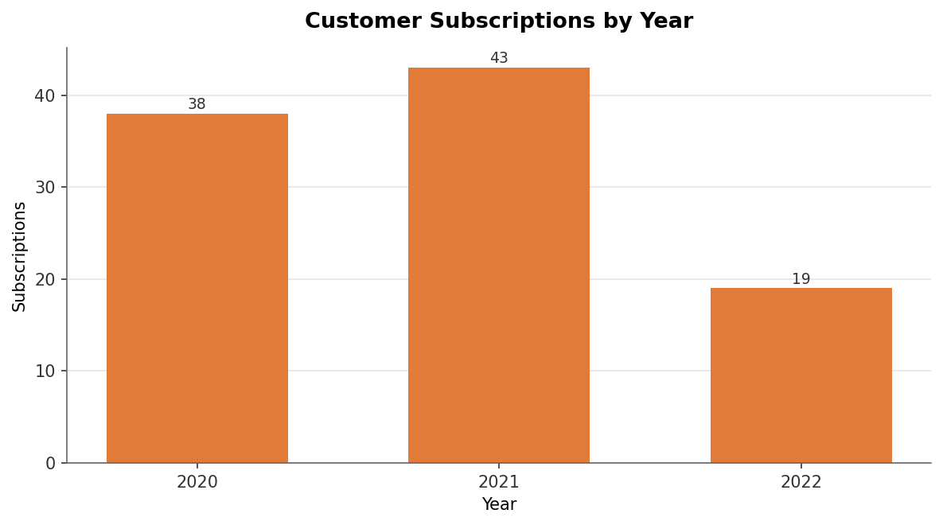
Figure 2 — New subscriptions per calendar year.

3.3 Email domains
Email addresses span 98 distinct domains across 100 customers — essentially one domain per customer. The most common domain, colon.com, appears only 2 times. This suggests customers are individuals using personal or unique addresses rather than employees grouped under a small set of corporate domains.
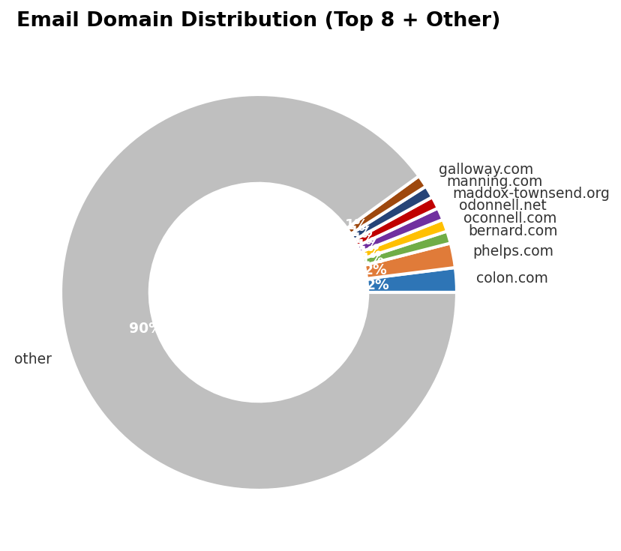
Figure 3 — Share of customers by email domain (top 8 + other).

3.4 Company representation
Among 100 customers there are 99 unique company names — only one duplicated company appears in the dataset. The chart below shows the top companies by customer count; the long tail of one-customer-one-company suggests this is sampled data from many disconnected organizations rather than a concentrated B2B base.
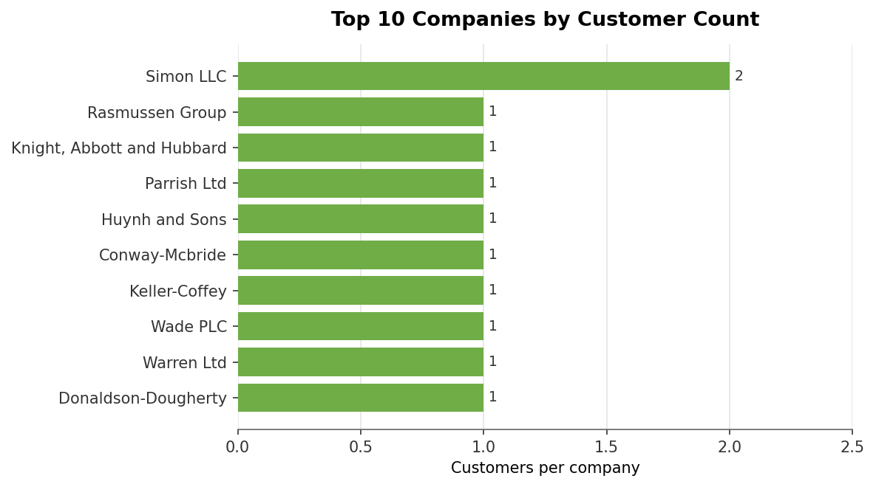
Figure 4 — Top 10 companies by customer count.

4. Conclusions
Three patterns stand out from the cleaned dataset:
- Data quality is high. No structural issues required correction — every record had a parseable date, a syntactically valid email, and a unique Customer Id.
- Distribution is broad and shallow. Customers are spread across most fields with very few repeats — almost every country, city, company, and email domain appears at most once or twice. This is more consistent with a generated sample than a real-world customer book, where you would expect clustering by region and employer.
- Time coverage is short. The subscription window covers roughly 2.5 calendar years (2020-01 to 2022-05), with 2021 the most active year. Any year-over-year comparison should treat 2022 as a partial year.
For further analysis, useful next steps would include enriching country data with regional groupings (continent, GDP tier), bucketing subscription dates into monthly cohorts to surface seasonal patterns, and joining against any available revenue or engagement data to separate active customers from dormant ones.

