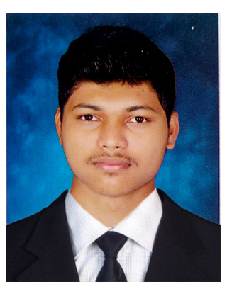 **Amith Rayan Fernandes**

 [St.joseph Villa, neermarga, M](https://maps.app.goo.gl/NmwVDxdWTodgizWe6)angalore - [574219](https://maps.app.goo.gl/NmwVDxdWTodgizWe6)

[](tel://8722277308/) +91 8722277308 / 9844264859

[](mailto:rayanfernandes9@gmail.com) [rayanfernandes9@gmail.com](mailto:rayanfernandes9@gmail.com)

[](https://www.linkedin.com/in/rayanfer) [Linkedin.com/in/rayanfer](https://www.Linkedin.com/in/rayanfer)

To constantly learn new technology and apply them, express my ideas and dedicate myself for betterment of the organization.

|  |  |  |  |  |
| --- | --- | --- | --- | --- |
| **Course** | **Institution** | **University** | **Year of Completion** | **Marks Obtained** |
| B. E | Canara Engineering College, Bantwal | Visvesvaraya Technological University | 2020 | 6.47  (CGPA) |
| P.U.C | Padua P.U College,Nantoor | Karnataka PU Board | 2016 | 84 % |
| SSLC | Navachetana English Medium school, Neermarga | Karnataka Secondary Education Board | 2014 | 91.68 % |

* **Fiabilite Network Solution Private Ltd**

Worked on Embedded IOT, User Interface Design and Cloud Deployment.

* Self-Regulating Intelligence Platform for Greenhouse Farmers (Rs.30,000 funded by Analog Devices )
* Virtual Telepresence Robot
* Automatic vehicle logging and admitting system for residential/factory using number plate recognition ( Raspberry Pi )
* IOT based home security and automation
* Attended workshop on Electronics in Medical applications conducted by IEEE
* Attended workshop on Python and Raspberry Pi conducted by IEEE SB CEC
* NPTEL Certification in Embedded System Design with ARM
* 3rd place in line follower competition conducted by BITS pilani ,Goa Campus 2018.
* 1st place in best designed RC car conducted by St.Joseph Engineering College during TIARA 2017.
* 1st place in Robo Soccer conducted by IEEE SB CEC during International Arduino day 2017.
* 2nd place in project expo(smart IOT home) conducted IEEE SB CEC during International Arduino day 2017.
* Finalists of Anveshan, a national event organized by AnalogDevices during june 2019 in bangalore.
* Participated in HACK-A-THON conducted by IEEE SB CEC during 2019.(worked on Virtual Telepresence Robot)
* Participated in MAKE-A-THON conducted by IEEE SB CEC during November 2016.(worked on live video streaming RC rover)

**Career Objective:**

**Education:**

**Extracurricular Activities:**

**Workshops / Certificates:**

**Internship:**

**Projects:**

**Programming Environment:**

* C and C++
* Python
* Embedded C
* HTML
* CSS
* JavaScript
* Verilog HDL
* MATLAB Code

**Development boards:**

* Arduino UNO, Nano
* STM32 ARM Cortex M3
* Node MCU
* 8051 microcontroller
* Raspberry pi 3b+ ,zero

**Tools and IDEs:**

* Visual Studio Code
* ISE Design Suite – Xilinx
* Arduino IDE
* Proteus Simulation Tool
* Cadence Design Tools
* Keil Development Tool
* IAR Workbench
* Code Composer Studio

**Languages :**

* English
* Hindi
* Kannada
* Tulu

**Interests:**

* IoT
* Programming
* Embedded Systems

**Hobbies:**

* Learning and playing

guitar,keyboard etc

**Technical Skill:**

**Personal Details:**