Homepage UI Improvement Brief
Design direction inspired by BAROQUE Pakistan
Objective: Refine ZARKOONY’s homepage UI to feel more cohesive, premium, and editorial. Use BAROQUE as a visual reference for clean fashion e-commerce presentation, while retaining ZARKOONY’s own bespoke-couture identity.

1. Current homepage review
The current hero image is a strong starting point: it communicates formal couture through rich interiors, detailed garments, and a full-width composition. Keep the campaign image unless a responsive crop or image-quality issue requires adjustment. The main task is to refine the UI around it rather than redesign the entire page.
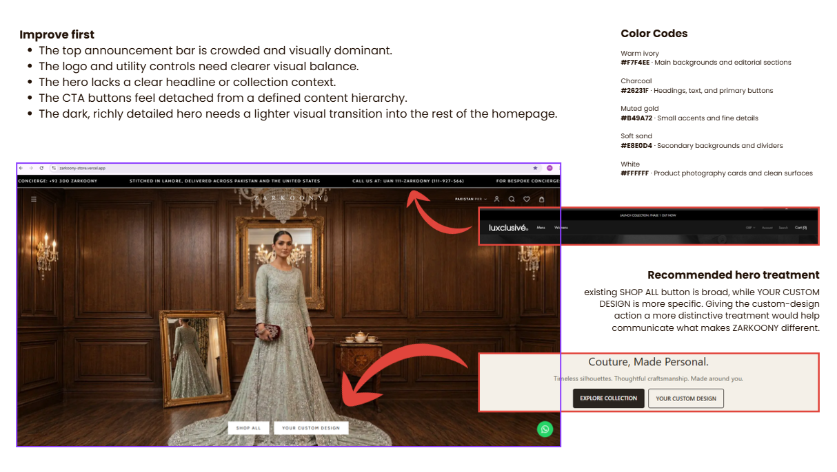
Current annotated UI review supplied by design.

2. Priority changes

P1 — Announcement bar
Reduce the visual weight and density of the top announcement strip. Use one concise message at a time, or rotate messages only if needed. Keep the text vertically centered, consistent in size, and fully visible; fix the clipped text at the right edge. Suggested type size: 10–12 px, medium weight.

P1 — Hero and CTA hierarchy
Keep the existing hero image and overall full-width treatment. Establish a clear hierarchy between the two CTAs: make “Explore Collection” the primary action and “Your Custom Design” the secondary action, or reverse this only if custom design is the primary business goal. Keep button heights, padding, and alignment consistent. Avoid adding a large text block if it obscures the garment or makes the hero crowded.

P1 — Header balance
Keep the logo centered and the utility controls aligned on a consistent horizontal line. Standardize icon size, stroke weight, and spacing. Keep the currency selector visually secondary. Check that the logo and icons remain legible over both dark and light campaign images.

P1 — Typography system
Use a consistent two-font system: Cormorant Garamond for editorial/display headings and Manrope for body copy, product details, buttons, and utility UI. Suggested starting weights: headings 400; body 400; UI/buttons 500–600. Confirm fonts load correctly and test the hierarchy at desktop and mobile sizes.

P2 — Color system
Use the following restrained palette consistently. Keep gold as a minor accent rather than a dominant UI color; let product and campaign photography provide most of the visual richness.

P2 — Section rhythm and product cards
Below the hero, create clearer separation between collections, new arrivals, and craftsmanship content. Use consistent product-image ratios, aligned card text, readable prices, and generous whitespace. Alternate editorial image layouts where useful rather than repeating the same section composition throughout.

P2 — Responsive behavior
Review desktop, tablet, and mobile separately. Ensure the announcement text does not clip, the hero subject remains visible, CTA buttons fit comfortably, heading wraps are intentional, and product cards maintain consistent proportions.

3. Proposed color tokens
Token | Hex | Use
Warm ivory | #F7F4EE | Main backgrounds and editorial sections
Charcoal | #26231F | Headings, body text, primary buttons
Muted gold | #B49A72 | Small accents and fine details
Soft sand | #E8E0D4 | Secondary surfaces and dividers
White | #FFFFFF | Clean product-card surfaces

4. Typography and sizing guidance
Element | Suggested desktop size | Weight
Hero heading | 48–64 px | Cormorant Garamond 400
Section headings | 30–40 px | Cormorant Garamond 400
Product titles | 13–15 px | Manrope 500
Body copy | 14–16 px | Manrope 400
Buttons | 11–12 px | Manrope 500
Announcement bar | 10–12 px | Manrope 500
These are starting values, not fixed requirements. Tune them to the existing component system, accessibility, and responsive breakpoints. Avoid excessive letter spacing on large headings; reserve it for small uppercase labels.

5. Suggested homepage content order
- 01. Hero campaign — Existing campaign image, concise headline if needed, clear CTA hierarchy.
- 02. Featured collections — Two or three distinct collection features with strong imagery.
- 03. New arrivals — Consistent product grid and clean product information.
- 04. The art of bespoke — Craftsmanship image plus concise explanation of made-to-order value.
- 05. Formalwear editorial — A second campaign-style feature with a different composition.
- 06. Bespoke benefits — Measurements, tailoring, and alteration information in a compact layout.
- 07. Newsletter and footer — A clean closing section without repeated or unnecessary content.

6. What to avoid
- Do not replace the hero image solely to imitate BAROQUE.
- Do not add decorative borders, shadows, gradients, or gold accents without a clear purpose.
- Do not make both hero CTAs equally dominant; establish a primary and secondary action.
- Do not repeat the same collection layout in every section.
- Do not sacrifice mobile image composition or text readability for the desktop design.

7. Definition of done
- Announcement bar content is fully visible and visually restrained.
- Header logo and utility icons align consistently.
- Hero CTAs have clear hierarchy and consistent dimensions.
- Typography and color tokens are applied consistently across the homepage.
- Product cards use consistent image ratios and aligned text.
- Desktop and mobile layouts have been checked for clipping, wrapping, spacing, and readability.

Design intent: Aim for a clean, editorial luxury experience inspired by BAROQUE’s visual discipline, while keeping ZARKOONY’s bespoke-couture character distinctive.

