Project Pitch

E D U C A T I O N A L C H I L D R E N ’ S G A M E

Jeremiah Onunkwo Rayansh Chowatia Abrianna Primavera
Aubin Chriss Izere ENSE 281
1

P R O J E C T I D E A / B A C K G R O U N D

T H E P R O B L E M O U R B E L I E F

- Environmental education often feels passive and overwhelming

- Learners struggle to connect with ecosystems they’ve never explored
- People care more when they discover, not when they’re just told
- Curiosity-driven learning builds stronger understanding

- Low engagement leads to low retention and low conservation awareness

2

P R O D U C T & O P P O R T U N I T Y

OUR APPROACH
  - Interactive exploration of a single ecosystem
  - Sticker-book style discovery of animals and resources
  - Short, digestible conservation facts
THE PRODUCT
- Ecosystem Educational Discovery Application
- Web-based and easy to access
- Designed for classrooms and independent learners

WHY THIS WORKS
  - Encourages curiosity and self-paced learning
  - Makes complex systems easier to understand

3
THE OPPORTUNITY
- Growing demand for engaging digital learning tools
- Fits modern attention spans and learning styles
- Builds early conservation awareness



R E A S O N S

To educate about conservation and the environment To create an engaging interactive experience

4

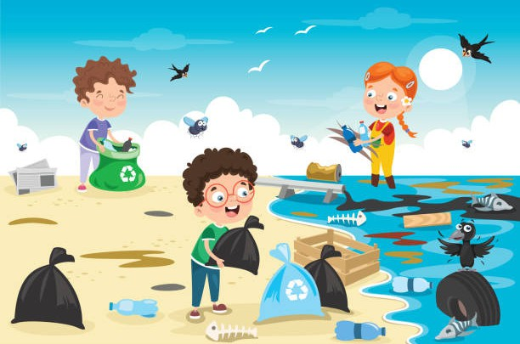
I M P A C T

  - Now, kids learn conservation mostly through passive info (reading/videos)
  - Our project will create an interactive, choice-based way to learn conservation through play
  - Build early awareness of freshwater wildlife and threats
  - Encourage responsible choices (cleaning pollution, sustainable fishing)
  - Make conservation of Saskatchewan ecosystems feel local and achievable

5

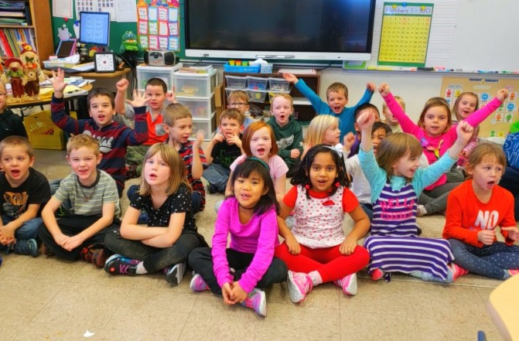
W H O ?

  - Elementary-aged children (ages 5–9)
  - Primary setting: Saskatchewan classrooms and homes
  - Learn through interactive play and exploration
  - Collect animals in a sticker book to identify them
  - See how choices (cleaning trash, fishing decisions) affect the ecosystem and animal populations

6

E N V I S I O N E D P R O J E C T

- Simple 2D Game
- Designed for elementary school aged children
- Teaches about freshwater ecosystems and
animal conservation through the act of discovery

7

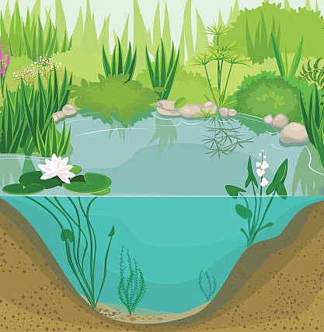
E N V I S I O N E D P R O J E C T

    - Background: Section view of a freshwater ecosystem

8

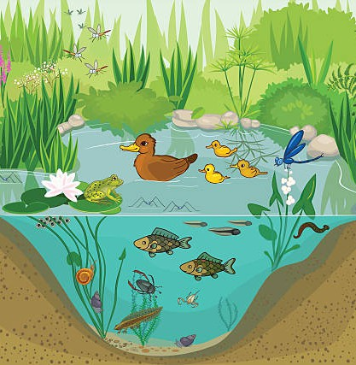
E N V I S I O N E D P R O J E C T

    - Background: Section view of a freshwater ecosystem
    - Animals will populate the area

9

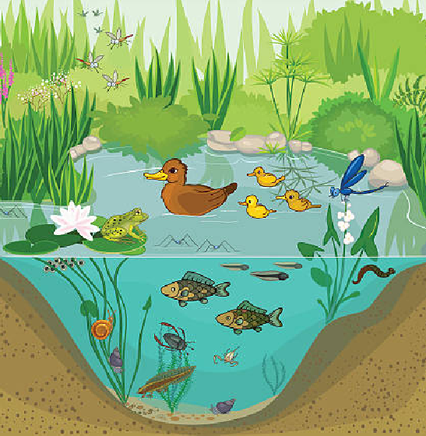
E N V I S I O N E D P R O J E C T

    - Background: Section view of a freshwater ecosystem
    - Animals will populate the area
    - Once clicked, the animal will be added to the user’s sticker book

10



E N V I S I O N E D P R O J E C T

    - Background: Section view of a freshwater ecosystem
    - Animals will populate the area
    - Once clicked, the animal will be added to the user’s sticker book
    - Sticker book: will only contain the name and outline of an animal until it is discovered.

11

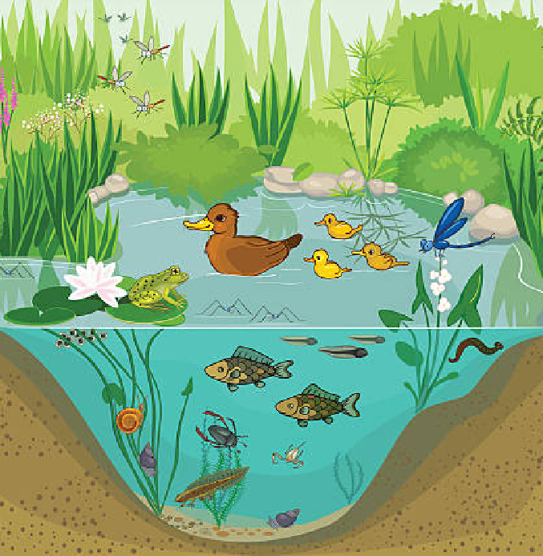
E N V I S I O N E D P R O J E C T

    - Background: Section view of a freshwater ecosystem
    - Animals will populate the area
    - Once clicked, the animal will be added to the user’s sticker book
    - Sticker book: will only contain the name and outline of an animal until it is discovered.
    - Events that affect animal populations

12

C O N S T R A I N T S A N D L I M I T A T I O N S

- Inexperience
  - In creating games
  - In visual art
- Lack a great understanding of freshwater ecosystems
- Knowledge and skills of our audience
- Chosen programming environment
- Model View Controller (MVC) architecture
- Domain-driven design
- Limited time

13

Thank you!

Jeremiah Onunkwo Rayansh Chowatia Abrianna Primavera
Aubin Chriss Izere ENSE 281
14

I M A G E R E S O U R C E S

- Empty ecosystem: https://www.istockphoto.com/vector/pond-gm491148062-75600195
- Full ecosystem: https://www.istockphoto.com/vector/at-the-pond-gm491135038-75593673
- https://discoverweyburn.com/articles/what-is-regional-kids-first-offering-se-sask-communities
- https://www.istockphoto.com/illustrations/cartoon-of-water-pollution-for-kids

15

