Edge-Intelligence
LAB_Excercise-1

Name: R. Amarnath
Roll No: 25MML0051

TASKS -
1. Identify Jupyter Notebook
2. Open Jupyter Notebook
3. Choose a Data format
4. Choose a Dataset
5. Load the Dataset

Step-1: installing and importing the required packages
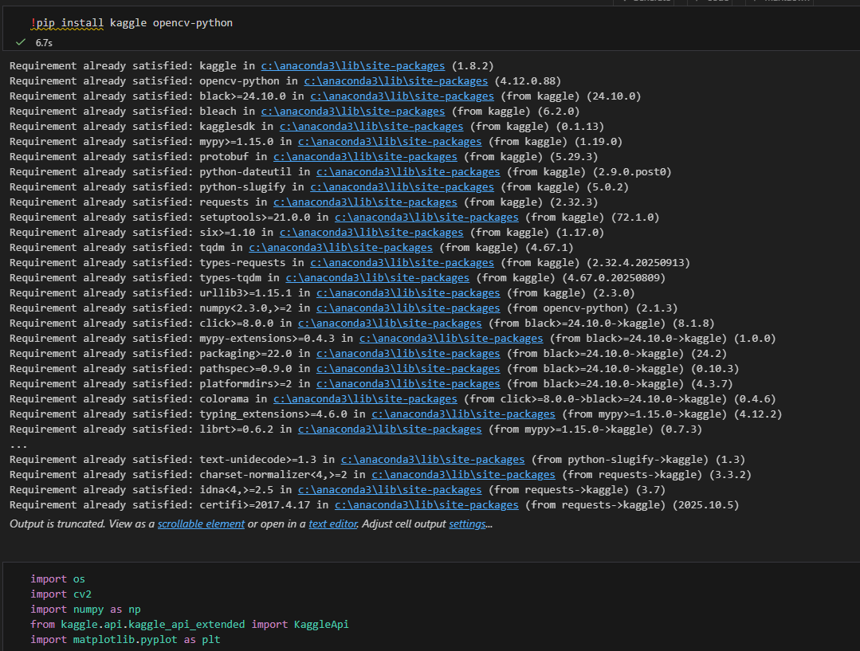
Step-2: loading the dataset using the Kaggle api
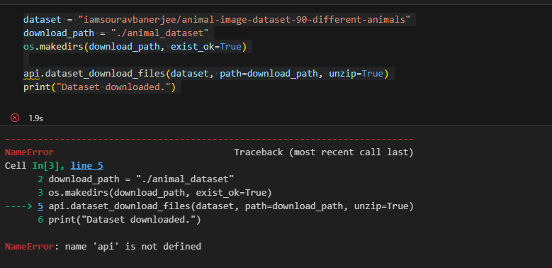
This error is because of the api authentication from the Kaggle to get access from the authorized person. The correct code is :
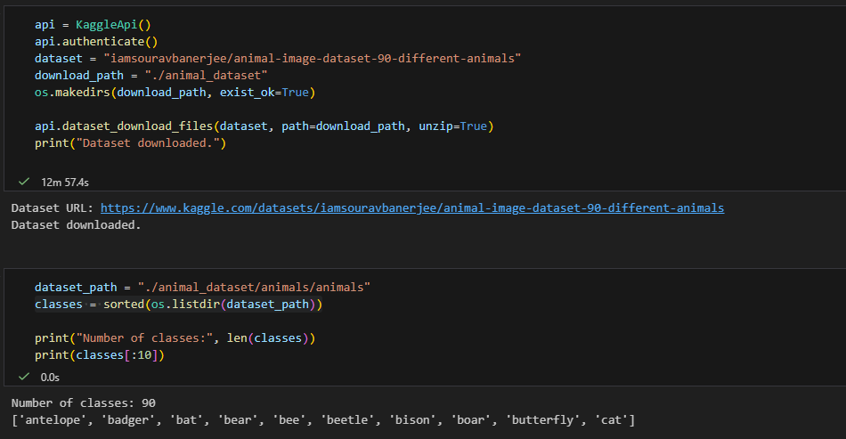
This will show the first 10 animal folders in the dataset in the sorted order.

Step-3: Visualize the images from different folders or the different animals
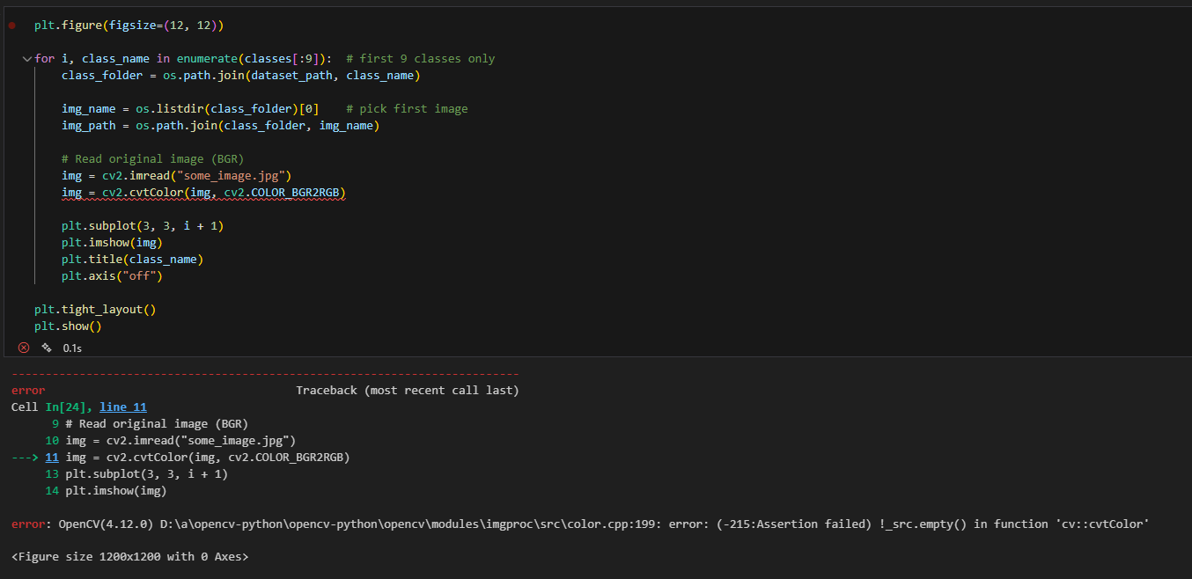
The error shows that
img is EMPTY (None).
OpenCV is saying: “I cannot convert colors because the image does not exist.”

The corrected code is :
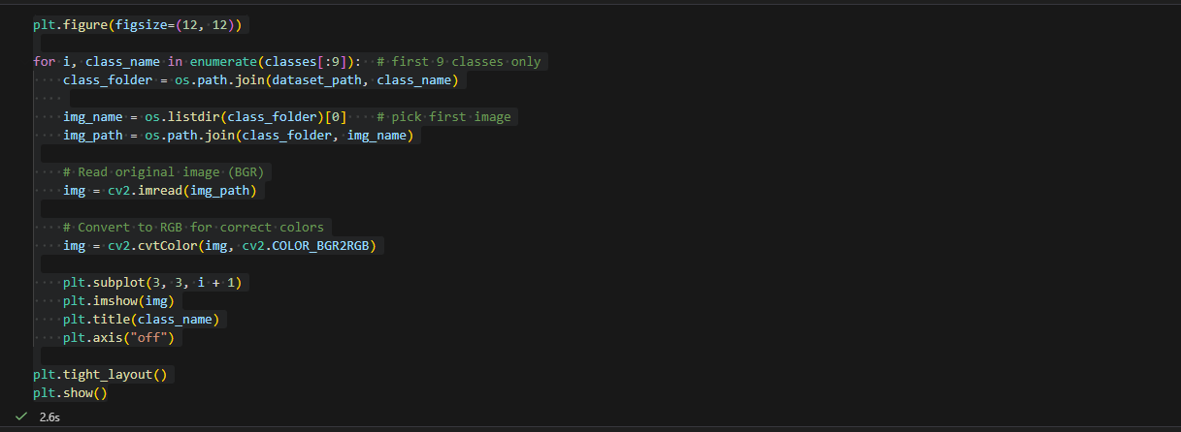 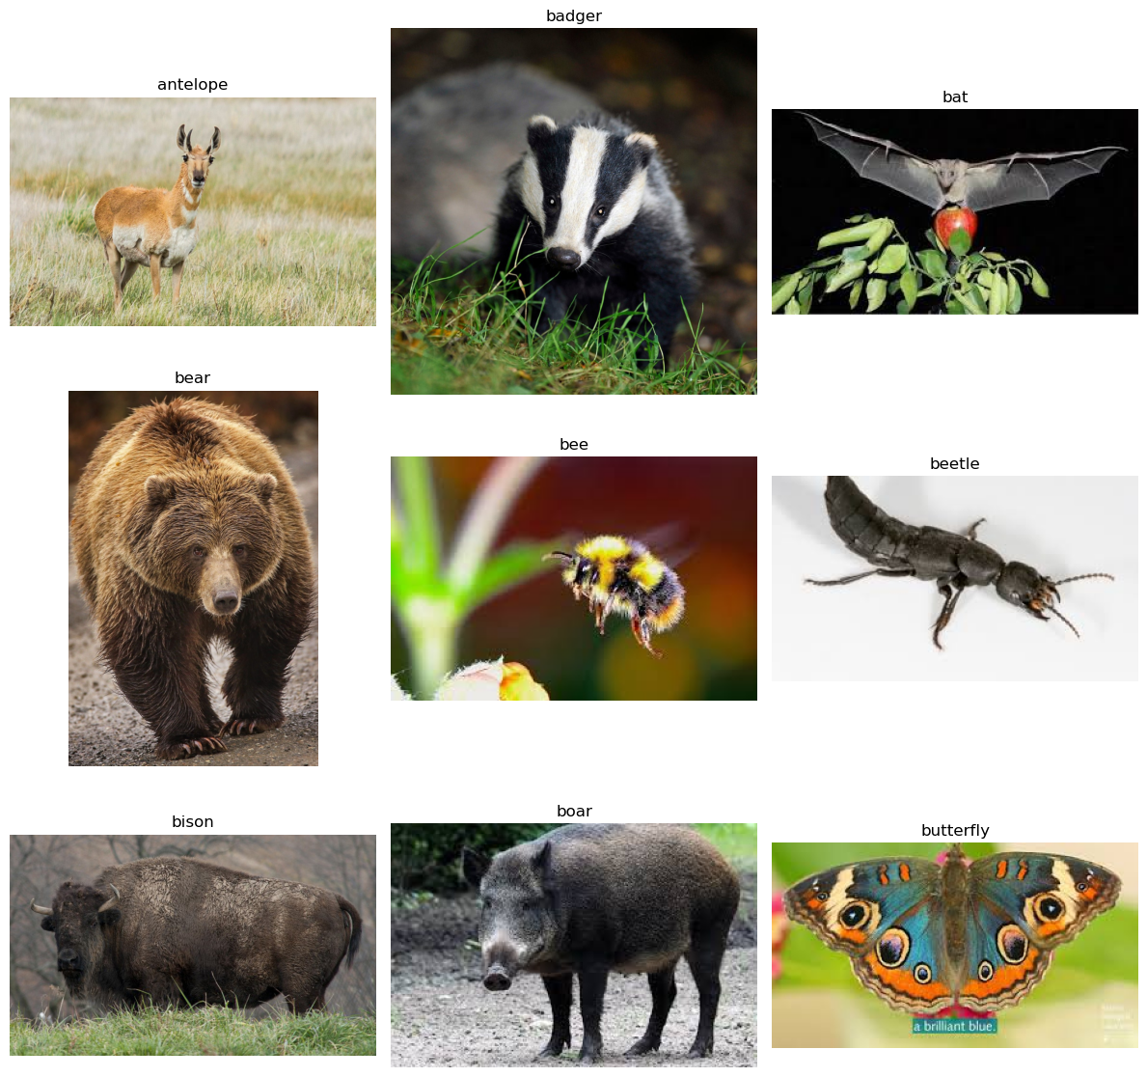

Step-4 :Resizing all the images to (255,255)
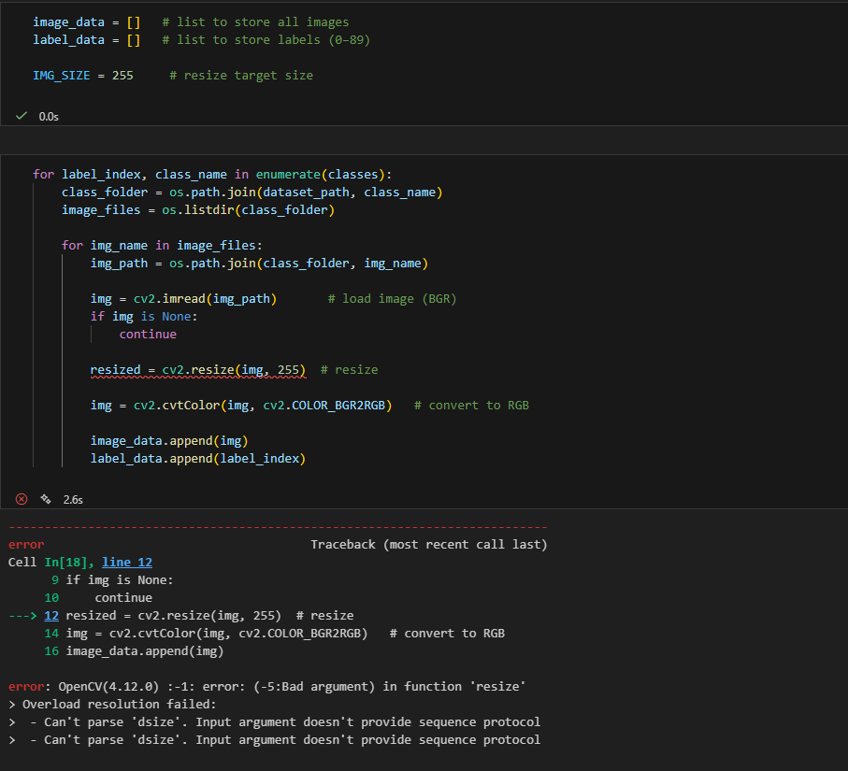
The error occurs because cv2.resize() requires a tuple (width, height), but the code mistakenly passed a single integer 255. OpenCV cannot interpret a single number as a valid image size, so it throws a "Bad argument" error.
The correct code is :
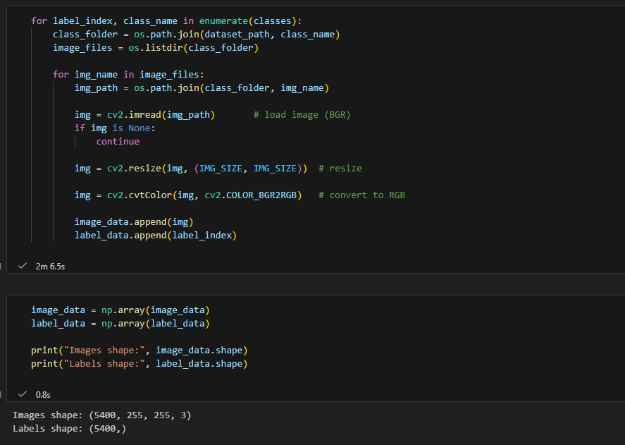
Step-5: Save the reshaped images
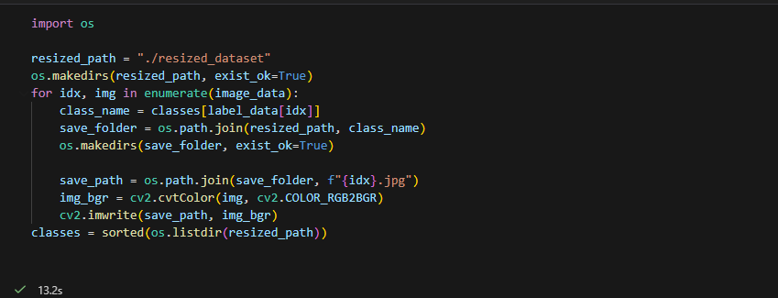

Step-6: After reshaping again check or visualize the images.
