Meme-spiration Site Plan

Al Godoy
WDD 130

Overview

Purpose

Meme-spiration is a meme website focused on combining philosophical ideas with humor. Instead of typical internet memes, the site will present memes that contain deep questions, reflective quotes, or existential thoughts, while still maintaining a humorous tone.
The goal is to create a small digital space for introspection and curiosity, where visitors can laugh but also reflect on ideas about life, purpose, and perspective.

Audience

This site is designed for users who enjoy thought-provoking content, philosophy, and internet culture.
Branding

Website Logo


Style Guide

Color Palette
Primary | Secondary | Accent 1 | Accent 2
#000000 | #121212 | #32CD32 | #FFFFFF

Typography

Heading Font: Slab Serif

Paragraph Font: Sans-Serif

Navigation
Home Philosophy Contribute

Content

Website Structure:

The website will be very simple and minimalistic with three main navigation pages.

Page Breakdown
1. Home Page (Main Page)
The Home page will serve as the central hub for navigating the website’s meme categories rather than displaying memes directly.
Layout
The page will follow the site’s color palette:
- Primary background: #000000 (black)
- Secondary sections: #121212 (dark gray)
- Accent color for links and highlights: #32CD32 (lime green)
- Text color: #FFFFFF (white)
Intro Text
At the top of the page there will be a short sentence introducing the theme of the website.
Example:
“Memes for people who think too much.”
This line sets the tone for the combination of philosophy and internet humor.
Meme Category Navigation
Instead of showing memes immediately, the Home page will present a list of meme categories that users can choose from.
These category links will be displayed in the accent color (#32CD32) to make them stand out as interactive elements.
Example categories include:
- Existential Memes
- Theo Memes
- Overthinking Memes
- Absurd Memes
When a user clicks one of these links, the page will scroll down to the corresponding meme section on the same page.
Meme Sections
Further down the page, each category will have its own section containing several memes related to that theme.
Each meme will include:
- A meme image
- A short caption or philosophical quote
This structure keeps the homepage simple while allowing users to quickly navigate to the type of memes they want to see.

2. Philosophy Page (About the Website)

This page explains the purpose of Meme-spiration.

Content

It should include short sections answering:

Why memes?

Why philosophy?

Why combine them?

The tone should feel thoughtful but slightly humorous, explaining that the site exists to mix deep thinking with internet culture.

Use the same color palette and typography as the rest of the site so the design stays consistent.

3. Contribute Page (Fake Submission Form)

This page will simulate a meme submission page.

It should include a simple form layout with the following fields:

Name

Email

Meme Title

Philosophical Quote

Upload Meme Image

There should also be a Submit button styled with the accent color #32CD32.

The form does not need real functionality. When the user clicks submit, it can simply show a message such as:

“Thank you for contributing to Meme-spiration.”
Now, you may be asking, where are the images? Let's make it fun, make your own :p

Wireframes


For home:

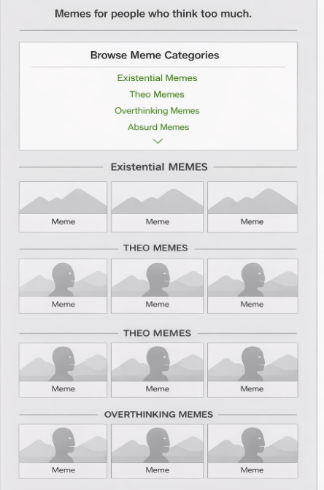
Philosophy Home Contribute

