**TASK A**

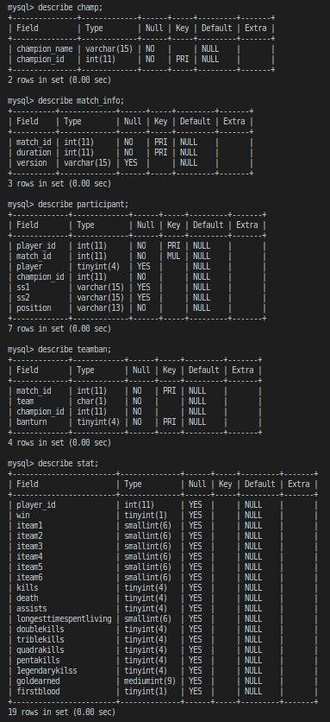

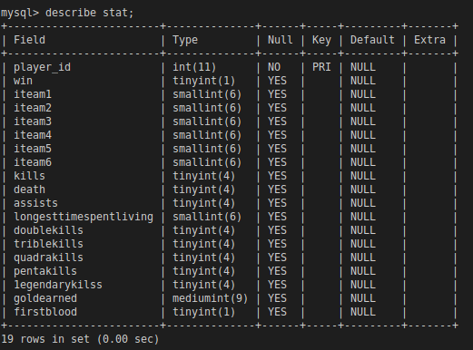

1. What the difference between type “char” and type “varchar”?

Char data type is fixed length data type. For example, if you declare **CHAR (10)**, then it will always take 10 bytes whether you are storing 1 character or 10 character in this variable or column. But if we declared **VARCHAR(10)** data type, it will take the number of bytes equal to the number of characters stored in this column.(not fixed length)

1. Type “boolean” would be stored as which type in MySQL?

Mysql doesn’t have Boolean type built in, thus it stored Boolean type as tinyint(1).

1. How many bytes it should take for “tinyint”, “smallint”, “mediumint”, “int”? (e.g. 8 bytes for “bigint”) And what’s the range they can express? (e.g. from -1000 to 1000)

Tinyiny : 1 bytes

Smallint : 2 bytes

Mediumint: 3 bytes

Int: 4 bytes

1. What do you think about this table schema? If you can change this table architecture, how would you modify it and why?

I think this table is very good , however, I think it is very difficult to search for enemy from each player_id in table stat,so if I can change the table,I would add attribute enemy_player_id, enemy_average_gold and so on.

**TASK B**

**1.**

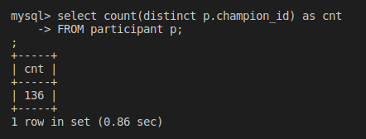

**2.**

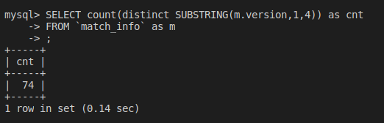

**3.**

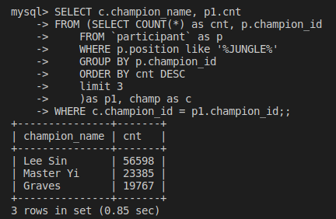

**4.**

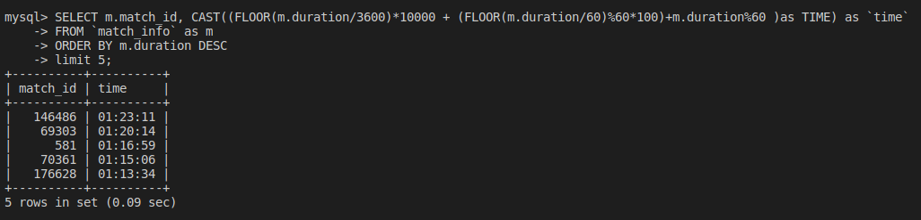

**5.**

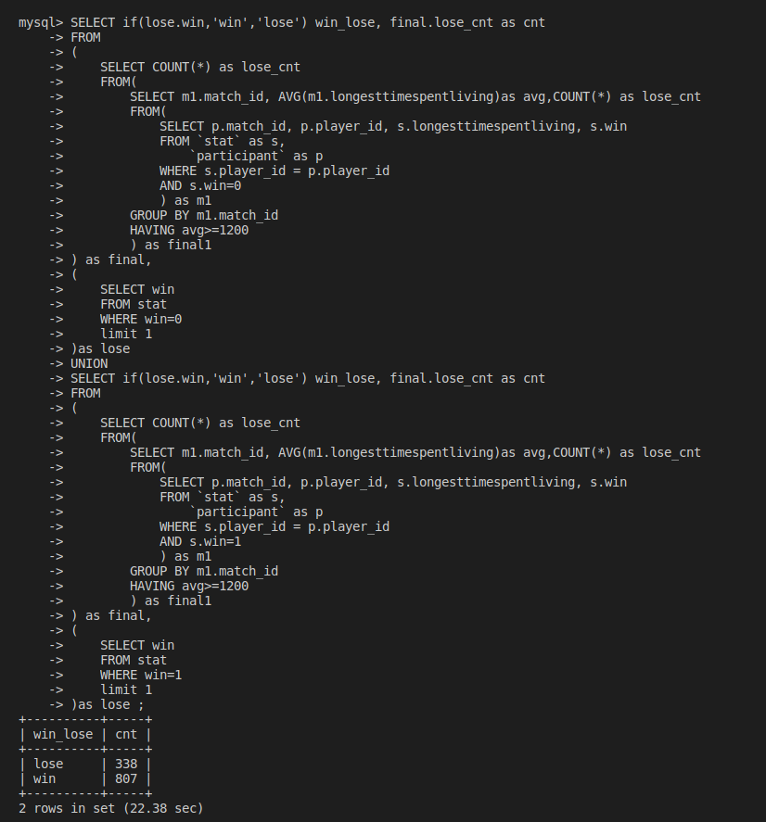

**6.**

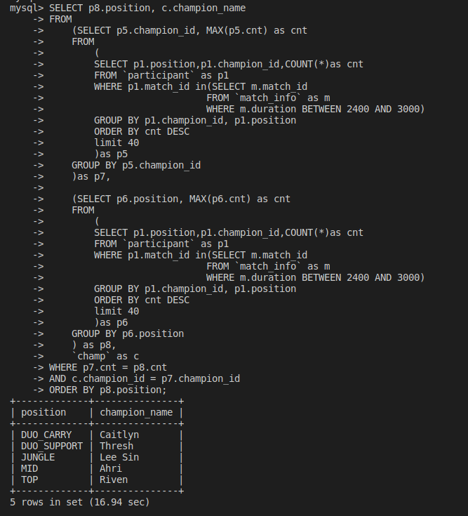

**7.**

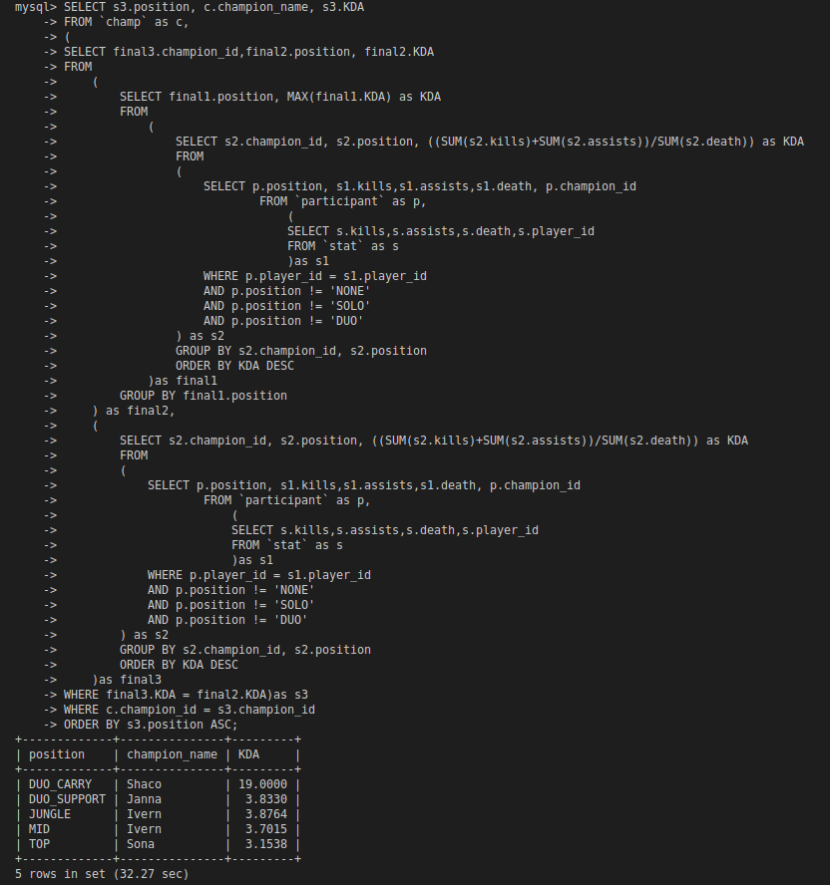

**8.**

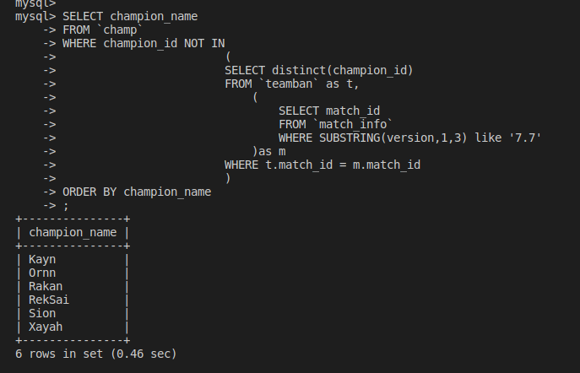

**9.**

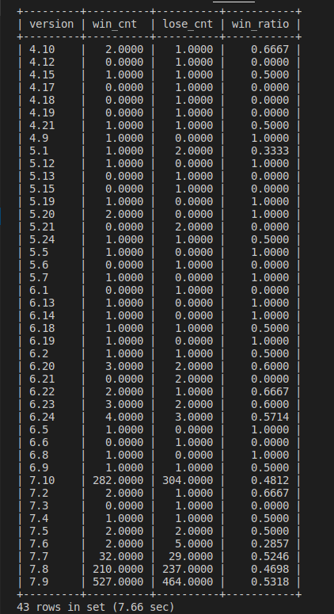

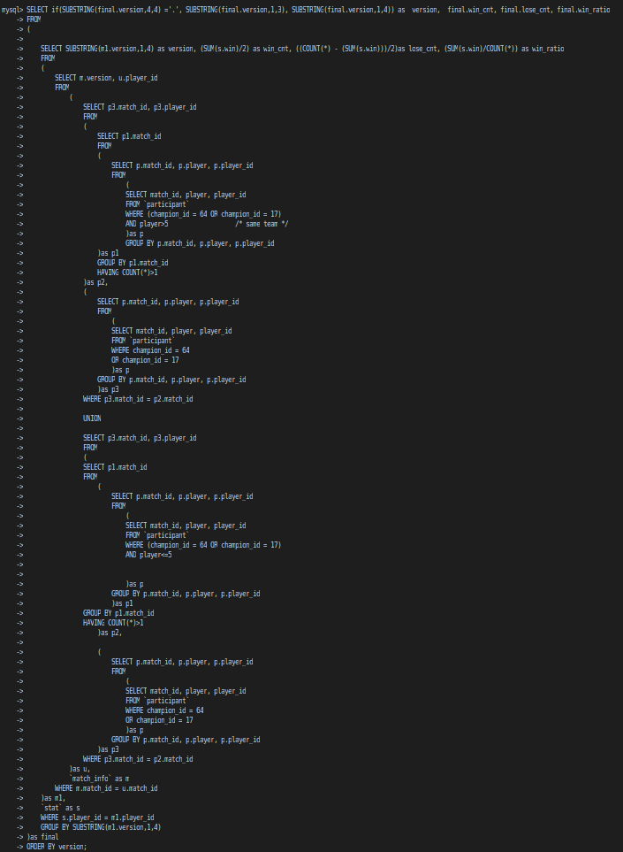

**10.**

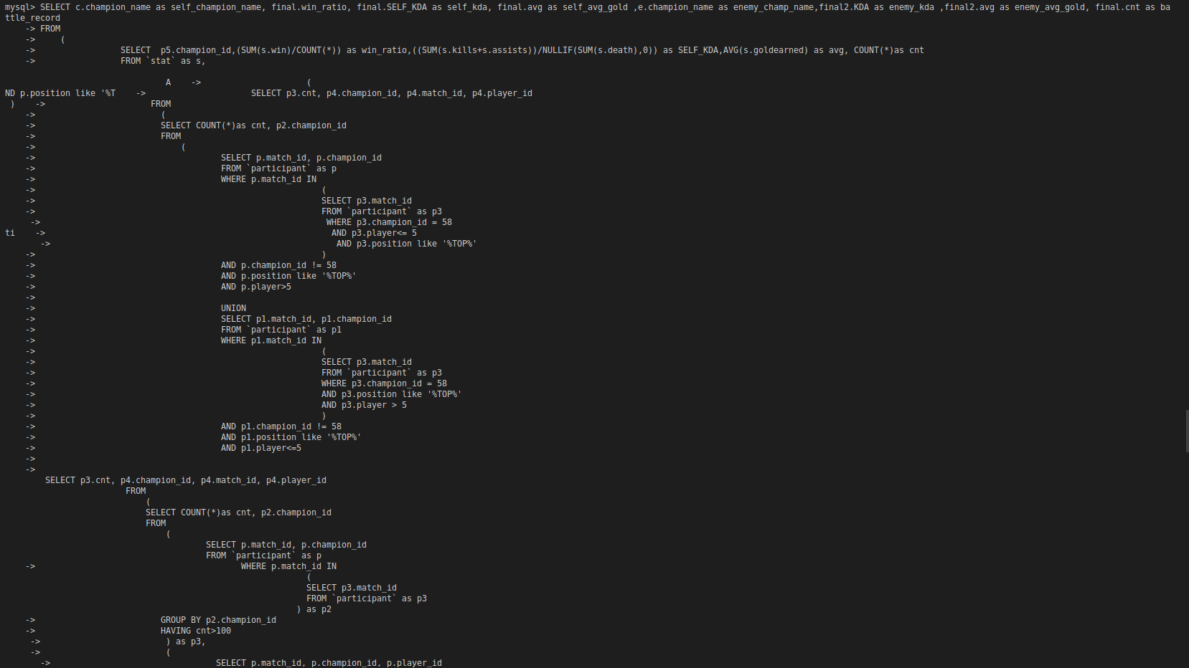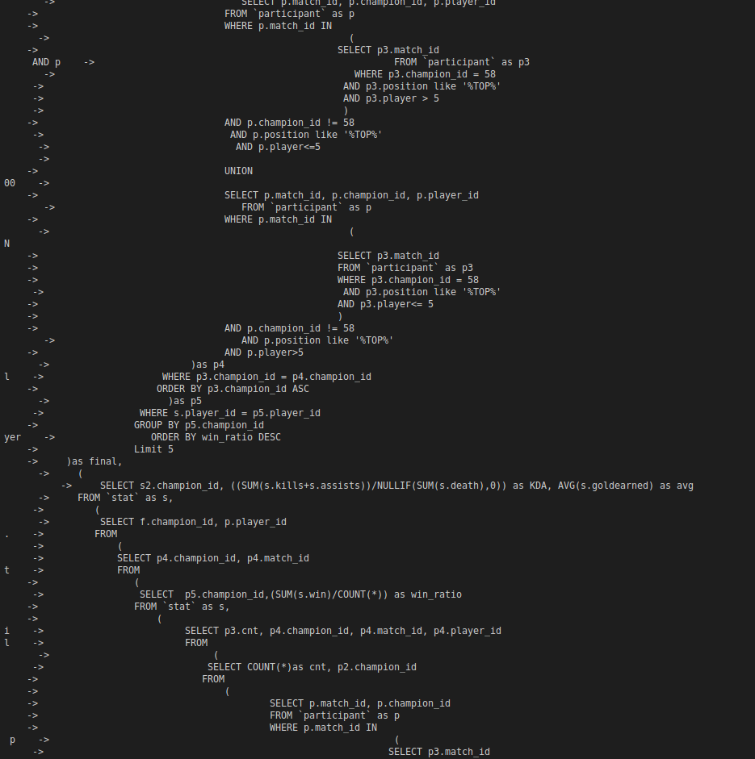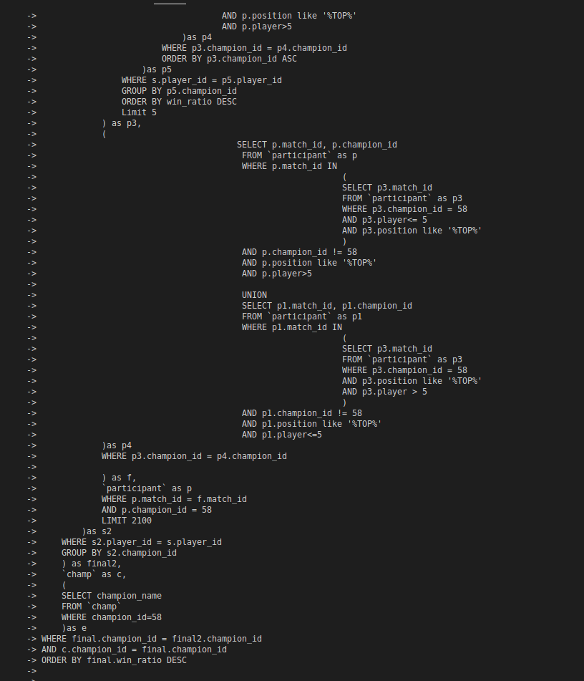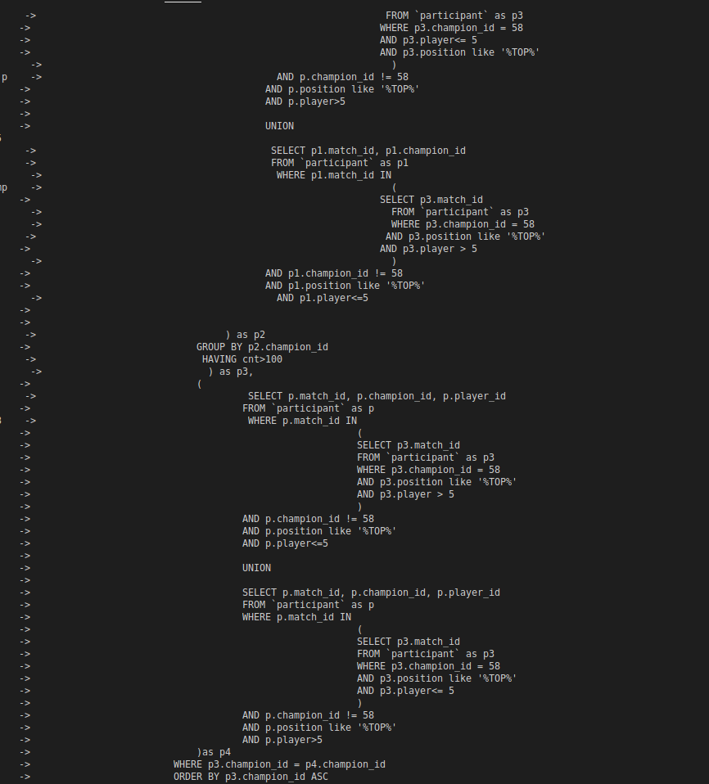

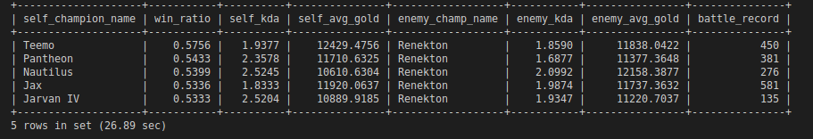

**11.**

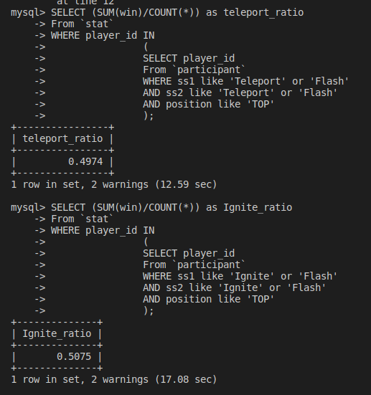

**我是找出上路帶flash and teleport的所有場的勝率，跟找出上路帶ignite and flash的勝率，而推論出前者的勝率比較高一些**

**12.**

**這題我想找出pentakill最多次的英雄的champion_name及他們戴的兩個技能(兩個技能位置不一樣就算不一樣，因為我覺得技能放在不同位置也可能有差異) 並且找出他們的win_ratio**

