RoboCup Junior 2019 Rescue Simulation (former CoSpace)

Team Description Paper

Team Name: SAC SIM

Participants: Lucas Chew,

[lucaschew0@gmail.com](mailto:lucaschew0@gmail.com)

Richard Liu,

Richardliu018@gmail.com

Kevin Mi,

Mikevin920@yahoo.com

Leon Kwok,

Xjhlg123555@gmail.com

Mentor: Stephen Holmes,

[stephen.holmes@sac.on.ca](mailto:stephen.holmes@sac.on.ca)

Institution: St. Andrew’s College

Country: Canada

Contact Person: Stephen Holmes,

[Stephen.holmes@sac.on.ca](mailto:Stephen.holmes@sac.on.ca)

Date: July 27th, 2019

RoboCupJunior 2019

Team Description Paper

Rescue Simulation (former CoSpace)

Lucas Chew, Richard Liu, Kevin Mi, Leon Kwok

SAC SIM, Canada

**Abstract:**

The overall goal of our team participating in this competition is to learn and experience how to affect the engineering side of the world, only using programming skills, given the necessary hardware already. It enables us to try to devise algorithms and theories that could help us solve an issue in a coding language and user interface in which we have never used before. Splitting this overall goal into smaller parts, would cause the goals of effective time management, communication, and problem solving. A goal for us would be time management, as there are tasks within the competition to program certain problems or scenarios given time limit restraints, causing our develop and brainstorming process to be efficient as possible. This also leads into our next minor goal, which would be communication. As throughout the development of our rescue simulation program, communication was key, assigning different sections to different people according to their skills and knowledge. Also, this would apply during the different sections of the competition, such as the part where we are assigned to a group with other people and have to communicate in order to solve the overall issue. Lastly, the final goal would be problem solving, as every program is meant to solve an over arching problem/issue. For us, the main problem was the algorithms that we had to code and develop, which would also continue during the competition, to refine and edit the parts that would require changes.

**Introduction:**

We are all grade 11 students from St. Andrew’s College in Aurora, Canada, taking computer science and computer engineering. We are all interested in engineering and robotics, due to the technological development that has occurred in the past few years. We decided to pick this event due to our passion and knowledge for computer science as well as the algorithmic challenges that occur in the project. For our roles, Lucas is the project manger, assigning parts of the code to different individuals to develop. Other than that, Richard, Kevin, and Leon are the coders, that do the hard job of sitting in front of a computer, thinking about why they decided to do this, as well as developing algorithms and parts of it. This RoboCup is our first RoboCup for worlds, though we have competed in other events are qualifiers in Canada, such as rescue maze and rescue line.

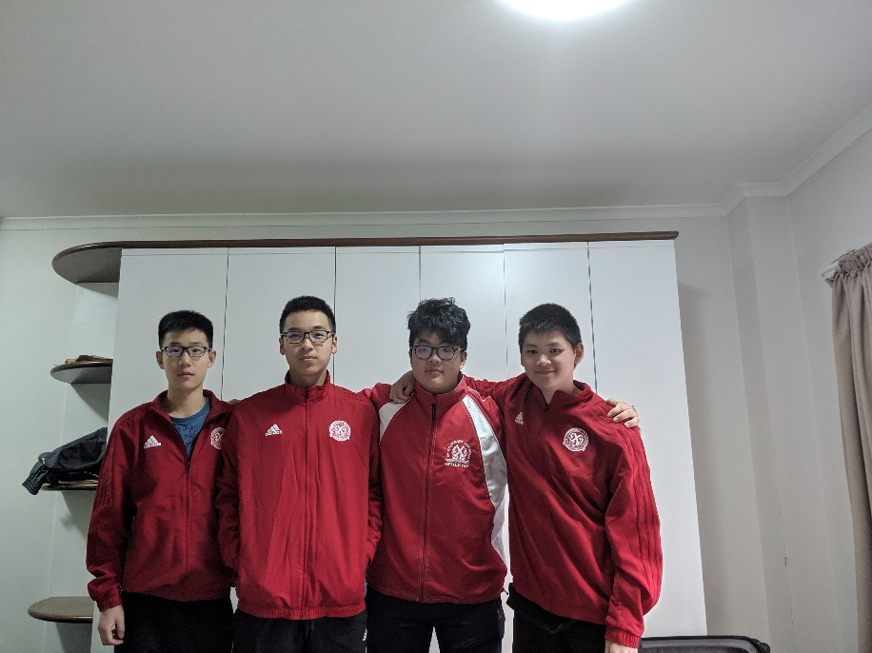

https://youtu.be/ayTzqfNnLLY

**Strategy:**

For World 1, there isn’t much of a strategy that we could use as the positions of x and y were unavailable, which made it difficult to try to develop an algorithm. For World 2, our algorithm is to store the coordinates of a deposit zone, and when the robot contains 6 objects within it, it would try to move according to the location of its current position compared to the position of the stored location, using the compass to try to guide its way back.

An example of the code would be:

* If x > heldX
  + Spin robot right until compass is 90 degrees
  + Move forward
* If y > heldY
  + Spin robot right until compass is 180 degrees
  + Move forward

This program would break when a wall is seen (obstruction of path), a danger zone is detected, when it is going out of boundaries, and when the deposit zone has been detected. For the initial storing of location of the deposit zone, we have to find it initially of spawn on it, which would allow it to find its way back to where it was, or else the robot would just wander until it would find one, using the random searching from World 1.

An algorithm that we thought of but could not put it into code was having a 2D array of booleans, which would be the length/dimensions of the field. Every time that the robot would move, and it was successful, it would store that the coordinate of that value was true, and that it was able to traverse onto that location without being harmed, and every time that it interacted with something, such as a wall or avoid area, it would mark it as false, so that it would know not to return into that same area. This would allow for the robot to also find deposit zones, as it would know which parts of the map were explored and would not return there unless every section was found. Once all the objects were loaded, it would use a search algorithm such as Depth First Search (DFS) and would try to find the most efficient path to the nearest deposit zone, allowing the robot to earn points faster, though the initial search would be slower, and would mean that we would send the robot to World 2, as soon as it pasted 3 minutes. This would be difficult for us though, as we are not proficient coders in C and instead within Java and Python, which would make transforming the data types and search algorithm difficult to implement.

**Discussion and Conclusion:**

Overall, our team’s experience with CoSpace was quite a difficult journey, as we were introduced to a new language, and given the limited knowledge and time, had to develop a program that would solve and complete the rescue. Furthermore, it was quite difficult to attempt to program algorithms by trying to develop our own datatypes, in which we eventually could not figure out. Though our journey was difficult, there we still many positives throughout our experience, such as brainstorming and working through problems together, and trying to find the easier solution to solve the problem that would be do-able with our skill knowledge.

For our future work, all of us are still going to be continuing down the path with technology, though we may split into different paths in university, such as computer science, engineering and business. We also will hopefully get the chance to come back to Robocup Junior to compete once again with a newer and better improved algorithm and knowledge that we gain from this competition.

**Acknowledgements:**

The first person that I would like to acknowledge would be a team member that could not make it onto the trip due to an internship, Alex Zhang. He was one of the original members of this team that helped develop the program as well as instructing other members on what to do, as well as how to use the interface.

The second person I would like to acknowledge would be one of our coaches which were unable to attend due to a medical issue, Mr. Terry Prezens. He was the first teacher to bring up the competition to our school, which eventually lead to the formation of our team. He helped us with the brainstorming process for the algorithms and helped us in the way we approached the program.

Lastly, I would like to acknowledge our coaches, Mr. Stephen Holmes and Mr. Lawrence DeMello, who brought us here to Australia and helped with the final stages of the program and the development process. Thank you!