The value of energy efficiency in Tunisia's power system (2030)
Rayen Romdhani, Energy Engineering, ENIM (Monastir, Tunisia). October 2026.
Model: PyPSA-Earth v0.10.0 with the study code in this repository. All result numbers come from results/summary.csv, results/avoided.csv, results/pathway_*.csv, results/saving_cost.csv and results/validation.csv; all inputs come from data/assumptions_register.xlsx.

Summary
Tunisia plans 35% renewable electricity by 2030 and generates almost all the rest from gas (94.5% of generation in 2024). This study asks what each MWh of electricity saved, or moved in time, is worth to the 2030 power system.
Saving 15% in every hour (S1-15 vs S0) avoids, per MWh saved | Value
System cost | 60 EUR
Gas burnt for power | 0.91 MWh (thermal)
CO2 | 0.18 t
New capacity | 449 MW per TWh saved per year

- With STEG's 10% reserve margin, the base case needs 423 MW of new gas turbines. A 10% saving already avoids all of them.
- Saving first on summer air conditioning (S1-15C) avoids 20% more gas per MWh than an even cut, although only 39% of the saving fits on the cooling load.
- Letting 300 MW of load move by up to 3 hours, on top of the 15% saving, cuts another 22 M EUR per year and 0.24 Mt of CO2.
- At the base gas price the least-cost system reaches 56% renewables, so the 35% target does not bind. It binds only in G-lo-S0, G-lo-S1-15.
- Built year by year at Tunisia's demonstrated pace (2027-2030 pathway), renewables reach only 22% in 2030 (27% with the 15% saving), and each MWh saved avoids 0.39 t of CO2 and 70 EUR.
- Saving is not free: a more efficient air conditioner costs 50-92 EUR per MWh saved, against 86 EUR avoided at the meter. Raising the standard to the EU's 2014 level pays for the power system.

1. Question and scope
The study measures what one MWh of electricity saved through efficiency, or moved in time through demand flexibility, avoids in 2030: new capacity, gas burnt, system cost and CO2. The renewable target stays in force in every scenario, so the comparison is between systems that all meet it.
The model covers Tunisia only, with two network nodes (north and south), 8,760 hourly steps and the 2013 weather year, solved with the open-source solver HiGHS. It does not include the cost of the efficiency programmes themselves, the planned ELMED link to Italy, or other countries.

2. Method

2.1 Base network and 2024 calibration
PyPSA-Earth, used unmodified, builds the Tunisian grid, power plants, renewable potentials and hourly demand from open data. Its plant list does not match the official fleet, so the thermal fleet is rebuilt from the ONEM 2024 statistics: 2,527 MW of combined cycle and 3,117 MW of gas turbines and steam units. One efficiency factor for existing gas units is fitted so that a 2024 run burns as much gas as STEG reported. The hourly demand shape is stretched to the official load factor and minimum-to-peak ratio.
2024 check (calibrated model) | Model | Official | Difference
Gas burnt for power (TWh thermal) | 37.0 | 36.8 | +0.4%
Gas fleet efficiency (net) | 0.49 | 0.49 | +0.0%
Peak demand (MW) | 4,901 | 4,888 | +0.3%
Gas share of generation | 93.6% | 94.5% | -1.0%

The gas-burnt check is independent of the fit: the factor was fitted on STEG's specific consumption, and the gas total comes from a separate ONEM table.

2.2 The 2030 system
Demand grows from 22.5 TWh in 2024 at 3.2% per year, STEG's base-case forecast as quoted by JICA (2022). Imports stay at their 2024 level (3.1 TWh, flat over the year), so every MWh saved falls on domestic generation. The model then builds solar, onshore wind, batteries and gas turbines at least cost, using 2030 costs from PyPSA technology-data. In every scenario it must:
- produce at least 35% of domestic generation from solar, wind and hydro;
- keep firm capacity (gas and hydro) at least 10% above peak demand, STEG's planning margin;
- build the committed solar and wind projects (data/committed_projects.csv) and keep the existing fleet.
After each solve the pipeline checks the energy balance, the renewable share, the reserve margin, that no load is shed and that committed and existing capacity is kept. All 11 scenarios pass.

2.3 Scenarios
Scenario | What changes against S0
S0 | Base case: 2030 demand, base gas price
S1-10, S1-15, S1-20 | Demand 10, 15 or 20% lower in every hour
S1-15C | Same 15% of annual energy, taken first from summer cooling load
S2-300, S2-600 | S1-15 plus 300 or 600 MW of load that can move by up to 3 hours
G-lo-S0, G-lo-S1-15 | S0 and S1-15 with the gas price x0.5
G-hi-S0, G-hi-S1-15 | S0 and S1-15 with the gas price x1.5

Shiftable load is modelled as a free, lossless store at each node that starts and ends every day half full. Load can be brought forward or postponed, but every MWh moved must come back within 3 hours, and the load moved up plus the load moved down in one hour cannot exceed the shift limit.

3. Results

3.1 Main scenarios
 | S0 | S1-10 | S1-15 | S1-20 | S1-15C | S2-300 | S2-600
Domestic demand (TWh) | 24.08 | 21.36 | 20.00 | 18.64 | 20.00 | 20.00 | 20.00
New gas turbines (MW) | 423 | 0 | 0 | 0 | 0 | 0 | 0
New solar (MW) | 3,797 | 3,105 | 2,796 | 2,474 | 2,670 | 3,321 | 3,816
New onshore wind (MW) | 2,121 | 1,857 | 1,714 | 1,574 | 1,853 | 1,629 | 1,485
Gas burnt (TWh thermal) | 21.55 | 19.09 | 17.83 | 16.60 | 17.09 | 16.63 | 15.89
CO2 (Mt) | 4.27 | 3.78 | 3.53 | 3.29 | 3.38 | 3.29 | 3.15
Renewable share | 56% | 56% | 56% | 56% | 57% | 58% | 60%
System cost (M EUR/yr) | 1,327 | 1,157 | 1,084 | 1,012 | 1,073 | 1,062 | 1,045
Average price (EUR/MWh) | 54.7 | 54.2 | 53.5 | 52.8 | 53.1 | 52.5 | 51.9

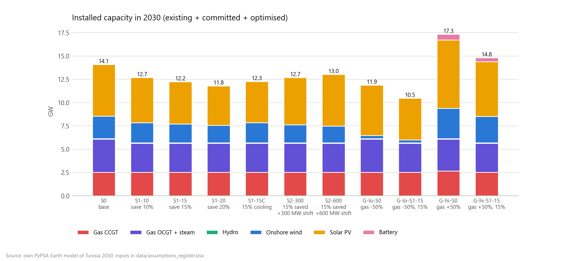
Figure 1. Installed capacity in 2030 by scenario.
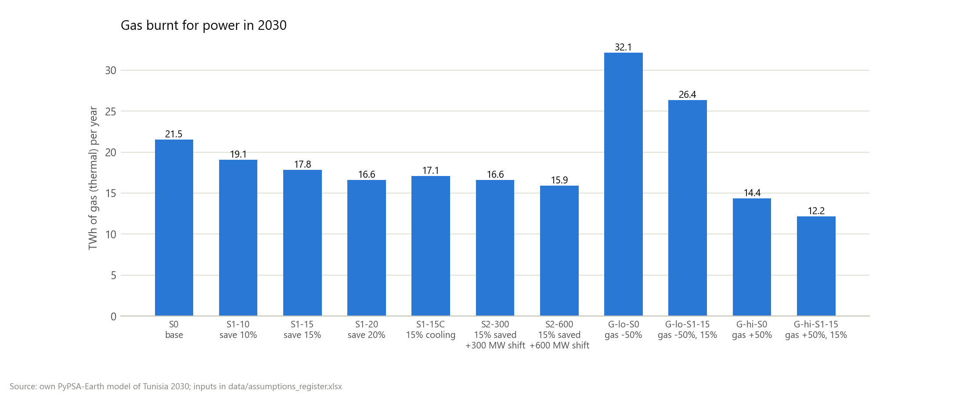
Figure 2. Gas burnt for power in 2030 by scenario.

3.2 What one MWh saved avoids
Scenario | vs | Cost (EUR/MWh) | CO2 (t/MWh) | Gas (MWh/MWh) | Capacity (MW per TWh)
S1-10 | S0 | 62.6 | 0.18 | 0.90 | 507
S1-15 | S0 | 59.6 | 0.18 | 0.91 | 449
S1-20 | S0 | 58.0 | 0.18 | 0.91 | 422
S1-15C | S0 | 62.4 | 0.22 | 1.09 | 446
S2-300 | S0 | 65.0 | 0.24 | 1.21 | 341
S2-600 | S0 | 69.2 | 0.27 | 1.39 | 255
G-lo-S1-15 | G-lo-S0 | 43.0 | 0.28 | 1.42 | 348
G-hi-S1-15 | G-hi-S0 | 70.1 | 0.11 | 0.54 | 616

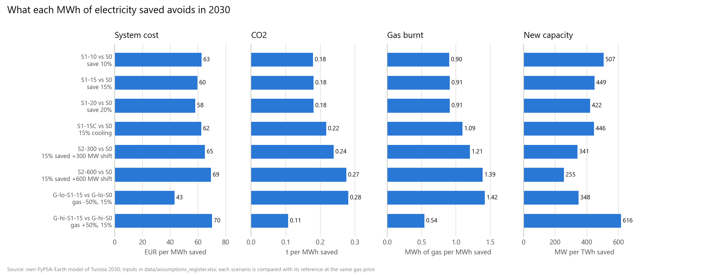
Figure 3. What each MWh saved avoids, against the reference at the same gas price.

3.3 Findings
Efficiency avoids new gas plant. The base case needs 423 MW of new gas turbines to keep the reserve margin. A 10% saving lowers the peak enough to avoid all of it, which is why the first 10% saved is worth the most (62.6 EUR/MWh against 59.6 for 15%). Beyond that point, further savings avoid mostly solar and wind that would otherwise be built.
Timing matters. In S1-15C only 39% of the 15% saving fits on the summer cooling load; the rest is an even cut. That is enough to avoid 20% more gas per MWh and 11.5 M EUR per year more than S1-15, because air-conditioning hours are the hours when gas runs.
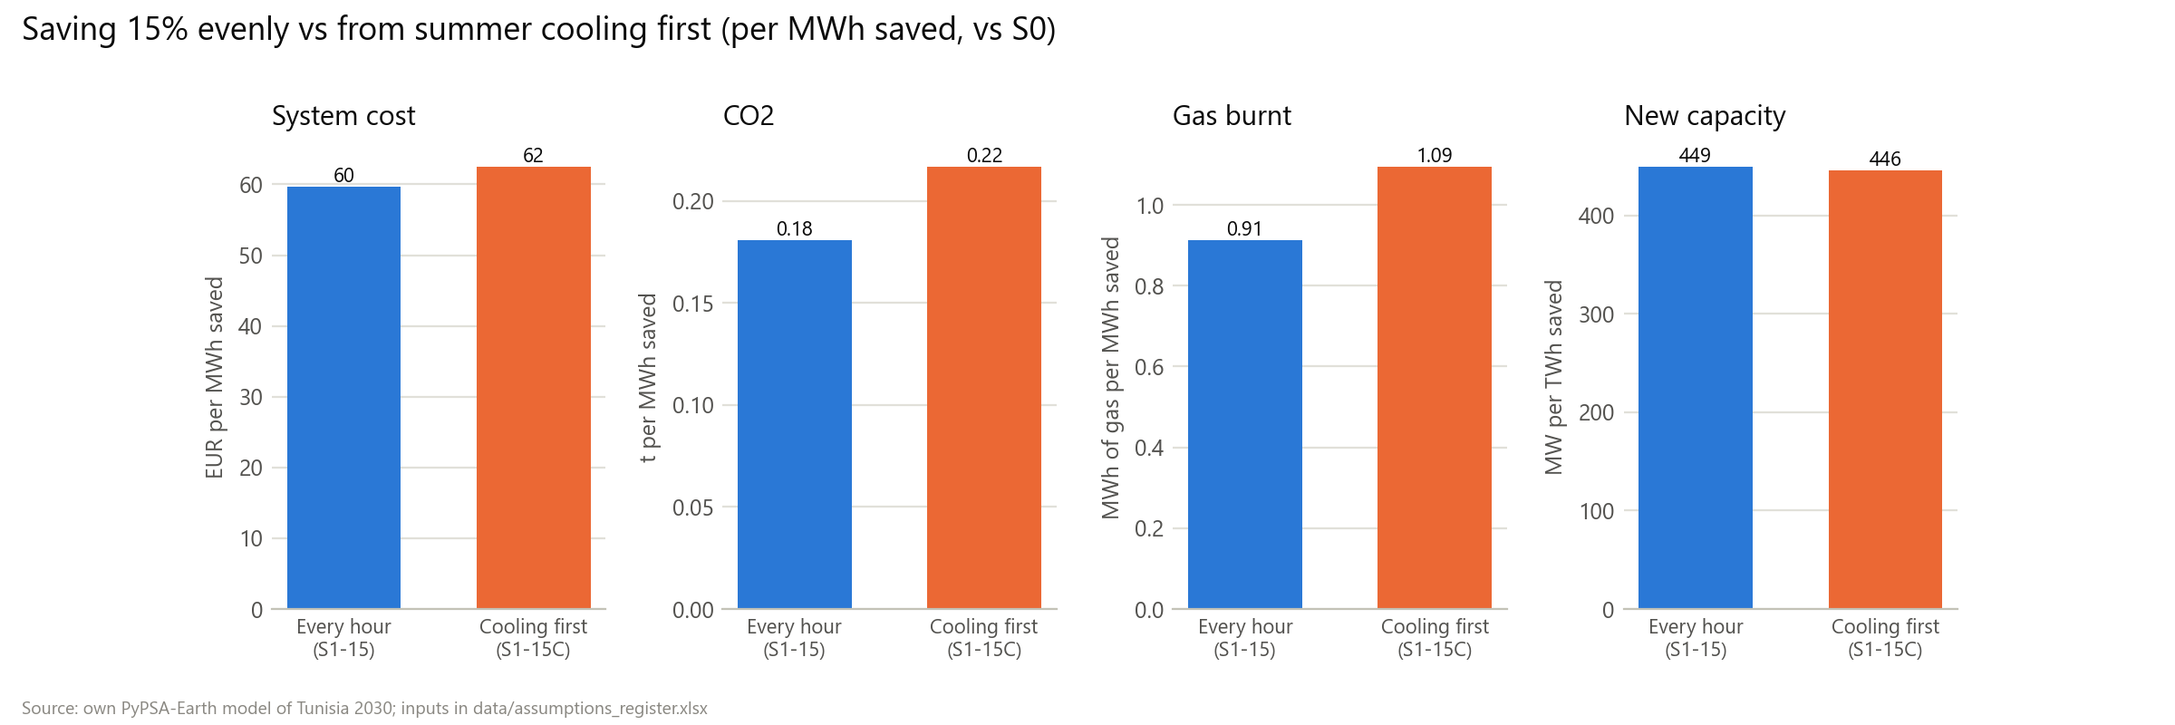
Figure 4. The same 15% saved evenly or from cooling first.
Flexibility adds to efficiency. Shifting 300 MW of load saves 22.1 M EUR per year on top of S1-15, about 74,000 EUR per MW per year. The model moves morning and evening load into the midday solar hours, builds more solar and burns less gas. Under the reserve rule, flexibility gets no credit for lowering the peak, so all of this value is energy.
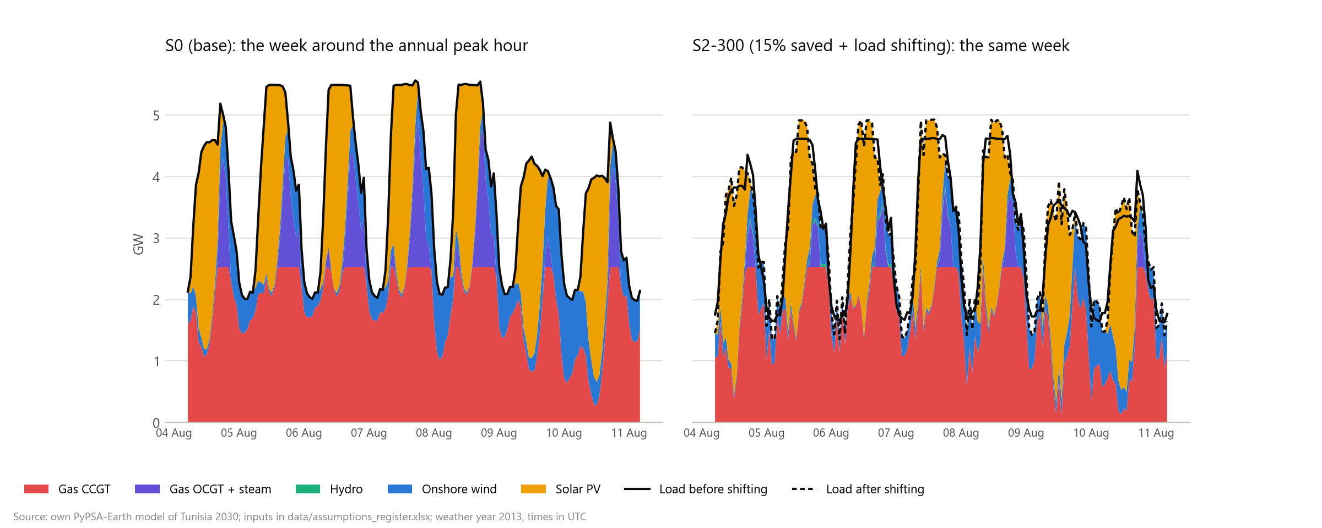
Figure 5. Dispatch in the week around the annual peak, S0 and S2-300.
The gas price changes the result most. With gas at x0.5, each MWh saved avoids 0.28 t of CO2, because the saving mostly displaces gas. With gas at x1.5, the reference system is already 70% renewable with 3,148 MWh of batteries, and each MWh saved avoids only 0.11 t of CO2 but 70 EUR.
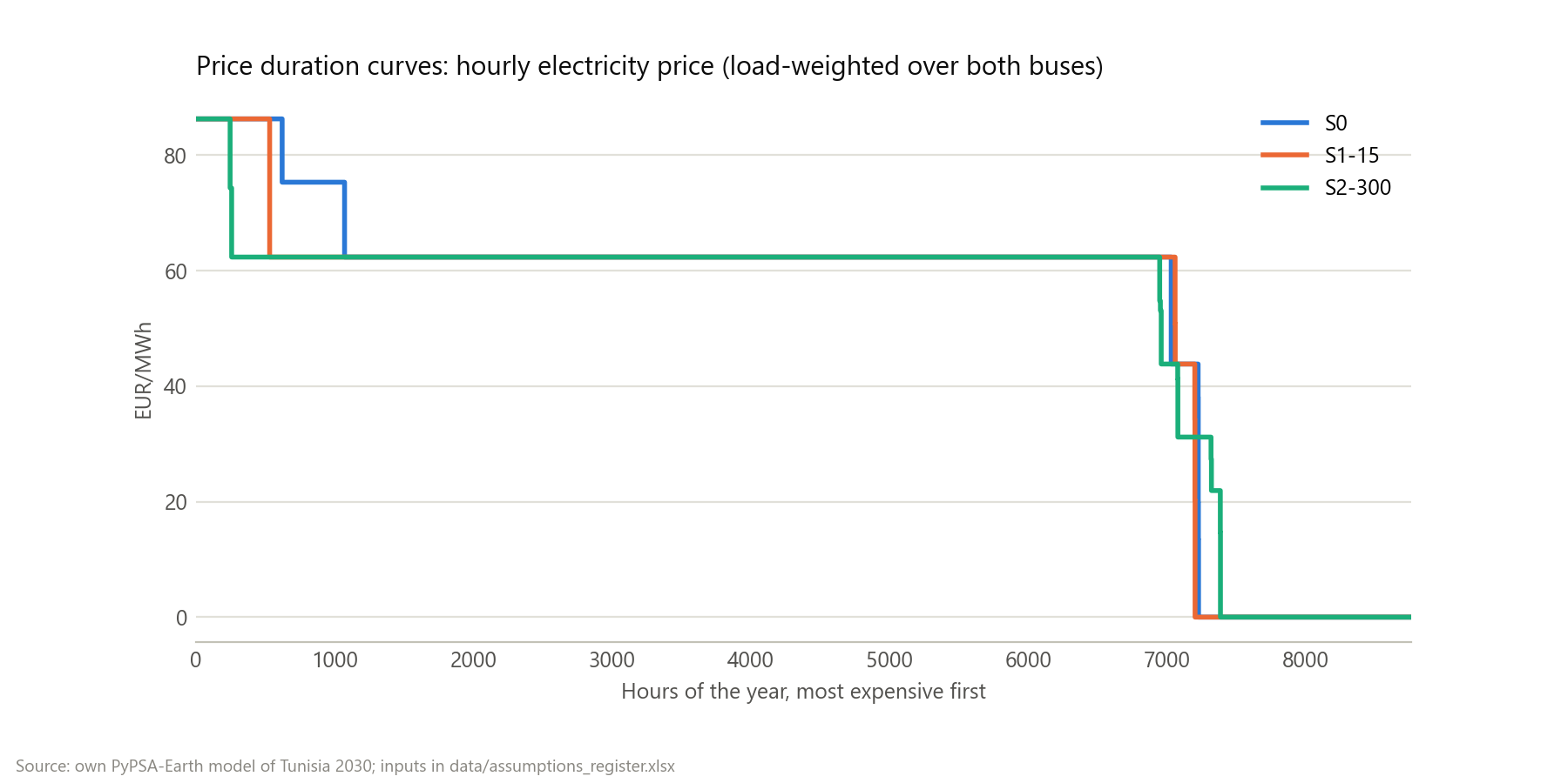
Figure 6. Hourly electricity price, sorted, for S0, S1-15 and S2-300.

3.4 The 2027-2030 pathway
The runs above solve 2030 in one step and may build any amount. The pathway instead solves 2025 and 2026 once (base case), then each scenario for 2027, 2028, 2029 and 2030 in turn. Each year keeps what was built before, committed projects switch on in their expected year, and new building is capped at Tunisia's demonstrated pace: 268 MW of solar a year beyond the committed projects, no new wind before 2029 and then 75 MW a year, and batteries only from 2029 (at most 150 MW / 540 MWh). Savings and shifting reach their full size in 2030, a quarter at a time from 2027. The 35% target is measured, not enforced.
Over 2027-2030, per MWh saved | Cost (EUR) | CO2 (t) | Gas (MWh)
S1-10 vs S0 | 71.1 | 0.36 | 1.83
S1-15 vs S0 | 70.1 | 0.39 | 1.95
S1-20 vs S0 | 69.3 | 0.40 | 2.00
S2-300 vs S0 | 72.0 | 0.40 | 2.02
G-lo-S1-15 vs G-lo-S0 | 40.9 | 0.43 | 2.19
G-hi-S1-15 vs G-hi-S0 | 95.2 | 0.36 | 1.80

- Renewables reach 22% of generation in 2030 without extra saving, 27% when saving 15% and 29% when saving 20%: the 35% target is out of reach at this pace, and efficiency closes part of the gap.
- Each MWh saved (S1-15) avoids 0.39 t of CO2 and 1.95 MWh of gas, against 0.18 t and 0.91 MWh in the unconstrained 2030 run: with little room to build solar, a saved MWh comes off a gas plant.
- Without extra saving the model adds 423 MW of combined cycles by 2030 for the reserve margin; every saving scenario adds none.
- Shifting 300 MW is worth 6.8 M EUR in 2030, much less than in the unconstrained run, because there is little midday solar to shift into.
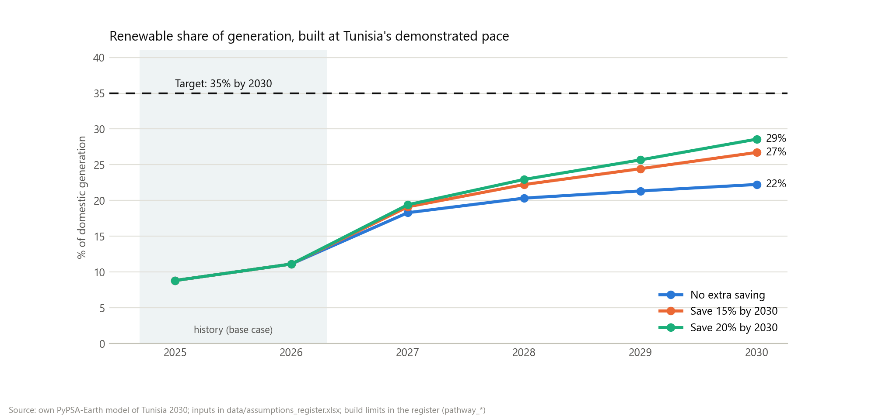
Figure 7. Renewable share year by year on the pathway, against the target.
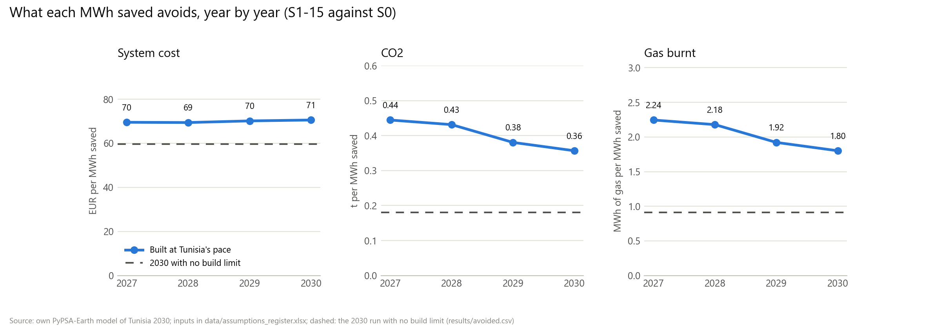
Figure 8. What each MWh saved avoids, year by year (S1-15 vs S0), against the unconstrained 2030 run (dashed).

3.5 What saving costs: efficient air conditioners
The model treats saving as free. The one Tunisian measure with a published cost per kWh saved is the split air conditioner (LBNL, Cost-Benefit Analysis for Air Conditioner in Tunisia, 2023): prices and yearly electricity use at each efficiency level, against today's market average. The extra price is spread over the unit's 10.5-year life at the model's 7.1% discount rate and divided by the kWh saved each year, then converted at 1.1827 US$ per EUR (2021). It is compared with the value of a cooling-first MWh saved on the pathway (S1-15C, 2027-2030), raised by the 18% grid losses because the AC saves at the meter, and with the STEG tariff the owner stops paying.
Measure (vs today's market average) | Extra price (US$) | kWh saved a year | Cost (EUR/MWh) | Net for the system (EUR/MWh)
Cooling-only AC, EU 2014 standard | 48 | 90 | 62 | +24
Cooling-only AC, best available | 220 | 279 | 92 | -6
Reversible AC, EU 2014 standard | 51 | 119 | 50 | +36
Reversible AC, best available | 227 | 346 | 77 | +10

- A saved MWh is worth 86 EUR to the power system at the meter (71 EUR at the plants) and 128 EUR to the owner.
- Raising the minimum standard to the EU's 2014 level costs 50-62 EUR per MWh saved: it pays for the power system.
- The best available units cost 77-92 EUR per MWh: close to break-even for the system, and every level pays for the owner.
- A standard would deliver 9% (EU level) to 25% (best available) of the S1-15C saving in 2030; the other measures have no sourced Tunisian cost per kWh.
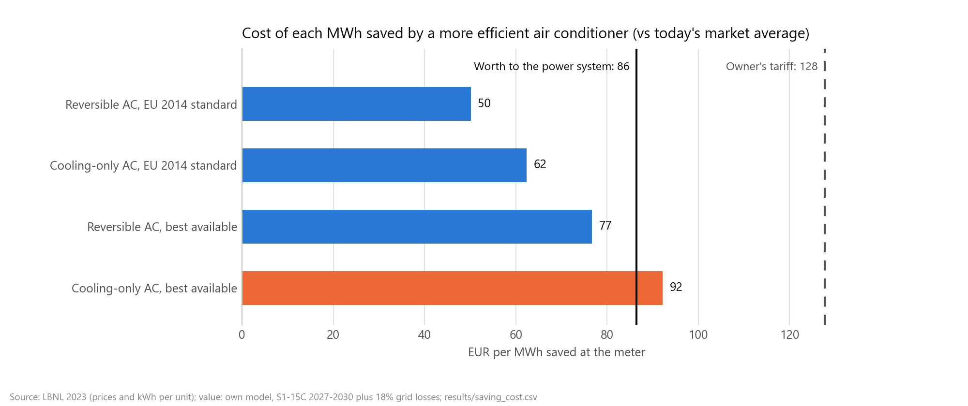
Figure 9. Cost per MWh saved by more efficient air conditioners, against what the MWh is worth to the power system and to the owner.

4. Limitations
- In the 2030 runs nothing limits how fast renewables are built: the base case adds 5.9 GW of solar and wind, far above Tunisia's recent pace. The pathway (section 3.4) caps building; its caps are judgements based on past pace, and it assumes committed projects arrive on time.
- The cost of efficiency programmes is not modelled. The avoided cost per MWh is the most a programme could cost and still pay off for the power system. Section 3.5 prices one measure (air-conditioner standards, equipment cost only); the cost of the whole saving is unknown.
- One weather year (2013) at 1-hour steps. A 3-hour test run built 2.7% more solar and 3.9% more wind (resolution benchmark in docs/project-history/phase2-base-network.md).
- Demand growth and the 2030 peak come from STEG's forecast as quoted by JICA (2022), a secondary source.
- Imports are flat at their 2024 level, so every MWh saved falls on domestic generation.
- The fitted efficiency factor for existing gas units also stands in for plant outages, which are not modelled.
- The reserve margin is one national capacity rule, not a reliability study.
- System cost includes the annualised cost of plants that already exist. Differences between scenarios are meaningful; the absolute level is not the cost of the real system.

5. Inputs and sources
Every input is a row of data/assumptions_register.xlsx with its unit, type and source; rows typed 'assumption' have no published source and are explained in the register notes. The study inputs:
Input | Value | Unit | Type | Source
re_target_2030 | 0.35 | share | sourced | TAP, 9 Oct 2026: Head of Government reaffirms 35% target
flex_cap_mw | 300 | MW | sourced | TAP, 9 Oct 2026: action plan targets 300 MW peak-demand reduction
flex_cap_hi_mw | 600 | MW | assumption
flex_max_hours | 3 | h | assumption
gas_price_factor_lo | 0.5 | x base | assumption
gas_price_factor_hi | 1.5 | x base | assumption
demand_growth | 0.032 | 1/yr | sourced | JICA / TEPSCO / KPMG, Data Collection Survey on Power Sector in Tunisia, Final Report (Mar 2022), quoting STEG's base-case forecast, p.2-17 and p.5-34
peak_ref_2030_mw | 6,000 | MW | sourced | JICA / TEPSCO / KPMG, Data Collection Survey on Power Sector in Tunisia, Final Report (Mar 2022), quoting STEG's base-case forecast, p.2-17 and p.5-35
discount_rate | 0.071 | 1/yr | sourced | PyPSA-Earth v0.10.0 config.default.yaml, costs.discountrate
demand_2024_twh | 22.51 | TWh | sourced | ONEM / Ministry of Industry, Mines and Energy, Memento du secteur de l'énergie, Chiffres de 2024 (Aug 2025), table 'ELECTRICITE', printed p.18
imports_2024_twh | 3.113 | TWh | sourced | ONEM / Ministry of Industry, Mines and Energy, Memento du secteur de l'énergie, Chiffres de 2024 (Aug 2025), table 'ELECTRICITE', printed p.18
gas_price_eur_per_mwh_th | 28.42 | EUR/MWh_th | sourced | PyPSA technology-data v0.15.0 costs_2030.csv (gas, fuel); original: World Bank Commodity Markets 2025 and ENTSO-E/ENTSOG TYNDP 2024
cap_2024_ccgt_mw | 2,527 | MW | sourced | ONEM / Ministry of Industry, Mines and Energy, Memento du secteur de l'énergie, Chiffres de 2024 (Aug 2025)
cap_2024_ocgt_mw | 2,457 | MW | sourced | ONEM / Ministry of Industry, Mines and Energy, Memento du secteur de l'énergie, Chiffres de 2024 (Aug 2025)
cap_2024_steam_mw | 660 | MW | sourced | ONEM / Ministry of Industry, Mines and Energy, Memento du secteur de l'énergie, Chiffres de 2024 (Aug 2025)
cap_2024_re_mw | 368 | MW | sourced | ONEM / Ministry of Industry, Mines and Energy, Memento du secteur de l'énergie, Chiffres de 2024 (Aug 2025)
cap_2024_total_mw | 6,012 | MW | sourced | ONEM / Ministry of Industry, Mines and Energy, Memento du secteur de l'énergie, Chiffres de 2024 (Aug 2025)
gen_2024_gas_twh | 18.16 | TWh | sourced | ONEM / Ministry of Industry, Mines and Energy, Memento du secteur de l'énergie, Chiffres de 2024 (Aug 2025)
gen_2024_oil_twh | 0.0719 | TWh | sourced | ONEM / Ministry of Industry, Mines and Energy, Memento du secteur de l'énergie, Chiffres de 2024 (Aug 2025)
gen_2024_hydro_twh | 0.016 | TWh | sourced | ONEM / Ministry of Industry, Mines and Energy, Memento du secteur de l'énergie, Chiffres de 2024 (Aug 2025)
gen_2024_wind_twh | 0.337 | TWh | sourced | ONEM / Ministry of Industry, Mines and Energy, Memento du secteur de l'énergie, Chiffres de 2024 (Aug 2025)
gen_2024_solar_twh | 0.6278 | TWh | sourced | ONEM / Ministry of Industry, Mines and Energy, Memento du secteur de l'énergie, Chiffres de 2024 (Aug 2025)
gen_2024_total_twh | 19.21 | TWh | sourced | ONEM / Ministry of Industry, Mines and Energy, Memento du secteur de l'énergie, Chiffres de 2024 (Aug 2025)
gas_share_2024 | 0.945 | share | sourced | ONEM / Ministry of Industry, Mines and Energy, Memento du secteur de l'énergie, Chiffres de 2024 (Aug 2025)
peak_2024_mw | 4,888 | MW | sourced | ONEM / Ministry of Industry, Mines and Energy, Memento du secteur de l'énergie, Chiffres de 2024 (Aug 2025)
steg_specific_consumption_2024 | 194.8 | toe(GCV)/GWh | sourced | ONEM / Ministry of Industry, Mines and Energy, Memento du secteur de l'énergie, Chiffres de 2024 (Aug 2025)
steg_demand_2030_gwh | 28,362 | GWh | sourced | JICA / TEPSCO / KPMG, Data Collection Survey on Power Sector in Tunisia, Final Report (Mar 2022), quoting STEG's base-case forecast, p.2-17
load_factor_2030 | 0.54 | share | sourced | JICA / TEPSCO / KPMG, Data Collection Survey on Power Sector in Tunisia, Final Report (Mar 2022), quoting STEG's base-case forecast, p.5-34
min_to_peak_2030 | 0.34 | share | sourced | JICA / TEPSCO / KPMG, Data Collection Survey on Power Sector in Tunisia, Final Report (Mar 2022), quoting STEG's base-case forecast, p.5-35
ccgt_efficiency | 0.58 | per unit | sourced | PyPSA technology-data v0.15.0 costs_2030.csv (CCGT, efficiency); original: Danish Energy Agency, inputs/technology_data_for_el_and_dh.xlsx
ccgt_vom | 5.61 | EUR/MWh | sourced | PyPSA technology-data v0.15.0 costs_2030.csv (CCGT, VOM); original: Danish Energy Agency, inputs/technology_data_for_el_and_dh.xlsx
ocgt_efficiency | 0.41 | per unit | sourced | PyPSA technology-data v0.15.0 costs_2030.csv (OCGT, efficiency); original: Danish Energy Agency, inputs/technology_data_for_el_and_dh.xlsx
ocgt_vom | 6.011 | EUR/MWh | sourced | PyPSA technology-data v0.15.0 costs_2030.csv (OCGT, VOM); original: Danish Energy Agency, inputs/technology_data_for_el_and_dh.xlsx
gas_ncv_per_gcv | 0.9 | ratio | sourced | ONEM / Ministry of Industry, Mines and Energy, Memento du secteur de l'énergie, Chiffres de 2024, conversion table (PDF p.22)
existing_gas_efficiency_factor | 0.8634 | x tech-data | assumption | Calibrated (Task 10) so the dispatch-only 2024 run matches STEG's measured fuel use: ONEM Memento 2024, specific consumption 194.8 toe(PCS)/GWh, PCI = 0.9 PCS
ocgt_investment | 581.4 | EUR/kW | sourced | PyPSA technology-data v0.15.0 costs_2030.csv (OCGT, investment); original: Danish Energy Agency, inputs/technology_data_for_el_and_dh.xlsx
ocgt_fom | 1.78 | %/year | sourced | PyPSA technology-data v0.15.0 costs_2030.csv (OCGT, FOM); original: Danish Energy Agency, inputs/technology_data_for_el_and_dh.xlsx
ocgt_lifetime | 25 | years | sourced | PyPSA technology-data v0.15.0 costs_2030.csv (OCGT, lifetime); original: Danish Energy Agency, inputs/technology_data_for_el_and_dh.xlsx
gas_co2_intensity | 0.198 | tCO2/MWh_th | sourced | PyPSA technology-data v0.15.0 costs_2030.csv (gas, CO2 intensity); original: Stoichiometric calculation with 50 GJ/t CH4
gas_for_power_2024_ktep_ncv | 3,168 | ktep (net CV) | sourced | ONEM / Ministry of Industry, Mines and Energy, Memento du secteur de l'énergie, Chiffres de 2024 (Aug 2025)
cap_2024_selfgen_solar_lv_mw | 315 | MW | sourced | ONEM / Ministry of Industry, Mines and Energy, Memento du secteur de l'énergie, Chiffres de 2024 (Aug 2025)
cap_2024_selfgen_solar_mvhv_mw | 125 | MW | sourced | ONEM / Ministry of Industry, Mines and Energy, Memento du secteur de l'énergie, Chiffres de 2024 (Aug 2025)
reserve_margin | 0.1 | share of peak | sourced | JICA / TEPSCO / KPMG, Data Collection Survey on Power Sector in Tunisia, Final Report (Mar 2022), p.5-33
gas_supply_domestic_2024_ktep | 1,212 | ktep (net CV) | sourced | ONEM / Ministry of Industry, Mines and Energy, Memento du secteur de l'énergie, Chiffres de 2024 (Aug 2025), table 'Gaz naturel' (approvisionnement, ktep-pci)
gas_supply_royalty_2024_ktep | 909 | ktep (net CV) | sourced | ONEM / Ministry of Industry, Mines and Energy, Memento du secteur de l'énergie, Chiffres de 2024 (Aug 2025), table 'Gaz naturel' (approvisionnement, ktep-pci)
gas_supply_purchases_2024_ktep | 2,290 | ktep (net CV) | sourced | ONEM / Ministry of Industry, Mines and Energy, Memento du secteur de l'énergie, Chiffres de 2024 (Aug 2025), table 'Gaz naturel' (approvisionnement, ktep-pci)
energy_independence_2024 | 0.41 | share | sourced | ONEM / Ministry of Industry, Mines and Energy, Memento du secteur de l'énergie, Chiffres de 2024 (Aug 2025), 'Bilan d'énergie primaire'
steg_established_year | 1,962 | year | sourced | JICA / TEPSCO / KPMG, Data Collection Survey on Power Sector in Tunisia, Final Report (Mar 2022), p.2-1
steg_generation_share | 0.86 | share | sourced | JICA / TEPSCO / KPMG, Data Collection Survey on Power Sector in Tunisia, Final Report (Mar 2022), p.2-1
anme_established_year | 1,985 | year | sourced | JICA / TEPSCO / KPMG, Data Collection Survey on Power Sector in Tunisia, Final Report (Mar 2022), p.2-1
tsp_re_target_2030 | 0.3 | share | sourced | JICA / TEPSCO / KPMG, Data Collection Survey on Power Sector in Tunisia, Final Report (Mar 2022), p.2-2
indc_co2_intensity_cut_2030 | 0.41 | share | sourced | JICA / TEPSCO / KPMG, Data Collection Survey on Power Sector in Tunisia, Final Report (Mar 2022), p.2-2
gas_supply_domestic_2023_ktep | 1,607 | ktep (net CV) | sourced | ONEM / Ministry of Industry, Mines and Energy, Memento du secteur de l'énergie, Chiffres de 2024 (Aug 2025), table 'Gaz naturel' (approvisionnement, ktep-pci)
solar_capacity_2024_mw | 773 | MW | sourced | Enerdata, 'France's Voltalia expands Tunisian portfolio with 132 MW solar project' (4 Feb 2026)
solar_growth_2024 | 0.53 | share | sourced | Enerdata, 'France's Voltalia expands Tunisian portfolio with 132 MW solar project' (4 Feb 2026)
pathway_solar_extra_mw_per_year | 268 | MW/yr | assumption
pathway_wind_first_year | 2,029 | year | assumption
pathway_wind_extra_mw_per_year | 75 | MW/yr | assumption | Enerdata, 'Tunisia launches a tender for 1.7 GW of renewables' (5 Jan 2023)
pathway_battery_first_year | 2,029 | year | assumption | Mercom, 'Tunisia invites bids for 300 MW solar plus 150 MW/540 MWh battery storage project' (Mar 2026)
pathway_battery_mw | 150 | MW | assumption | Mercom, 'Tunisia invites bids for 300 MW solar plus 150 MW/540 MWh battery storage project' (Mar 2026)
anme_demand_cut_2030 | 0.3 | share | sourced | AllAfrica / La Presse, ANME announcement of the national energy-conservation strategy (24 Oct 2025)
pathway_battery_mwh | 540 | MWh | assumption | Mercom, 'Tunisia invites bids for 300 MW solar plus 150 MW/540 MWh battery storage project' (Mar 2026)
ac_lifetime_years | 10.5 | years | sourced | LBNL (Letschert, Agarwal, de la Rue du Can, Park), Cost-Benefit Analysis for Air Conditioner in Tunisia, LBNL-2001527 (Feb 2023), Table 13
ac_cool_price_bau_usd | 469 | US$ | sourced | LBNL (Letschert, Agarwal, de la Rue du Can, Park), Cost-Benefit Analysis for Air Conditioner in Tunisia, LBNL-2001527 (Feb 2023), Table 11
ac_cool_price_eu_usd | 517 | US$ | sourced | LBNL (Letschert, Agarwal, de la Rue du Can, Park), Cost-Benefit Analysis for Air Conditioner in Tunisia, LBNL-2001527 (Feb 2023), Table 11
ac_cool_price_best_usd | 689 | US$ | sourced | LBNL (Letschert, Agarwal, de la Rue du Can, Park), Cost-Benefit Analysis for Air Conditioner in Tunisia, LBNL-2001527 (Feb 2023), Table 11
ac_cool_kwh_bau | 604 | kWh/yr | sourced | LBNL (Letschert, Agarwal, de la Rue du Can, Park), Cost-Benefit Analysis for Air Conditioner in Tunisia, LBNL-2001527 (Feb 2023), Table 11
ac_cool_kwh_eu | 514 | kWh/yr | sourced | LBNL (Letschert, Agarwal, de la Rue du Can, Park), Cost-Benefit Analysis for Air Conditioner in Tunisia, LBNL-2001527 (Feb 2023), Table 11
ac_cool_kwh_best | 325 | kWh/yr | sourced | LBNL (Letschert, Agarwal, de la Rue du Can, Park), Cost-Benefit Analysis for Air Conditioner in Tunisia, LBNL-2001527 (Feb 2023), Table 11
ac_rev_price_bau_usd | 486 | US$ | sourced | LBNL (Letschert, Agarwal, de la Rue du Can, Park), Cost-Benefit Analysis for Air Conditioner in Tunisia, LBNL-2001527 (Feb 2023), Table 12
ac_rev_price_eu_usd | 537 | US$ | sourced | LBNL (Letschert, Agarwal, de la Rue du Can, Park), Cost-Benefit Analysis for Air Conditioner in Tunisia, LBNL-2001527 (Feb 2023), Table 12
ac_rev_price_best_usd | 713 | US$ | sourced | LBNL (Letschert, Agarwal, de la Rue du Can, Park), Cost-Benefit Analysis for Air Conditioner in Tunisia, LBNL-2001527 (Feb 2023), Table 12
ac_rev_kwh_bau | 887 | kWh/yr | sourced | LBNL (Letschert, Agarwal, de la Rue du Can, Park), Cost-Benefit Analysis for Air Conditioner in Tunisia, LBNL-2001527 (Feb 2023), Table 12
ac_rev_kwh_eu | 768 | kWh/yr | sourced | LBNL (Letschert, Agarwal, de la Rue du Can, Park), Cost-Benefit Analysis for Air Conditioner in Tunisia, LBNL-2001527 (Feb 2023), Table 12
ac_rev_kwh_best | 541 | kWh/yr | sourced | LBNL (Letschert, Agarwal, de la Rue du Can, Park), Cost-Benefit Analysis for Air Conditioner in Tunisia, LBNL-2001527 (Feb 2023), Table 12
ac_tariff_usd_per_kwh | 0.151 | US$/kWh | sourced | LBNL (Letschert, Agarwal, de la Rue du Can, Park), Cost-Benefit Analysis for Air Conditioner in Tunisia, LBNL-2001527 (Feb 2023), Table 13
grid_losses | 0.18 | share | sourced | LBNL (Letschert, Agarwal, de la Rue du Can, Park), Cost-Benefit Analysis for Air Conditioner in Tunisia, LBNL-2001527 (Feb 2023), Table 16
ac_saving_2030_eu_gwh | 287 | GWh/yr | sourced | LBNL (Letschert, Agarwal, de la Rue du Can, Park), Cost-Benefit Analysis for Air Conditioner in Tunisia, LBNL-2001527 (Feb 2023), Table 17
ac_saving_2030_best_gwh | 841 | GWh/yr | sourced | LBNL (Letschert, Agarwal, de la Rue du Can, Park), Cost-Benefit Analysis for Air Conditioner in Tunisia, LBNL-2001527 (Feb 2023), Table 17
usd_per_eur_2021 | 1.183 | US$/EUR | sourced | Deutsche Bundesbank, ECB euro reference rate, annual average, series BBEX3.A.USD.EUR.BB.AC.A04

Modelling tools. The study is built on these open-source tools:
- T. Brown, J. Hörsch, D. Schlachtberger, "PyPSA: Python for Power System Analysis", Journal of Open Research Software 6(1), 4 (2018). doi:10.5334/jors.188
- M. Parzen et al., "PyPSA-Earth. A new global open energy system optimization model demonstrated in Africa", Applied Energy 341, 121096 (2023). doi:10.1016/j.apenergy.2023.121096

6. Reproducing the study
The code, tests, scenario files and step-by-step instructions are in the repository README. One command (snakemake -j 1) rebuilds, solves and checks all 11 scenarios, for 2030 and for the 2027-2030 pathway, in about two hours on a laptop, and scripts/make_figures.py and scripts/make_report.py redraw the figures and this report.

